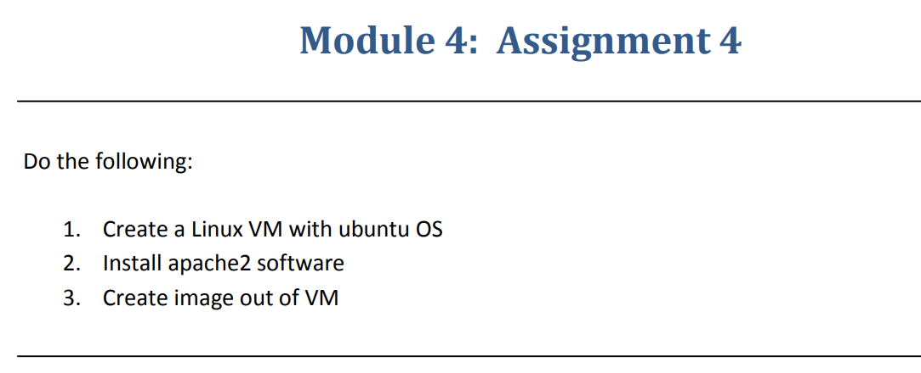

**Step-1:-** Created a VM by using Linux OS

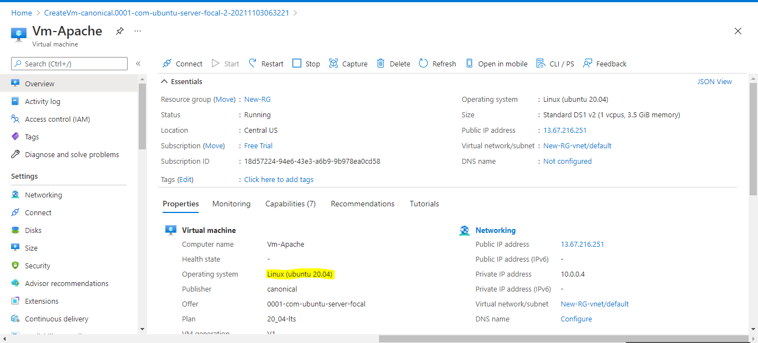

**Step-2:-**Installed apache2 software.

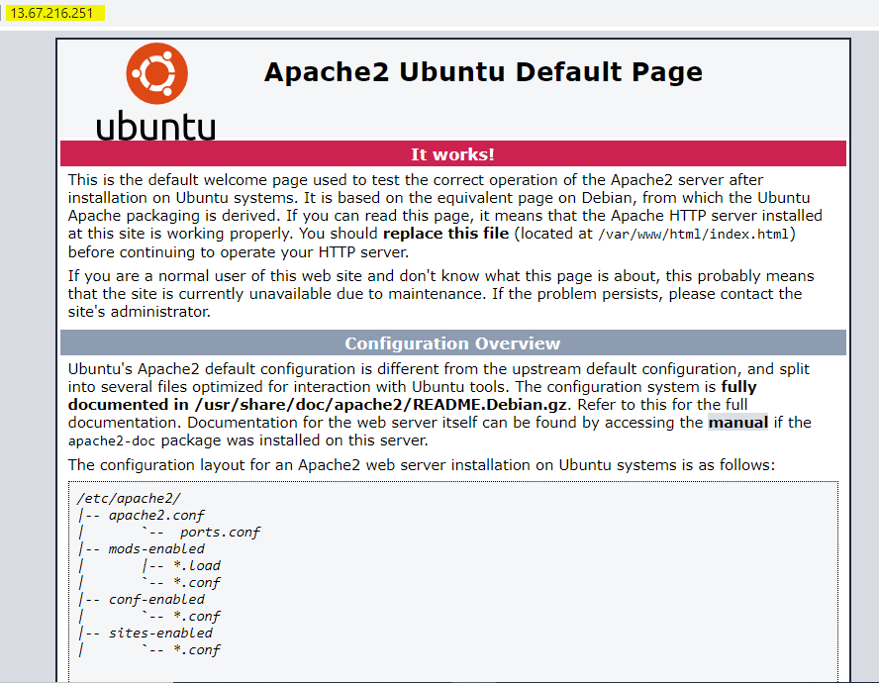

**Step-3:-**Created image out of VM

