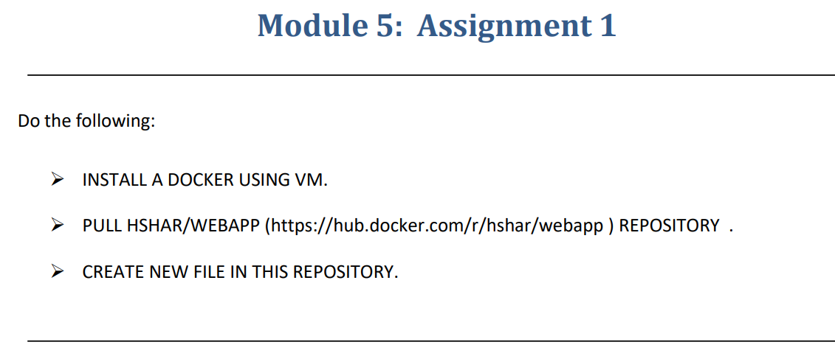

Step-1:-Created VM and Installed a Docker on the VM

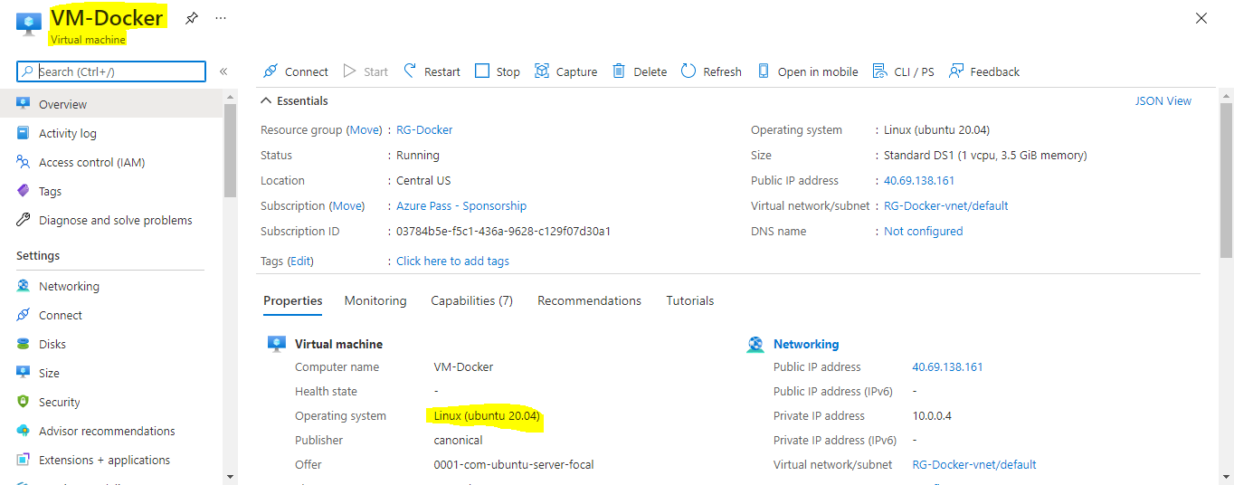

Step-2:-Using Putty and IP address Login to the VM

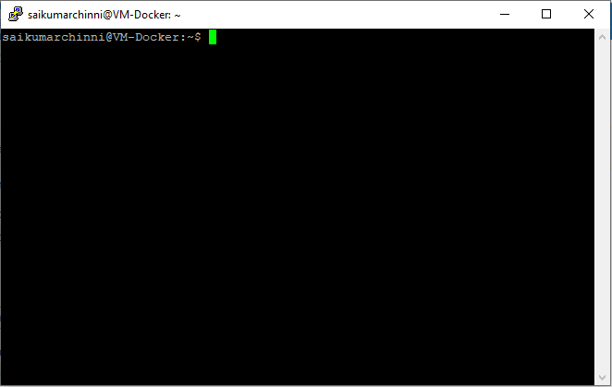

Step-3:-Enter the **sudo apt-get update** to update all the packages

And to install the docker **sudo apt-get install docker.io –y**

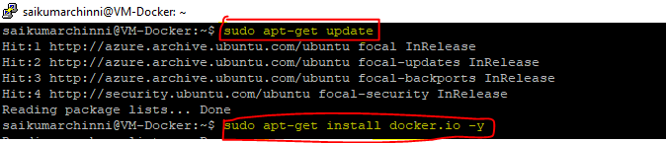

Step-4:-We have to install CLI

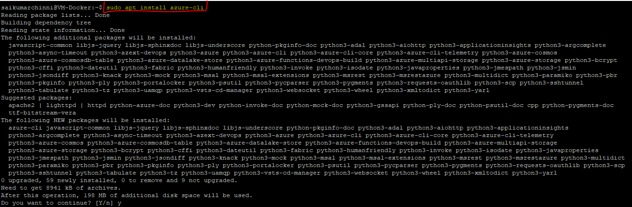

Step-5:-Pull the HSHAR/Webapp by using **docker pull hshar/webapp**

