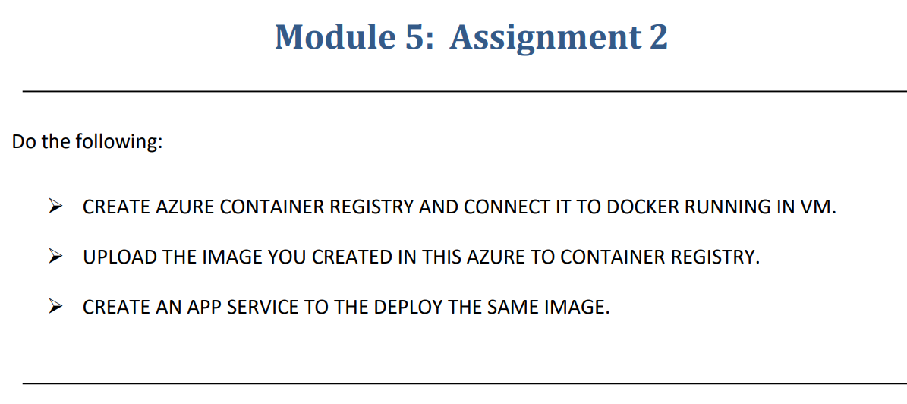

Step-1:-Using the previously created VM from Module-5 Assignment-1

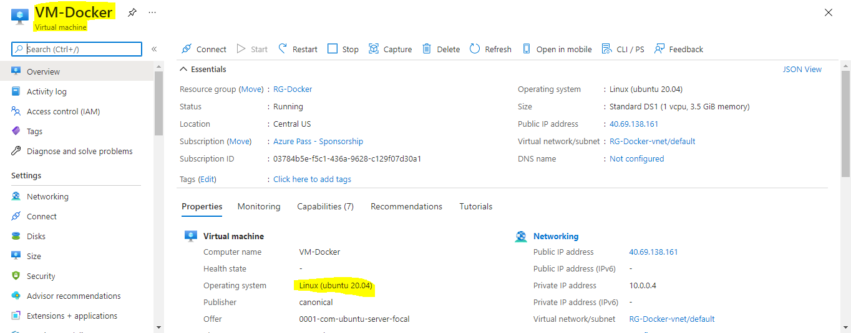

Step-2:-We have to install CLI

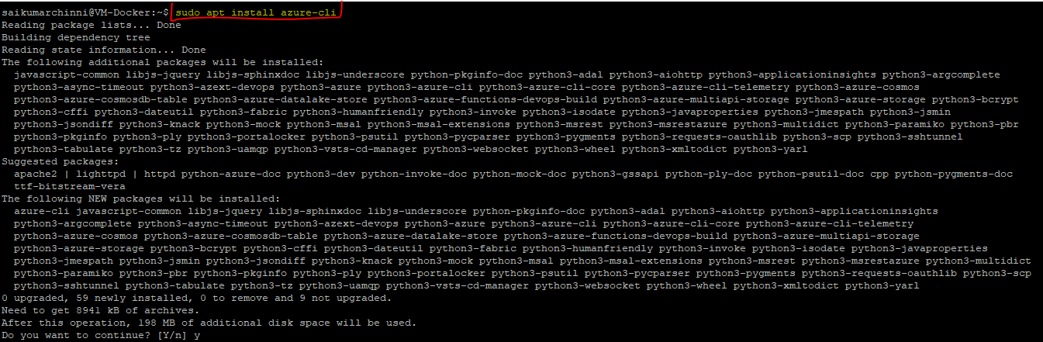

Step-3:-We have login to our Azure Portal for that we have to **az login** after that we will get one link and password,we have to paste that link on browser it will ask for password we have to enter password.

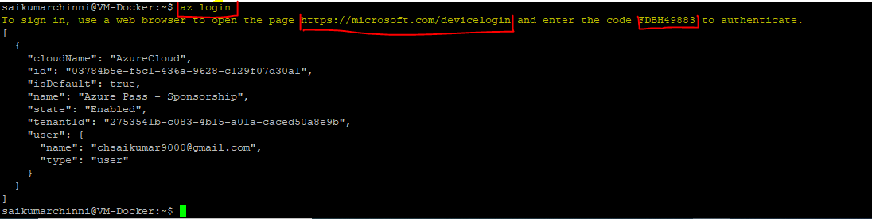

Step-4:-We have to create Container Registery on azure portal and we have to login to ACR(Azure Container Registery) from linux using **az acr login --name saikumarchinni**

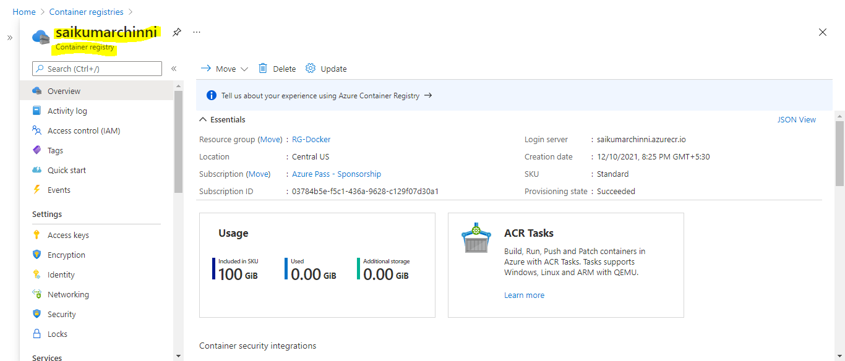



Step-5:-We have to give the TAG to the image **[docker tag hshar/webapp saikumarchinni.azureusercr.io/hshar/webapp:s1]** After that we have push the image to ACR by giving **[docker push saikumarchinni.azurecr.io/hshar/webapp:s1]**

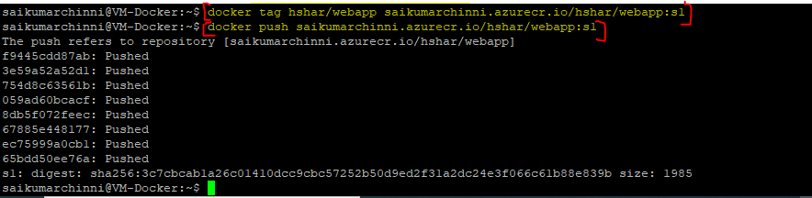

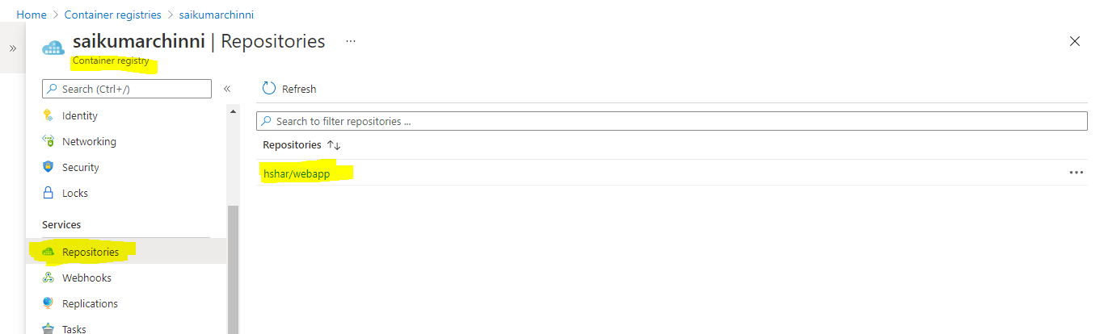

Step-6:-Create an App service,While creating we have to select **Docker Container.**

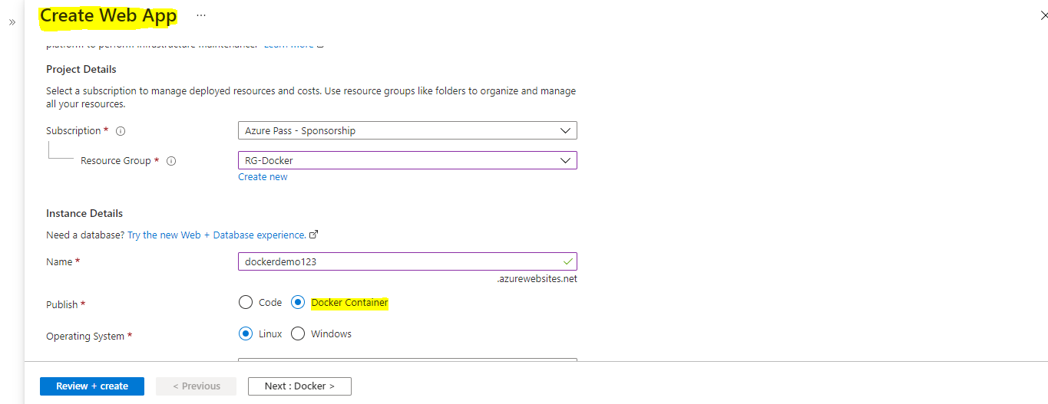

On the Next tab (Docker) we have to select the following.

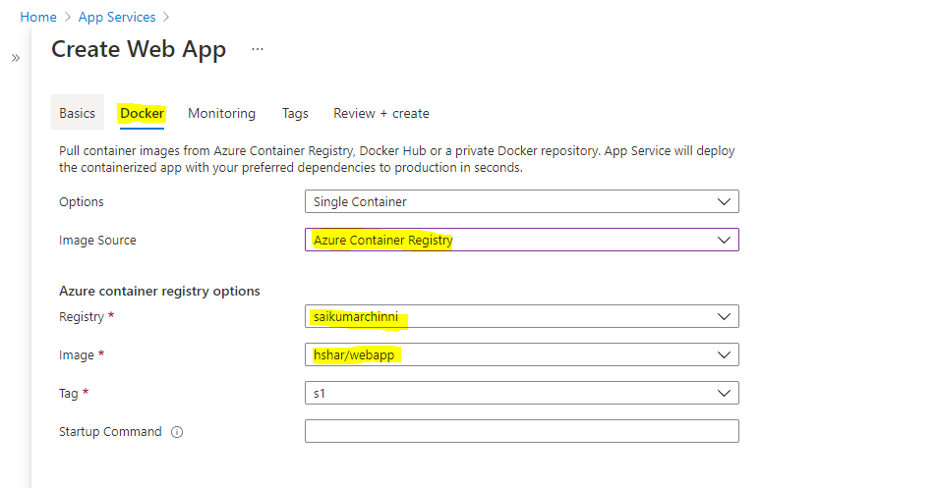

After deployment of App Services go to deployment center and there we can see the image which we loaded.

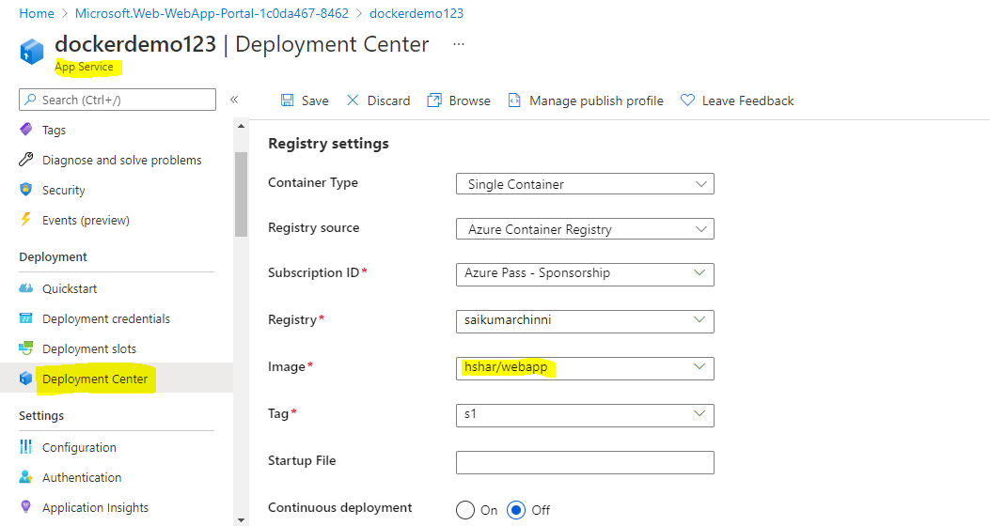

Step-7:-Click on the Browse on the deployment center we will re direct to the webapp page.

