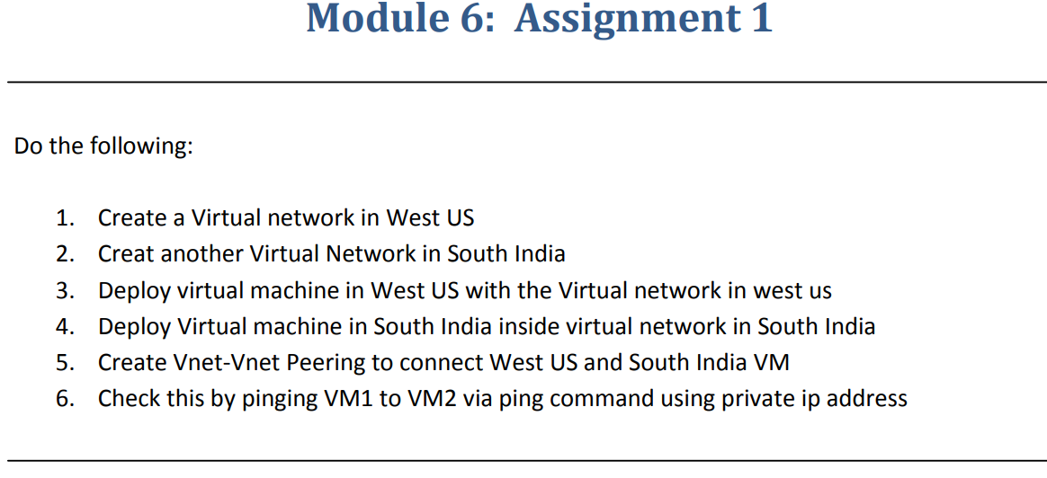

**Step-1**:-Created Virtual Network on WEST US Region.

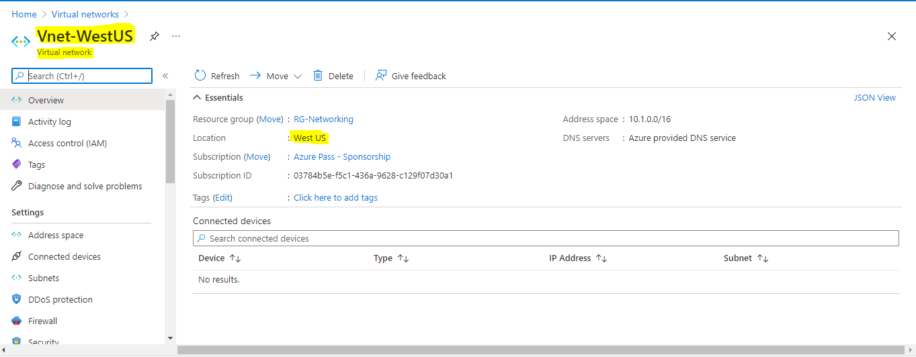

**Step-2**:- Created another Virtual Network on Central US Region There is no avalaiablity of sizes on south india region.

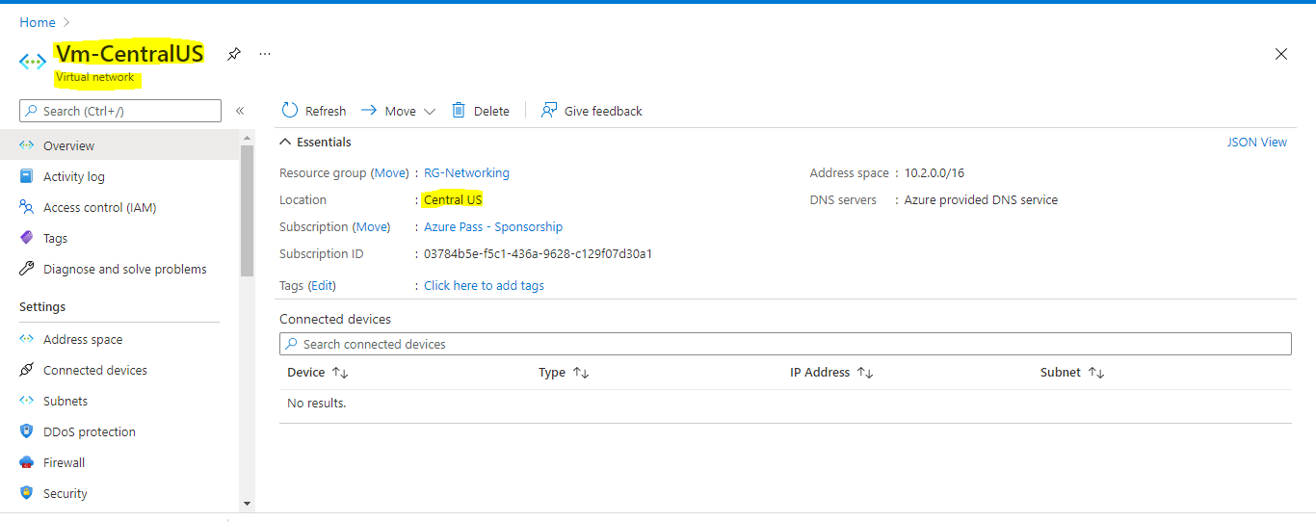

**Step-3**:-Deploying a VM in WEST US with the VNET in West US.

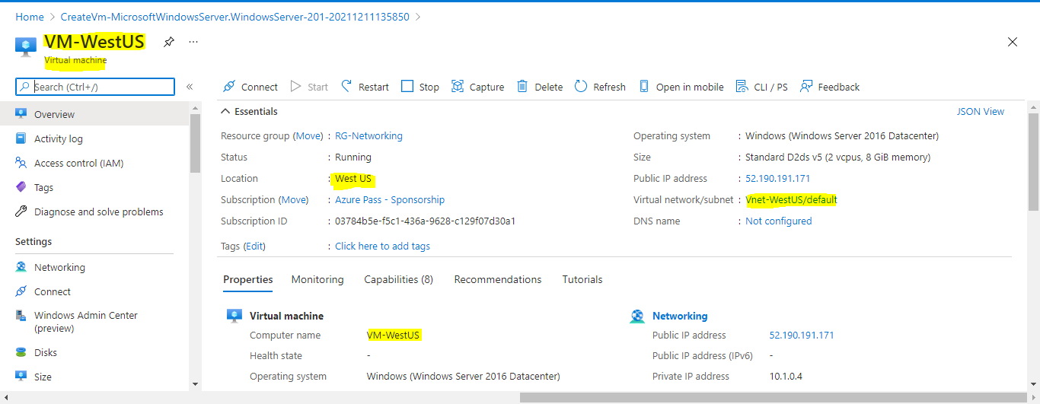

**Step-4**:-Deploying a VM in Central US with the VNET in Central US.

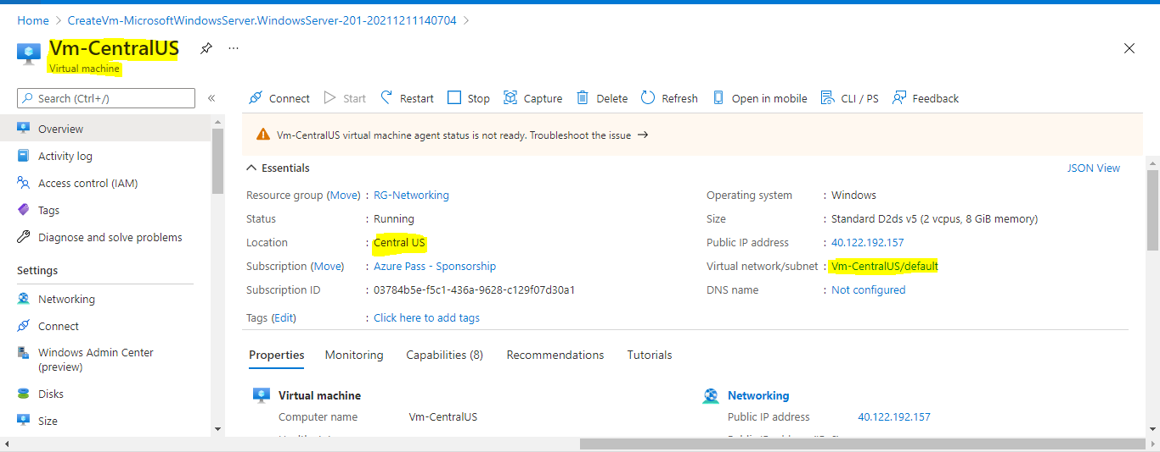

**Step-5**:-To create Vnet Peering between the two VMs we have to selcet any one of the networking and we have to click on Peerings options and we have to add the peering.

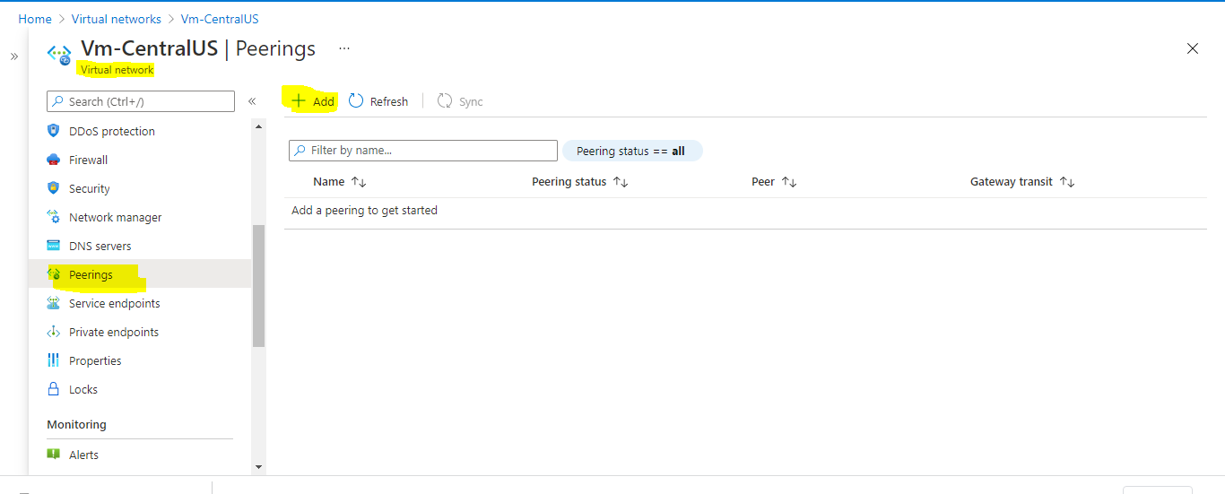

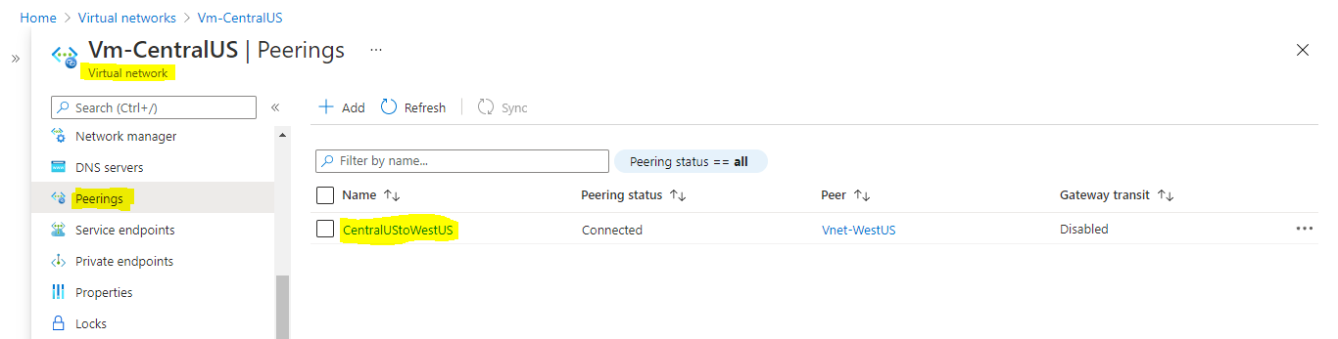

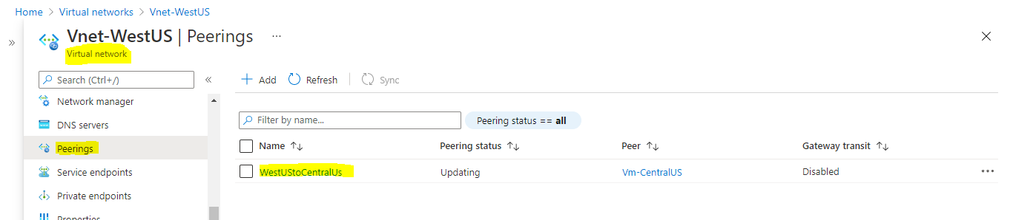

**Step-6**:-To check whether it got peeredor not we have to login to the VM and on CMD prompt we have to give **ping private ip of other VM.**

