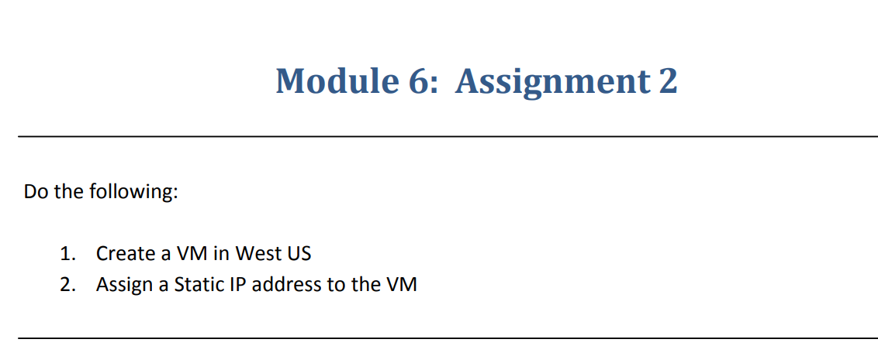

**Step-1**:-Deploying a VM in Central US

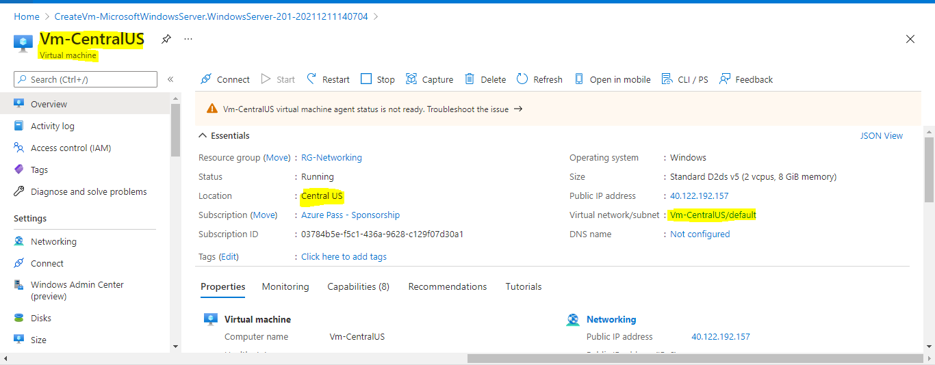

**Step-2**:-After Deploying the VM click on IP address and click on Configuration and select the static option

