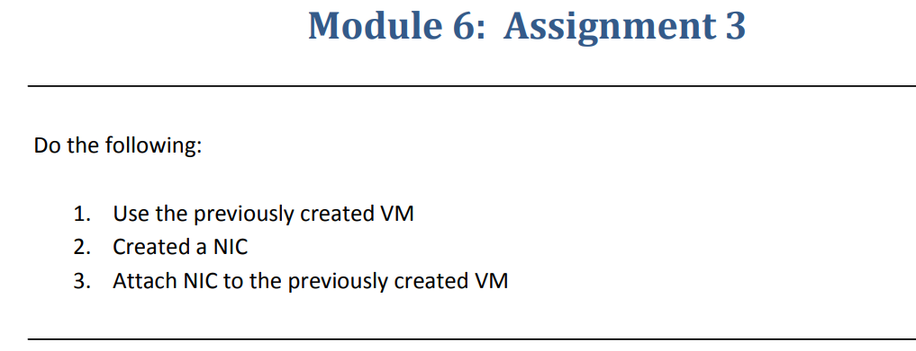

**Step-1**:-Deploying a VM in West US

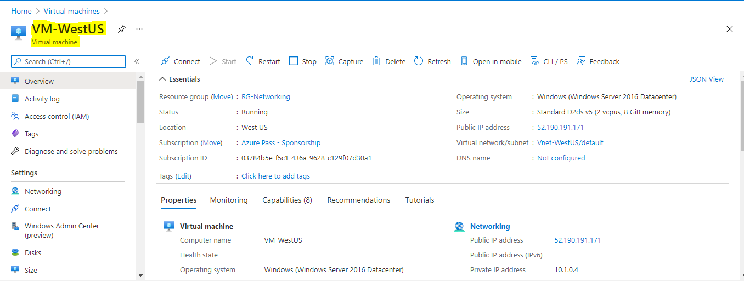

**Step-2**:-Created a NIC(Network Interface Card).

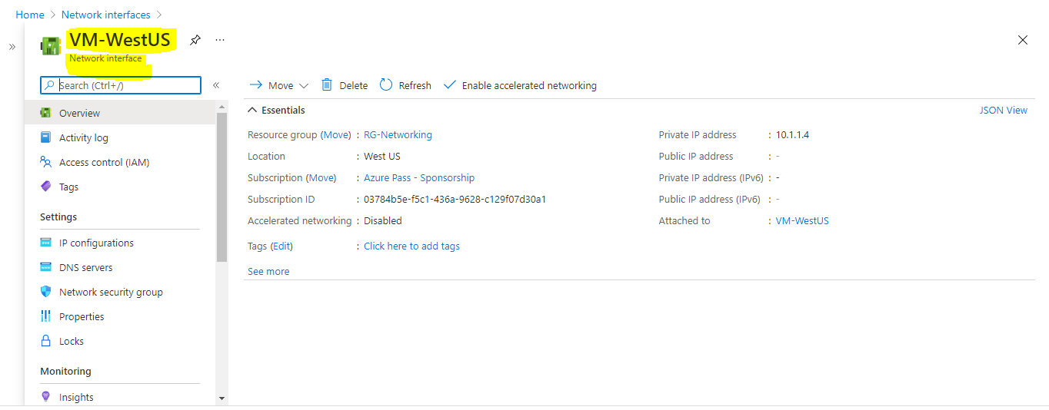

**Step-3**:-Attach the Created NIC to the VM for that we have to Stop/Deallocate the VM then only we can attach the new NIC to the VM

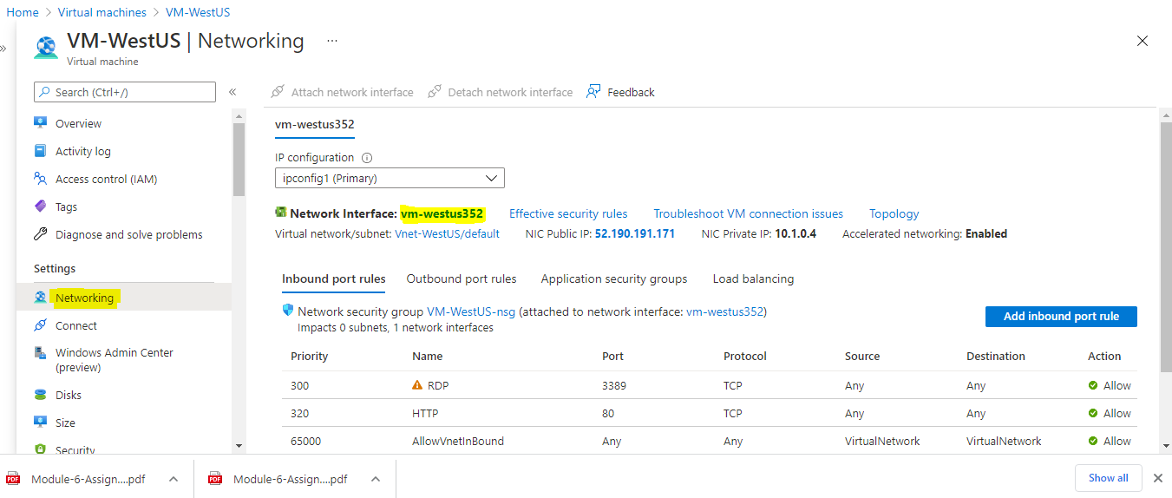

After we stopped the VM the Attach NIC option is highlighted.

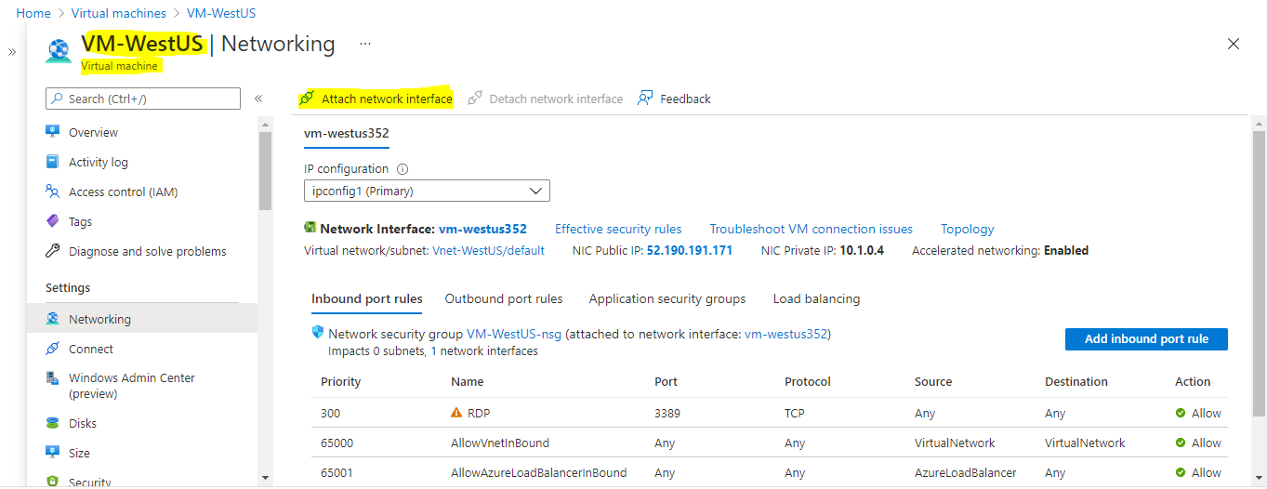

We have to select the NIC which we created

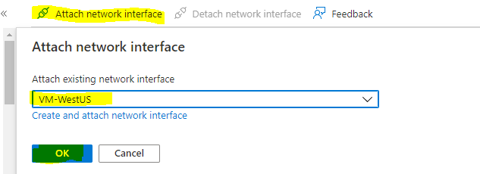

**Step-4**:-Succesfully attached the NIC

