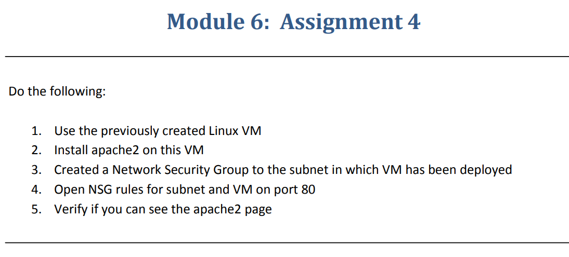

**Step-1**:-Deployed a VM with Linux OS

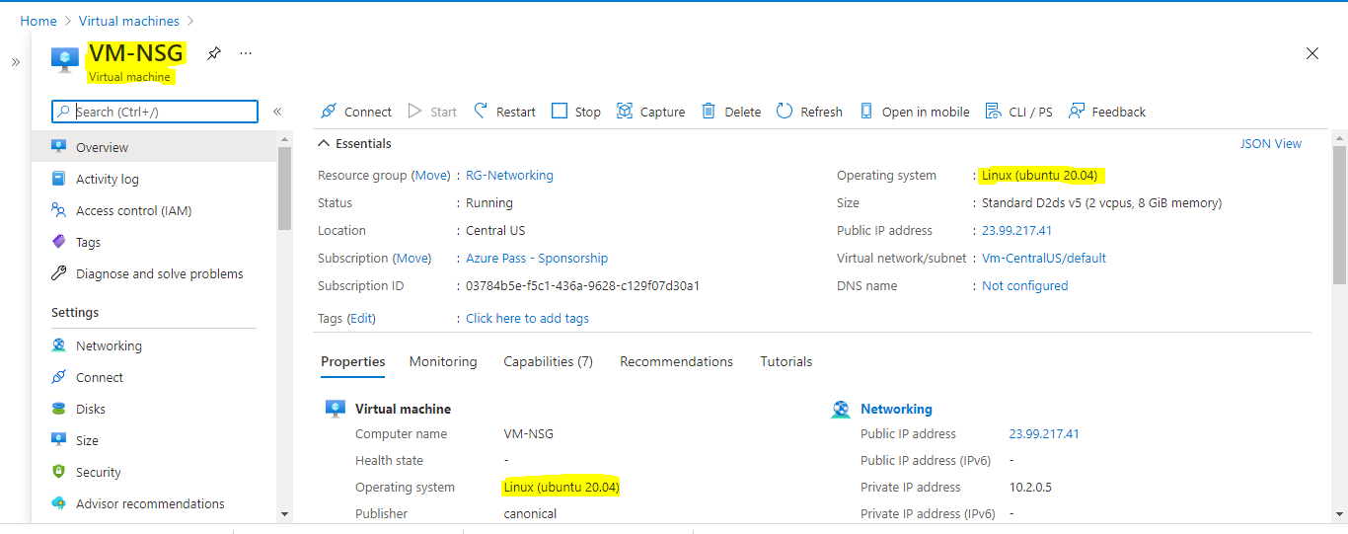

**Step-2**:-Installed apache2 on the VM but we are not able to connect by IP address.

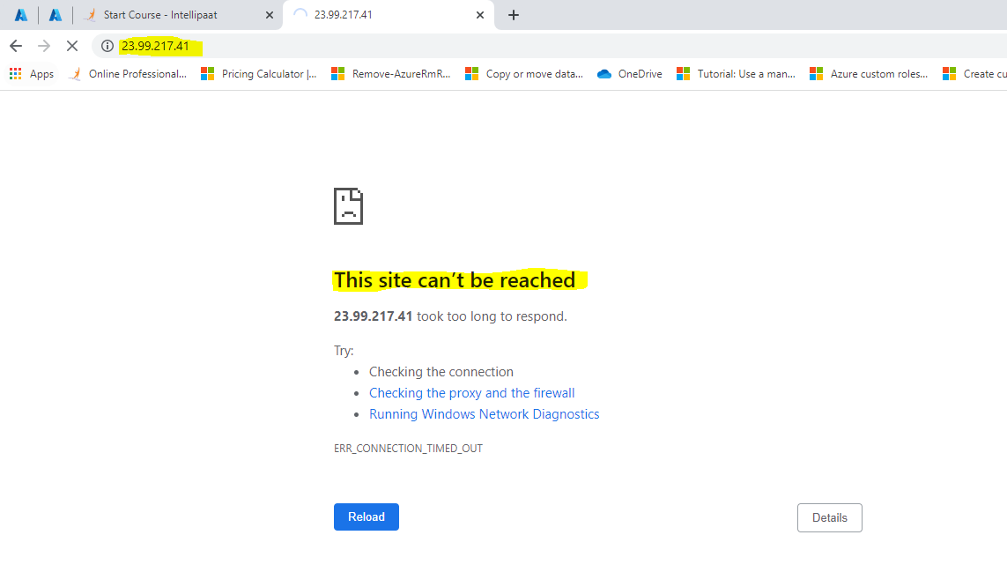

**Step-3**:-We don’t have http port so we have to create Network security group(NSG)

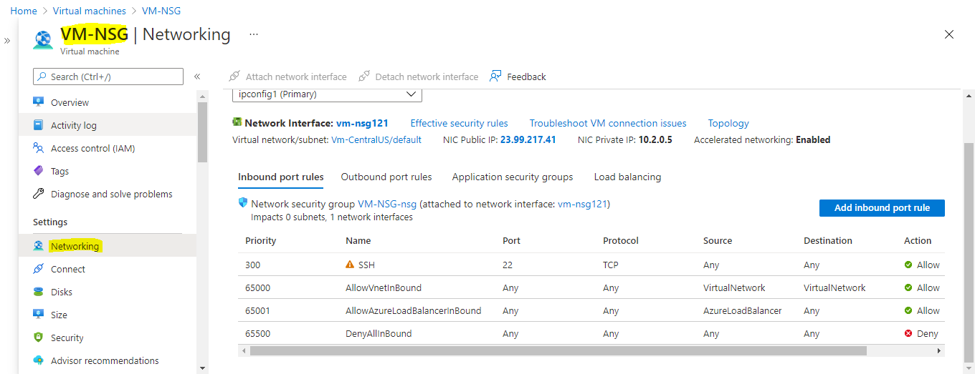

We have to add inbound rule to the NSG

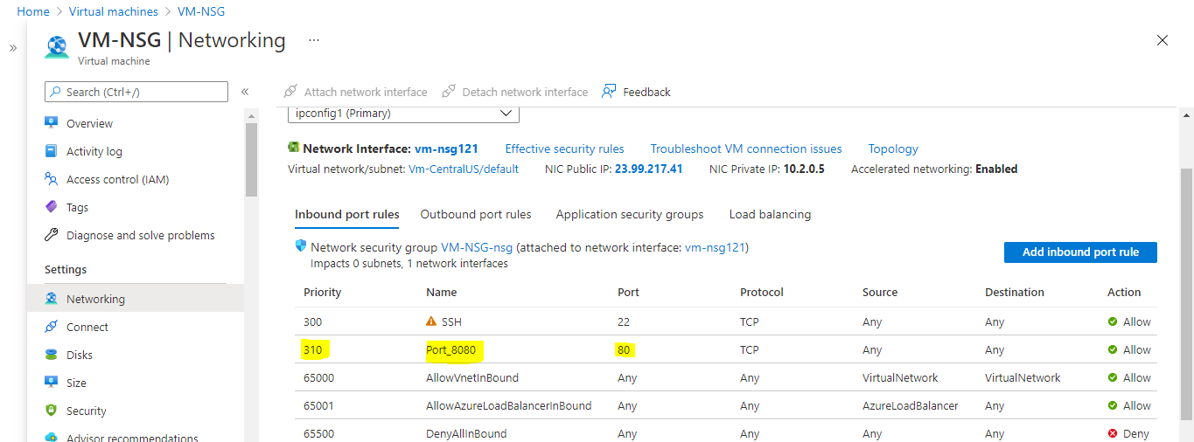

Now we can see apache2 with IP address

