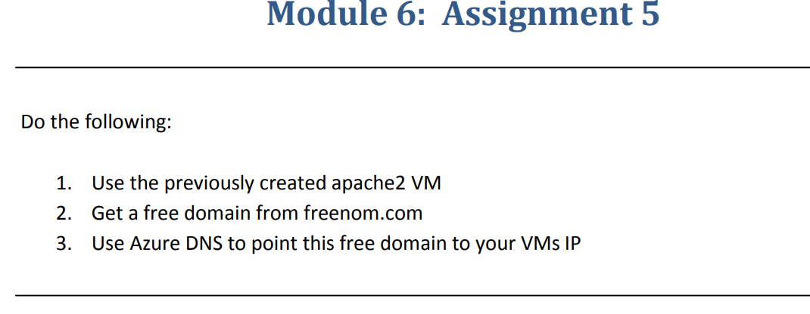

**Step-1**:-Delpoyed a VM with Linux OS

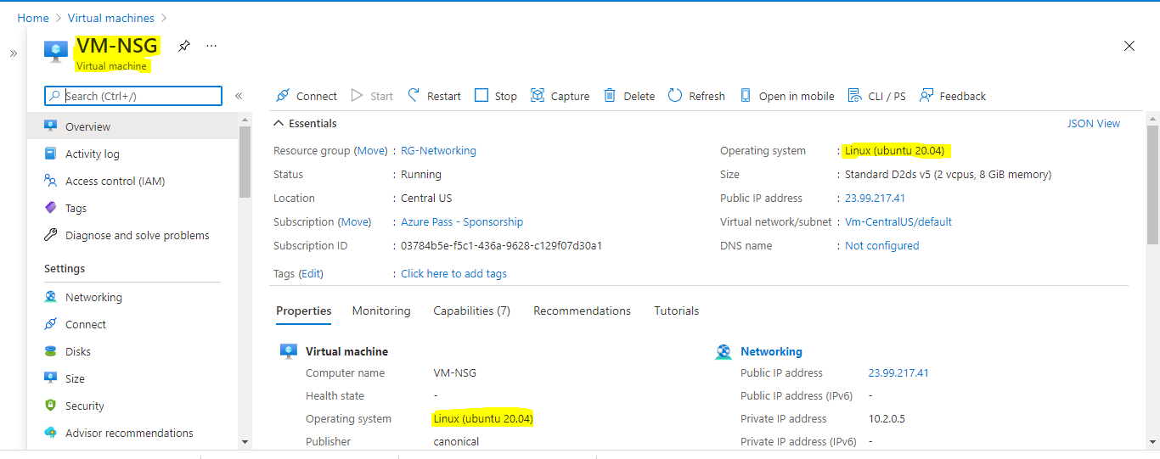

**Step-2**:- Installed apache2 on VM

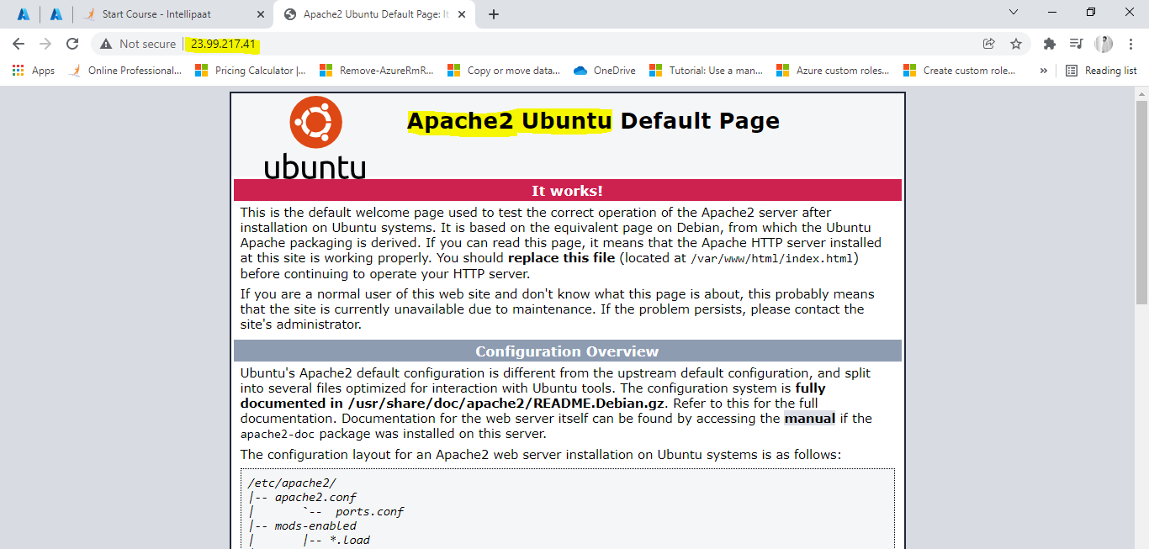

**Step-3**:-Created a DNS zone

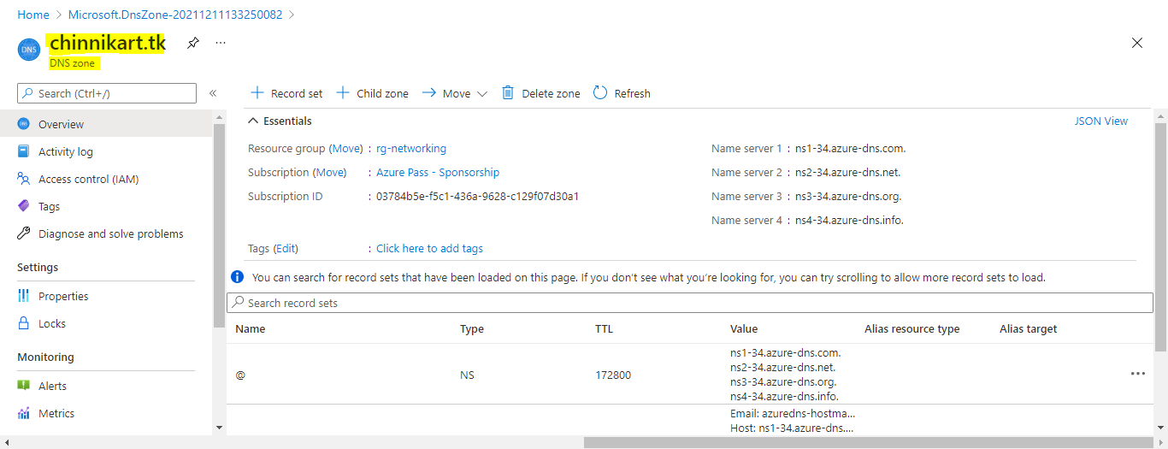

Add a Record Set and paste the IP address of the respective VM

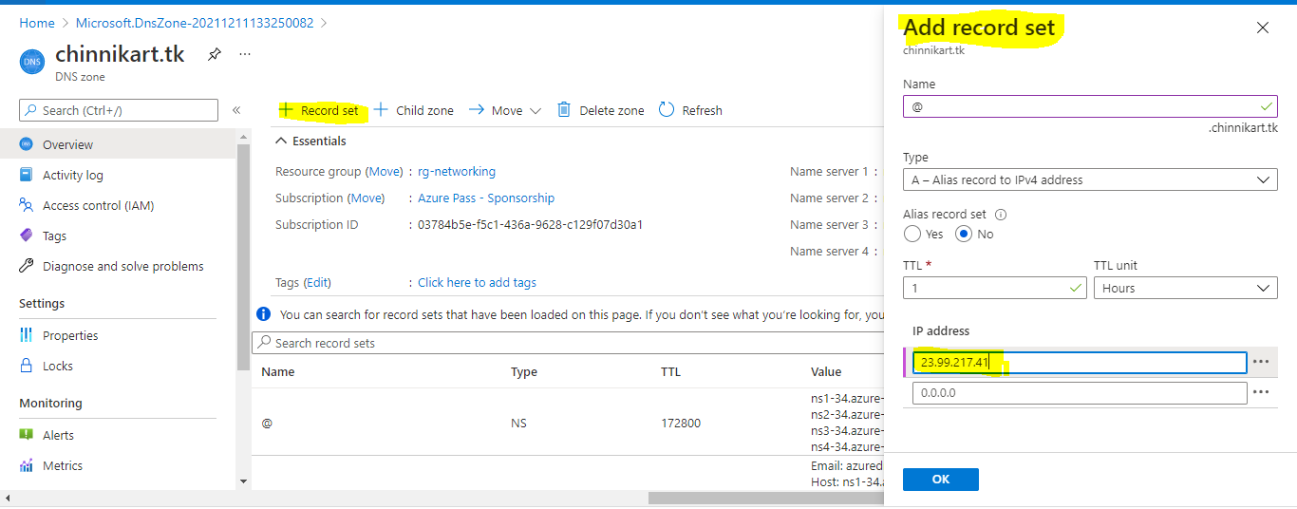

**Step-4**:- Now we can access the website by domain name

