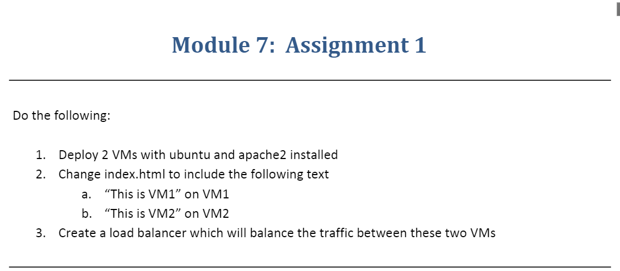

**Step-1**:-Created Two VMs with Linux OS and installed apache2 on both VMs

**VM-1**

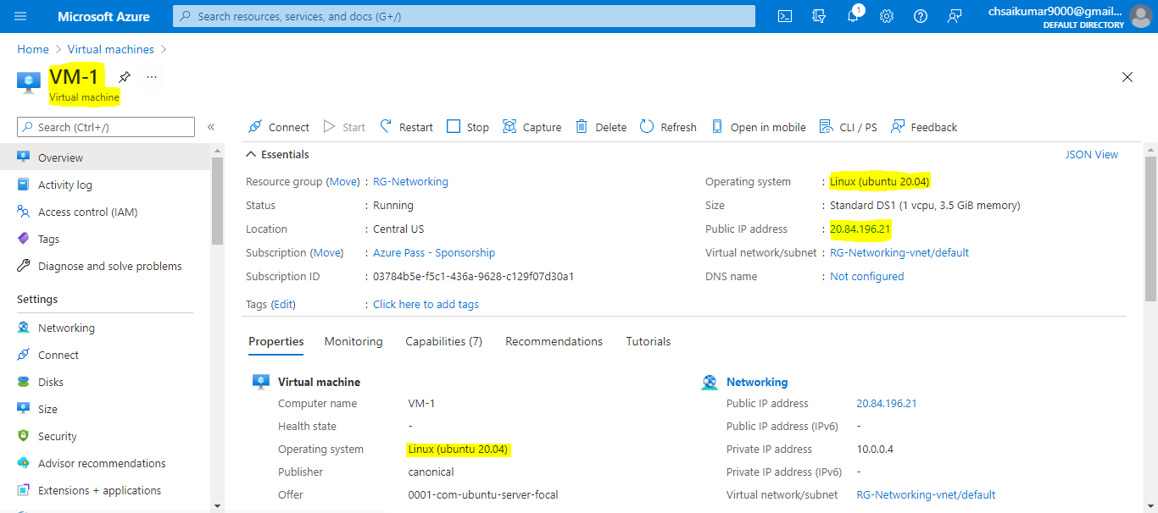

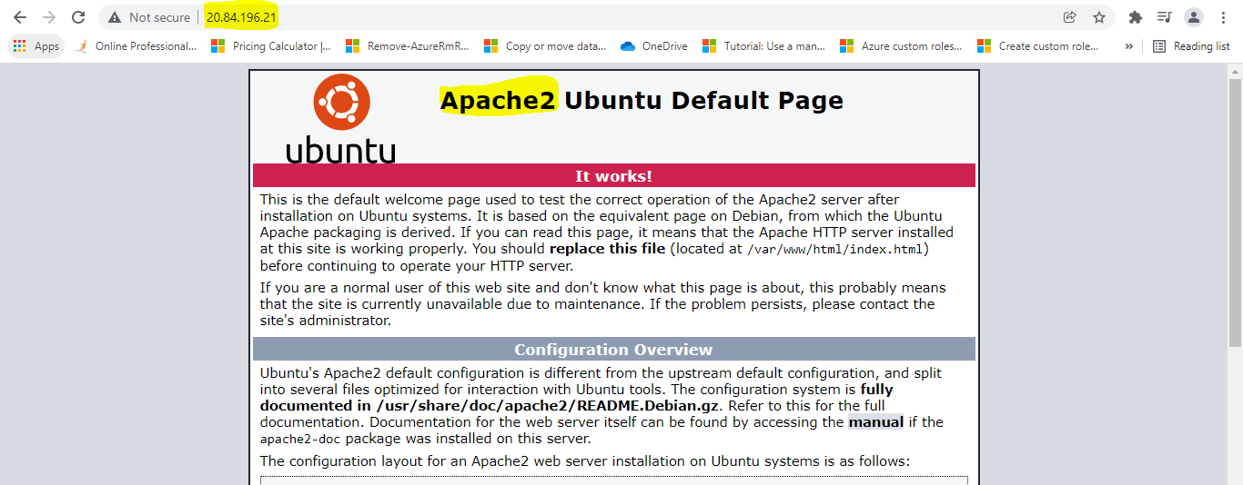

**VM-2**

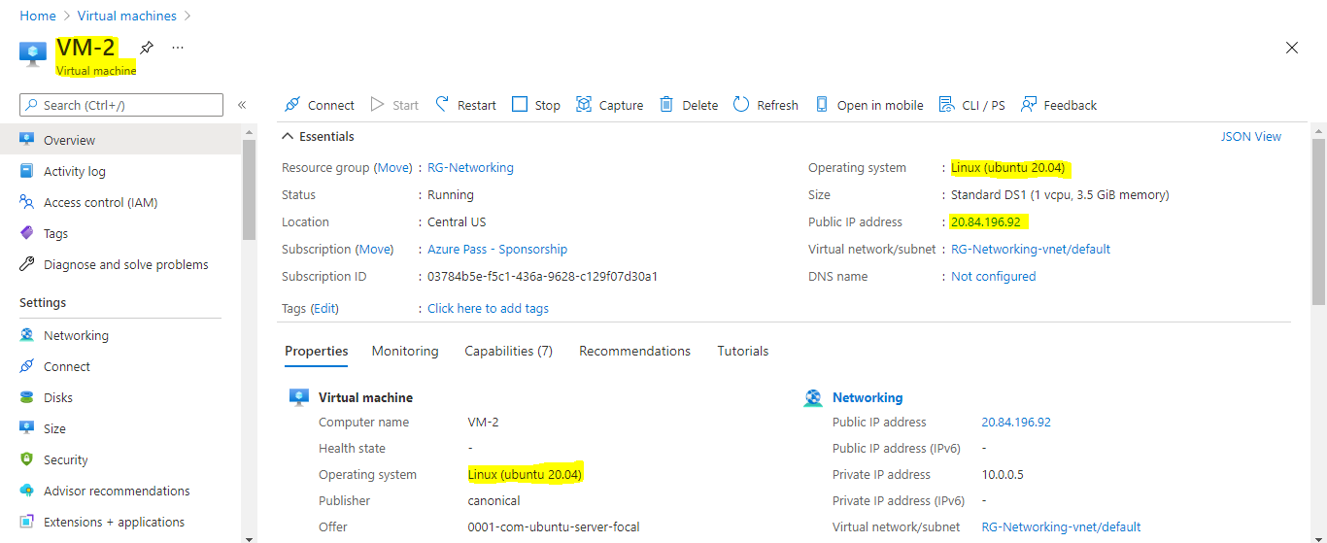

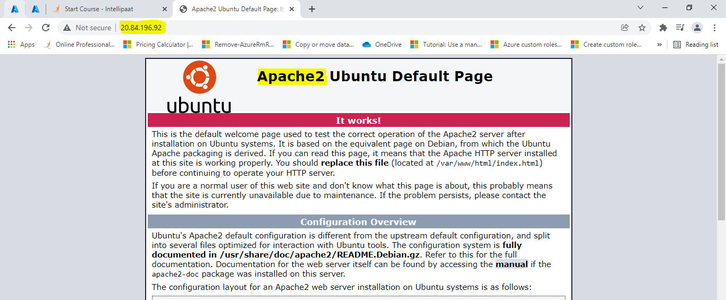

**Step-2:-** To change the Index.html we have to do following steps

* First we have to login to the Linux Machine and enter

cd /var/

cd/var/www/html=To root folder directory

sudo chmod 777 index.html=To read and write the data(chmod-change mode)

vi index.html=vi is a editor where we can give our custom text (To insert text we have to give ESC and enter I to give the text and after completion we have to give :wq to exit from editor)

sudo service apache2 stop

sudo service apache2 start

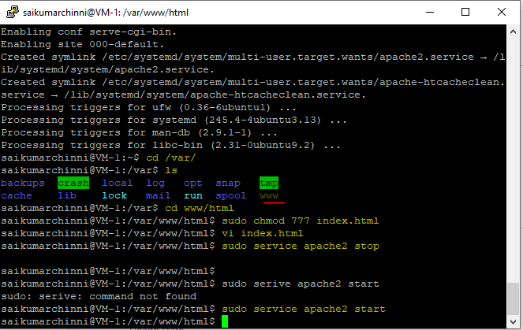

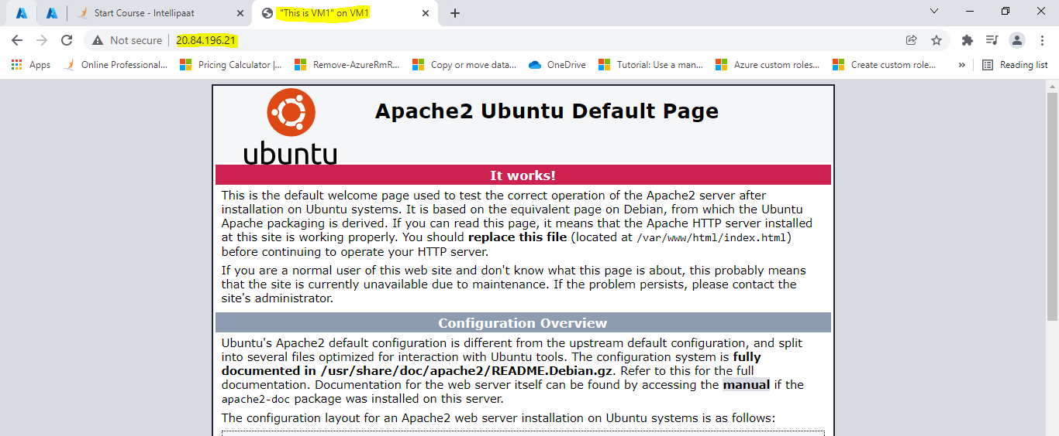

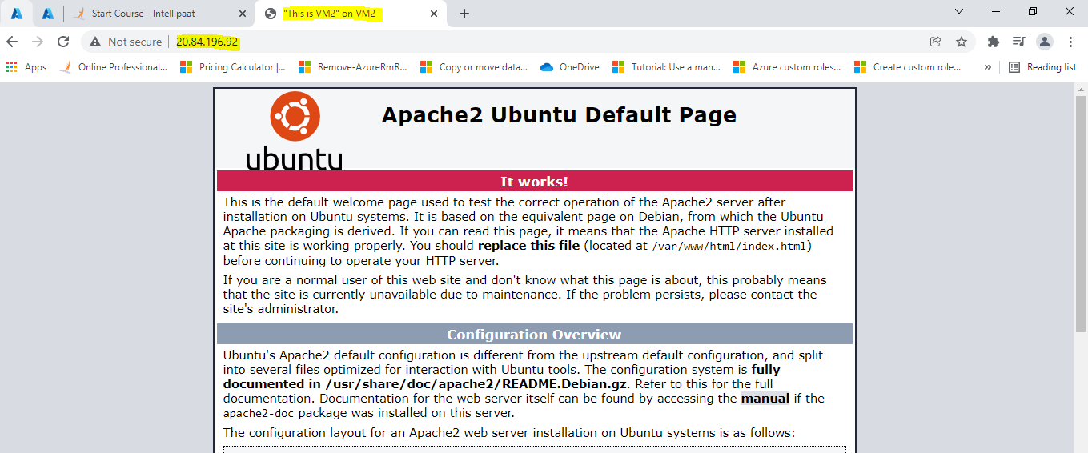

**Step-3**:- Created a load balancer between two VMs

