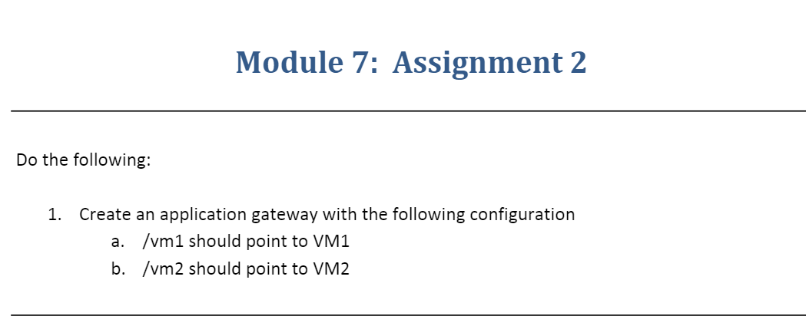

Step-1:-Created Two VMs with Windows OS and installed IIS on both VMs

Before creating VMs we have to create VNet first with two subnets one is for VMs and another subnet is for application gateway.

**VNET**

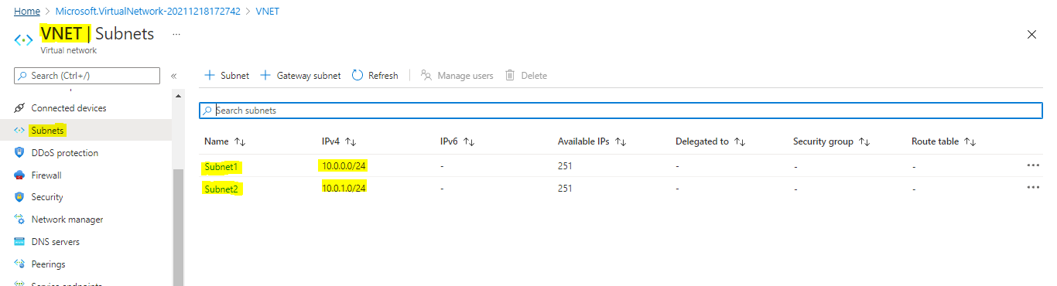

**VM-1**

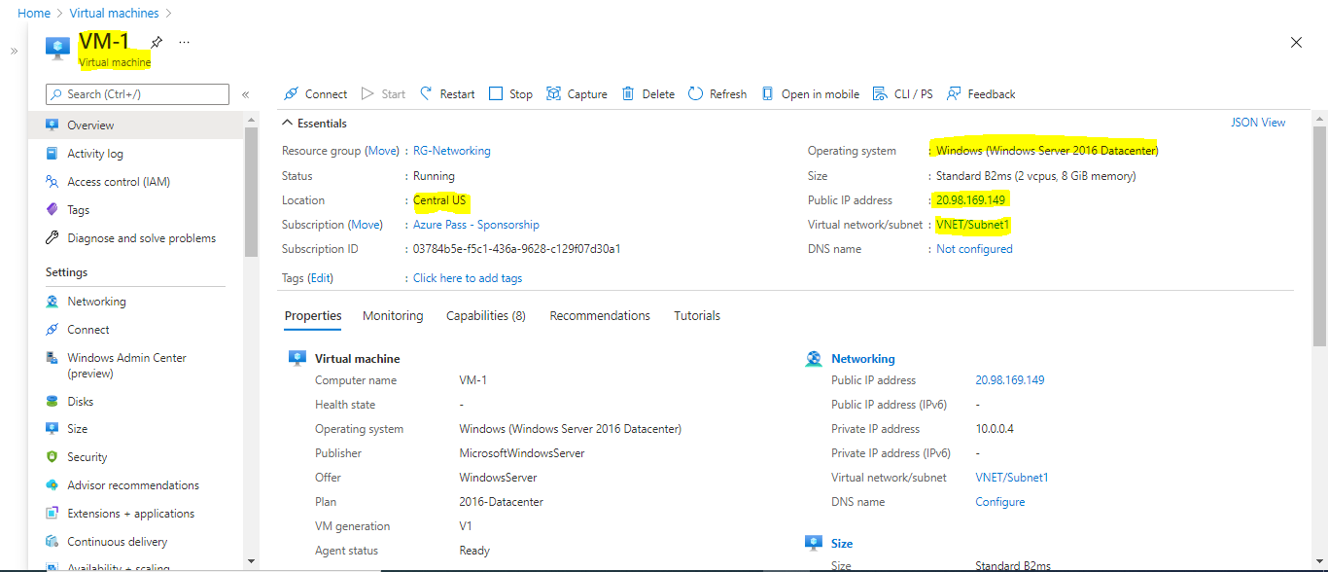

**VM-2**

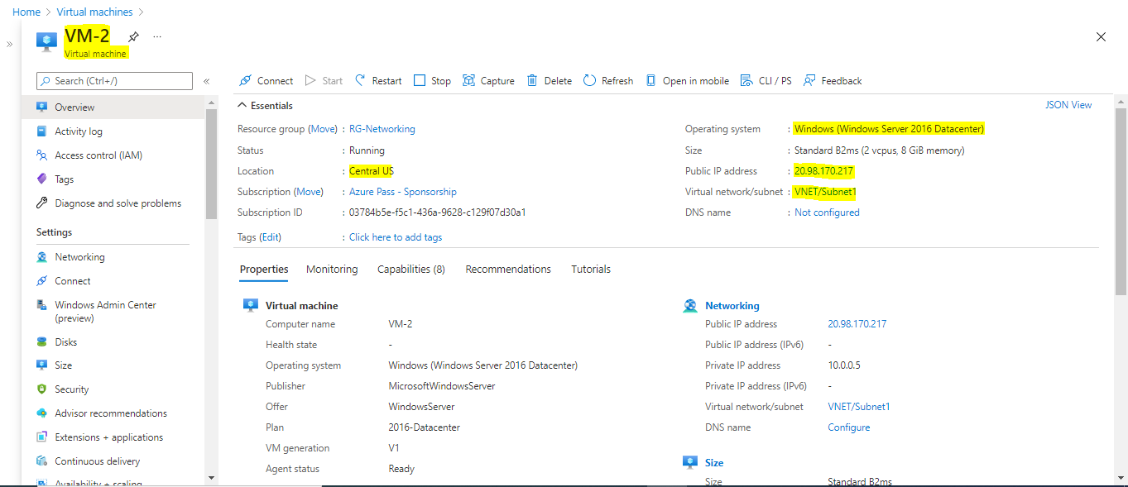

We have create html file on both the VMs as shown

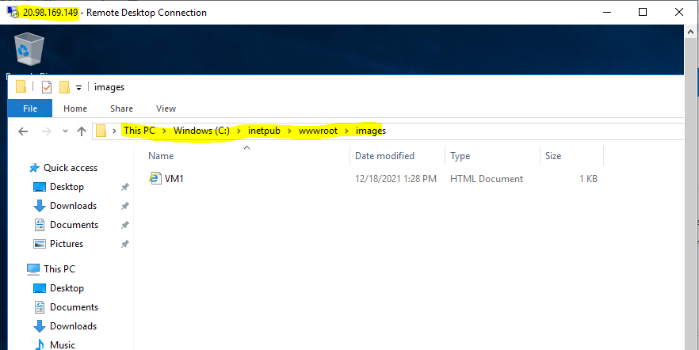

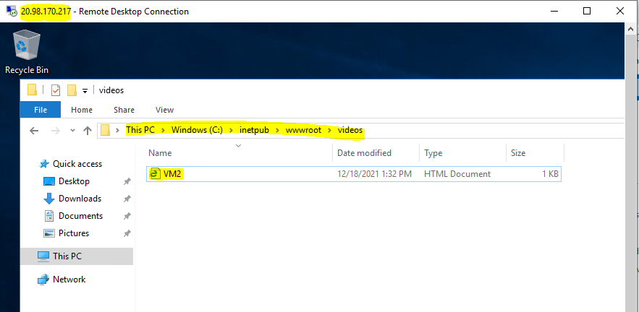

**Step-2**:- Created an Application Gateway

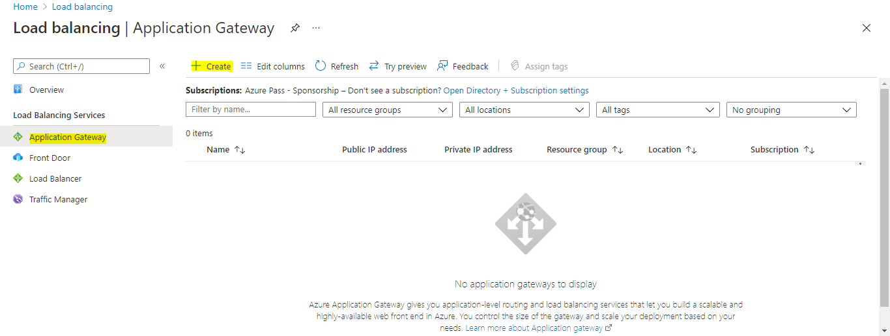

We have to select the other subnet which we created for application gateway

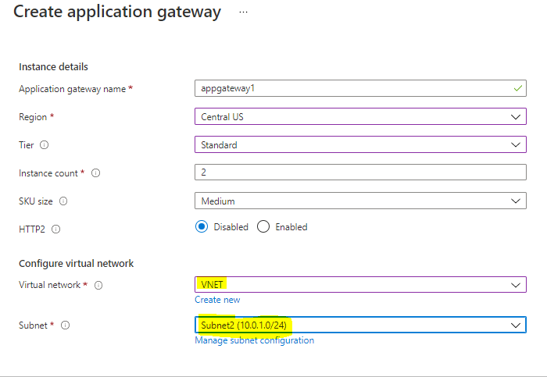

We have to add two VMs to the backend pool (pool1-VM1 &pool2-VM2)

