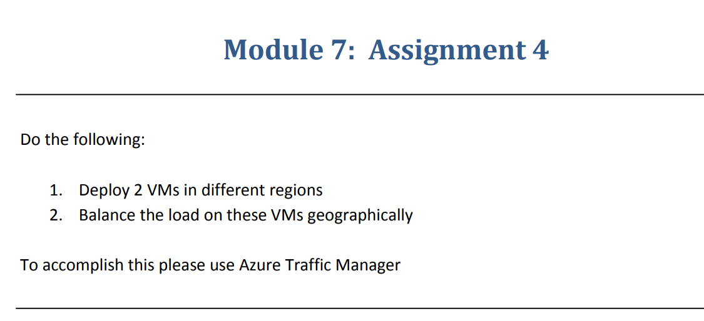

**Step-1**:-Created Two VMs in two different regions and install IIS on both the VMs

**VM-1**

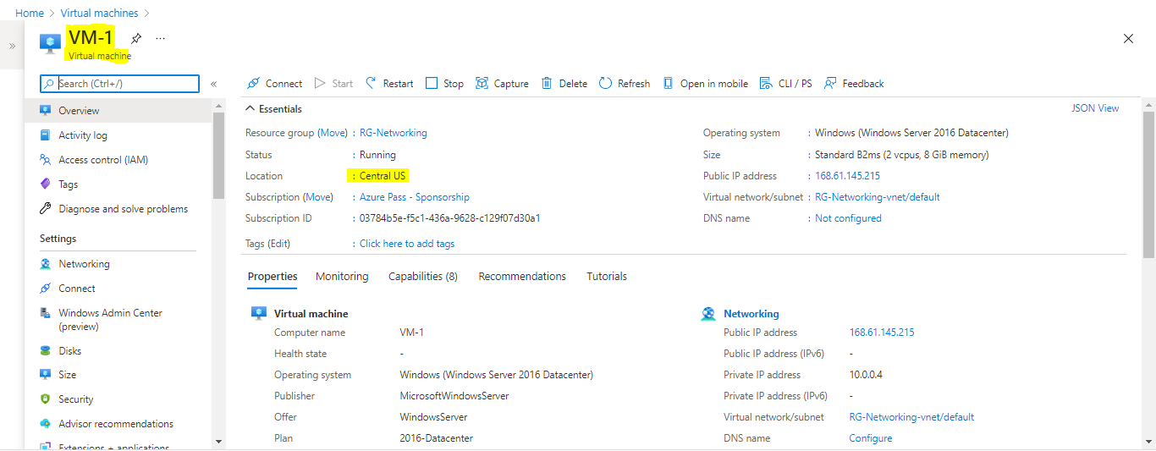

**VM-2**

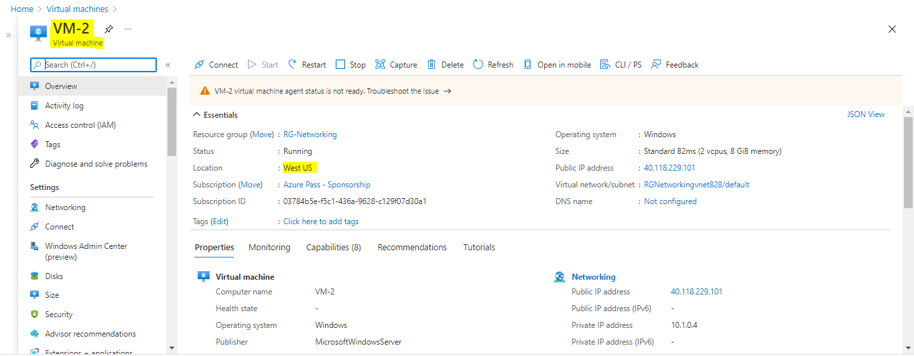

**Step-2**:- We have to create Traffic manager profile and we have to add VMs as Endpoints

Traffic manager is a DNS based load balancer so we have to configure DNS to the IP address

IP address>Create an alias record>Create a DNS zone

