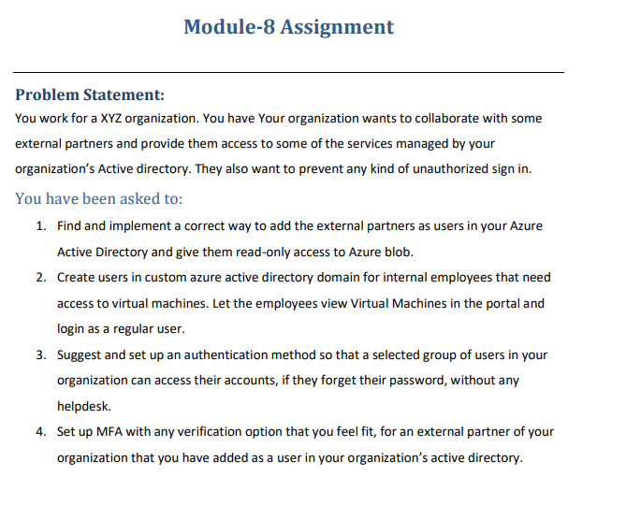

**Step-1**:-Create a New user with the basic details

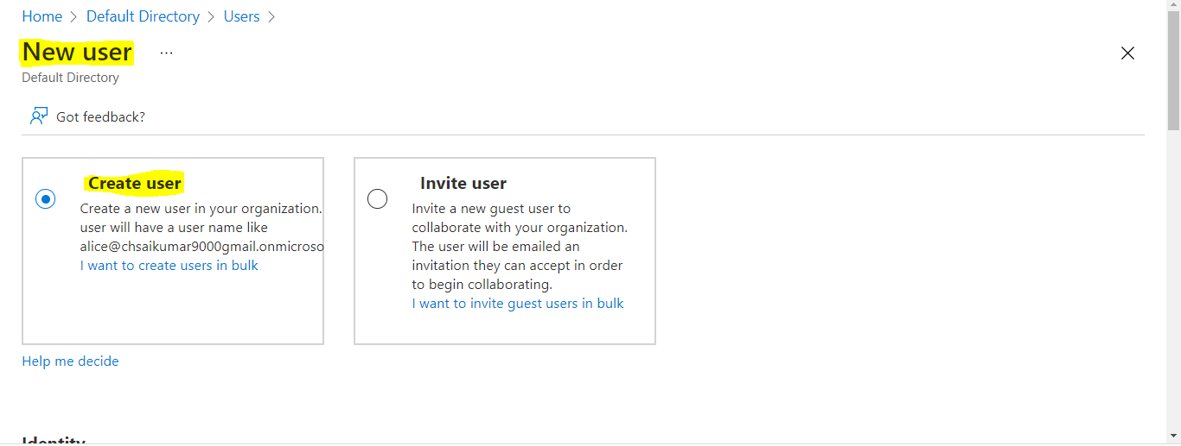

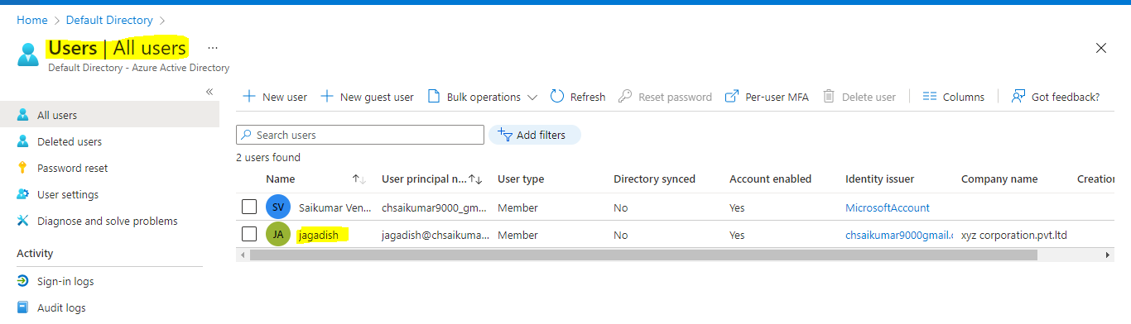

Create a Role based access control (RBAC) for blob storage.

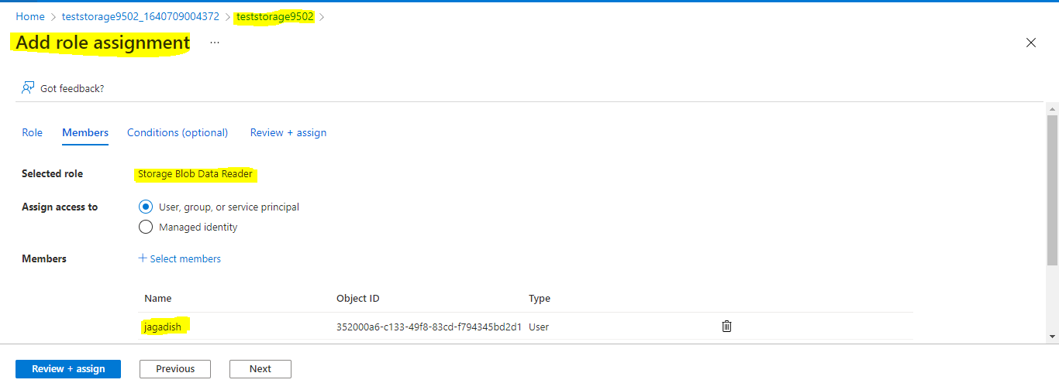

**Step-2**:-Create a custom Active Directory(Tenant)

Create a Tenant

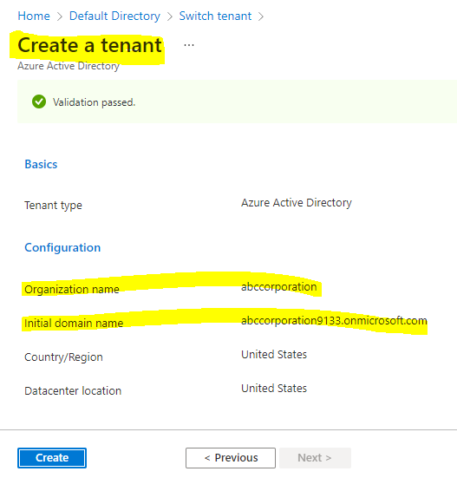

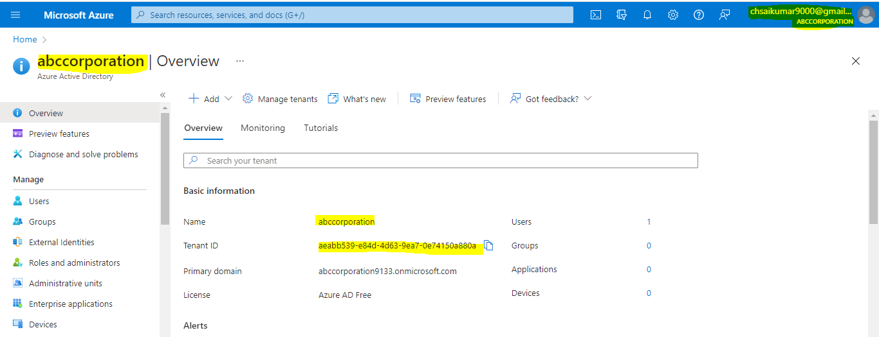

We have created a Tenant but we don’t have subscription to give the RBAC roles ,so for that we are woring on default directory.

Created a role for view virtual machine in the portal and login as aregular user

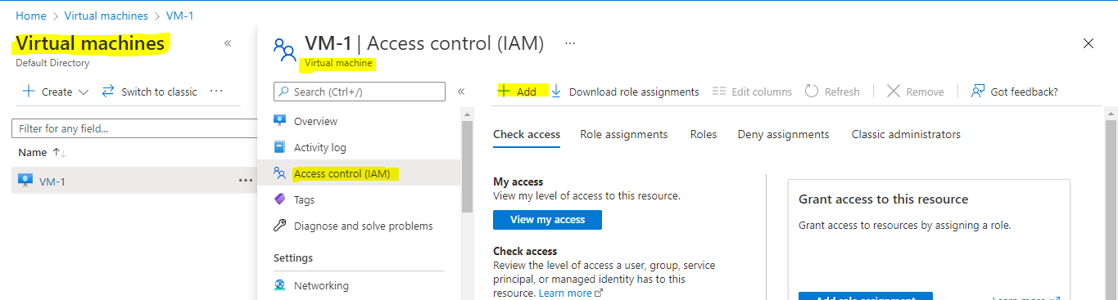

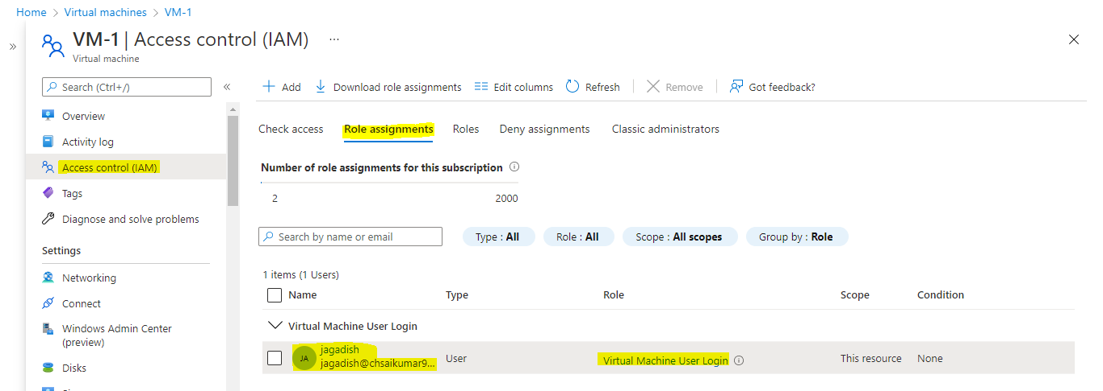

From the user login Azure portal we can view the virtual machine.

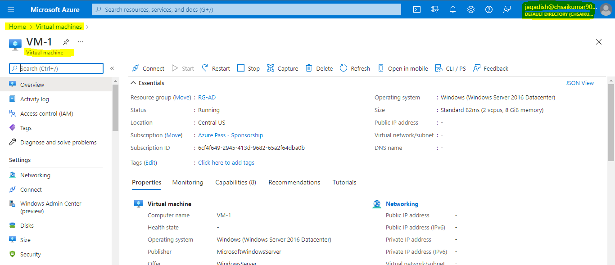

**Step-3**:-Create an authentication process for a particular group

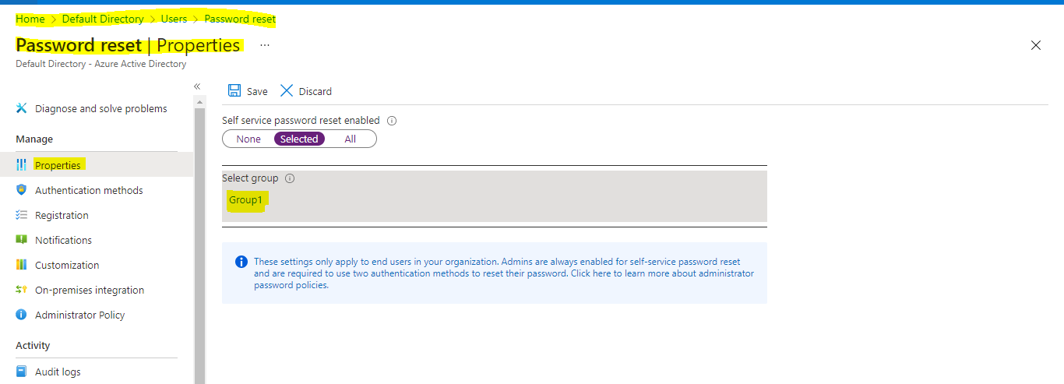

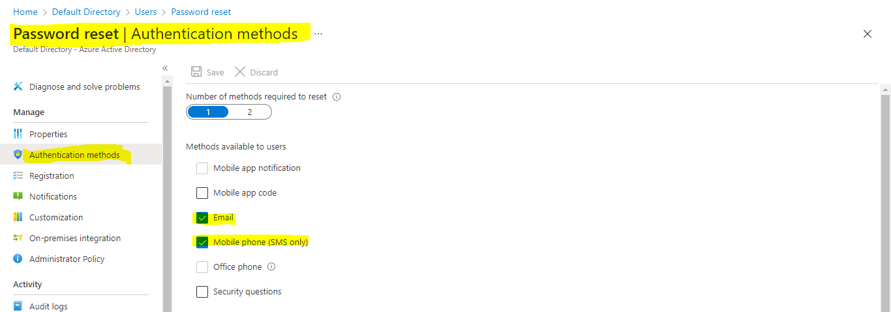

**Step-4**:-Create an MFA (multi factor authentication)

Select the user and click on Per-user MFA

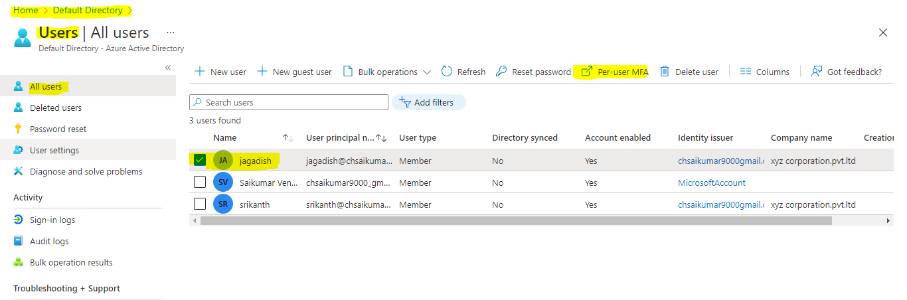

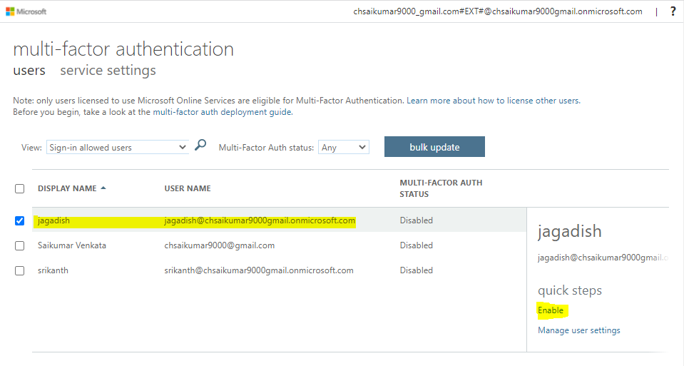

Now it will ask for multiple factor for login.

