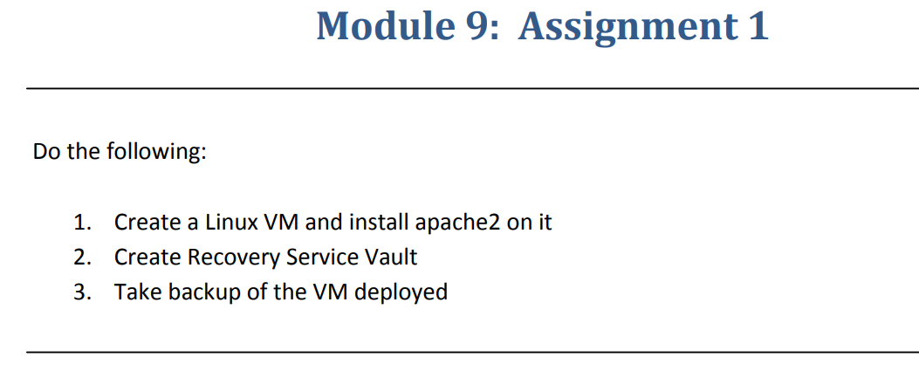

**Step-1**:-Created a Linux VM and installed apachew2 on a VM.

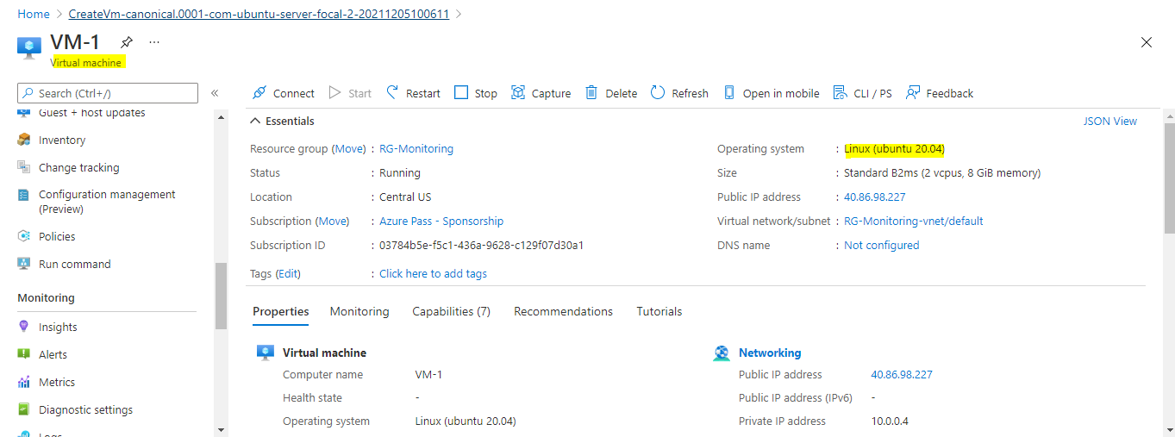

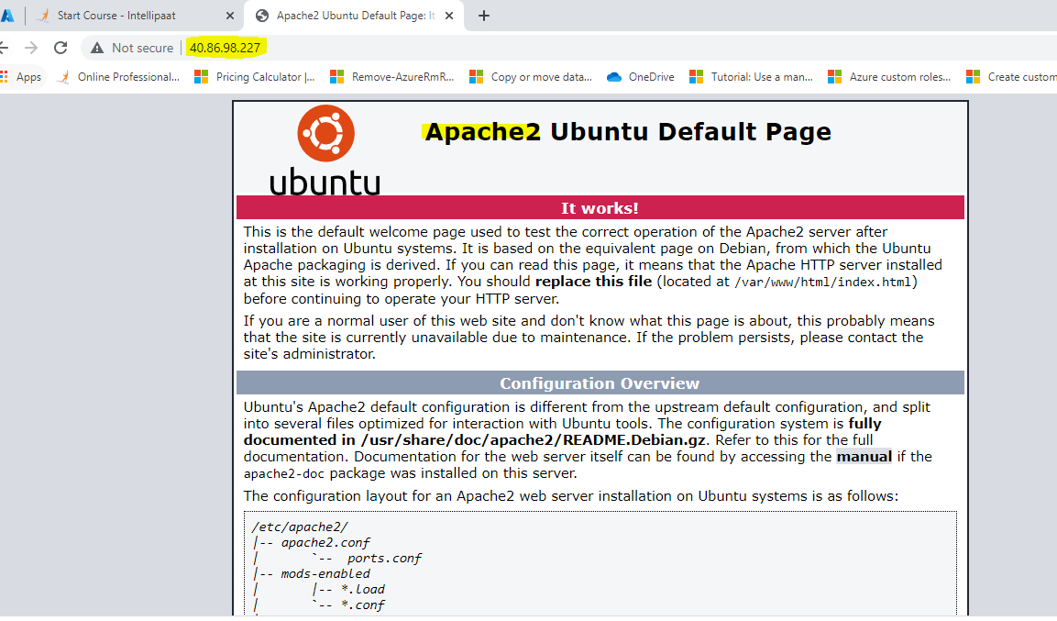

**Step-2**:-Created Recovery service Vault.

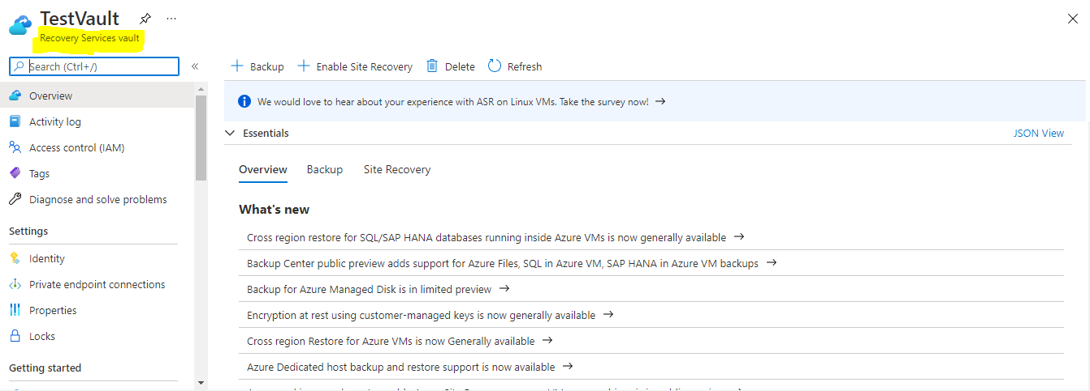

**Step-3**:-Took a Backup for VM that we deployed

