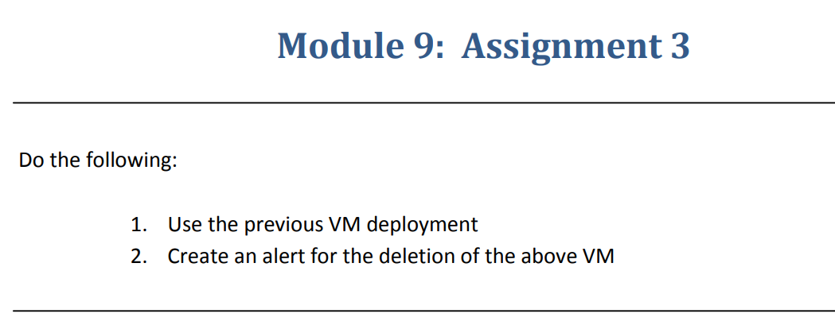

**Step-1**:-Created a Linux VM and installed apache2 on a VM.

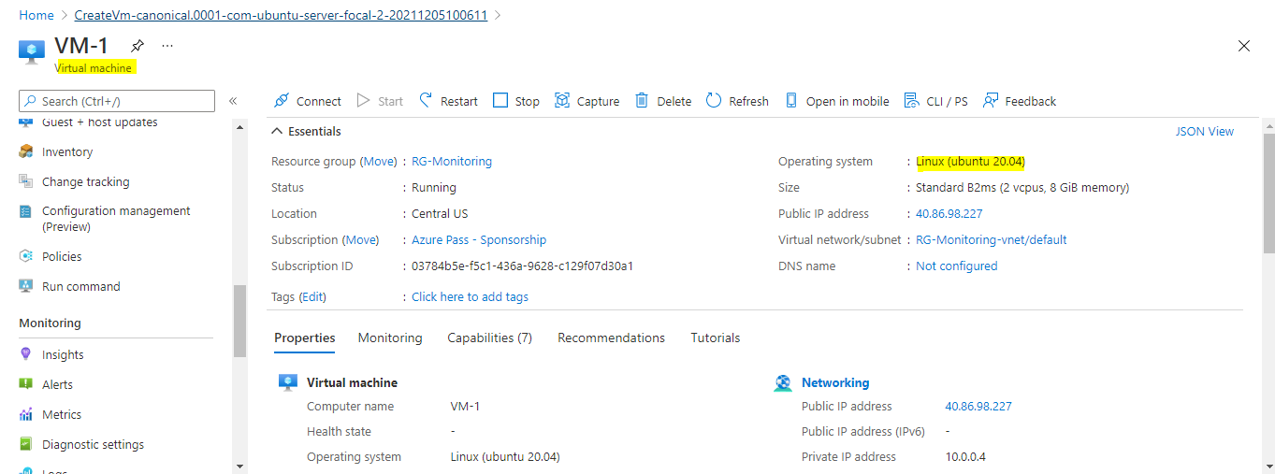

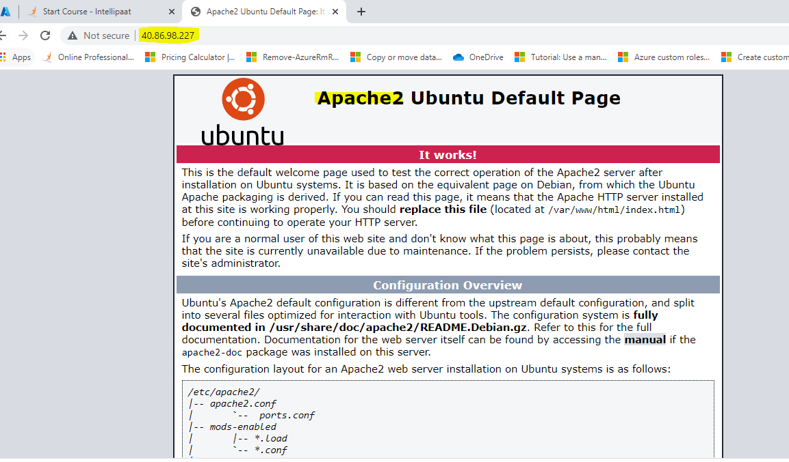

**Step-2**:-Created an alert for Deletion of above VM

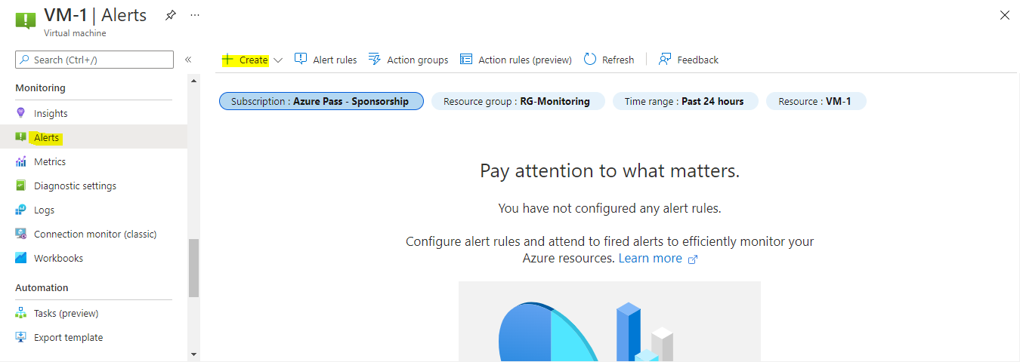

* Create a **Conditon** that if someone is trying to delete the vm we will get notification.

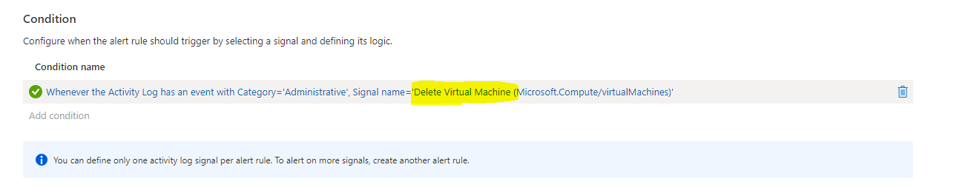

* Create one action rule in this we have to specify the details like phone number and email address that we get notified.

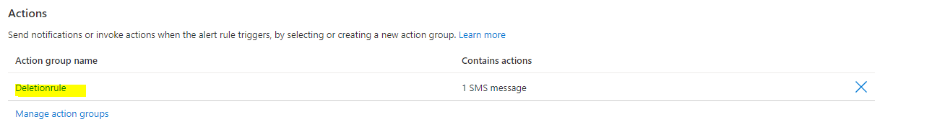

* Create an alert rule details.

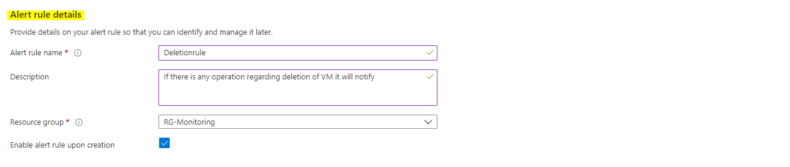

* Alert rule created .

