1. Aim: Basic Spring Application with Constructor Injection.

Description:
In this lab, we will create a simple Spring application using constructor-based dependency injection. Constructor Injection is a technique wherein Spring's IoC (Inversion of Control) container injects the dependencies through the class constructor at runtime.
This example involves:
- The Employee class represents an employee entity with the attributes eno & ename.
- It uses constructor overloading to allow object creation with either full or partial employee details like eno in overriding class.
- Configuring Spring beans using an XML configuration file (app.xml).
- The FinalDemo class initializes the Spring container using app.xml to perform constructor injection and retrieve the Employee bean for execution.

Folder Structure:
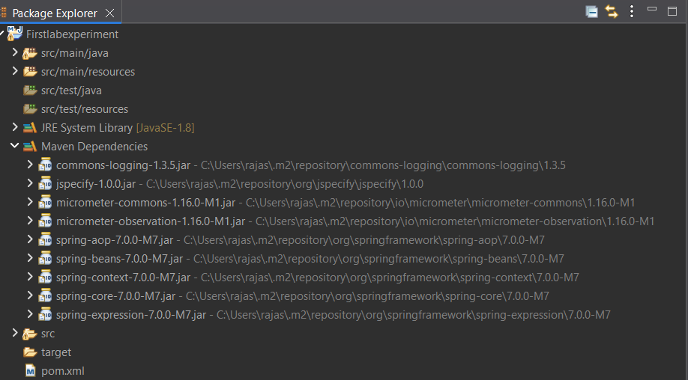

Program:

1) Employee.java

package org.example;

public class Employee {

int eno;
String ename;
public Employee(int eno, String ename) {
super ();
this.eno = eno;
this.ename = ename;
}
public Employee(int eno) {
super();
this.eno = eno;

}
@Override
public String toString() {
return "Employee [eno=" + eno + ", ename=" + ename + "]";
}

}

2) FinalDemo.java

package org.example;

import org.springframework.context.ApplicationContext;
import org.springframework.context.support.ClassPathXmlApplicationContext;

public class FinalDemo {
public static void main(String[] args) {
// TODO Auto-generated method stub
ApplicationContext context = new ClassPathXmlApplicationContext("app.xml");
Employee e1 = context.getBean("e",Employee.class);
System.out.println(e1);
}

}

3) app.xml

<?xml version="1.0" encoding="UTF-8"?>
<beans xmlns="http://www.springframework.org/schema/beans"
xmlns:xsi="http://www.w3.org/2001/XMLSchema-instance"
xsi:schemaLocation="http://www.springframework.org/schema/beans
https://www.springframework.org/schema/beans/spring-beans.xsd">
<bean id="e" class="org.example.Employee">

<constructor-arg index="0" value="158></constructor-arg>
<constructor-arg index="1" value="Abdul Razaqq"></constructor-arg>

</bean>
</beans>

4) pom.xml

<project xmlns="http://maven.apache.org/POM/4.0.0" xmlns:xsi="http://www.w3.org/2001/XMLSchema-instance" xsi:schemaLocation="http://maven.apache.org/POM/4.0.0 https://maven.apache.org/xsd/maven-4.0.0.xsd">
<modelVersion>4.0.0</modelVersion>
<groupId>MCA</groupId>
<artifactId>First_project</artifactId>
<version>0.0.1-SNAPSHOT</version>

<dependencies>
<!-- https://mvnrepository.com/artifact/org.springframework/spring-core -->
<dependency>
<groupId>org.springframework</groupId>
<artifactId>spring-core</artifactId>
<version>7.0.0-M7</version>
</dependency>

<!-- https://mvnrepository.com/artifact/org.springframework/spring-context -->
<dependency>
<groupId>org.springframework</groupId>
<artifactId>spring-context</artifactId>
<version>7.0.0-M7</version>
</dependency>

</dependencies>
</project>

Output:

Employee [eno=139, ename=Radha]

2. Aim: Basic Spring Application with Setter Injection

Description:
In this lab, we develop a simple Spring application to illustrate Setter-based Dependency Injection. Unlike constructor injection, in setter injection, the container injects dependencies using JavaBean-style setter methods after the object is constructed.
This application consists of:
- Book which is a POJO (Plain Old Java Object) with setter methods – pgno & bookName.
- Configuring Spring beans using an XML configuration file (config.xml).
- We use the <property> tag to inject values into bean fields via setter methods
Program:
1) Book.java
package org.example;

public class Book {
int pgno;
String bookName;
public int getPgno() {
return pgno;
}
public void setPgno(int pgno) {
this.pgno = pgno;
}
public String getBookName() {
return bookName;
}
public void setBookName(String bookName) {
this.bookName = bookName;
}
@Override
public String toString() {
return "Book [pgno=" + pgno + ", bookName=" + bookName + "]";
}
public void read() {
System.out.println("This is Book class read method");
}
}

2) FinalDemo.java

package org.example;

import org.springframework.context.ApplicationContext;
import org.springframework.context.support.ClassPathXmlApplicationContext;

public class FinalDemo {

public static void main(String[] args) {
// TODO Auto-generated method stub
ApplicationContext c=new ClassPathXmlApplicationContext("config.xml");
Book b1=c.getBean("b",Book.class);
b1.read();
System.out.println(b1.getBookName());
System.out.println(b1.getPgno());

}

}

3) config.xml
<?xml version="1.0" encoding="UTF-8"?>
<beans xmlns="http://www.springframework.org/schema/beans"
xmlns:xsi="http://www.w3.org/2001/XMLSchema-instance"
xsi:schemaLocation="http://www.springframework.org/schema/beans
https://www.springframework.org/schema/beans/spring-beans.xsd">
<bean id="b" class="org.example.Book">

<property name="pgno" value="158"></property>
<property name="bookName" value="Same as Ever"></property>

</bean>
</beans>

4) pom.xml
<project xmlns="http://maven.apache.org/POM/4.0.0" xmlns:xsi="http://www.w3.org/2001/XMLSchema-instance" xsi:schemaLocation="http://maven.apache.org/POM/4.0.0 https://maven.apache.org/xsd/maven-4.0.0.xsd">
<modelVersion>4.0.0</modelVersion>
<groupId>MCA</groupId>
<artifactId>SecondLabExp</artifactId>
<version>0.0.1-SNAPSHOT</version>

<dependencies>
<!-- https://mvnrepository.com/artifact/org.springframework/spring-core -->
<dependency>
<groupId>org.springframework</groupId>
<artifactId>spring-core</artifactId>
<version>7.0.0-M7</version>
</dependency>
<!-- https://mvnrepository.com/artifact/org.springframework/spring-context -->
<dependency>
<groupId>org.springframework</groupId>
<artifactId>spring-context</artifactId>
<version>7.0.0-M7</version>
</dependency>

</dependencies>
</project>

Output:
This is Book class read method
Same as Ever
139

3. Aim: Spring Auto Scanning Example.

Description:
In this lab, we create a basic Spring application using annotation-based configuration. With auto scanning, Spring can automatically detect and manage beans in the specified package without declaring them manually in the XML configuration.
This application consists of:
- A FirstStudent class representing a Spring-managed component.
- A SecondStudent class with a dependency on FirstStudent, injected using @Autowired.
- Use of @Component annotation to mark Java classes as Spring beans.
- A minimal app.xml configuration using <context:component-scan> to enable automatic scanning and wiring of components.

Program:

1) FirstStudent.java

package com.example;

import org.springframework.stereotype.Component;

@Component
public class FirstStudent {

@Override
public String toString() {
return "My name is Razaqq, I am studying MCA II";
}
}

2) SecondStudent.java

package com.example;

import org.springframework.beans.factory.annotation.Autowired;
import org.springframework.stereotype.Component;

@Component
public class SecondStudent {

@Autowired
FirstStudent f;

@Override
public String toString() {
return "My name is Abdul Razaqq, I am working as a Software Engineer "+f ;
}
}

3) FinalDemo.java
package com.example;

import org.springframework.context.ApplicationContext;
import org.springframework.context.support.ClassPathXmlApplicationContext;

public class MainDemo {

public static void main(String[] args) {

ApplicationContext context=new ClassPathXmlApplicationContext("app.xml");
SecondStudent s=(SecondStudent)context.getBean(SecondStudent.class);
System.out.println(s);
}

}

4) app.xml

<beans xmlns="http://www.springframework.org/schema/beans"
xmlns:xsi="http://www.w3.org/2001/XMLSchema-instance"
xmlns:context="http://www.springframework.org/schema/context"
xsi:schemaLocation="http://www.springframework.org/schema/beans
http://www.springframework.org/schema/beans/spring-beans-2.5.xsd
http://www.springframework.org/schema/context
http://www.springframework.org/schema/context/spring-context-2.5.xsd">

<context:component-scan base-package="com.example"></context:component-scan>
</beans>

5) pom.xml

<project xmlns="http://maven.apache.org/POM/4.0.0" xmlns:xsi="http://www.w3.org/2001/XMLSchema-instance" xsi:schemaLocation="http://maven.apache.org/POM/4.0.0 https://maven.apache.org/xsd/maven-4.0.0.xsd">
<modelVersion>4.0.0</modelVersion>
<groupId>MCA</groupId>
<artifactId>ThirdLabExp</artifactId>
<version>0.0.1-SNAPSHOT</version>

<dependencies>
<!-- https://mvnrepository.com/artifact/org.springframework/spring-core -->
<dependency>
<groupId>org.springframework</groupId>
<artifactId>spring-core</artifactId>
<version>7.0.0-M7</version>
</dependency>
<!-- https://mvnrepository.com/artifact/org.springframework/spring-context -->
<dependency>
<groupId>org.springframework</groupId>
<artifactId>spring-context</artifactId>
<version>7.0.0-M7</version>
</dependency>

</dependencies>
</project>

Output:
My name is Radha, I am working as a FullStack devolper. My name is Radha, I am studying MCA II

