Elevator consists of following parts:

Car , machine drive, control system, hoistway.

**Machine drive:**

It is the most important part of the elevator located at elevator machine room(power unit).

Gear : ( up to 2.5 m/sec)

Gearless : used in high speed lifts(2.5 to 10m/sec).

Drive consists of break, sheaves.

Motor :

There are different types of motors

The motor with 5hp which can carry which can carry 408kgs(people).

The motor with 7.5hp which can carry 650kgs(nearly 8 people).

The motor with 10hp mostly used in hospitals because they need to carry patients with bed.

If the building is of less than 5 floors, we can use 5hp motor for elevator.

If the building is of 5-10 floors, we can use 7.5hp motor for elevator.

Car :

Elevator Car is the vehicle that travels between the different elevator stops carrying passengers and/or goods, it is usually A heavy steel frame surrounding a cage of metal and wood panels.

There are mild steel and stainless steel elevator cars.

Stainless steel is stronger than the mild steel.

Hoistway:

Guide rails for both the car and counterweight.

Counterweight.

Suspension (Hoisting) Ropes (Cables).

Landing (Hoistway) doors.

The ropes in the elevator are attached to the car and the counterweights.

The counterweight is the half weight of the car plus the weight of 50% of the people inside the lift.

So the motor only needs energy to lift the 50% of the weight of the people who is inside the lift.

If the counter weight is not there then the motor needs more energy to carry the entire weight.

The control system of the elevator and the motor are arranged on the top of the hoist way.

Control system:

Elevator Control System is the system responsible for coordinating all aspects of elevator service such as travel, speed, and accelerating, decelerating, door opening speed and delay, leveling and hall lantern signals.  
  
It accepts inputs (e.g. button signals) and produces outputs (elevator cars moving, doors opening, etc.).

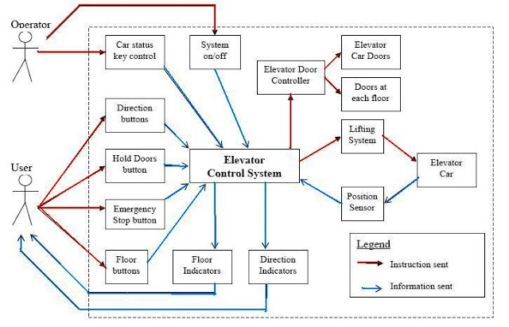

Safety system:

Device for locking landing doors.

Over speed governor which control the gear to not exceed beyond the

Buffers: buffer  is a device designed to stop a descending car or counterweight beyond its normal limit.

actuate the safety gear if the car speed exceeds.

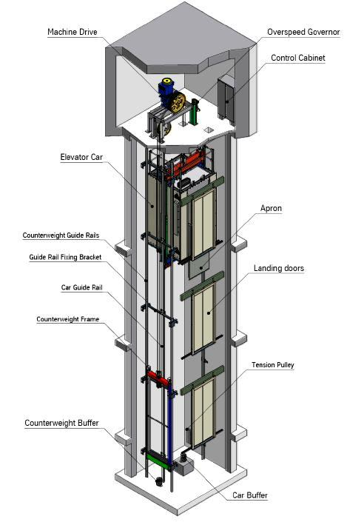

.

In machine room less(MRL) elevators the machine is installed to the wall.

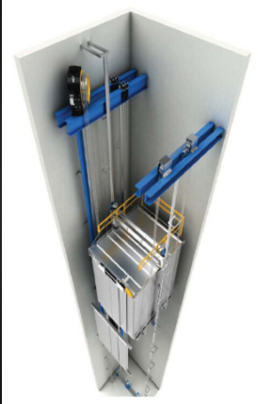

ARD(Automatic Rescue Device):

Which is used to move the lift to the nearest floor when the power is off by using the energy from batteries.

Bringing the car to nearest level and opens the door using internal batteries.

Different types of doors for elevator:

Automatic

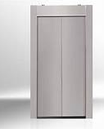

Swing doors

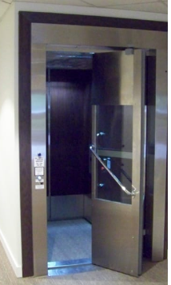

Collapsible doors

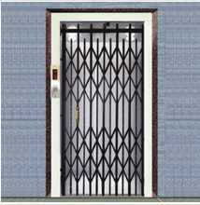

Working :

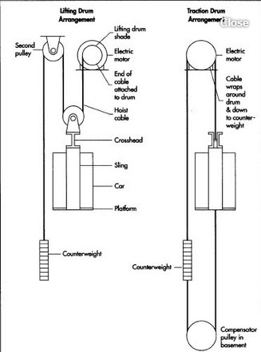

A very strong metal rope is joined to the top of the elevator car and goes up though a “sheaves” in the engine room above the elevator.

The sheave is like a pulley wheel with grooves in it to hold the rope tightly.

On the other side of the rope is a weight. Which is about as heavy as the elevator car when it is half full. This balances the car, so that not too much energy is needed to move it.

Both the weight and the elevator car are held in place by guide rails at the sides of the elevator shaft (the tunnel the elevator is in).

A motor can turn the wheel in either direction so that the elevator either goes up or down (with the weight doing the opposite).

When you push the button inside the elevator, you activate the motor.

When the motor stops, the grooves in the pulley wheel keep the rope in place so the elevator stops moving.