Day 10 - 20th June 2025

**What is a process ?**

A process is an instance of a running program it has it own memory space system resource

**What is a thread ?**

A thread is a light weight sub task with in a process it represents one path of execution and shares the same memory space with other threads in the same process

TASK 3

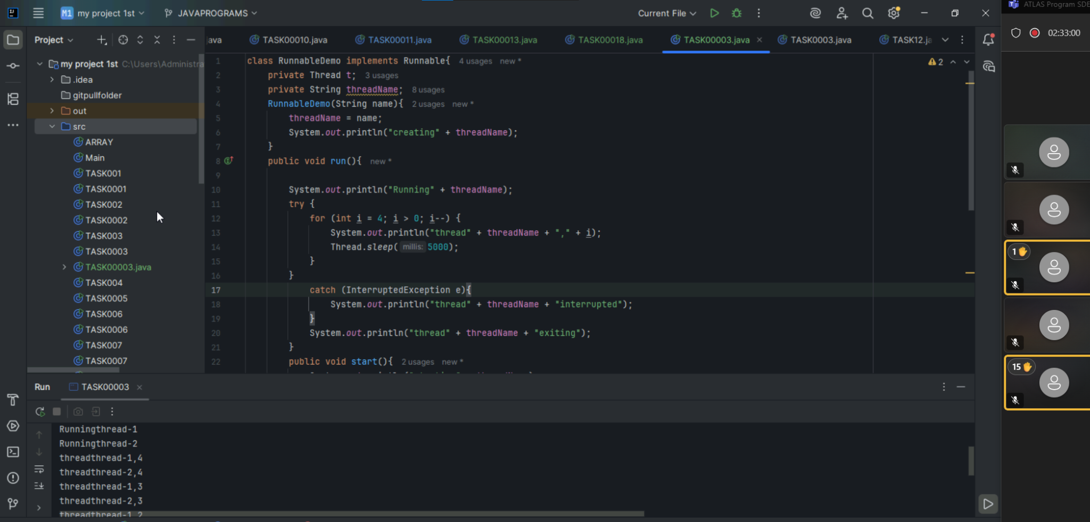

TASK 4

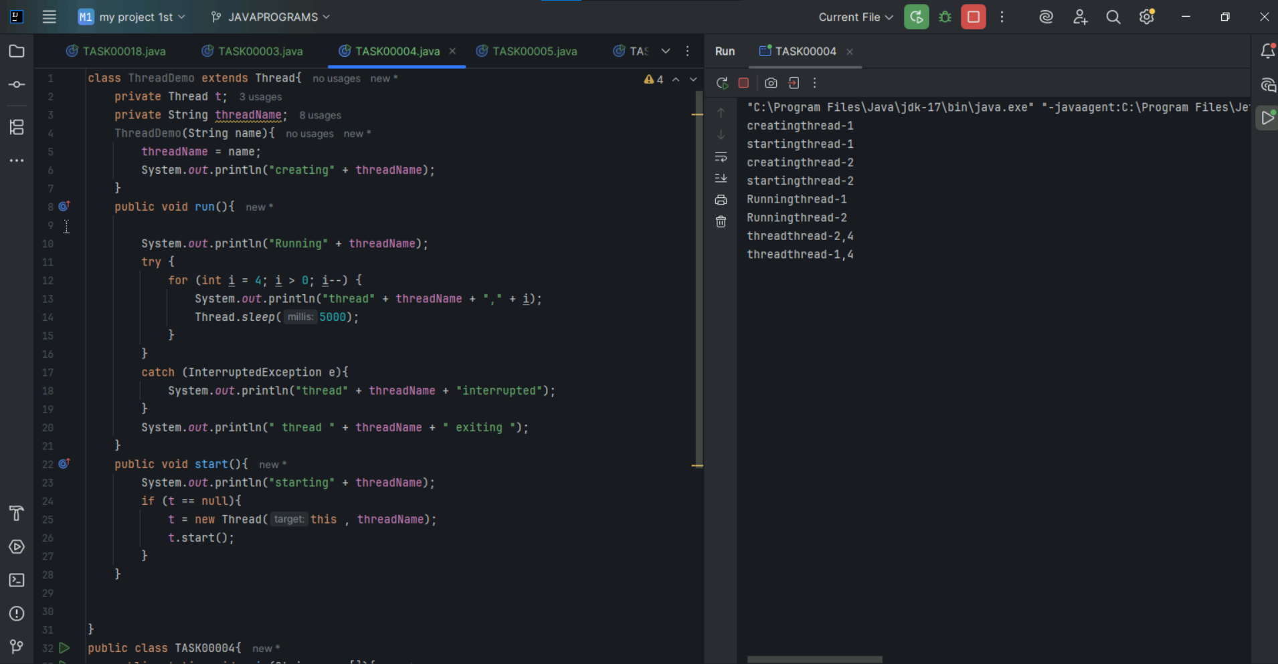

TASK 5

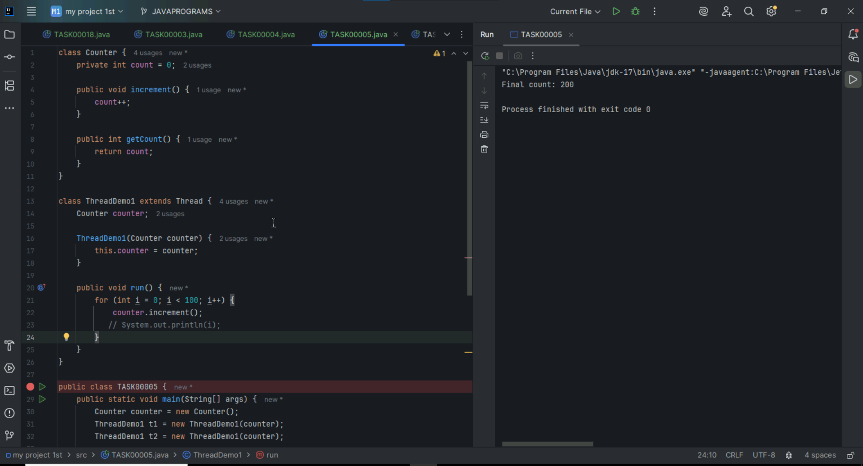

Task 6

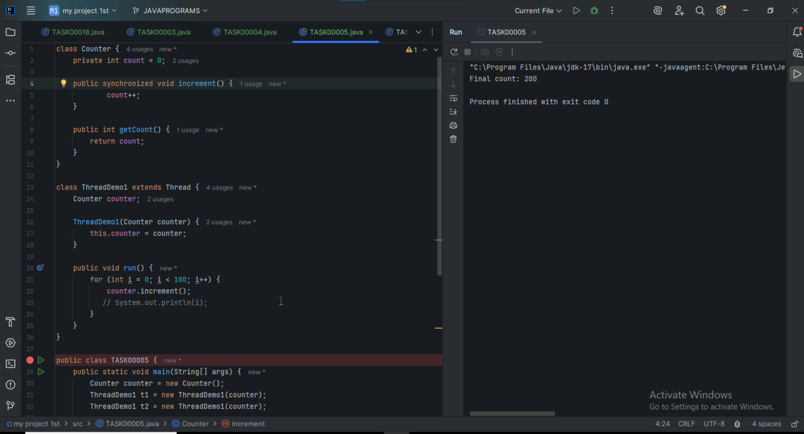

Task 7

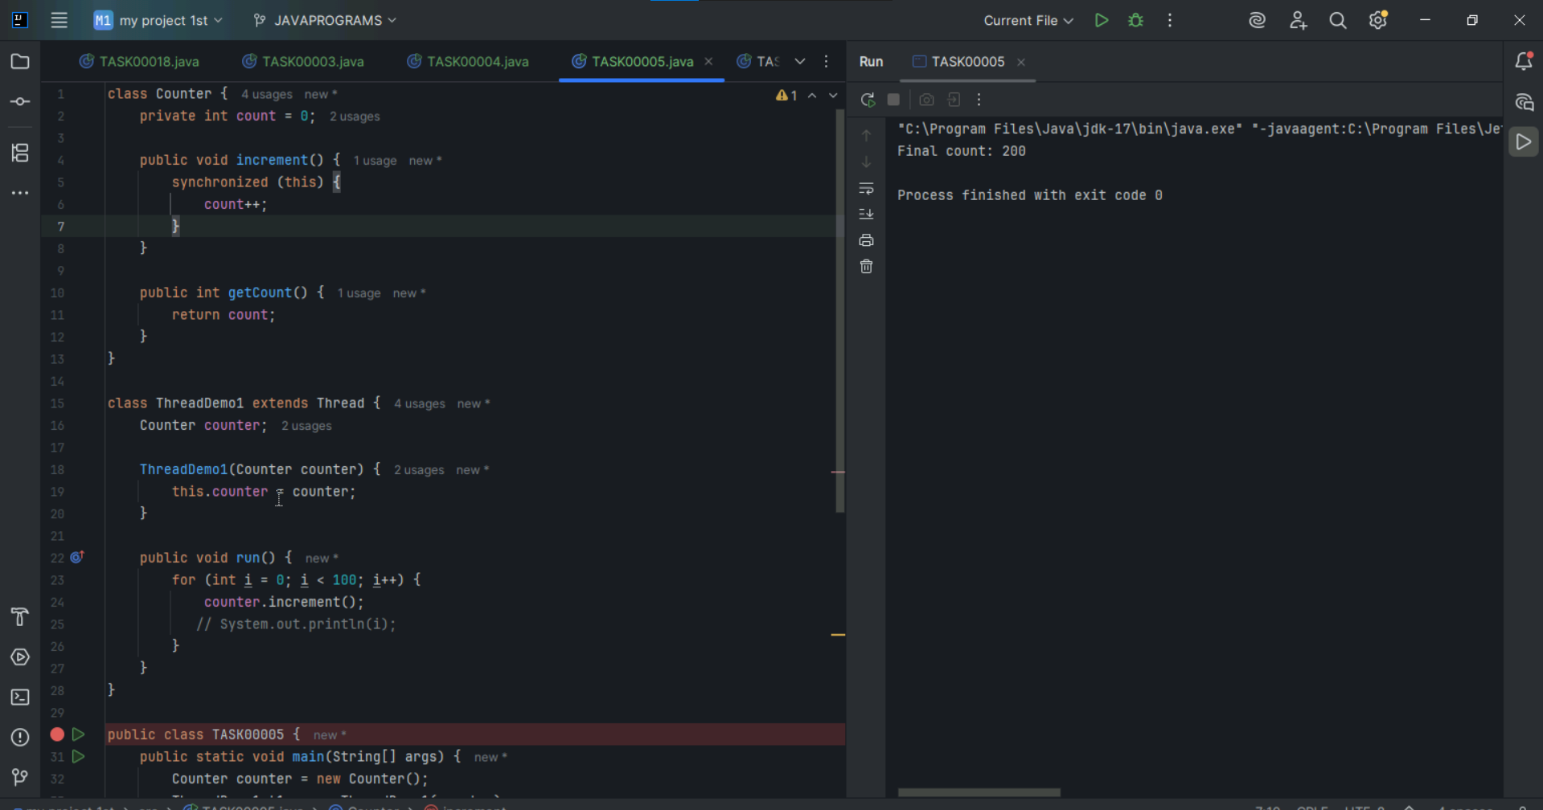

Task 9

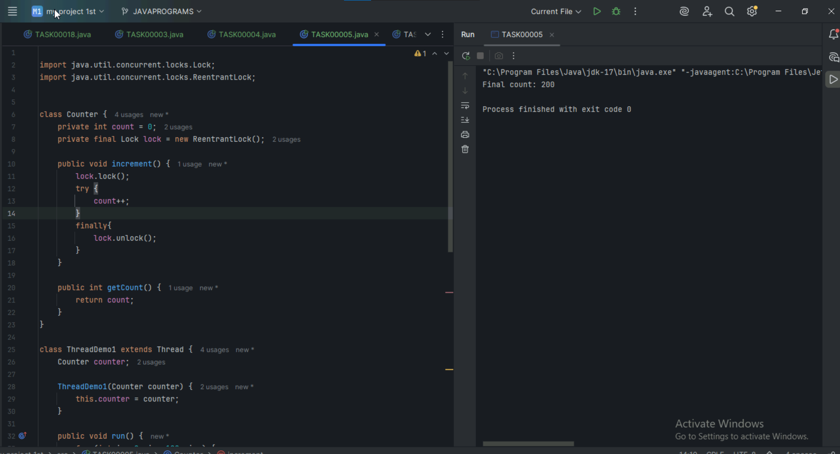

Task 10

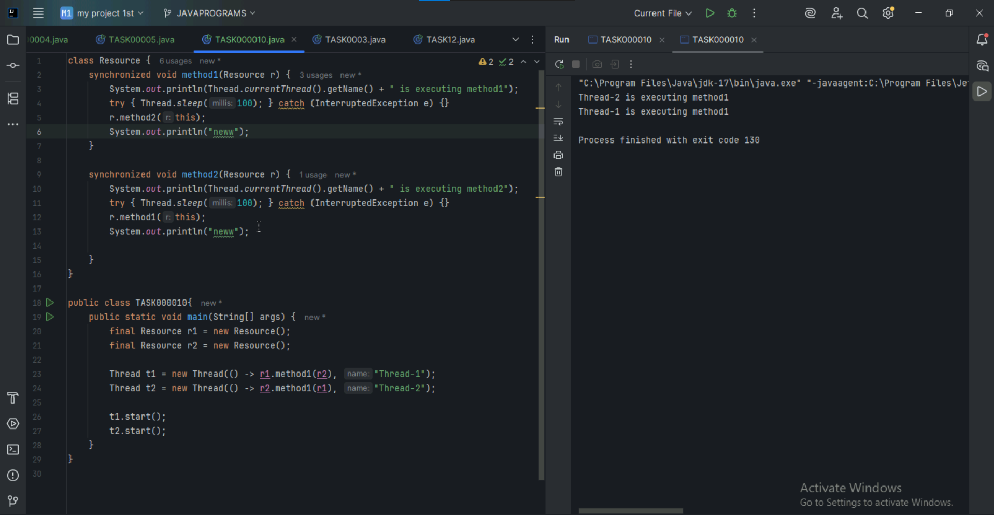

TASK 11

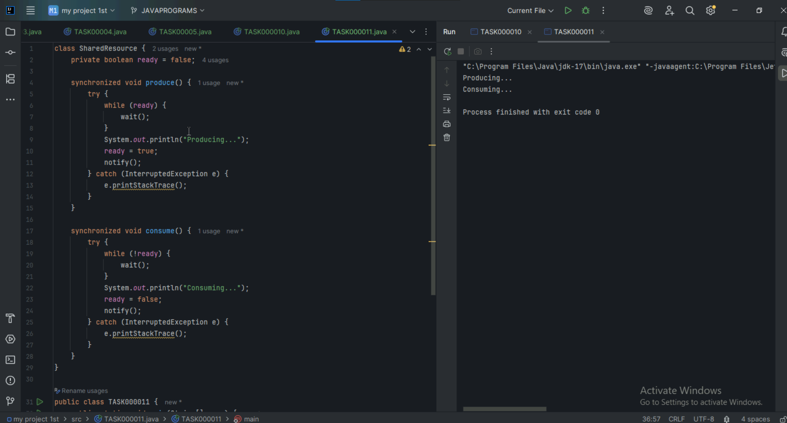

TASK 12

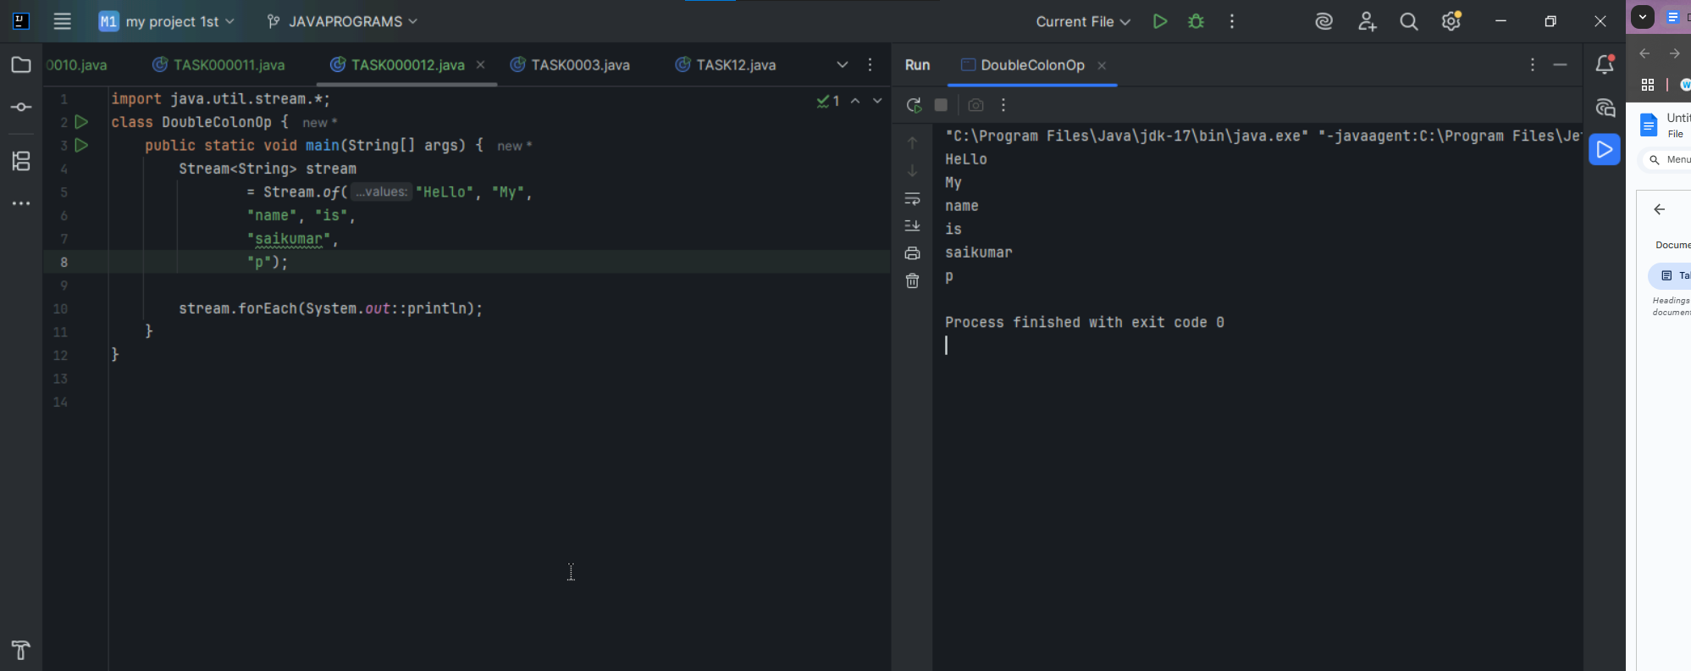

TASK 14

What is demon threading .?

Daemon threa is a background thread that runs in the background to perform tasks like garbage collection,handling background I/O operations without blocking main program from exiting

TASK 15

What are the debugging tools in Java ?

Java Debugger (jdb),

IDE debuggers like IntelliJ IDEA and Eclipse,

and tools like VisualVM and JProfiler.