EDA & Data Preprocessing
ARCHITECTURE FLOWCHART:

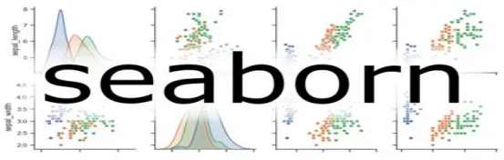

Exploratory Data Analysis (EDA)
- Understand Data Structure
- Univariate Analysis
- Bivariate/Multivariate Analysis
- Outlier Detection
- Missing Values Analysis
Data Preprocessing
- Handling Missing Values
- Handling Outliers
- Encoding Categorical Variables
- Feature Scaling

Monitoring





Data Importing
Data Storage



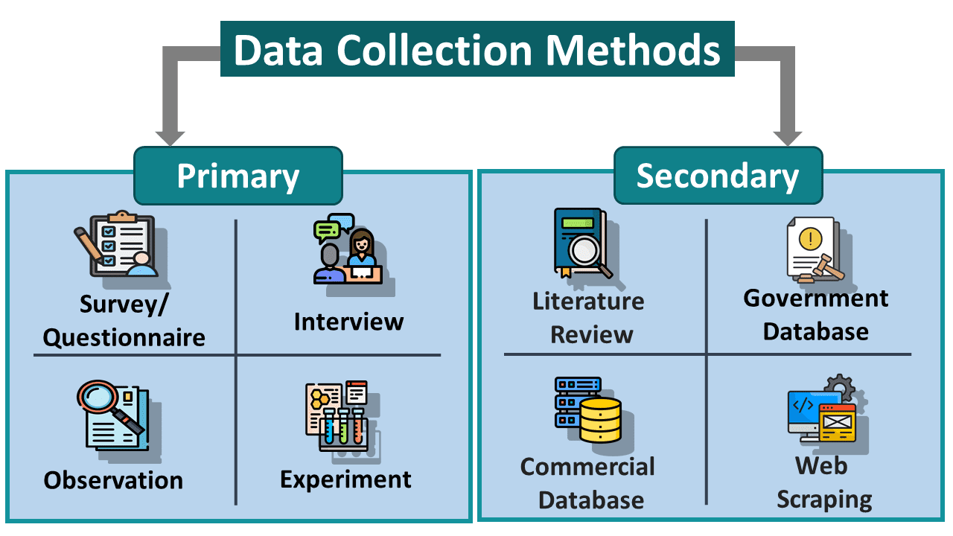
Business Understanding

> Business Problem: Optimizing IVF clinic operations with predictive analytics and real-time insights to enhance scheduling, resource utilization, and patient satisfaction.
. Clarify Objectives
. Define Success Metrics
. Understand Processes

