**ICP 7:**

Problem Statement:

Keyspace Creation:

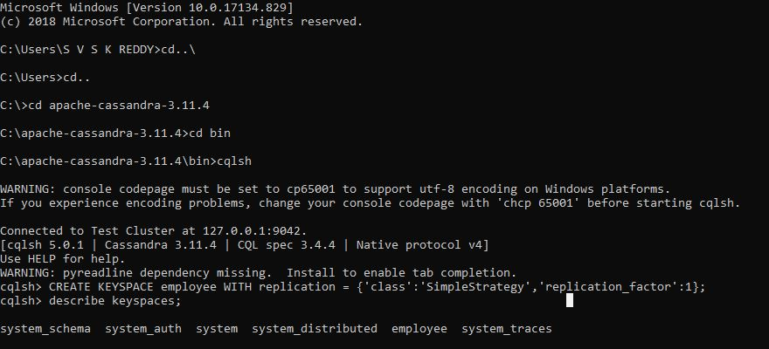

Table Creation(Employee1):

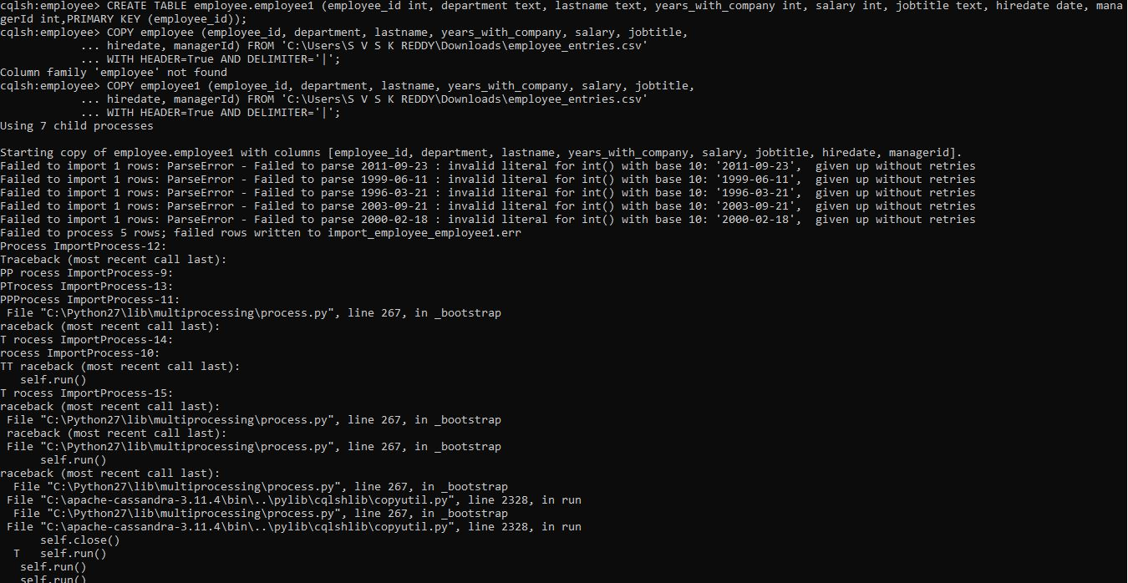

Query 1:

select employee_id, lastname, jobtitle, hiredate from employee1;

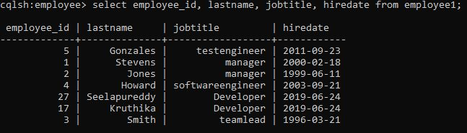

Query2:

select lastname,salary from employee1 where jobtitle='clerk' ALLOW FILTERING;

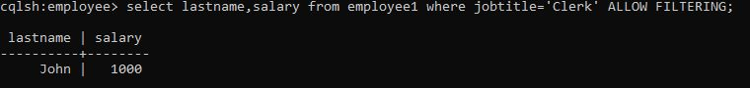

Query3:

select lastname,salary from employee1;

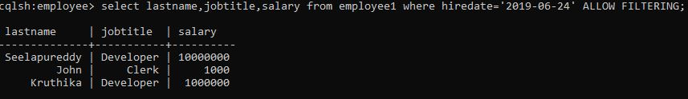

Query4:

select lastname, salary, managerId from employee1 where salary=50000 allow filtering;

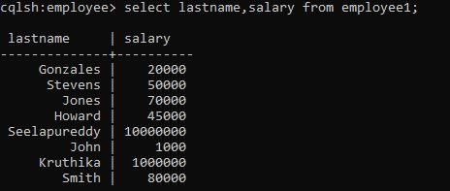

Query5:

select * from department where dept_no >= 20 allow filtering;

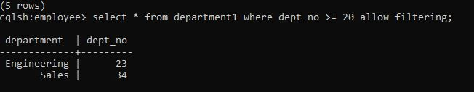

Query6:

select lastname, salary, managerId from employee1 where salary=50000 allow filtering;

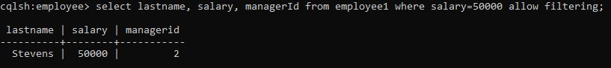

Bonus:

