Tasks
Learners have to develop a dashboard to support the answers to the following questions.

Objective Questions:

- What is the total no. of tables present in the data?
Ans: There is only 1 sheet so 1 Table.
- What is the total no. of attributes present in the data?
Ans: Use =COLUMNS(A:AI)
35 attributes.
From range (A1: AI)
- The data consists of some inconsistent and missing values so ensure that the data used for further analysis is cleaned.
Ans: The dataset contained missing and inconsistent values.
so, I cleaned it by,
1. Removing unwanted columns such as:
_id, user, guru, isWhiteListUser, queue, and statementEntryId.
2. Search for duplicates and remove them.
This improved data quality and prepared the dataset for analysis
which is present in Cleaned data sheet.
- What is the change in daily call volume day by day and also find the average daily call volume.
Ans:

createdAT - Year-Month-Day | COUNTA of CallSid | Daily Change in call volume | Average daily call volume
2023-12-01 | 228 | 0 | 246.03
2023-12-02 | 332 | 104
2023-12-03 | 383 | 51
2023-12-04 | 364 | -19
2023-12-05 | 253 | -111
2023-12-06 | 254 | 1
2023-12-07 | 254 | 0
2023-12-08 | 138 | -116
2023-12-09 | 288 | 150
2023-12-10 | 430 | 142
2023-12-11 | 424 | -6
2023-12-12 | 358 | -66
2023-12-13 | 348 | -10
2023-12-14 | 226 | -122
2023-12-15 | 276 | 50
2023-12-16 | 258 | -18
2023-12-17 | 185 | -73
2023-12-18 | 233 | 48
2023-12-19 | 209 | -24
2023-12-20 | 178 | -31
2023-12-21 | 159 | -19
2023-12-22 | 163 | 4
2023-12-23 | 241 | 78
2023-12-24 | 232 | -9
2023-12-25 | 258 | 26
2023-12-26 | 255 | -3
2023-12-27 | 242 | -13
2023-12-28 | 181 | -61
2023-12-29 | 260 | 79
2023-12-30 | 179 | -81
2023-12-31 | 158 | -21
2024-01-01 | 115 | -43
2024-01-02 | 196 | 81
2024-01-03 | 107 | -89
Grand Total | 8365
Approach - - -
1.Create a pivot table by using the cleaned data sheet.
2. use the (Created_at) in rows and in values use
COUNTA of Call Sid.
2. To calculate the change in daily call volume day by day, use = C9 – C8.
3. For the average daily call volume,
use =AVERAGE (C8:C41).
- Which months experienced the highest and lowest call volumes?
Ans: Highest call volumes – December.
Lowest call volumes – January.
createdAT - Month | COUNTA of CallSid
Jan | 418
Dec | 7947
Grand Total | 8365
Approach - - -
1. Create a pivot table by using the cleaned data sheet.
2. Group by Months and apply Count of CallSid in Values.
- What is the total operational cost for that month?
Ans:
createdAT - Year-Month | SUM of astrologersEarnings
2023-Dec | 93786.16295
2024-Jan | 5360.408
Grand Total | 99146.57095
Approach - - -
1. Create a pivot table by using the cleaned data sheet.
2.Taking created_AT by grouping (year – month)
and the sum of astrologers Earnings in values.
- What is the average number of calls handled per agent per day?
Ans:
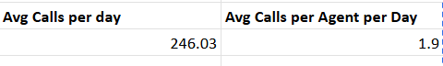

Approach - - - -
1. Create a pivot table by using the cleaned data sheet.
2. Finding the total count of calls for all the days.
3. Finding the no of unique days.
4. Getting avg no of Calls per day.
5. Finding the total count of unique agents.
6. Finding avg no of calls per agent per day.
- How many repeat callers are there, and what percentage of total calls do they represent?
Ans:
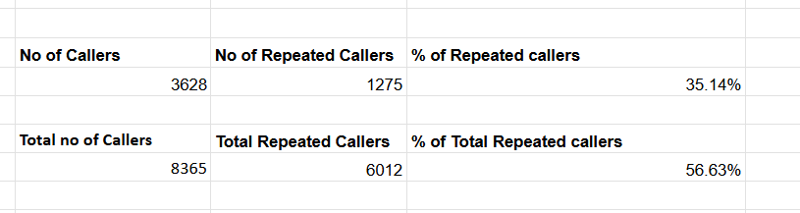
Approach - - -
1. Create a Pivot Table by using the cleaned data sheet.
2. Finding no of Callers, use =COUNT(B8:B10351)
3. Finding No of Repeated Callers, use =COUNTIF(C8:C10351,">1")
Till here we have got the Count of repeated callers.
4. Finding Total no of Callers, use =SUM(C8:C10351)
5. Finding Total no of Repeated Callers, use =SUMIF(C8:C10351,">1",C8:C10351)
6. Finding the % of total Repeated callers, use =(F12-F9)/E12
This will give us the % of total Repeated callers.
- What are the total sales generated by the call centre for each product category?
Ans:
consultationType | SUM of netAmount
Call | 168442.035
Chat | 45494.68333
Complementary | 0
public_live_Call | 50.597
Grand Total | 213987.3153

Approach - - -
1.Create a Pivot Table by using the cleaned data sheet.
2.Apply consultation Type in the row and sum of the net Amount in the values.
- How many calls were made for each user ID and guru ID?
Ans:
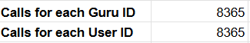
Approach - - -
1.Create 2 pivot tables by using the cleaned data sheet.
2.Gid & uid in Rows for both pivot tables.
3.Count of Callsid in values for both the pivot tables.
- What is the correlation between call duration and customer satisfaction?
Ans:
Approach - - -
1. Create a Pivot Table by using the cleaned data sheet.
2. use =CORREL('Cleaned data'!P:P,'Cleaned data'!AC:AC) to find the correlation where p is the time Duration and AC is the rating.
- Which guru has the highest and lowest customer satisfaction scores?
Ans:
guruName | AVERAGE of rating
Tarot Mystical | 7.5
Astro Pujaa Rai | 7.5

Tarot Rittika | 0.0
Tarot Mystical, Astro Pujaa Rai - Highest.
Tarot Rittika - lowest.
Approach - - -
1. Create a Pivot Table by using the cleaned data sheet.
2. Use guruName in the rows and average of rating in the values.
3. Filter in row as guruName descending sort by average of rating.
- What is the average customer satisfaction score by month?
Ans:
createdAT - Year-Month | AVERAGE of rating
2023-Dec | 2.949637572
2024-Jan | 2.676413255
Grand Total | 2.93463446
Approach - - -
1. Create a Pivot Table by using the cleaned data sheet.
2. use created_AT in rows and Average of rating in values.
- How many categorical columns are there in the data? [Search about categorical and continuous data, and try to answer this question]
Ans: 15

Subjective Question:

- Should the investment be used to hire more agents, improve training programs, or upgrade call center technology?

Ans: Approach - - -
1. For hiring more agents, we compare Average ratings for each guru (using gid).

2. For improving training, we compare Average call duration for each guru (using gid).

3.To see if you have to upgrade the call center technology, call and chat status with their average call duration and average chat seconds.
Analysis - - -
1.Hiring more agents (Based on avg Guru rating – gid) :
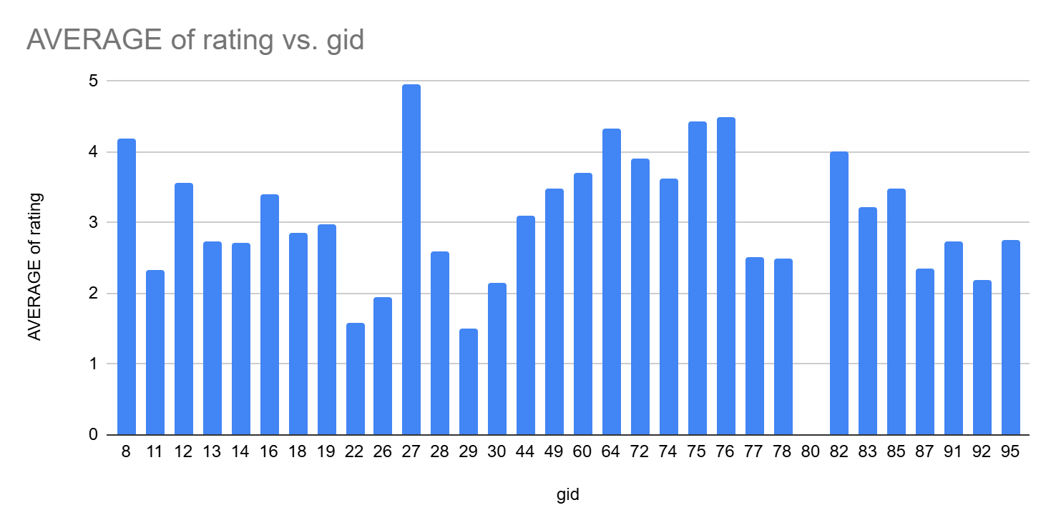

1.Some gurus have higher average rating which means they handle customers very well and they have very good expertise.

2.few gurus have lower average rating which means they have issues in skill gaps, communication, Burnout.

High rated gurus are likely handling very huge amount of calls, increasing dependency risk.

2.Improving Training Programs (Average Call Time vs gid) :
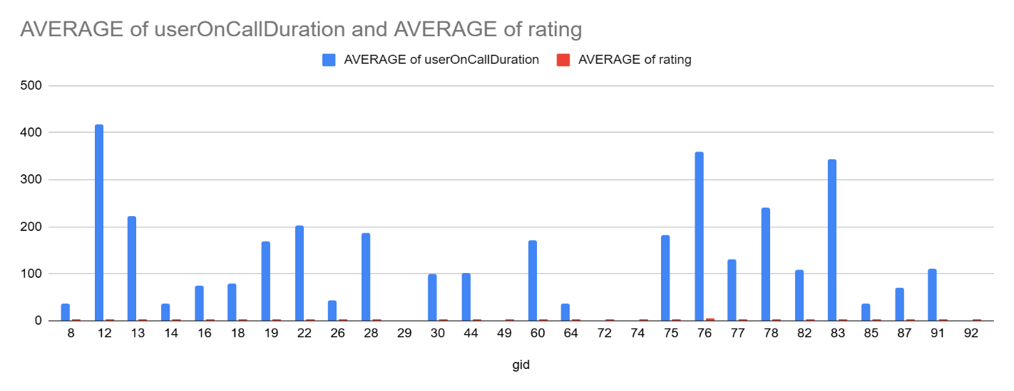

1.Gurus with shorter average call duration and higher ratings demonstrate
great knowledge on the product and strong communication skills.

2.Gurus with longer average call duration and lower ratings suggests they
have difficulty in handling queries & lack of domain knowledge.

3.Few Gurus who are having long average call durations but good ratings suggest
that they have good quality score, but they might have been low in terms of tools
& process.

3.Upgrading Call Centre Technology (Call Vs Chat duration):
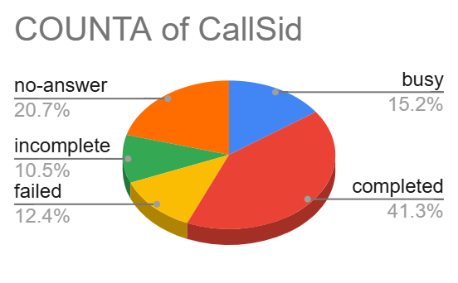

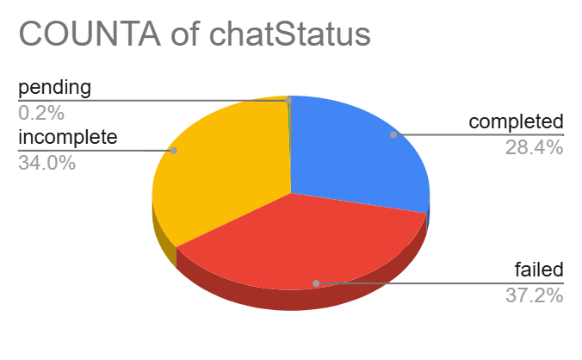

1. High chat failure rate suggests follow-up needed, the chatStatus distribution shows failed is the largest segment (~37%) followed by incomplete (~34%), meaning over 70% of chats did not reach a successful completed outcome, this indicates chat flows or bot/agent handoffs need review and targeted fixes to improve resolution rates.
2.Calls complete more often than chats, but unanswered calls are significant
callStatus shows completed is the biggest share (~41%), yet no-answer (~21%) and busy (~15%) together account for ~36% of call attempts, implying outreach volume is reasonable but contactability is an issue (timing, caller ID, or dial strategy).

3.Chat adoption is comparatively lower, suggesting underutilization of cost-efficient digital channels.

Recommendations - - -
1.Hiring More Agents:

1.prioritize hiring in teams where gurus show high ratings but high workload, to prevent burnout and quality degradation.

2.Replace very low rating and high-income gurus with the gurus who are having good work experience waiting in the market for an opportunity.

3.Gradually re distribute call volumes by onboarding junior agents under high rated mentors that can help juniors understand the communication levels with the customers.

2.Improving Training Programs:
1.Design targeted training for gurus with long call times and low ratings
Depending on if they are week in
communication, product knowledge, call structuring.
2. Use best performing gurus call recordings as a role – playing example to make the them understand how they can get better.
3.Introduce performance-based coaching, focusing on reducing call time with out impacting customer satisfaction.
3.Upgrading Call Centre Technology:
1.Promote chat-based support for issues where the customers need to share us proofs and agents need a detailed explanation from the customers which cannot be possible on calls so the call flow decreases.

2. For chats invest in AI - Integrated chatbots and CRM integrations to handle basic queries and close by itself so that the chat agent’s volume can be reduced by large volumes.

3.Setup a re routing system where if the toughest calls gets routed to the junior agents those can be transferred instantly to the experienced ones.
- What are the potential risks of each investment option (hiring, training, technology upgrades), and how can they be mitigated?

Ans:

1) Hiring more agents:
Risks:
- Hiring increases payroll and training cost.
- New agents may take time to reach expected performance.
- If workload is not redistributed properly, the same efficiency problem may continue.
Mitigation:
- Hire in phases instead of all at once.
- Provide strong onboarding and mentoring from top performers.
- Review workload and performance regularly so calls are assigned fairly.
2) Improving training programs:
Risks:
- Training takes time away from live work.
- Generic training may not fix the real skill gaps.
- Improvement may not last if there is no follow-up.
Mitigation:
- Give targeted training based on actual weak areas like long calls or low ratings.
- Use call recordings and examples from best agents.
- Track performance after training and provide regular coaching.
3) Upgrading technology:
Risks:
- Technology upgrades can be expensive.
- Poorly designed automation may frustrate customers.
- New tools may not help much if agents still lack skills.
Mitigation:
- Start with the most useful upgrade first, such as chatbots or CRM integration.
- Test the system on simple cases before full rollout.
- Combine technology changes with training and proper routing of complex cases.

- How does AstroSage's call center performance compare to AstroGuru's average call volume, customer satisfaction, and agent performance?
Will you use any aggregation function or a visualization here to solve the problem?

Ans: We have been only provided the AstroSage data for the analysis, but Astro Guru has not been provided. Hypothetically, we can answer this problem statement based on the following criteria:
- Average Call Volume: We can use pivot table to calculate the total no of calls and average daily calls for astrosage and compare the value with astro guru’s dataset to identify the call handling capacity and create a line chart to visualise the KPI cards for call trends.

- Customer Satisfaction: we can create a pivot table and chart for user-wise and astrologer-wise ratings to compare the satisfaction levels of both call centres side by side.
- Agent performance: We can use a pivot table to calculate the calls handled vs. astrologer name and identify the top-performing astrologers in AstroSage and compare it with the Astro Guru’s top performers.

- How can the call center improve its handling of peak call periods to ensure high customer satisfaction?
Mention the functionality you will use for giving the suggestions, will it be any aggregated function or a visualization?
Ans:
Approach - - -
Here we have taken the users on call duration for each hour to understand the peak hours for the agent and optimise the problem accordingly.
Insights - - -
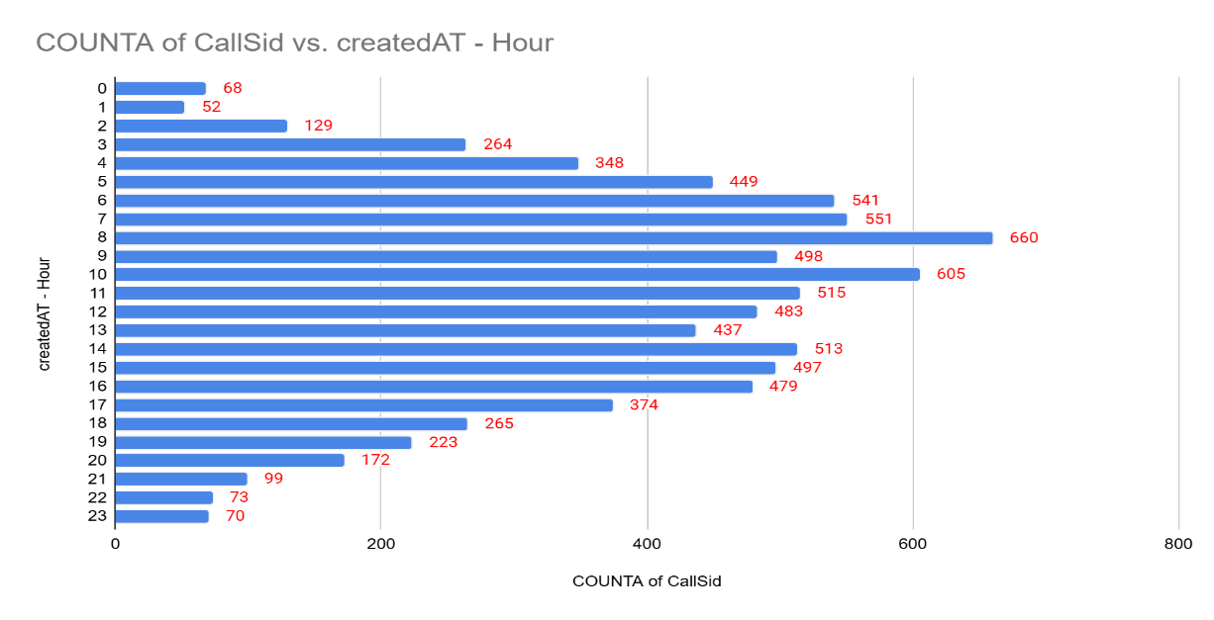

1.The users on call duration aggregated by hour clearly highlights specific peak
Hours where call volumes and handling times are significantly higher.
2.During these peak hours agents experiencing the higher work load and customers are waiting in the queue before they get attended by the agent.
3.Extended call durations in these peak hours creates fatigue to the agent and it negatively impacts on the customer satisfaction.
4.We can see that 1st 3 hours in the day and the last 4 hours in the day has the lowest calls volume which means agents can concentrate on other tasks such as training etc…
Recommendation - - -
The call centre can improve its handling of peak call periods and ensure high customer satisfaction on following the below process: -

1.Temporary hiring of gurus especially for the peak hours to distribute call volume evenly, so it drastically reduces the customer wait time.
2.Integrate AI in your IVR caller, so it asks customers on what their query is regarding and if it’s a basic query the AI solves it in the call, so this can reduce at least 30% of the calls queue length as lot of customers in general comes for basic queries only.
3.Providing Most important terms & conditions documentation ( MITC ) in the company’s website and app helps customers get through the solutions by spending some time on their own so that customer satisfaction increases with decrease in queue line.

4.Increase peak hour incentives for the agents so that they feel their efforts being valued and to maintain service quality during that time.

5.Conduct focused training programs to help agents manage peak hour calls efficiently and achieve a lower average call duration without compromising service quality.
- Based on historical data, what strategic initiatives should be prioritized to improve efficiency and customer satisfaction?

Ans:
Approach - - -
To address the problem statement, insights were derived using a combination of aggregate metrics and visual analysis. Call distribution was analysed to understand demand patterns and workload spread. Average Website Rating was used as a proxy for digital experience and customer satisfaction. The users' on-call duration was aggregated to identify efficiency gaps and peak-hour pressure. These insights collectively support data-driven decision-making for workforce planning, technology optimisation, and customer experience improvement.

Reference - - -

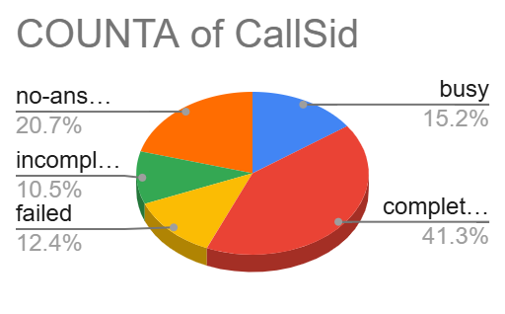

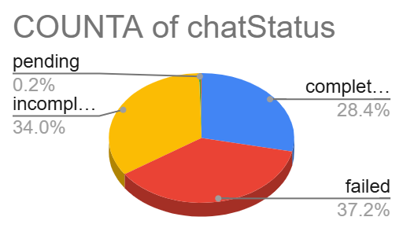

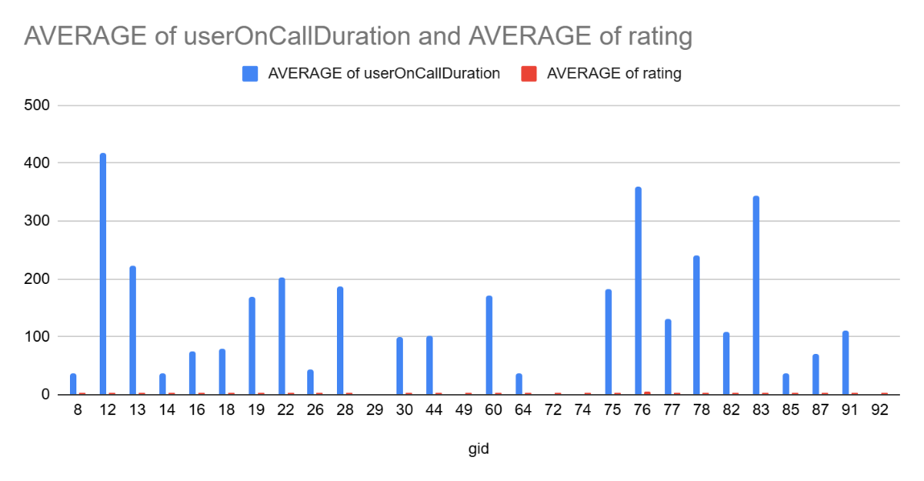

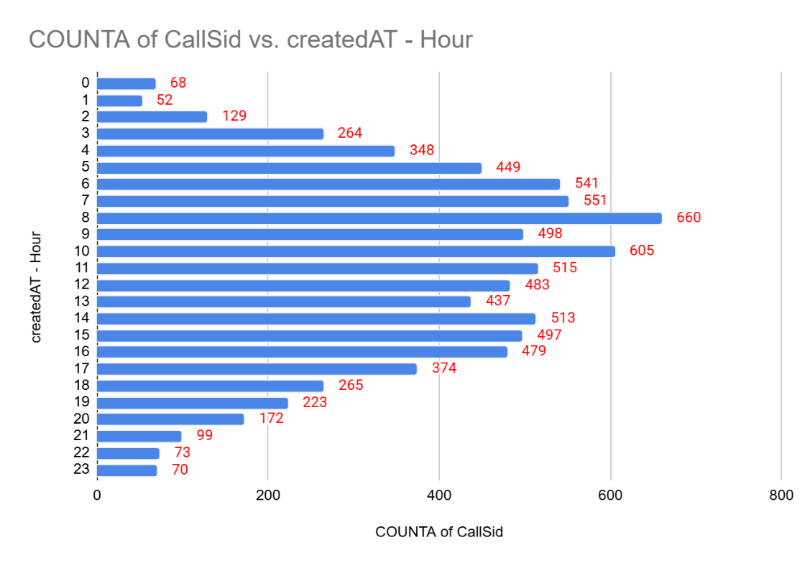

Insights - - -
● Uneven call distribution indicates workload concentration during specific periods,
increasing the risk of longer wait times and reduced service quality.
● Higher average on-call duration during peak hours suggests agent overload,
process inefficiencies, or complex query handling.
● Website ratings are lower compared to call engagement, indicating underutilisation
or usability issues in digital channels.
● Heavy reliance on calls for support highlights limited adoption of self-service
options, increasing operational costs.
● Variations in call duration across agents point to inconsistent performance levels
and training gaps.
● Lack of real-time visibility can delay responses to spikes in call volume, affecting
customer satisfaction.

Recommendation - - -
Based on the insights and visual evidence, the following strategic initiatives should be prioritised:

1. Data-Driven Workforce Planning
● Use average call duration and calls handled per hour to align staffing levels with
demand.
● Schedule additional agents during high-load periods to ensure balanced workload
distribution.

2. Peak-Hour Load Management
● Monitor peak-hour wait time to evaluate congestion handling efficiency.
● Introduce temporary staffing, shift realignment, and incentive-based scheduling
during peak hours.

3. Self-Service and Digital Channel Adoption
● Improve website usability to increase digital engagement and satisfaction scores.
● Deploy AI-driven chatbots for FAQs and routine queries to provide 24/7 support
and reduce call dependency.

4. Agent Performance Optimisation
● Identify best-performing agents using average call duration and resolution
efficiency.
● Implement targeted training programs to improve skill consistency and reduce
handling time.

5. Proactive Monitoring and Dashboards
● Develop real-time dashboards tracking call volume, wait time, and agent
performance.
● Enable faster operational responses to unexpected demand spikes.

6. Customer-Centric Experience Design
● Leverage call behaviour and website feedback to refine customer journeys.
● Focus on reducing effort for customers across both call and digital touchpoints to
enhance loyalty.
- What can be the key factors contributing to high customer satisfaction scores, and how can these be leveraged to improve overall performance?
What is the basis for the suggestions? And mention how you decided if the satisfaction score affects the ratings.

Ans:
Approach - - -
To identify the key factors contributing to high customer satisfaction scores, I analysed the relationship between consultation type, average of ratings, and user on call duration using pivot tables and visualisations. By comparing average ratings across consultation types and mapping ratings against average on-call duration, I assessed whether customer satisfaction scores are influenced by interaction quality, duration, and consultation medium.
Pie Charts - - -
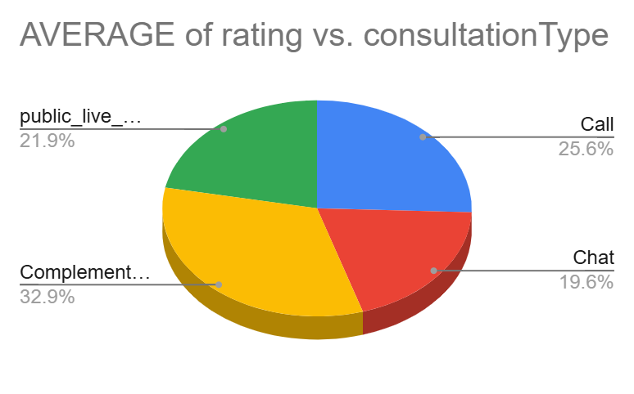

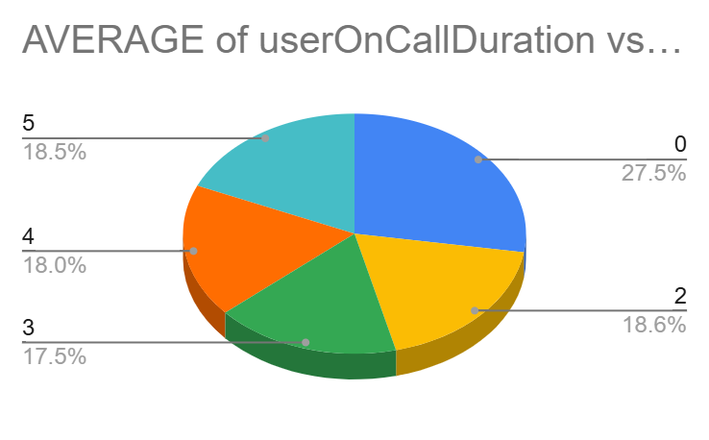
Insights - - -
● Complementary consultations have the highest average rating (4.50), contributing
approximately 32.9% of overall high satisfaction, indicating that value-added or
free services significantly improve customer perception.
● Chat consultations show the lowest average rating (2.69), highlighting a gap in
digital interaction quality and responsiveness.
● Call consultations maintain a moderate but stable average rating (3.50),
suggesting stronger trust and engagement compared to chat.
● Analysis of rating vs user on-call duration shows that higher ratings (3,4 and 5) are
associated with longer average call durations (114–117 units), indicating that
quality conversations outweigh speed in driving satisfaction.
● Lower ratings correspond to shorter call durations, suggesting rushed interactions
reduce perceived service quality.
● Highly rated calls demonstrate balanced participation between users and
astrologers, reinforcing the importance of two-way interaction in building trust.
Recommendation - - -
● Leverage complementary consultations by integrating similar value-added
elements into paid services to elevate overall satisfaction.
● Improve chat consultation experience by introducing AI-powered chatbots for
FAQs, faster response mechanisms, and better agent training for digital
interactions.
● Shift focus from reducing call duration to optimising call quality, ensuring
customers feel heard and understood.
● Encourage structured two-way conversations during calls through agent training,
improving engagement and trust.
● Use rating vs call duration dashboards to continuously monitor how interaction
quality impacts satisfaction scores and adjust performance metrics accordingly.
- How should the call center balance the workload among agents to ensure optimal performance and avoid burnout?
Mention your approach and spreadsheet function for the answer.
Ans:
Approach - - -
To balance workload among agents and prevent burnout, I analysed the average call duration for each guru, by comparing average call durations across each gurus, I identified whether certain gurus were handling longer or more complex calls, indicating workload imbalance. This comparison helps access agent efficiency and distribution of call responsibilities.
Chart - - -
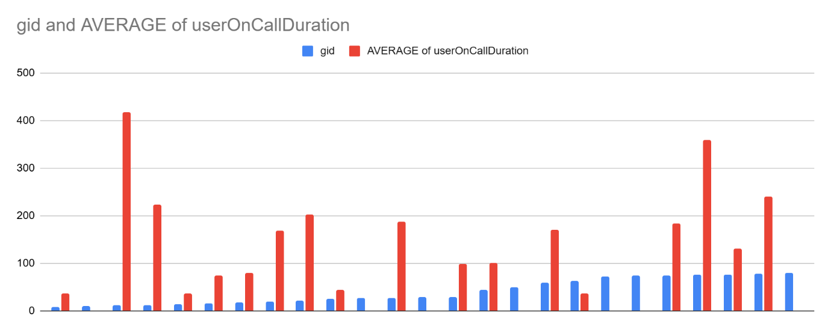

Insight - - -
● The bar chart shows a clear variation in average call duration among gurus,
indicating uneven workload distribution.
● A few gurus appear as outliers with noticeably higher average call duration,
suggesting they handle more complex or time-consuming calls.
● Several gurus fall below the overall average, indicating they are underutilised
compared to high-duration gurus.
● The visual gap between the highest and lowest bars highlights a significant
workload imbalance, which can lead to burnout for overburdened gurus and
inefficiency in resource utilisation.
Recommendation - - -
● Redistribute calls more evenly by implementing skill-based or load-based call
routing.
● Adjust shift schedules to ensure high-duration gurus receive adequate breaks and |
workload relief.
● Use high-performing, lower-duration gurus to absorb excess call volume during
peak hours.
● Provide targeted support or training to gurus handling complex calls to improve
efficiency without compromising quality.
● Continuously monitor average call duration per guru to proactively prevent burnout
and performance decline.
- What new technologies or tools could be implemented to enhance call center operations and customer service?

Ans : The following new technologies and tools can be implemented to enhance call
centre operations and improve customer service:
● AI-powered call routing and skill-based assignment can automatically route calls
based on customer preferences such as language, issue complexity, expected
duration, and agent expertise, improving first-call resolution.
● AI-driven training and performance analytics tools can identify skill gaps using call
duration, ratings, and resolution patterns, enabling personalised coaching for
agents.
● Chatbots and virtual assistants can handle FAQs and repetitive queries, reducing
call volume during peak hours while providing 24/7 customer support.
● Workforce Management (WFM) systems can forecast demand, optimise shift
scheduling, and balance workloads to prevent agent burnout and improve
efficiency.
● Customer Relationship Management (CRM) integration provides agents with a
unified customer view, enabling faster issue resolution and more personalised
interactions.
● Speech analytics and call monitoring tools can analyse tone, sentiment, and
keywords to improve service quality and ensure compliance.
● Omnichannel support platforms (call, chat, email, and social media) allow
seamless customer interaction across channels, improving customer experience
consistency.
● Real-time dashboards and monitoring tools help supervisors track call volume, wait
time, and agent performance, enabling proactive operational decisions.
9.What metrics should be included in the final dashboard to comprehensively view
call centre performance and guide investment decisions?
Ans:
The final dashboard’s key metrics to comprehensively view call centre performance and guide investment decisions are as follows:

Approach - - -
● Website Distribution -
This chart represents the percentage distribution of consultations across different platforms such as Guru Cool, App, and Dashboard. It helps identify the primary traffic source and platform-wise user engagement.

● Revenue Generated by Consultation Type (Net Amount) -
The consultation type revenue chart highlights the net earnings generated through Calls, Chats, and Public Live Calls. This visualisation helps in understanding which consultation type contributes the most to overall revenue.

● Call Distribution Over Hours -
The hour-wise call distribution chart displays call volume across different hours of the day. It helps identify peak and non-peak hours, enabling better resource planning and optimal guru availability.

● Day - Day Call Volumes -
This chart shows daily call trends and variations over time, allowing analysis of demand patterns, seasonal spikes, and overall engagement consistency.

● Month wise Astrologers earnings -
This chart determines the monthly earnings of overall astrologers, allowing to see the costs for the company on employees.

● Call and Chat Status Distribution Pie Charts -
These pie charts illustrate the distribution of completed and busy calls, along with completed and failed/incomplete chats. This helps measure service efficiency, customer satisfaction, and operational bottlenecks.

● Rating-Wise User Distribution -
The rating-wise user distribution chart shows how users are spread across different rating bands, providing insights into customer satisfaction levels and feedback trends.

● Rating-Wise Guru Distribution -
This visualization displays the number of gurus falling under each rating category. It helps evaluate overall guru performance quality and identify areas for training and improvement.

● Top 10 Guru’s Avg Rating -
This ranking highlights the top-performing gurus based on consultation volume and average ratings, helping to recognise high performers and analyse their contributions to platform success.

● Key Metric Headers (KPIs)
Summary cards are used to highlight critical metrics such as:
Total number of Gurus.
Total Guru Earnings (Net Amount).
Average daily Call Volume.
Revenue across consultations.

● Interactive Slicers
The dashboard includes slicers for Created_at, website, and consultation type.

Dashboard - - -

(Attached in Excel)
10. How would you allocate a 1 crore rupee investment to optimize operational
efficiency, enhance customer satisfaction, and boost profitability, and what
analysis-based recommendations would you offer to support this?
[you have to give bullet pointers to answer this question]

Ans: I allocate a 1 crore rupee investment to optimize operational efficiency,

1.We used the average rating of the guru chart to analyse each guru’s performance.

2.To enhance customer satisfaction, we need to calculate number of gurus and their ratings.
3.To boost profitability we need to calculate the net revenue generated by each consultation type.
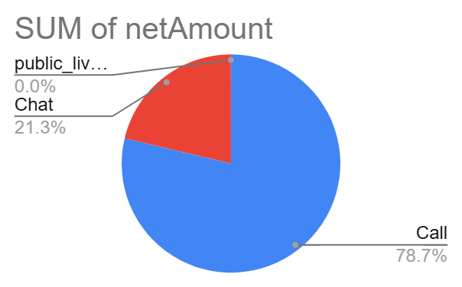

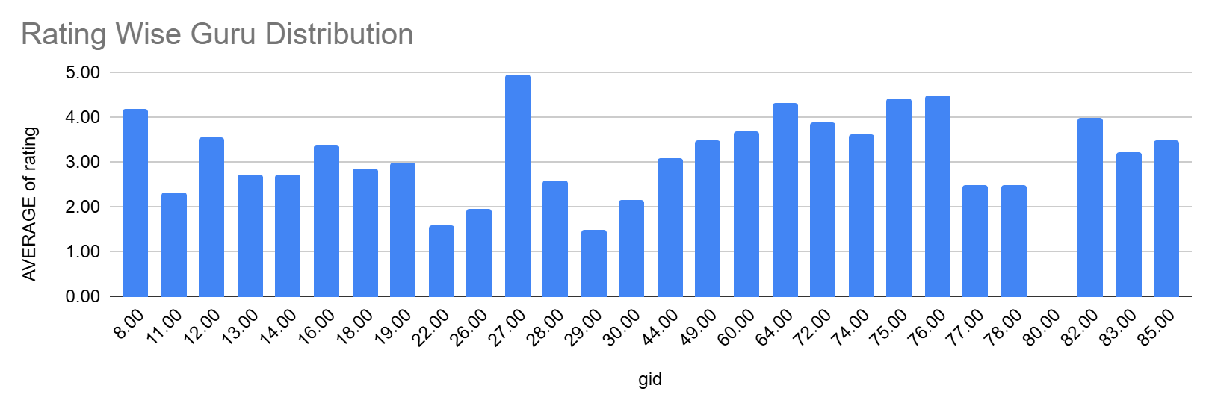

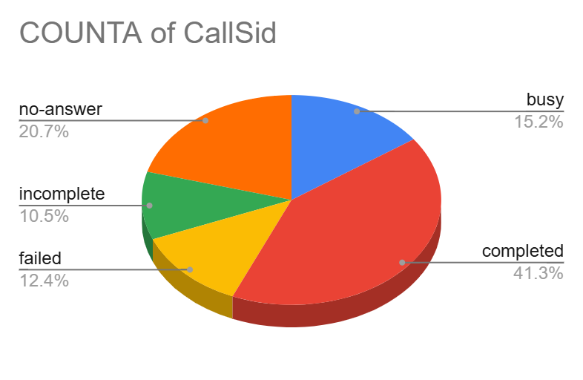

Insights - - -

● From the above given charts and pivot table, we can see that call consultations
contribute 78.72% of total revenue, chat contributes 21.26%, and complementary
and public live calls contribute almost 0%, which shows low revenue for chats and
other consultation types.
● In the average rating of the guru chart, we can see the majority of the gurus get
below a 6 rating, which indicates a low customer satisfaction score.
● The Call status distribution chart indicates low operational efficiency, via calls, only
41.3% of people can complete their calls with gurus for consultation.

Recommendations - - -
1. Call Operations Optimisation - 45 Lakh
We can utilise the 45 lakhs for the AI-based call routing and skill-based allocation and advanced workforce management tools. Rather than hiring more gurus, we can improve their efficiency via different training for high-value consultations and also utilise the off-peak period to optimise the staff's performances.

2. Chat Experience Enhancement - 25 Lakhs
We can provide AI chatbots for first-level queries, the structured chat scripts and response templates, faster SLA and escalation mechanisms and chat agent training and quality monitoring.

3. Upgrade Call Technology - 15 Lakhs
We can use CRM integration with call and chat systems to automatically share and sync data, creating a unified customer view, eliminating manual work, and improving efficiency, collaboration, and customer experiences across sales, marketing, and service. Also, speech analytics and sentiment analysis tools for better customer service according to their preferences. We can also implement cloud-based call centric solutions for the better customer satisfaction and to boost the portability for Astro sage.

4.To improve customer satisfaction – 15 Lakhs
This fund allocation can be utilised for loyalty programmes and repeat user incentives to promote quality consultation. The personalised recommendations are based on the basis of consultation history; for that, regular feedback and rating analysis systems work effectively to enhance customer satisfaction.

5. Enhance Complementary Services - 5 Lakhs
This fund is allocated to utilise limited promotional live sessions. Some complementary consultation for onboarding tools and awareness and trust building initiatives.

