TEAM – 10

Municipal Corporation Complaint Management System

Requirement Analysis Document

Prepared by
Y.Madhulatha, Y.Sailaja, A.Yashwanth, V.Srinu
ANITS
September 2017

Table of Contents
I Project Overview................................................................................................................... 3
1 Project Overview............................................................................................................... 3
2 The Purpose of the Project................................................................................................ 3
2a The User Business or Background of the Project Effort.............................................. 3
2b Goals of the Project ..................................................................................................... 3
2c Measurement ............................................................................................................... 4
3 The Scope of the Work ..................................................................................................... 4
3a The Current Situation .................................................................................................. 4
4 Product Scenarios..............................................................................................................4
4a Individual Product Scenarios .......................................................................................4
5 Stakeholders ..................................................................................................................... 4
5a Municipal Employee......................................................................................................4
5b Public User ................................................................................................................. 4
II Requirements ..................................................................................................................... 5
6 Product Use Cases ........................................................................................................... 5
6a Use Case Diagrams ..................................................................................................... 5
6b Product Use Case List................................................................................................. 5
6c Individual Product Use Cases .................................................................................... 6
7 Functional Requirements ................................................................................................ 7
8 Performance Requirements ..............................................................................................7
8a Speed and Latency Requirements ...............................................................................7
8b Precision or Accuracy Requirements ..........................................................................7
9 Dependability Requirements .......................................................................................... 7
9a Reliability Requirements ........................................................................................... 7
9b Availability Requirements.......................................................................................... 7
9c Robustness or Fault-Tolerance Requirements............................................................ 8
9d Safety-Critical Requirements .....................................................................................8
10 Maintainability and Supportability Requirements ....................................................... 8
10a Maintenance Requirements ..................................................................................... 8
10b Supportability Requirements ................................................................................... 8
10c Adaptability Requirements ...................................................................................... 8
10d Scalability or Extensibility Requirements.................................................................8
10e Longevity Requirements .......................................................................................... 8
11 Security Requirements .................................................................................................. 8
11a Access Requirements ................................................................................................8
11b Integrity Requirements ............................................................................................ 9
12 Usability and Humanity Requirements......................................................................... 9
12a Accessibility Requirements ......................................................................................9
III Design ..............................................................................................................................10
13 Proposed Software Architecture ...................................................................................10
13a Class Diagrams ........................................................................................................10
13b Dynamic Model ...................................................................................................... 11

- Project Description

- Project Overview
This Project will help the common people under the jurisdiction of a municipal corporation to register their grievances about day to day problems in their ward through a website. It will provide a common man to deliver his complaints and problems to municipal authority as well as let the municipal authorities to address the problem in a short period of time. This software provides an interface to register one’s complained and follow it up. It provides a camera module which help clicking up a picture of any problem that people are facing and upload its image along with the complaint. The location of complaint is tracked by Global Positioning System (GPS) unit.

- The Purpose of the Project

2a The User Business or Background of the Project Effort
Content
This is a Software where the user can send the complaint regarding the municipal corporation about the services and issues and get cleared from the corporation. For this user must open the website send the complaint to the administrator(Municipality).
Considerations
It is important for to maintain our surroundings and country clean and get services from the municipality. So to achieve this this may not possible for the municipal government to check each and every part of the country. So this app helps the user to get the services from municipality if any thing is not serviced by sending the complaint in the website.

2b Goals of the Project
Content
To get the services from the municipality and get cleared with the complaints we need to develop this project.
Motivation
The main Objectives of the Project:
- Developing the website that facilitates to communicate between community and municipality to become more easy and speed.
- Providing new method to send complaint to the municipality and ability to track them.
- Providing the people method for rating the quality of service.
- Increase quality of municipality's services by saving effort, time and take feedback.
- Increase the accuracy of the complaint.
- We want to give immediate and complete response to user who register the complaint.
- We want to be able to complete the complaint by taking action on it.

2c Measurement
We want to give immediate and complete response to users who register the complaint. This project creating facilitate the communication between the municipality and people, provide electronic method for sending complaints and notes about problems from customer to the municipality and provide service for tracking complaints.

- The Scope of the Work

3a The Current Situation
Creating mobile application that facilitate the communication between the municipality and people, provide electronic method for sending complaints and notes about problems from customer to the municipality and provide service for tracking complaints.

- Product Scenarios

4a Individual Product Scenarios

Yash is going on his vehicle to office and there is a traffic due to drainage overflow across the road due to rainy season and wants to report to the municipal office .He immediately opens the app and takes a photo and uploads it with location and sends to the administrator. He receives the notification about the registering to the complaint and status of completion of complaint

- Stakeholders

5a Municipal Employee
- Shall be able to browse complaints.
- Shall be able to forward complaint.
- Shall be able to reply to the complaint.
- Shall be able to delete complaint.
- Shall be sort complaints.
- Shall be search for some complaints depends on location, type or user.

5b Public User
- Shall be able to register his phone
- Shall be able to create new complaint.
- Shall be able to upload images.
- Shall be able to delete complaint.
- Shall be able rate the complaint treatment?

- Requirements

- Product Use Cases

6a Use Case Diagrams

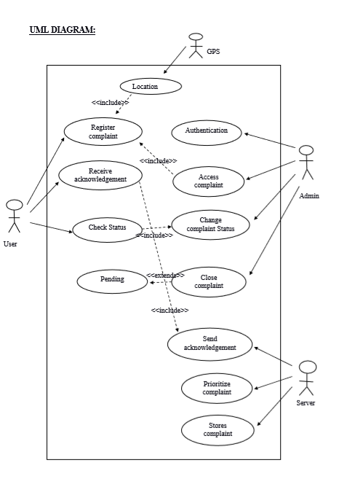

6b Product Use Case List
User
1. Register Complaint
2. Receive Ack
3. Check Status
Administrator
1. Authentication
2. Access complaint
3. Change Complaint status
4. Close Complaint

6c Individual Product Use Cases

1)Name: Register Complaint
Participating Actors: User,Admin,Gps
Entry Conditions: Opening the app and filling the details.
Exit Conditions: Submit the conditions.
Events Flow:
1. System provides the complaint register page.
2. User fill the details of the register form
i.Name
ii.Mobile number
iii.Location
iv.photo upload
3. Admin is going to access the complaint given by the user.

2)Name: Authentication
Participating Actors: Admin
Flow of Events:
1. System provide the login page of the admin.
2. Admin enters the details required for the authentication
i.Username
ii.Password

3)Name: Send Acknowlegdement
Participating Actors: User, Server
Flow of Events:
1. Server sends the ack of the complaint when it receives the complaint details.
2. The user receives the acknowledgement that he succesfully register a complaint.

4)Name: Check Status
Participating Actors: User,Admin
Flow of Events:
1. System updates the status of the complaint based on the priorities of the registered complaint. 2.User checks the status of the complaint after when system has updated and scheduled.

5)Name: Prioritize the Complaint
Participating Actors: Server
Flow of Events:
1. When the complaint is registered then the server stores the every complaint.
2.Then based on the priority numbers it prioritize the complaints and schedule them.

6)Name: Stores Complaint
Participating Actors: Server
Flow of Events:
1.Every complaint registered will be stored in the server according to their fields to perform queries.
2.this plays major role in prioritize and scheduling.

7)Name: Close complaint
Participating Actors: Admin
Flow of Events:
1. Admin closes the complaint when the complaint is finished and he updates the status of the complaint
2. If the complaint is not finished then the status will be in pending.

- Functional Requirements

1.Admin should able to access the complaints registered by the public and solve them based on the priority and update the status of completion of the complaint in the website.

2. Public can access the web and able to register the complaint (if any) and can check their complaint status.

- Performance Requirements

8a Speed and Latency Requirements
System must me give accuracy in timing depends on the area of the users and the time zone.

8b Precision or Accuracy Requirements
System must me give accuracy in timing depends on the area of the users and the time zone.

- Dependability Requirements

9a Reliability Requirements
- The system shall be available all the time for all users.
- The system shall be reliable.
- The system shall provide a daily backup plan for the database

9b Availability Requirements
This app is available for 24/7 hours. Anyone can upload any problem at anytime. Because problem may occur at any time.

9c Robustness or Fault-Tolerance Requirements
This app can detect any invalid data given by the user and shows a notification over there on the invalid data that "the data you entered is invalid.

9d Safety-Critical Requirements
Quantification of the perceived risk of damage to people, property, and environment. The user will not face any problem related to his health, property and environment. This is a simple and easy to handle. The user don't enter his official or any personal details like aadhar number. So there is no damage to the user. .
- Maintainability and Supportability Requirements

10a Maintenance Requirements
- A quantification of the time necessary to make specified changes to the webpage or modifications on the backend.
- To make everyone aware of the maintenance needs of the site, Public should know how the problems are resolved with the pics .
- There may be special requirements for maintainability, such as that the product must be able to be maintained by its end users or by developers who are not the original developers. These requirements have an effect on the way that the product is developed. In addition, there may be requirements for documentation or training.
- You might also consider writing testability requirements in this section.

10b Adaptability requirement:
This app is able to work at any environment. It has no environmental conditions. Because the app is designed by using JAVA code. JAVA is a platform independent.

10c Scalability or Extensibility Requirements
- This specifies the expected increases in size that the software must be able to handle.
- As a problems increases, our software must increase and should not give any problem and it should cope with the new volumes.
- To ensure that the designers allow for future capacities.
- The product shall be capable of processing the existing few customers. This
- number is expected to grow to very large extent of customers .
- The product shall be able to process more complaints intake per day and it should be successful in taking all the complaints.

10d Longevity requirements :
This specifies the expected lifetime of the app. The product shall be expected to operate within the maximum of five years. Depending on the investment and the changes in the Municipal organisation the app is expected to operate within five years.

- Security requirements

11a Access requirements :
This app manages the data of the admin that no one can see the data of him. Admin will be given a ID and Password. so with that ID and Password admin only can login into the account and manages the data.

- Usability and Humanity Requirements

12a Accessibility Requirements
System shall have accessed via internet so any user can use it.

III Design
- Proposed Software Architecture

13a Class Diagram

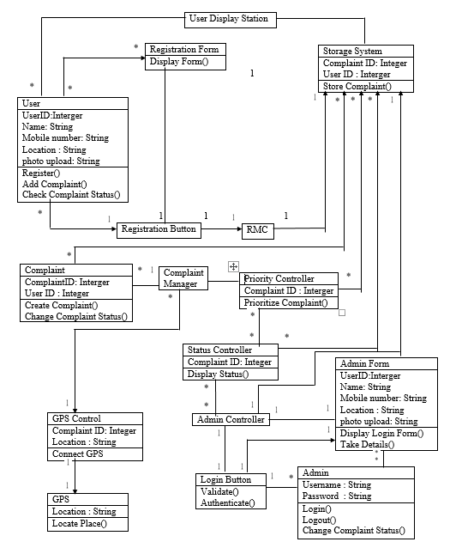

13b Dynamic Model

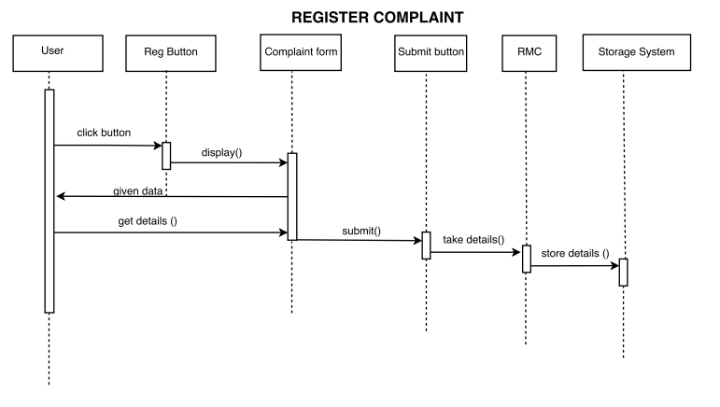

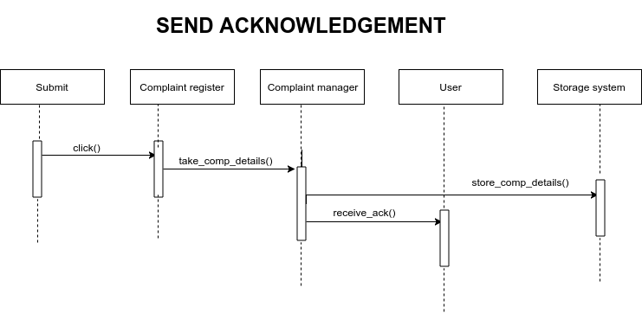

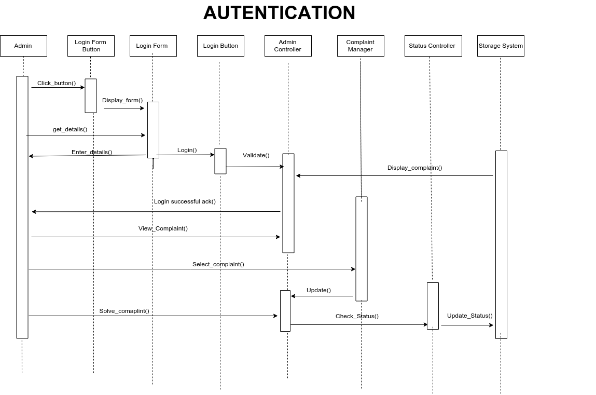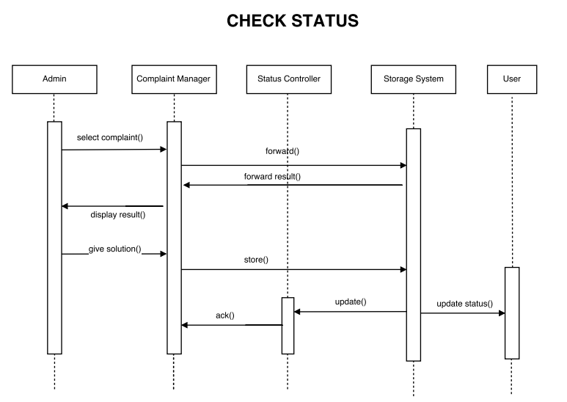

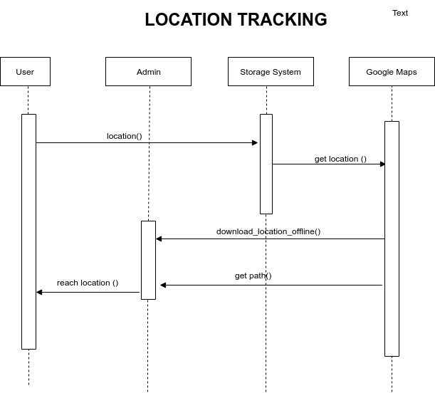

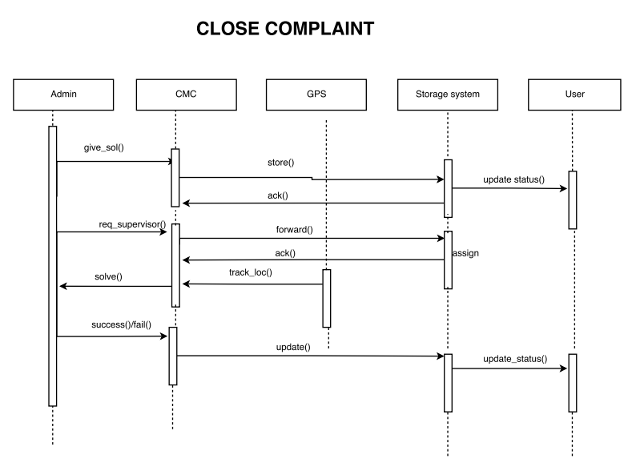

4-Tier Application Architecture

Machine A Machine B Machine C Machine D

 | Web |  |  |  | Presentation |  |  |  | Application |  |  |  | Database
 | Browser |  |  |  | Logic |  |  |  | Logic |  |  |  | Database
 | Thin Client |  |  |  | Web Server |  |  |  | App Server |  |  |  | Database Server
 | Client Tier |  |  |  | Presentation |  |  |  | Application |  |  |  | Data Tier
 |  |  |  |  | Logic Tier |  |  |  | Logic Tier
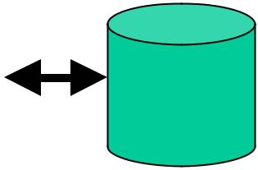



- All parts of the application can now be upgraded independently

- Even more scalable than 3-tier through replication in each tier

- Different types of clients can share the same application logic

  - Web clients

  - Cell phone/PDA clients

  - Fat clients

Tracebility
- Original requirements: As detailed as possible, with an owner. Each requirement should link to a business goal.
- For each phase of the project: This is key to the structure of the document. Do not overwrite whether requirements are met in previous stages. Include comments for each requirement - because often requirements will not be met in the way the envisioned.
- Documentation audit trail: Include documents where the requirement is explicitly addressed. Include multiple owners of the solution, because often the requirement is addressed by multiple streams. Who - unfortunately but typically - do not communicate with each other as much as they should.

