WEEK-2

TASK-2

NAME:C SAILAJA

EM ID:11433

DOMAIN:PYTHON

**SET OF BUILT-IN METHODS**

* Python has a set of built-in methods that you can use on sets.
* Add()
* Clear()
* Copy()
* Difference()
* Difference_update()
* Discard()
* Intersection()
* Intersection_update()
* Isdisjoint()
* Issubset()
* Issuperset()
* Pop()
* Remove()
* Symmetric_differenc()
* Symmetric_difference_update()
* Union()
* Update()

ADD()

* The add() method adds an element to the set.

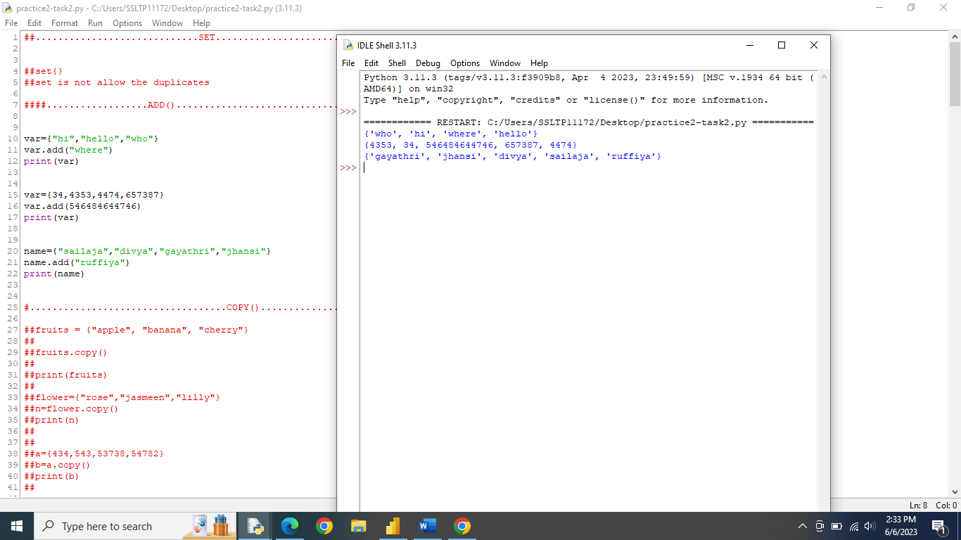

COPY()

* The copy() method copies the set.

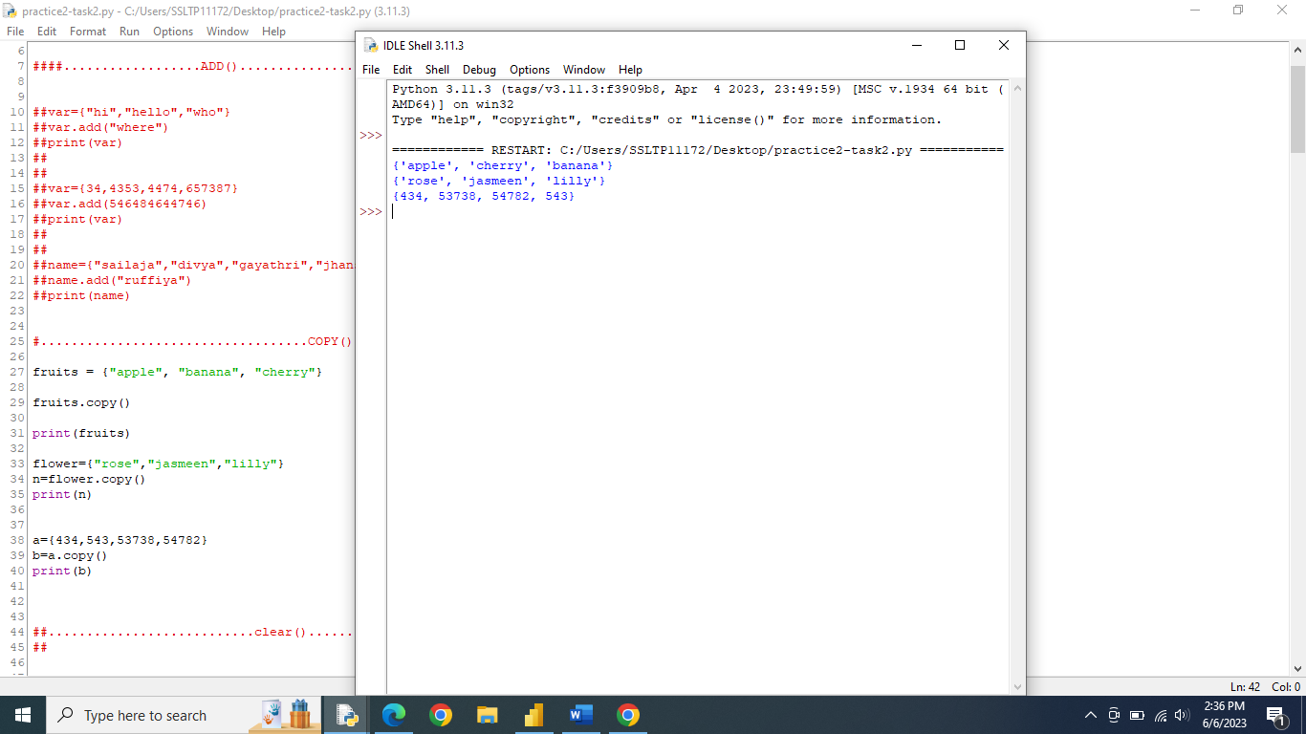

CLEAR()

* The clear() method removes all elements in a set.

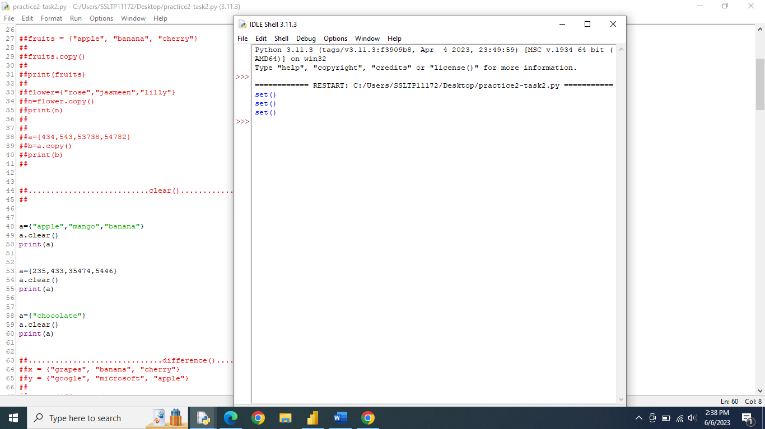

DIFFERENCE()

* The difference() method returns a set that contains the difference between two sets.

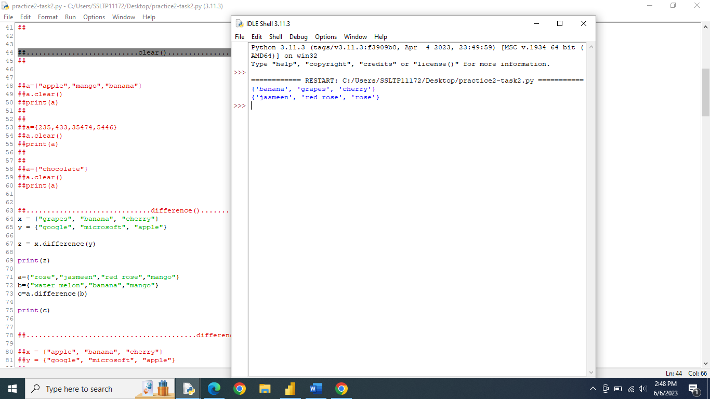

DIFFERENCE_UPDATE()

* The difference_update() method removes the items that exist in both sets.

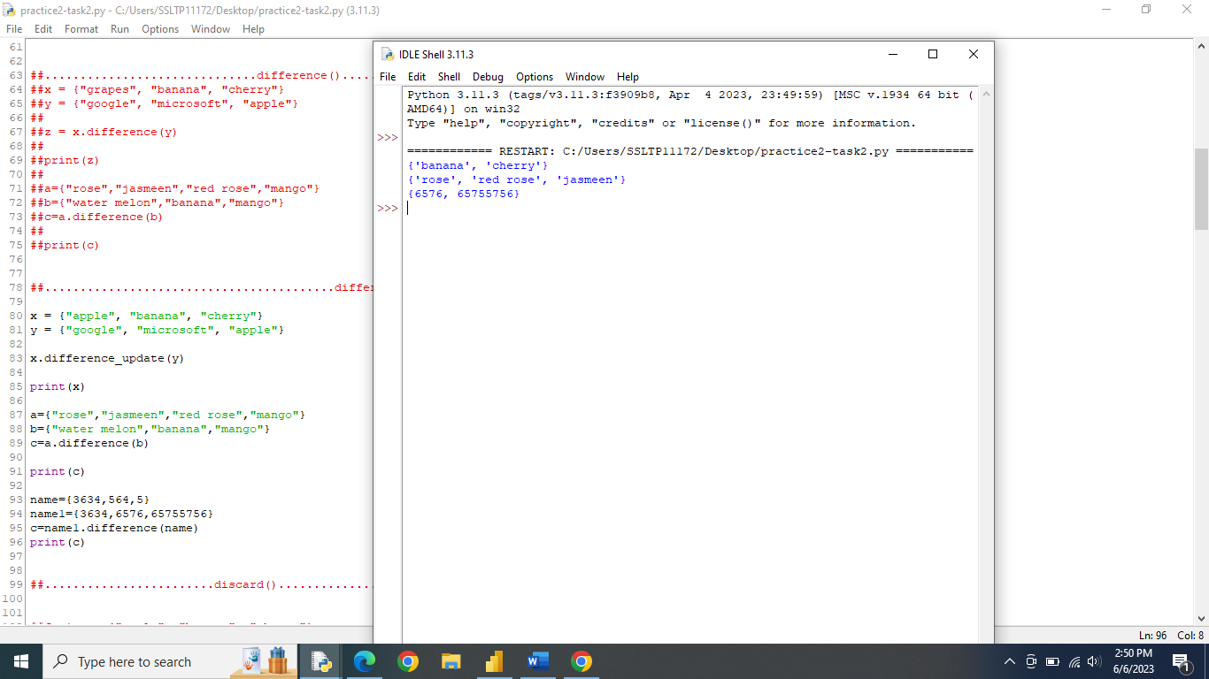

DISCARD()

* Remove the specified item

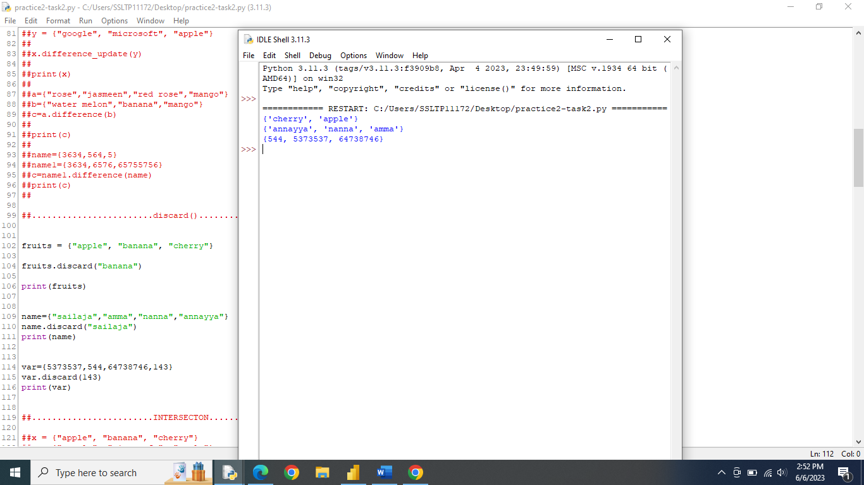

INTERSECTION()

* Return a set, that is the interesetion of two other set

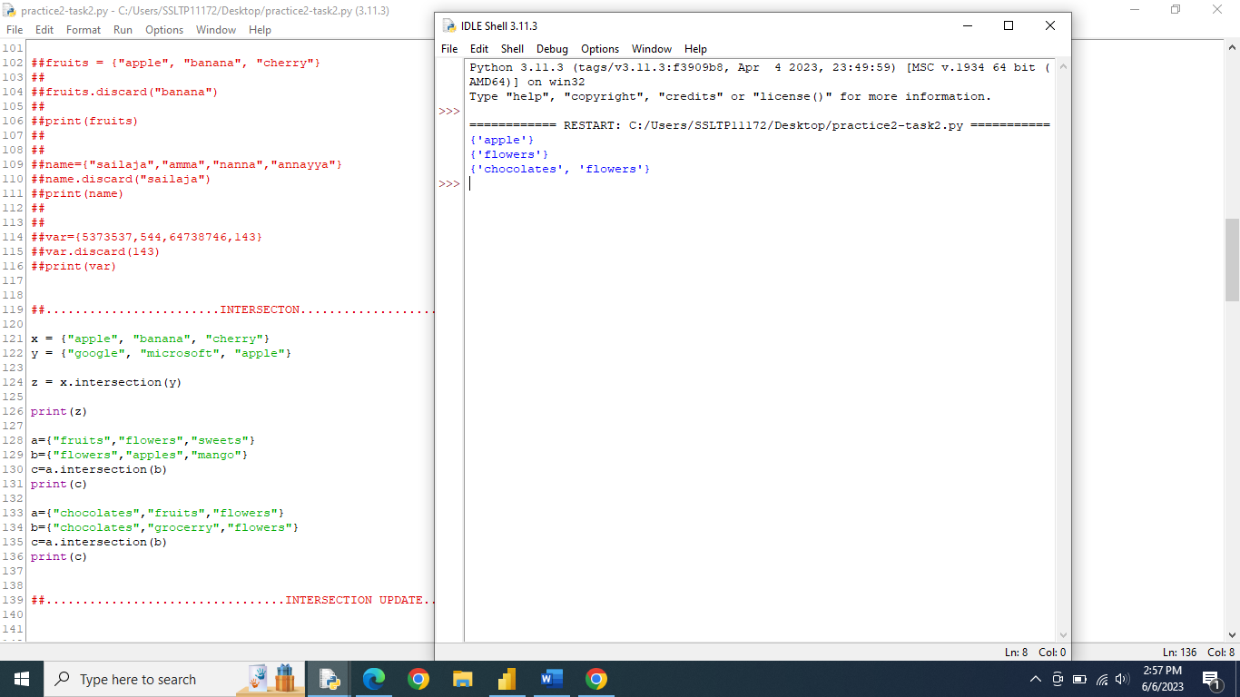

INTERSECTION_UPDATE()

* Removes the items in this set that are not present in other, specified set(s)

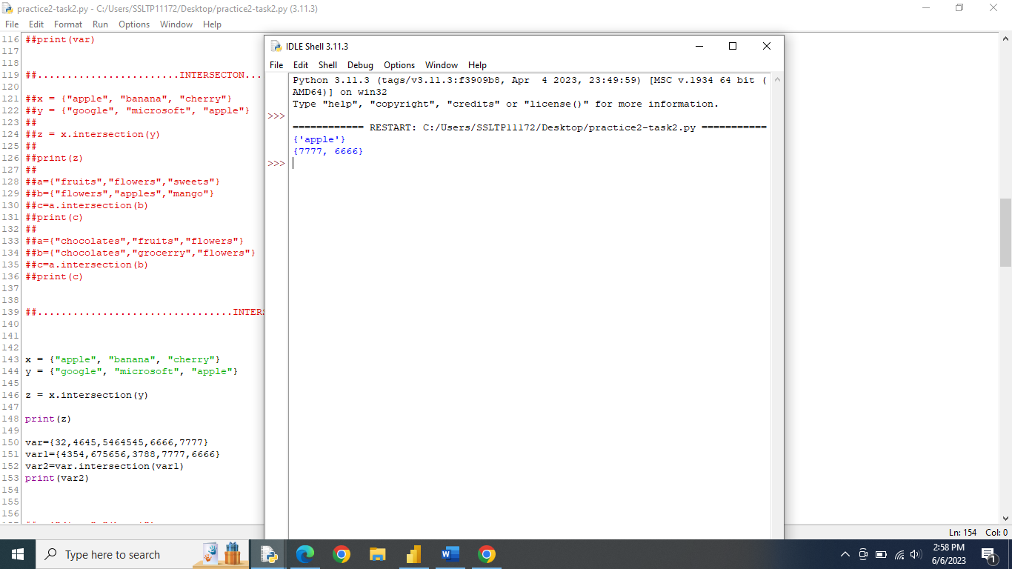

ISDISJOINT()

* Returns whether two sets have a intersection or not

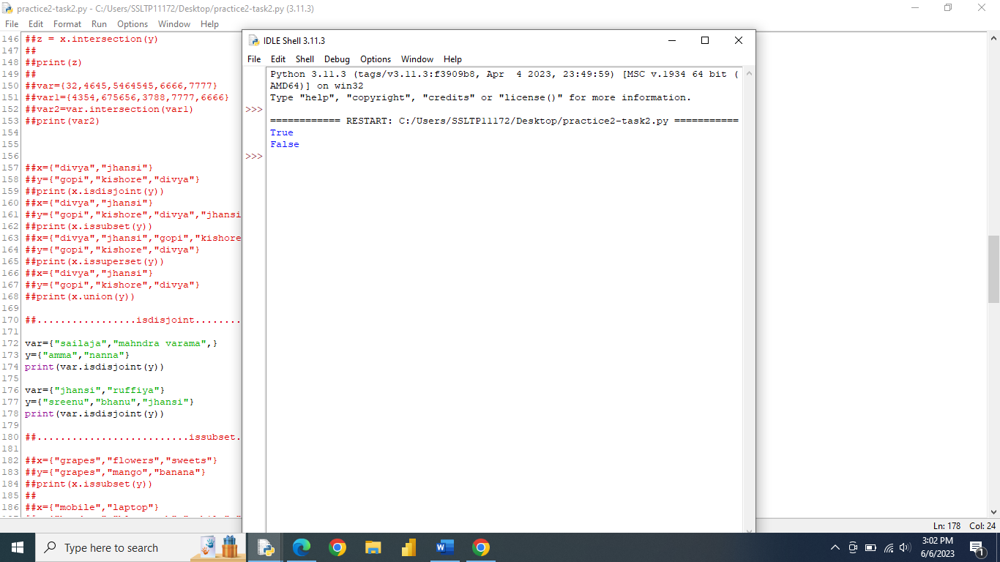

ISSUBSET()

* Returns whether another set contains this set or not

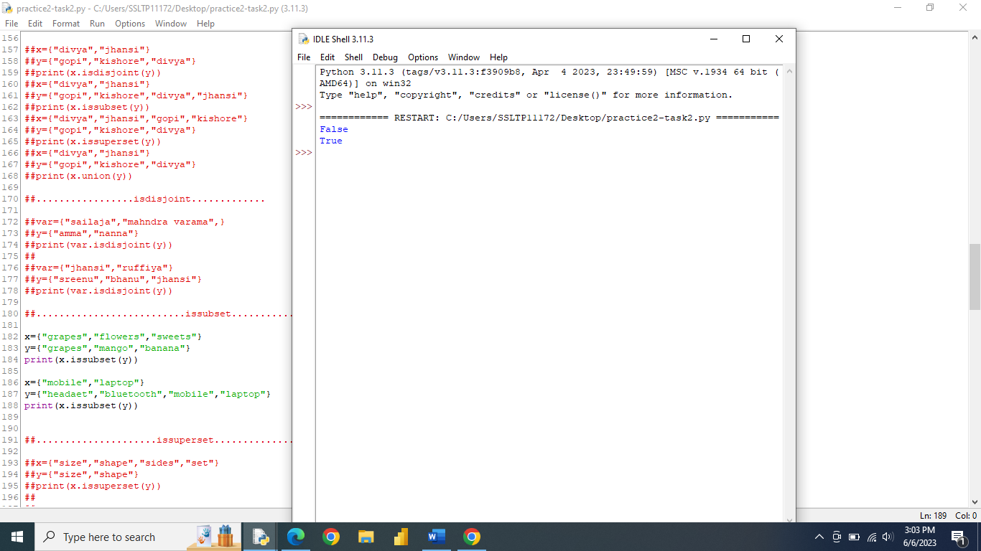

ISSUPERSET()

* Returns whethers this set contain another set or not

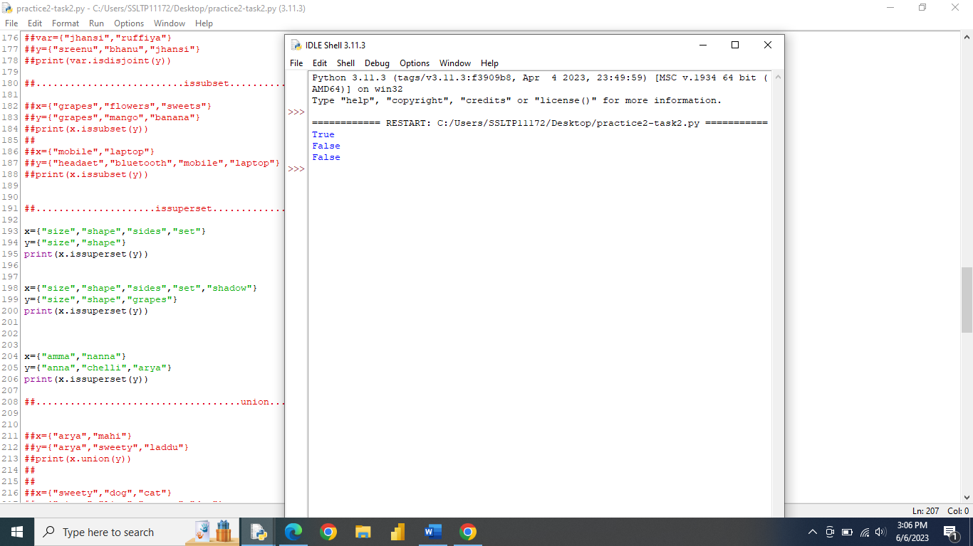

POP()

* Remove an elememts from the set

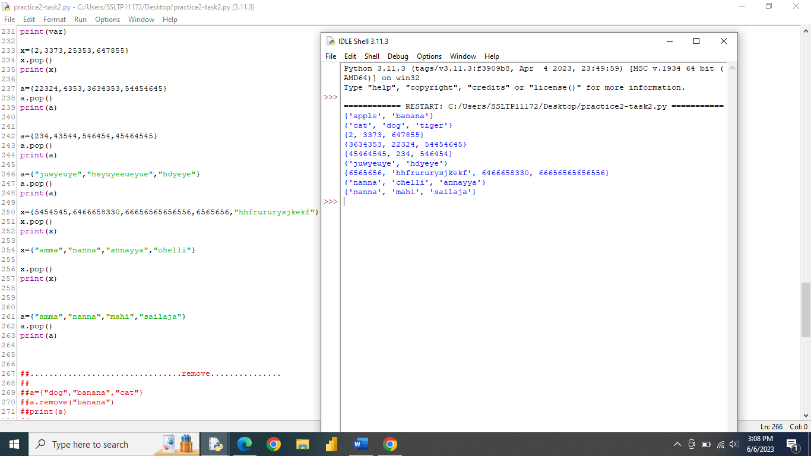

REMOVE()

* Remove the specified elements

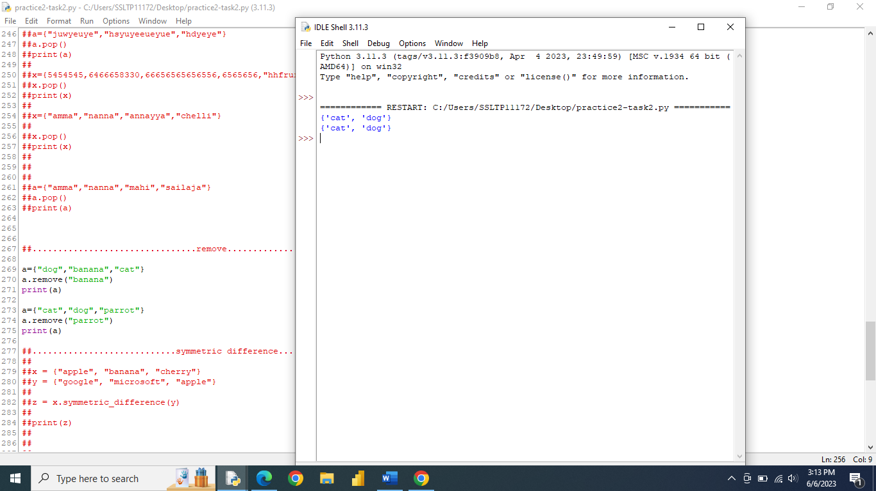

SYMMETRIC_DIFFERENCE()

* Returns a set with the symmetric differences of two sets

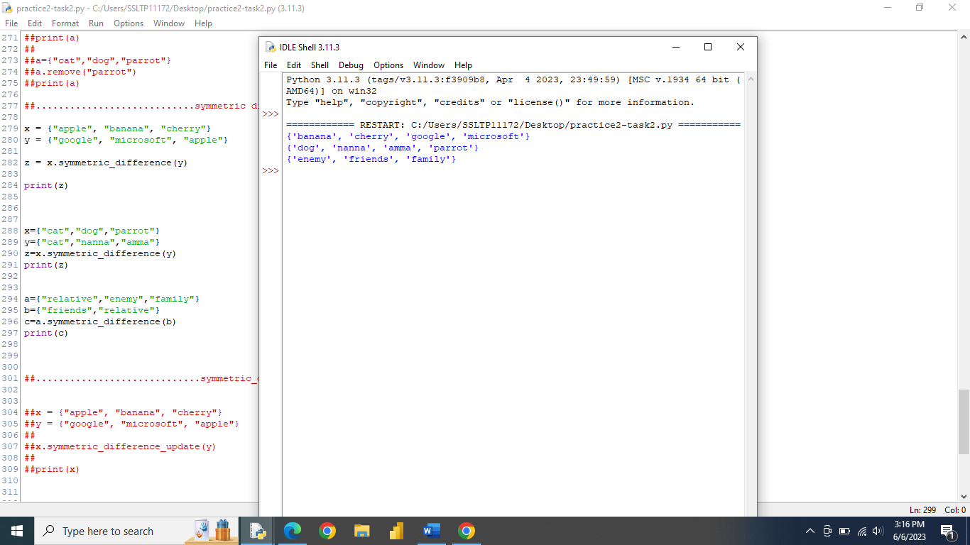

SYMMETRIC_DIFFERENCE_UPDATE()

* Insert the symmetric difference from this set and another

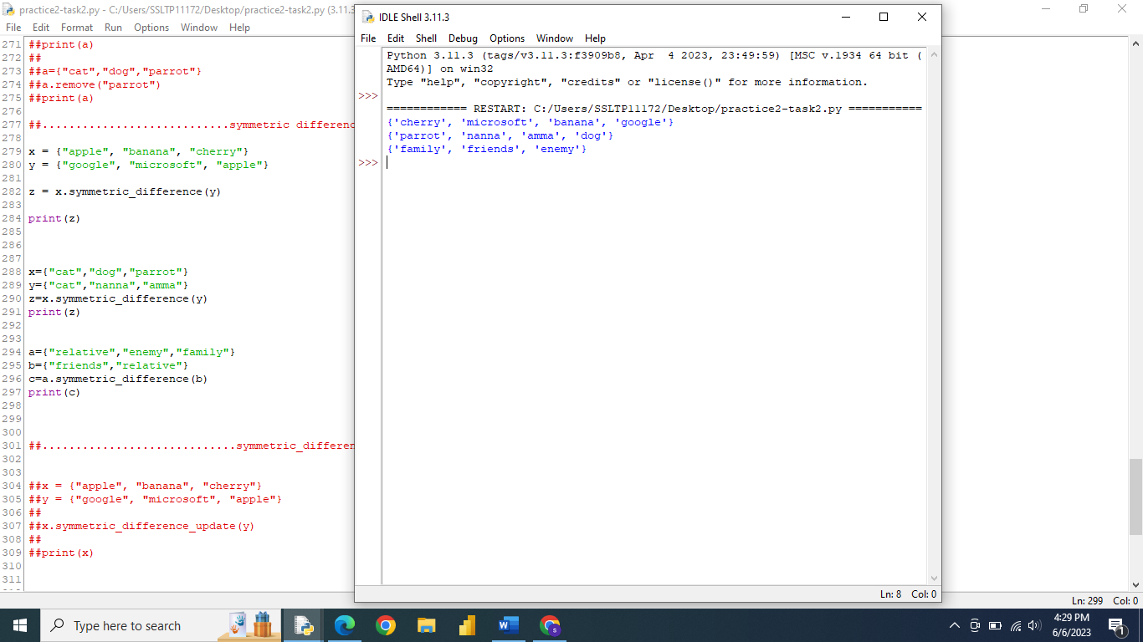

UNION()

Return a set containing the union of sets

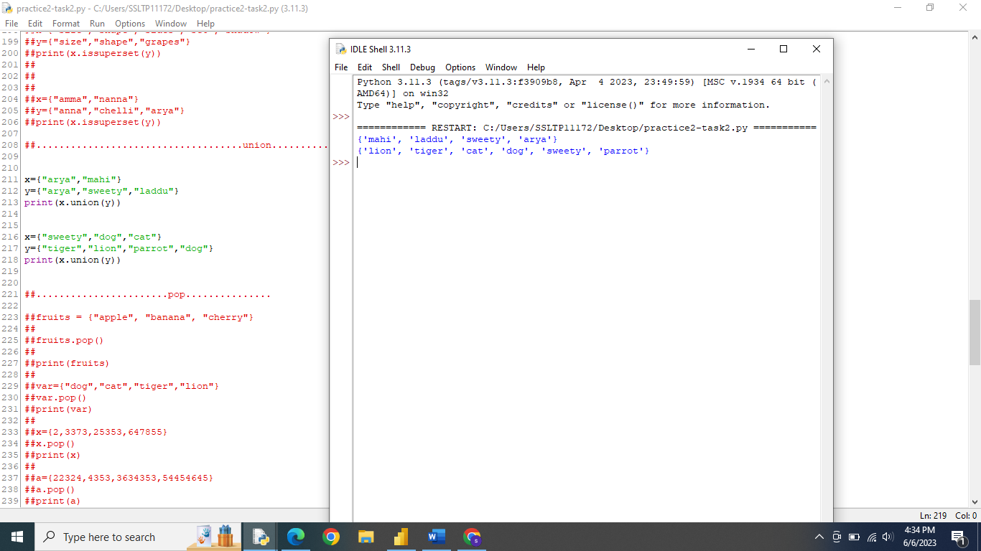

UPDATE()

* Update the set with the union of this set and others

