**CS551 Lab 1 Assignment**

***Sailaja Pedaprolu, 16157493***

**Task1-ScrumDo:**

The very first step is signing up into ScrumDo by providing the essential details.

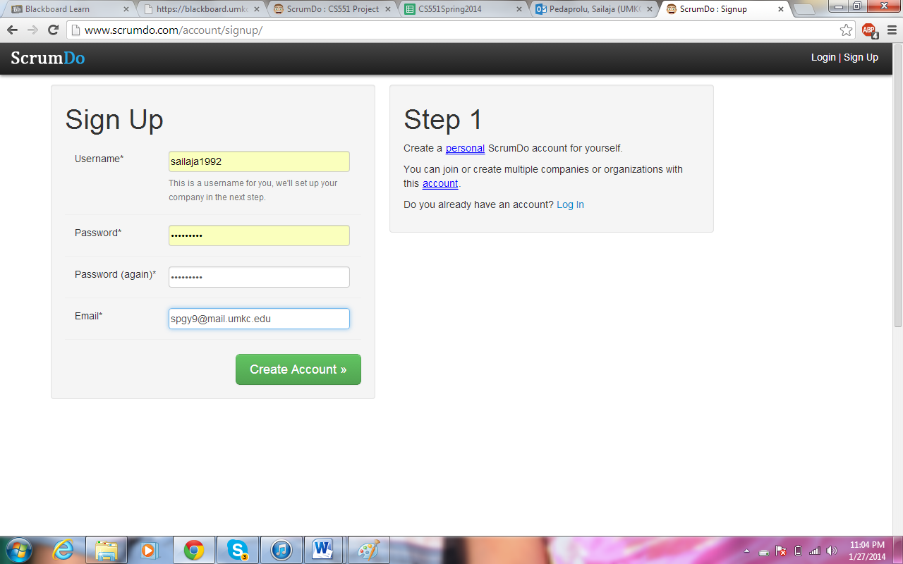

This creates an account for further usage of the features present in the ScrumDo. Now, under UMKC organization, project namely CS551 is created.

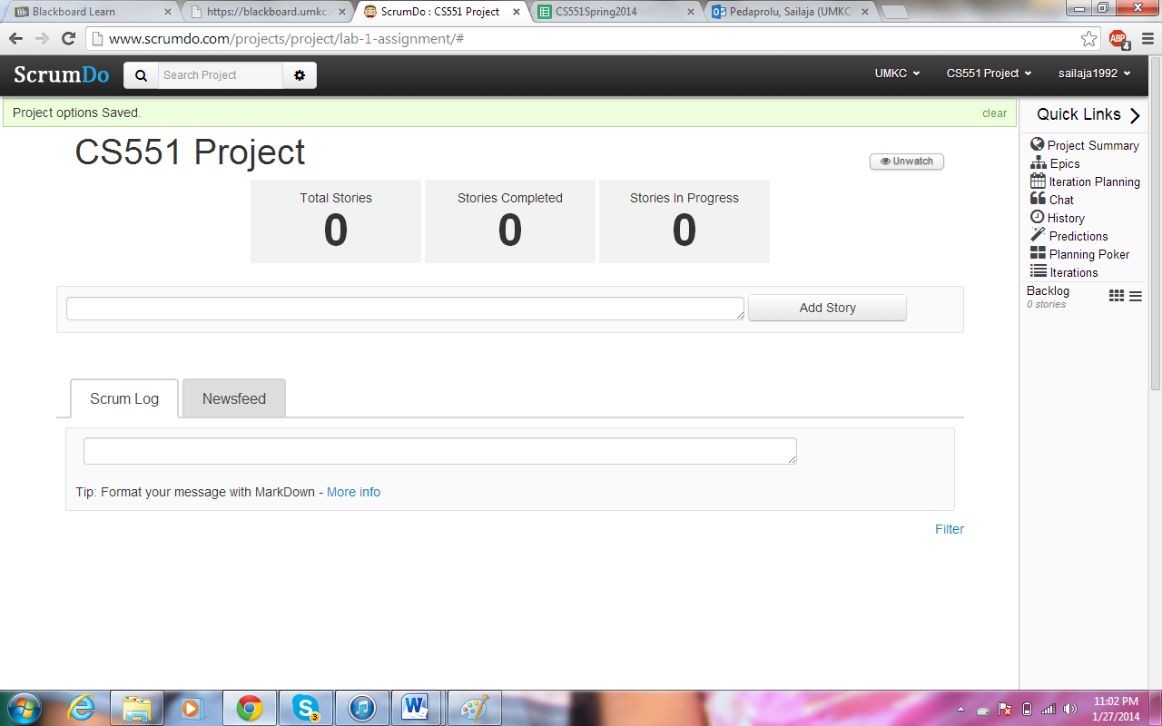

Next, the steps to be executed as part of the project are listed as stories with corresponding roles, descriptions, level of difficulties and many more.

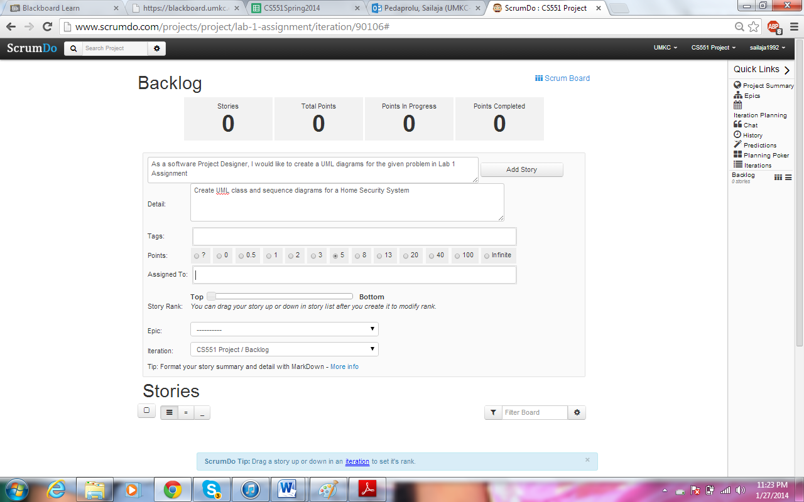

The listed stories can be seen in group in the backlog.

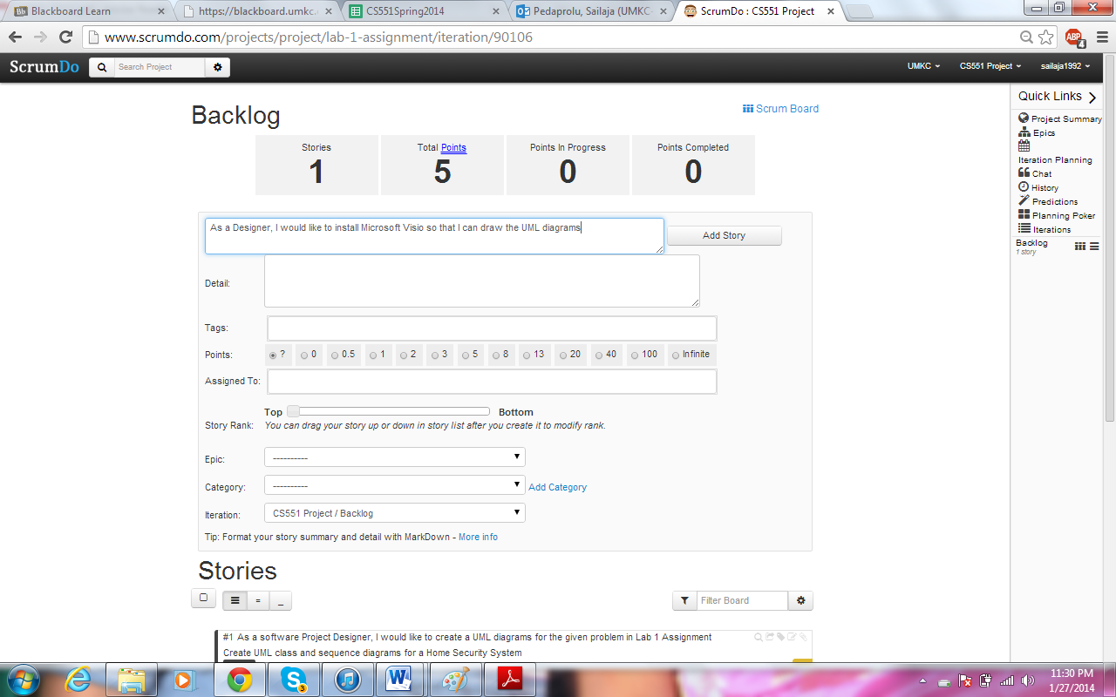

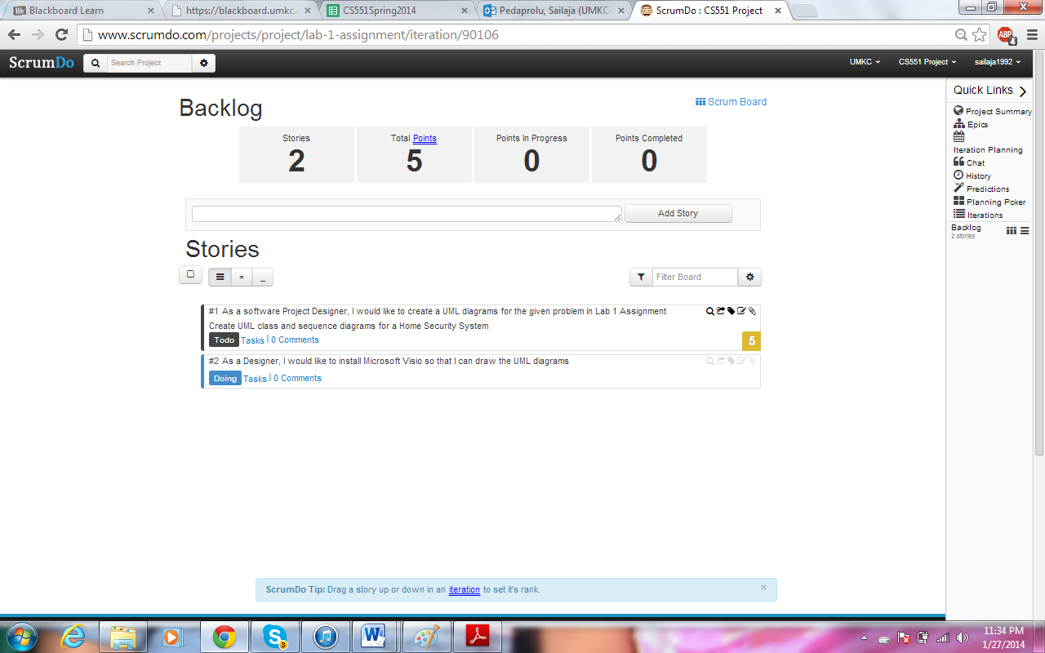

Different iterations can also be provided to introduce a time frame for each of the stories and sub stories.

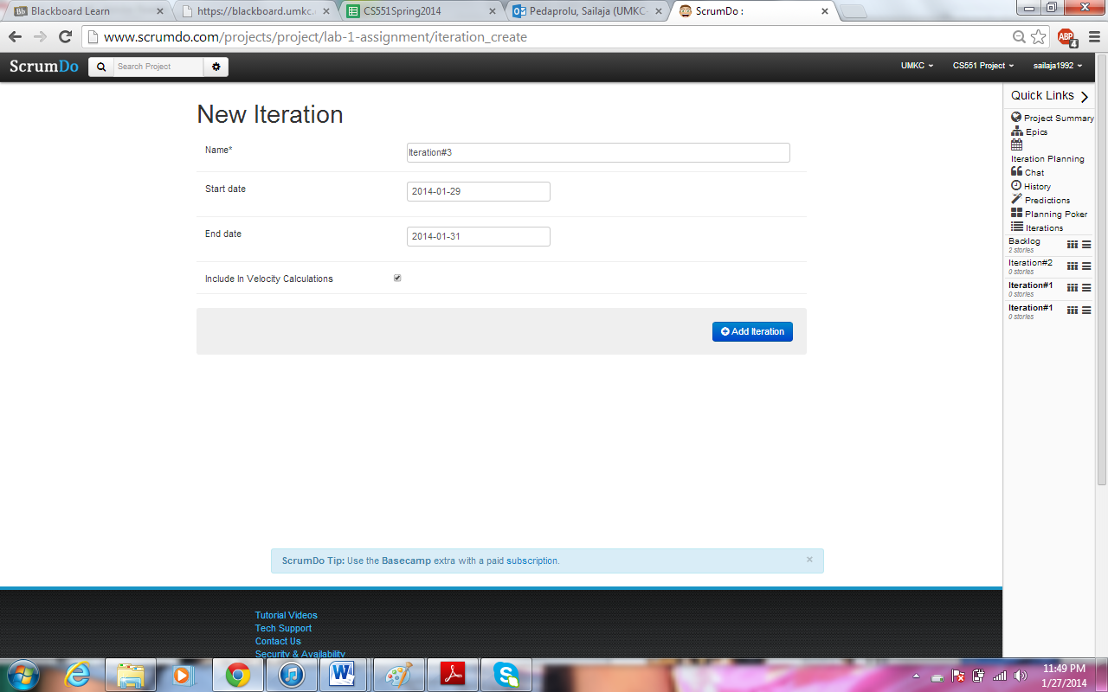

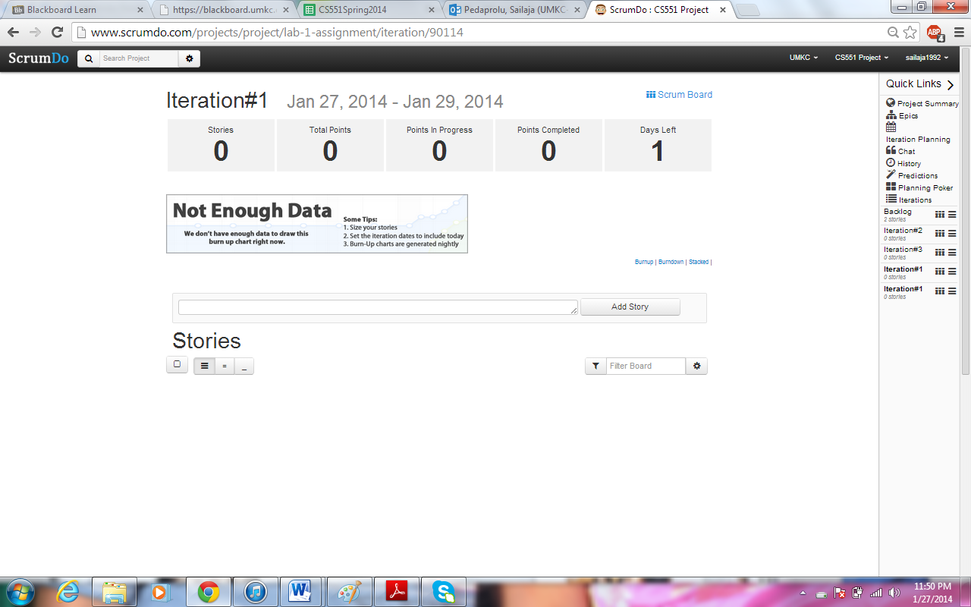

After creating the iterations, stories can be added to the iterations and vice-versa.

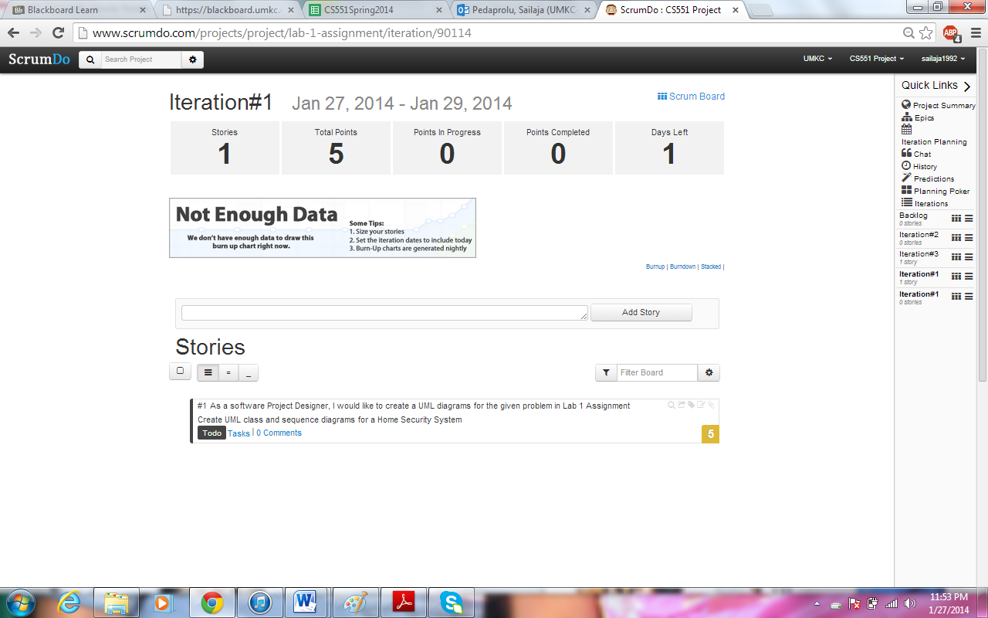

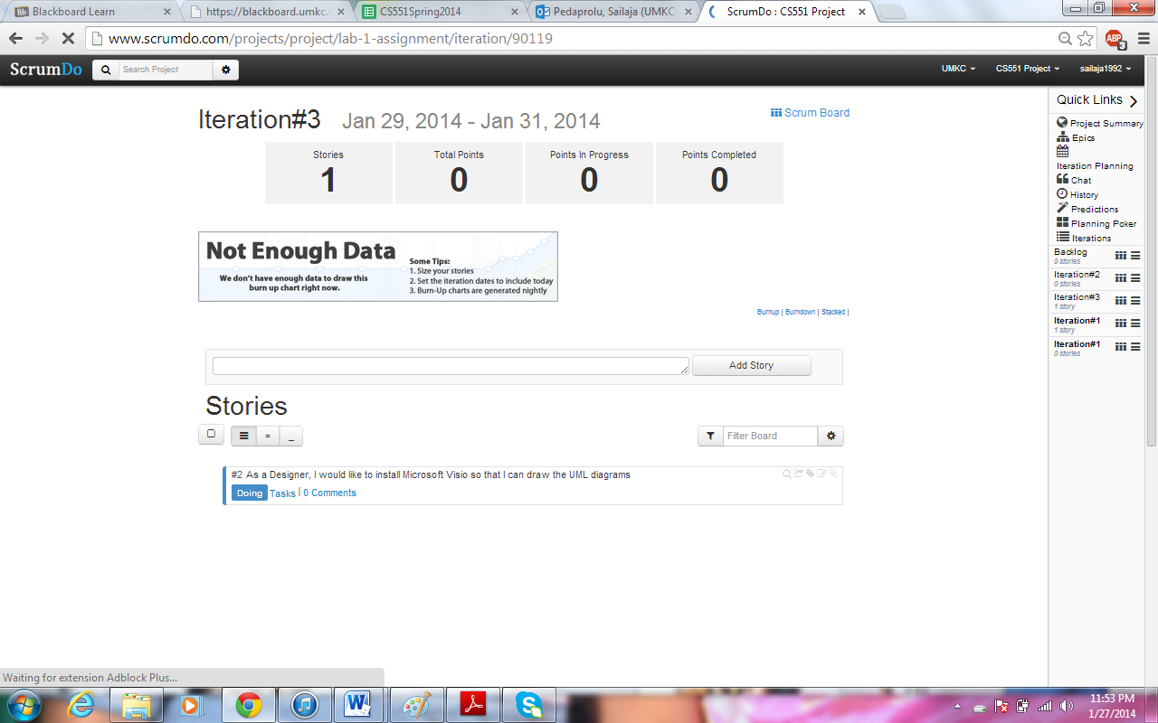

Once all iterations are framed they can be viewed altogether by navigating and using the options present in the side bar.

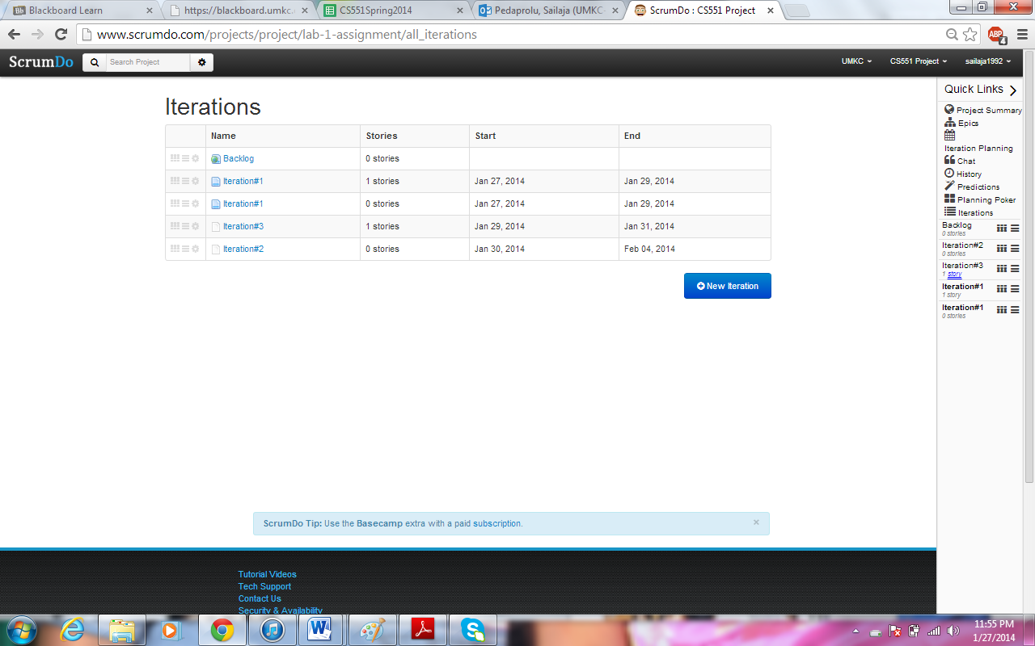

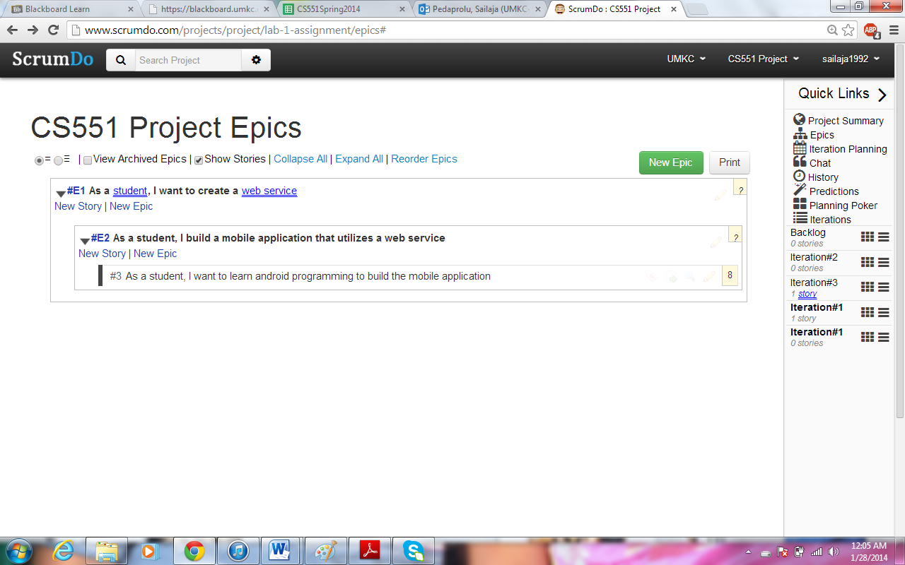

Epic and sub-epic can be created and the stories can be categorized into each of these using the options superscripted at the top left corner. Furthermore, the tasks can be grouped according to the status of their completion as shown below:

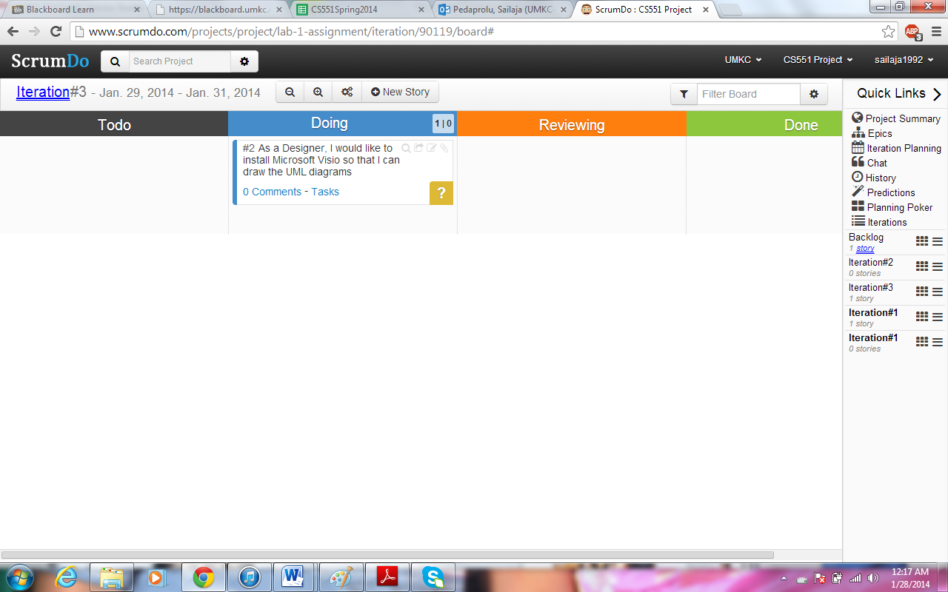

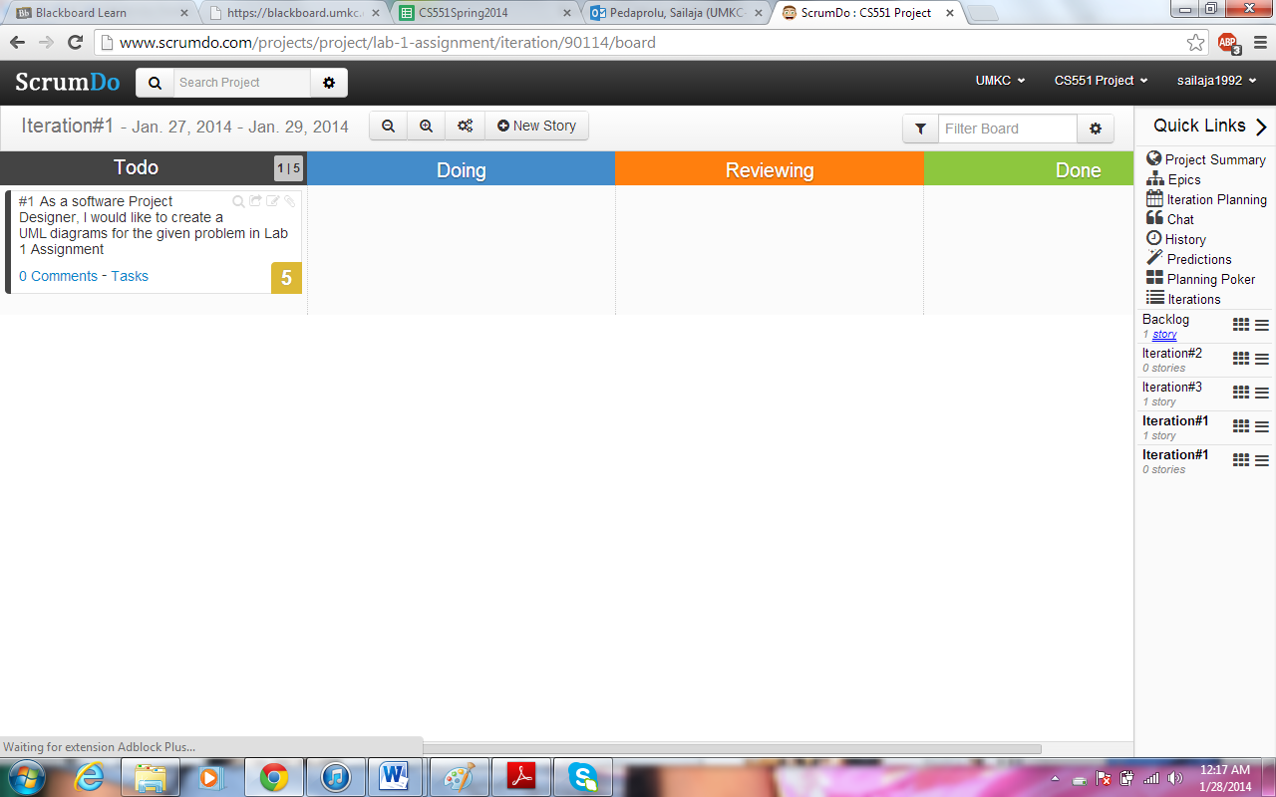

Clear view of the members of a team can be looked at by clicking ‘team’ present in the ‘organization’ group.

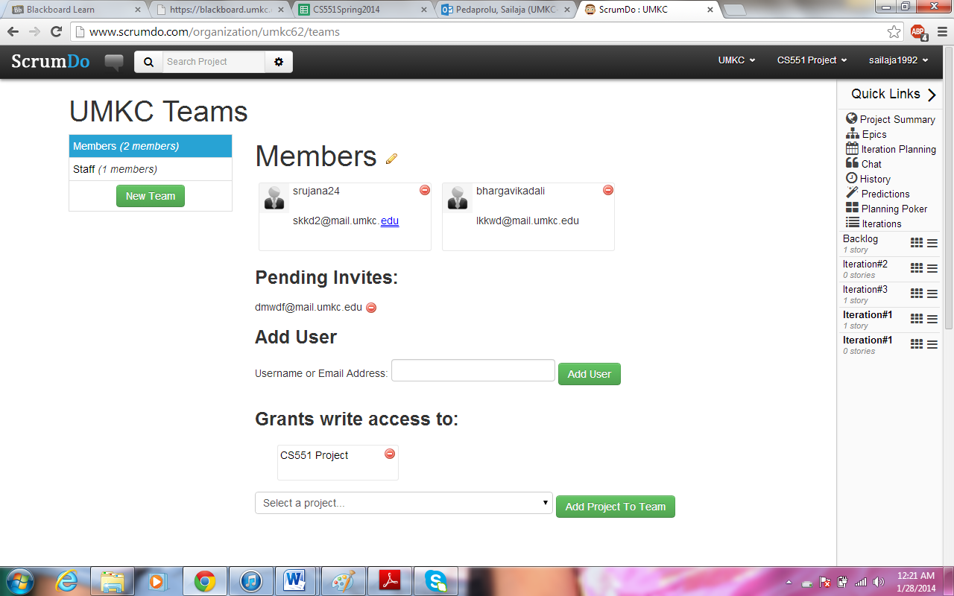

**Task2-Github:**

A Github account is created by providing credentials

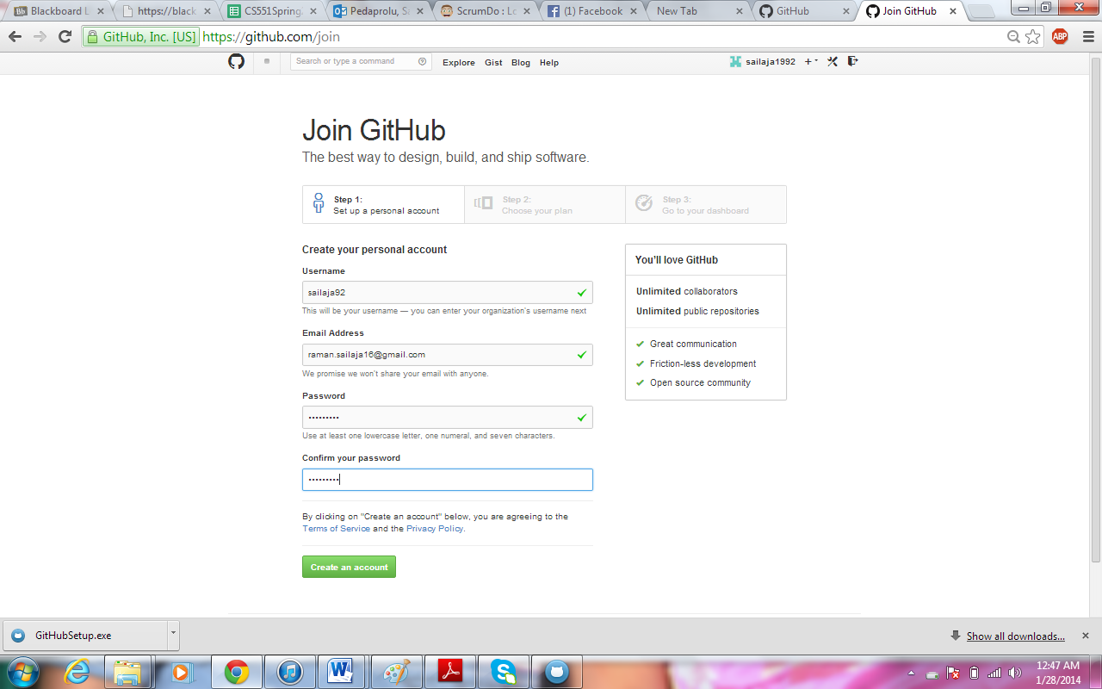

Then, a repository is created online.

