YUVAINTERN – NSDC INTERNSHIP
DATA SCIENCE PROJECT COORDINATOR
WEEK 5
Final Evaluation, Review and Presentation Planning
FreshPlan
Smart Meal Planner and Food Spoilage Prevention System
Project Detail | Information
Prepared By | KEDARISETTI . SAILAJA DEVI
Role | Individual Data Science Project Coordinator
Internship | 07 September 2026 – 12 October 2026
Project Duration | 5 Weeks
Technology Focus | Python | Pandas | NumPy | Matplotlib | Scikit-learn
Week 5 Focus | Final evaluation, lessons learned, success metrics and presentation planning

1. Executive Summary
FreshPlan is a Python-based student data science project designed to help users organize stored food, identify food that needs earlier attention, and connect available ingredients with simple meal suggestions. The project uses structured food and recipe data, basic Python analysis, priority rules and visualizations.
Week 5 brings the project work together through a final review. The review checks the project plan, data management, implementation, testing and monitoring. It also defines measurable success metrics, lessons learned, recommendations for future development and a presentation plan for explaining the project to faculty or internship evaluators.
The final review does not depend on one metric. Data quality, functional test results, recommendation behaviour, documentation and presentation readiness are considered together. This gives a more useful view of the project.

1.1 Main Final Goals
- Review the complete FreshPlan workflow from data input to final recommendation.
- Measure data quality using clear numerical checks.
- Test food-priority and recipe-matching functions using normal and edge cases.
- Use Python analytics to summarize the project data.
- Record useful lessons and realistic future improvements.
- Prepare a clear final presentation with examples, charts and a short demonstration.

2. Project Overview
FreshPlan focuses on a common household problem: food may be stored at home without an organized way to track it, decide which items should be used first, or connect the available items with meal ideas.
Feature | Purpose | Example
Food inventory | Store food information | Spinach, tomato, rice
Date analysis | Calculate a project-based remaining period | 3 days remaining
Priority | Show which items need earlier attention | Very High / High
Recipe matching | Connect ingredients with recipes | Spinach + dal recipe
Visualization | Show simple data patterns | Urgency/category chart

2.1 Final Review Scope
- Planning: objectives, scope, resources, risks and milestones.
- Data management: data fields, source tracking, cleaning and validation.
- Execution: Python processing, feature creation and recommendation logic.
- Monitoring: checking data quality, outputs, errors and progress.
- Final evaluation: compare planned targets with available project evidence.
- Presentation: explain the problem, method, output, evaluation and future scope.

3. Review of Project Phases
Phase | Main Work | Final Review Question | Evidence
Planning | Scope, objectives, risks and timeline | Was the project clearly defined? | Plan and milestone checklist
Data Management | Collection, cleaning and validation | Is the data suitable for analysis? | Data-quality summary
Execution | Features, analysis and recommendation logic | Does the workflow produce useful outputs? | Python output and examples
Monitoring | Testing, QA and issue checks | Are important errors identified? | Test checklist and issue notes
Final Review | Metrics, lessons and recommendations | What can be shown in the final presentation? | Evaluation summary

4. Success Metrics and Final Evaluation
The project is evaluated using data-quality, functionality, recommendation and project-management measures. The following targets come from the FreshPlan planning and data-management requirements.
Metric | Target / Check | How to Verify
Required-field completeness | ≥ 95% | Count records with all required fields
Duplicate rate | < 2% | Duplicate records ÷ total records × 100
Valid retained dates | 100% | Check date parsing and invalid dates
Inventory data | 150–200 planned records | Count cleaned valid records
Recipe data | 100+ planned records | Count valid recipe records
Core manual tests | ≥ 20 | Expected vs actual output
Prototype correctness goal | ≥ 90% | Correct checked outputs ÷ total tests
Core requirements | 100% | Final requirements checklist
External-source traceability | 100% | Check source log for retained references

Note: These are project targets and evaluation rules. They should be reported as achieved only after the actual project run is checked.

4.1 Data Quality Evaluation
For example, if 190 records are available and 186 contain all required fields, completeness is 186/190 × 100 = 97.9%. If 3 records are duplicates, the duplicate rate is 3/190 × 100 = 1.58%. These calculations show how the final review can be performed; they are not claimed project results.
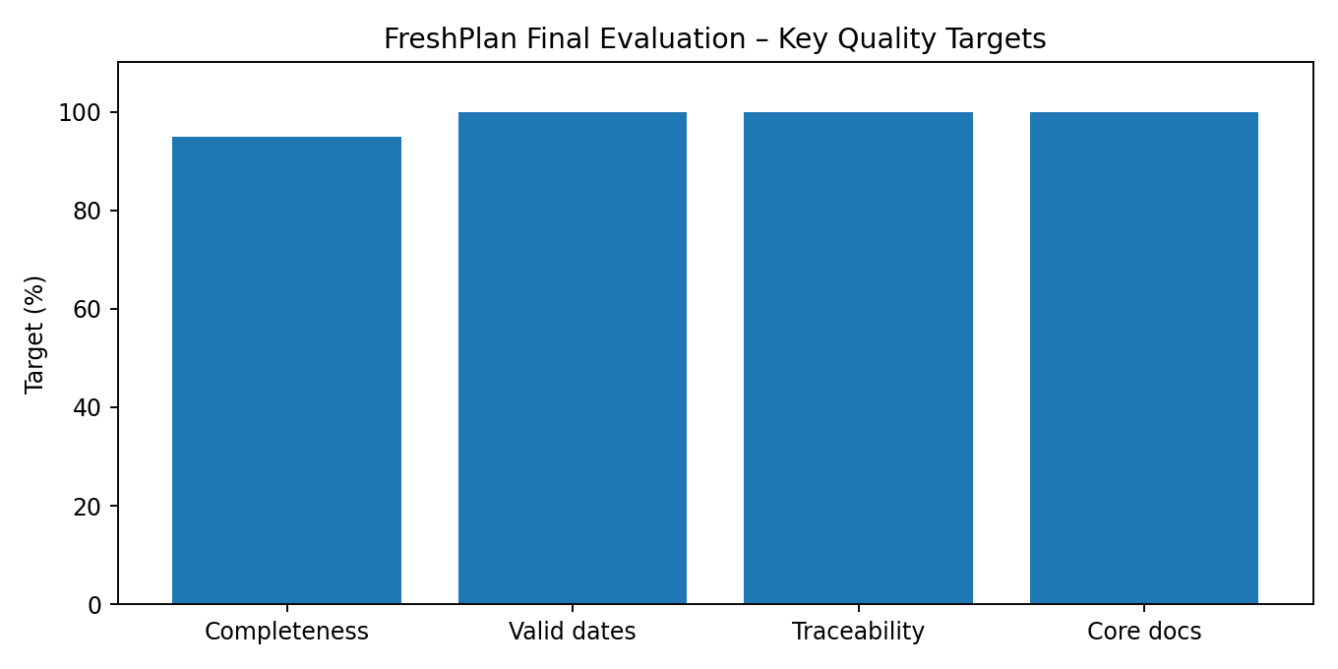
Figure 1. Key data-quality targets used for the final evaluation.

5. Python-Based Analytics
Python can be used to calculate final review values from the project dataset. Pandas is useful for tabular checks and Matplotlib can be used for simple charts.

5.1 Data Quality Check
import pandas as pd
df = pd.read_csv("food_inventory.csv")
required = ["Food_ID", "Food_Name", "Category",
"Quantity", "Storage_Location"]
completeness = df[required].notna().all(axis=1).mean() * 100
duplicate_rate = df.duplicated().mean() * 100
print("Completeness:", round(completeness, 2), "%")
print("Duplicate rate:", round(duplicate_rate, 2), "%")
This small program gives two useful evaluation values and can be extended to date validation, category counts and urgency distribution.

5.2 Urgency Summary
urgency_counts = df["Urgency_Level"].value_counts()
print(urgency_counts)
urgency_counts.plot(kind="bar",
title="Food Priority Distribution")
The resulting chart can show how many food items are in each priority category and can help explain the project output.

6. Functional and Recommendation Evaluation
Test Area | Sample Input | Expected Output
Food entry | Spinach, quantity 2 | Valid record stored
Date calculation | 18-Sep expiry, 15-Sep reference | 3 days remaining
Urgency | 2 days remaining | Very High / Use First
Recipe match | Required ingredients available | Recipe can be recommended
Missing ingredient | Recipe needs 5, user has 3 | Not shown as complete match
Invalid quantity | Quantity = -2 | Validation warning
Duplicate ID | F001 entered twice | Duplicate flagged
No matching recipe | Selected meal has no suitable recipe | Clear no-match message

6.1 Recommendation Checks
- Recipes using food with higher project urgency should be considered earlier.
- Only recipes with the required available ingredients should be shown as complete matches.
- Meal type and selected preferences should be respected.
- Expired or uncertain records should receive a caution rather than being treated as normal fresh ingredients.
- The system should give a simple reason for a recommendation.

6.2 Sample Evaluation Scenario
Food | Days Remaining* | Priority | Possible Use
Spinach | 2 | Very High | Spinach dal / curry
Tomato | 4 | High | Tomato rice / chutney
Carrot | 7 | Medium | Carrot stir-fry
Potato | 20 | Low | Plan for later

In this sample, spinach is considered first because its project-calculated remaining period is smallest. Tomato is next, followed by carrot and potato. This shows how the system can connect inventory information with meal planning.
Note: The remaining-day values above are project-created demonstration values and are not official food-safety limits.

7. Monitoring and Final Review Plan
What to Monitor | Frequency | Check | Action if Problem Appears
Missing values | Each data update | Pandas missing-value count | Correct or flag record
Duplicate IDs | Each data update | Duplicate ID check | Review duplicate
Date errors | Before analysis | Date parsing/logical check | Fix or exclude invalid date
Recommendation output | After rule changes | Run test cases | Correct rule
Test results | After code changes | Expected vs actual | Investigate failed case
Project progress | Weekly | Milestone checklist | Prioritise unfinished core work
Source records | When references change | Source log | Update reference note

Because FreshPlan is an individual student project, monitoring is kept simple. The main aim is to find important problems early and keep the workflow understandable.

8. Lessons Learned

8.1 Useful Project Practices
- Using a structured data dictionary makes food and recipe fields easier to manage.
- Pandas provides a simple way to inspect and clean tabular data.
- Derived fields such as Days_To_Expiry make raw dates more useful for prioritisation.
- Rule-based recommendations are easy to explain and test in a student project.
- Concrete sample cases make it easier to connect Python output with a real use case.
- Separating validation, feature creation, recommendation and testing keeps the workflow organised.
- Git/GitHub helps keep important code and report versions together.

8.2 Future Improvement Areas
- Increase the size and variety of the dataset.
- Add more verified food-storage references with clear source notes.
- Improve ingredient matching for similar names and quantities.
- Collect enough reliable labelled examples before comparing machine-learning models.
- Add a simple web or mobile interface after the core workflow is stable.
- Improve charts for easier understanding of priority and usage patterns.
- Consider regional-language support as a later usability feature.

9. Challenges and Success Factors
Area | Possible Challenge | Success Factor
Data | Incomplete food information | Clear validation rules
Shelf-life | Storage conditions can vary | Show guidance and uncertainty
Recommendation | Missing recipe ingredients | Ingredient-match validation
Coding | Changes can affect output | Small functions and tests
Scope | Optional features increase workload | Focus on core features
Evaluation | One metric is not enough | Use multiple success measures
Presentation | Too much technical detail | Use simple examples and diagrams

10. Final Evaluation Summary
Evaluation Area | Evidence to Check | Status
Project scope | Core features clearly listed | Achieved / Needs Work
Data quality | Completeness, duplicates and dates | Enter measured values
Core functions | Food entry, calculations, priority | Pass / Fail
Recommendations | Ingredient and meal filters | Pass / Fail
Testing | At least 20 planned test cases | Enter actual pass count
Documentation | Core report sections complete | Achieved / Needs Work
Ethics | Privacy, source and safety limits | Achieved / Needs Work
Presentation | Slides and demonstration ready | Ready / Needs Work

Note: The final status should be filled from the actual project evidence, not estimated values.

11. Final Review Flow
The final review can follow one simple path: confirm the project scope, check the data, evaluate implementation, run tests, summarize evidence and prepare the presentation.
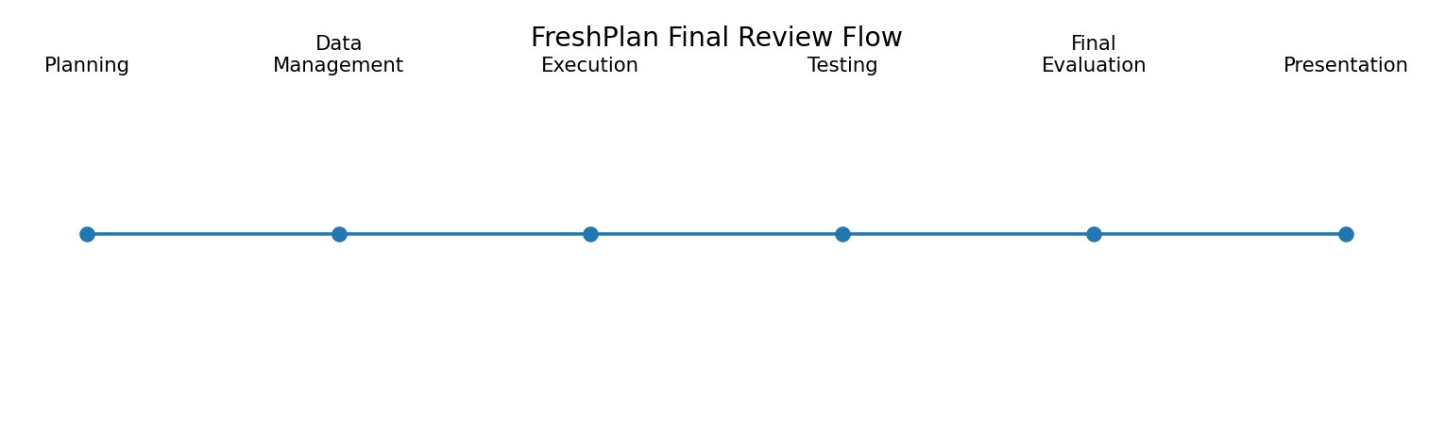
Figure 2. FreshPlan final review flow.

12. Final Presentation Plan
The presentation should follow a simple story: problem → data → Python method → output → evaluation → future work. This makes the project easier for faculty to understand.
Slide | Title | Main Points | Time
1 | Title | FreshPlan, student name, internship | 30 sec
2 | Problem | Food tracking and avoidable waste | 1 min
3 | Objectives | Main goals and scope | 1 min
4 | Data | Inventory, recipes, fields and sources | 2 min
5 | Workflow | Cleaning → features → analysis → recommendation | 2 min
6 | Python Implementation | Pandas, date calculation, priority logic | 2 min
7 | Sample Output | Spinach/tomato/carrot/potato example | 2 min
8 | Evaluation | Data quality and functional metrics | 2 min
9 | Lessons Learned | Useful practices and improvements | 1 min
10 | Future Scope | UI, better matching, larger data, optional ML | 1 min
11 | Conclusion | Main outcome | 1 min

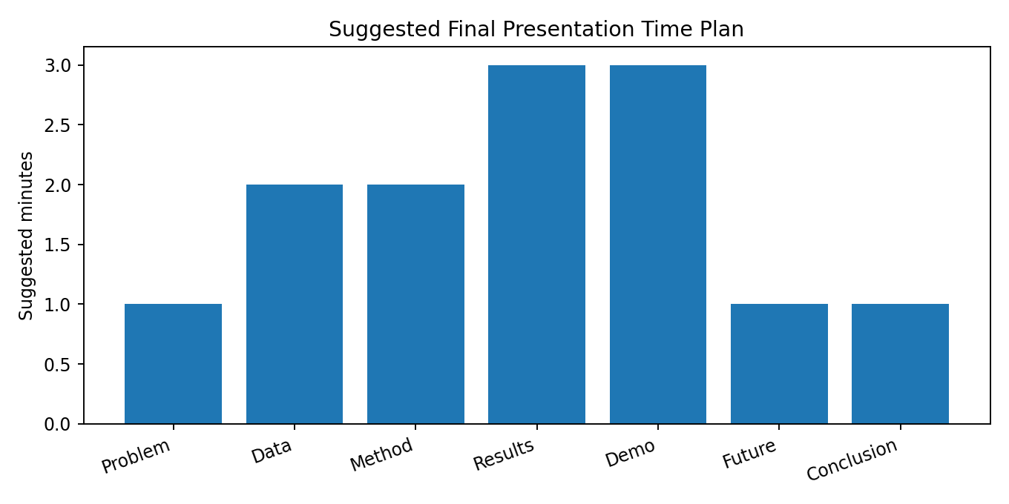
Figure 3. Suggested time allocation for the final presentation.

13. Sample Slide Content

Slide 1 – FreshPlan
- Smart Meal Planner and Food Spoilage Prevention System
- Python-based data science project
- Main idea: use available food more effectively

Slide 2 – Problem
- People may forget stored food items.
- Some items need attention earlier than others.
- Available ingredients are not always connected with meal planning.

Slide 3 – Solution
- Store food information in structured data.
- Calculate a project-based remaining period.
- Assign priority levels.
- Match available ingredients with recipes.

Slide 4 – Python Workflow
- Pandas → data loading and cleaning
- Date processing → Days_To_Expiry
- Rules → Urgency_Level
- Recommendation logic → recipe ranking
- Matplotlib → visual summaries

Slide 5 – Example Result
- Spinach: 2 days → very high priority
- Tomato: 4 days → high priority
- Carrot: 7 days → medium priority
- Potato: 20 days → low priority

Slide 6 – Evaluation
- Completeness target: ≥95%
- Duplicate rate target: <2%
- Planned inventory: 150–200
- Planned recipes: 100+
- Core manual tests: ≥20

Slide 7 – Future Scope
- Simple web/mobile interface
- Better ingredient matching
- Larger verified dataset
- Optional ML comparison
- Regional-language support

14. Presentation Speaking Plan
- Start with the everyday problem of not knowing which stored food should be used first.
- Explain that FreshPlan stores food and recipe information in structured data.
- Show the Python workflow and explain the role of Pandas and date calculations.
- Use the spinach example to show how the prototype assigns priority.
- Explain recipe matching and why unavailable ingredients are checked.
- Present evaluation metrics and clearly distinguish targets from measured results.
- Explain the main lessons learned and realistic future improvements.
- Finish with the overall value of FreshPlan.

15. Possible Faculty Questions and Short Answers
Question | Short Answer
Why did you choose FreshPlan? | It connects a common household problem with Python data analysis and recommendation.
Why Python? | Python has useful libraries such as Pandas and Matplotlib for data processing and visualization.
What is Days_To_Expiry? | It is the calculated difference between the project reference date and the expiry date.
Is it a food-safety guarantee? | No. It is a project estimate and should not replace official food-safety guidance or checking the actual food.
Why start with rules instead of ML? | Rules are easier to explain and test with a small student dataset.
How are recommendations tested? | Normal and edge-case inputs are compared with expected outputs.
What is the main success metric? | Several metrics are used together: data quality, functional tests, recommendations and project requirements.
What is future scope? | A user interface, better matching, larger data and optional ML comparison.

16. Final Recommendations
- Keep the first version simple and explainable.
- Use actual measured evidence when completing the final evaluation table.
- Keep project-created sample records clearly labelled.
- Maintain source notes for external food-storage information.
- Reuse the same test cases when comparing future versions.
- Add advanced machine learning only when enough reliable data is available.
- For the final demonstration, show one complete example from food entry to recommendation.

17. Conclusion
FreshPlan brings together planning, data management, Python implementation, testing, monitoring and final evaluation in one practical student-level data science project. The final review uses measurable checks for data quality, functionality, recommendation behaviour and documentation, giving a clear structure for judging the project.
The project also demonstrates data-driven decision-making in a simple way: food is entered, a project-based remaining period is calculated, a priority is assigned, and available ingredients are connected with meal suggestions. The final presentation will use concrete examples and simple charts so that both the technical process and practical purpose of FreshPlan are easy to understand.

18. Project Reference Notes
- FreshPlan Week 1 project plan – scope, objectives, quantitative goals, risks and five-week schedule.
- FreshPlan Week 2 data acquisition and management plan – data fields, sources, cleaning rules, quality targets and recommendation scoring.
- FreshPlan Week 3 execution report – Python workflow, feature engineering, recommendation baseline, testing, ethics and QA.
- FSSAI – food-safety and storage guidance relevant to the Indian context.
- FDA – household food-storage guidance.
- USDA FoodKeeper / FSIS – food storage-time reference information.
- USDA FoodData Central – optional food-composition information if nutrition features are included.

