YUVAINTERN – NSDC INTERNSHIP
FRESHPLAN
Smart Meal Planner and Food Spoilage Prevention System
WEEK 3 REPORT
Execution and Implementation of Data Science Solutions

Details | Information
Student Name | Kedarisetti Sailaja Devi
Internship | YuvaIntern / NSDC – Data Science Project Coordinator
Project Type | Individual Data Science Project
Project Title | FreshPlan: Meal Planner and Food Spoilage Prevention System
Technology Focus | Python | Pandas | NumPy | Matplotlib | Scikit-learn | SQLite
Week 3 Focus | Implementation, analysis, recommendation logic, testing, ethics and QA

1. Executive Summary
Week 3 converts the planning and data-management work completed in Weeks 1 and 2 into a practical implementation workflow for FreshPlan. The system will use Python to load, validate, clean and analyse food inventory and recipe data. Derived fields such as Days_To_Expiry and Urgency_Level will help identify which food items need attention first. A transparent rule-based recommendation method will initially connect food urgency with ingredient availability, meal type, dietary preference and preparation time.
To address the evaluation feedback, this report includes a concrete household example, a small sample analysis, measurable data-quality checks, realistic test cases and specific ethical scenarios. The sample values are project-created demonstration data and are not official food-safety limits. Machine learning is kept as a future option rather than being presented as an already completed model.

2. Week 3 Objectives
- Convert the Week 2 data-acquisition plan into an executable Python workflow.
- Validate missing values, duplicate records, dates, quantities and category labels.
- Perform basic exploratory data analysis using Pandas and Matplotlib.
- Create useful features such as Days_To_Expiry and Urgency_Level.
- Develop an explainable rule-based recommendation approach.
- Define a future model-training and validation process without claiming uncompleted ML work.
- Apply Git/GitHub, testing, QA and documentation practices.
- Strengthen ethical handling through practical scenarios involving food safety, privacy and data licensing.

3. Connection Between Weeks 1, 2 and 3
Week | Main Work | How It Leads to Week 3
Week 1 | Project planning, scope, risks and timeline | Defines what FreshPlan should achieve and how success will be checked.
Week 2 | Data acquisition, data dictionary, cleaning and source tracking | Defines what data is required and how it should be prepared.
Week 3 | Execution, analysis, feature engineering, recommendation and testing | Turns the planned data workflow into an implementable solution.

4. Implementation Workflow
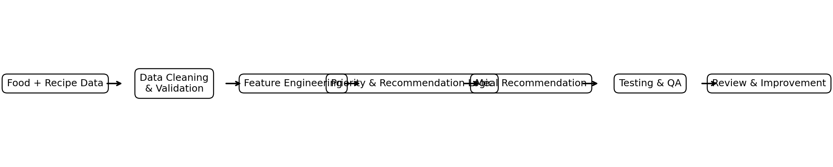
Figure 1. FreshPlan Week 3 implementation flow

5. Data Implementation Plan
FreshPlan will work with two main structured datasets: a food inventory dataset and a recipe dataset. The Week 2 plan targets approximately 150–200 food inventory records and 100+ recipe records. These are planned project targets, not completed results.
Field | Example | Purpose
Food_ID | F001 | Unique inventory reference
Food_Name | Spinach | Identifies the stored item
Quantity | 2 | Tracks available amount
Storage_Location | Refrigerator | Supports storage-related guidance
Purchase_Date | 2026-09-13 | Supports time-based analysis
Expiry_Date | 2026-09-17 | Used for prototype date calculations
Days_To_Expiry | 2 | Derived urgency feature
Urgency_Level | Very High | Prioritises attention
Recipe_ID | R014 | Connects food to recipes
Meal_Type | Lunch | Filters meal suggestions

6. Python Implementation

6.1 Load and Validate Data
import pandas as pd
df = pd.read_csv("food_inventory.csv")
print(df.shape)
print(df.isnull().sum())
The first check confirms the number of records and identifies missing values before recommendation logic is applied.

6.2 Create Days_To_Expiry
df["Expiry_Date"] = pd.to_datetime(df["Expiry_Date"], errors="coerce")
df["Reference_Date"] = pd.to_datetime(df["Reference_Date"], errors="coerce")
df["Days_To_Expiry"] = (df["Expiry_Date"] - df["Reference_Date"]).dt.days
Example: if a sample record has an expiry date of 18 September 2026 and a reference date of 15 September 2026, the calculated difference is 3 days. This is a planning calculation only.

6.3 Create an Urgency Level
def get_urgency(days):
if days < 0: return "Expired"
if days <= 2: return "Very High"
if days <= 5: return "High"
if days <= 10: return "Medium"
return "Low"

7. Feature Engineering
Feature | What It Means | Example
Days_To_Expiry | Estimated number of days between reference and expiry date | 2
Urgency_Level | Priority category derived from days | Very High
Ingredient_Match | Whether required ingredients are available | Yes
Meal_Type | Requested meal category | Lunch
Diet_Type | User preference filter | Vegetarian
Prep_Time_Min | Preparation-time convenience factor | 20
Prototype urgency rules: below 0 = Expired; 0–2 = Very High; 3–5 = High; 6–10 = Medium; above 10 = Low. These thresholds are project rules for prioritisation, not official food-safety limits.

8. Concrete Real-World FreshPlan Example
Consider a household that has spinach, tomato, carrot and potato. The user enters these items into FreshPlan with sample dates. The system compares their estimated remaining period and then prioritises items that need attention sooner.
Food Item | Storage | Days Remaining* | Priority | Example Meal Action
Spinach | Refrigerator | 2 | Very High | Spinach dal / spinach curry
Tomato | Refrigerator | 4 | High | Tomato rice / tomato chutney
Carrot | Refrigerator | 7 | Medium | Carrot stir-fry
Potato | Cool, dry place | 20 | Low | Plan potato curry later

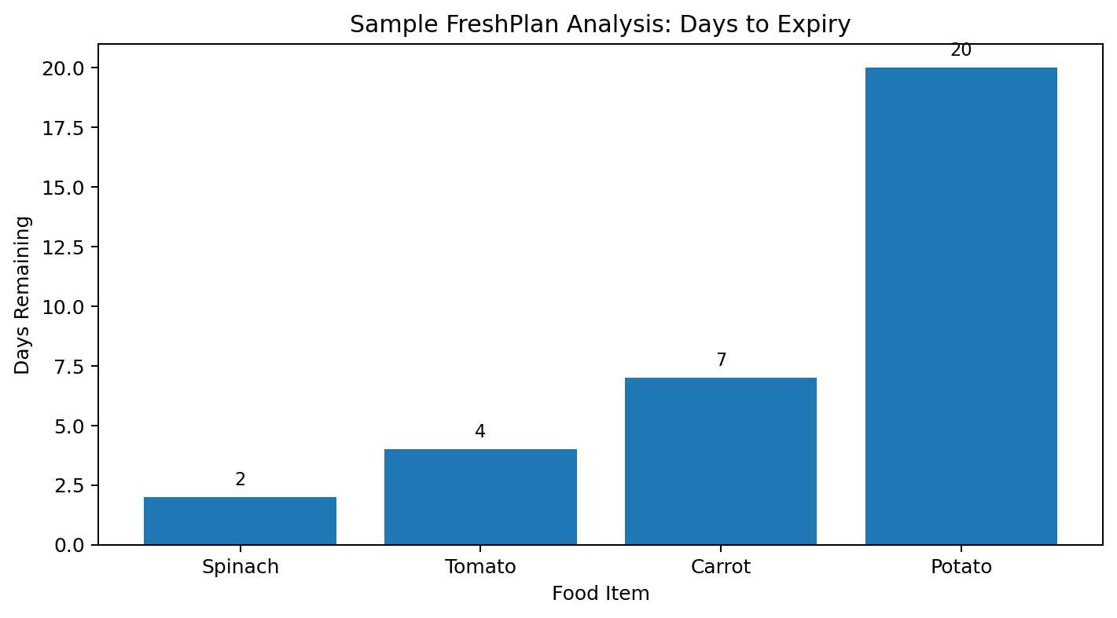
Figure 2. Sample analysis of remaining days

9. What the Analysis Shows
- Spinach has the smallest remaining value in the sample, so it receives the highest usage priority.
- Tomato also needs earlier attention than carrot and potato in this example.
- Potato is not unnecessarily prioritised because its sample remaining period is longer.
- The chart makes the difference between urgent and later-use items easier to understand.
- The same process can be extended to a larger dataset to count high-risk items, compare categories and identify common waste patterns.

10. Recommendation Logic – Step by Step
- Read the user's available food inventory.
- Calculate Days_To_Expiry for valid records.
- Assign a prototype urgency category.
- Remove or caution on expired/invalid records instead of treating them as fresh ingredients.
- Compare available ingredients with recipe ingredients.
- Filter recipes by meal type, dietary preference and practical preparation time.
- Prioritise recipes that help use food requiring earlier attention.
- Display the reason for the recommendation in simple language.

11. Sample Recommendation Scenario
If the user selects Lunch and has spinach, tomato, carrot and potato, FreshPlan can first check recipes containing spinach because it has the highest sample urgency. A spinach-dal recipe can be displayed if its required ingredients are available. A potato-based recipe can remain a later option. This makes the recommendation connected to the user's actual inventory rather than being a generic recipe suggestion.
Input Situation | System Response | Reason
Spinach: 2 days | Prioritise spinach-based meal | Highest sample urgency
Potato: 20 days | Do not prioritise unnecessarily | Longer sample period
Recipe missing one required ingredient | Do not mark as complete match | Prevents misleading recommendation
Expired item | Show caution / exclude from fresh-meal recommendation | Avoids presenting an expired item as normal

12. Rule-Based Baseline and Future ML
A rule-based baseline is appropriate for the first implementation because it is transparent and easy to debug. If the project later collects enough consistent labelled records, models such as Decision Tree, Logistic Regression or Random Forest can be experimentally evaluated. Any ML model will be compared with the rule-based baseline using appropriate evaluation metrics before it is considered for deployment.
from sklearn.model_selection import train_test_split
X_train, X_test, y_train, y_test = train_test_split(
X, y, test_size=0.2, random_state=42)
This is a conceptual future-stage reference; it does not claim that an ML model has already been trained.

13. Ethical and Responsible Implementation
FreshPlan deals with food-related decisions, so ethical implementation is important. The system should help users organise food and plan meals without presenting estimated shelf-life calculations as guaranteed proof that food is safe to eat. The project will also minimise personal data collection and maintain source traceability for external information.

13.1 Ethical Case Study 1 – Incorrect Shelf-Life Estimate
Scenario: FreshPlan calculates that a vegetable has several days remaining based on a reference date, but the actual storage conditions were poor or the food was already damaged. A user may misunderstand the estimate as a guarantee of safety.
Responsible response:
- Display estimates as guidance rather than guaranteed safety decisions.
- Ask users to follow product labels and reliable food-safety guidance where applicable.
- Provide caution messages when storage information is missing or uncertain.
- Do not recommend an item simply because a calculated date has not passed.

13.2 Ethical Case Study 2 – Privacy of Household Data
Scenario: A user records household inventory, purchase patterns or food habits. Storing unnecessary personal information could create a privacy risk even though the project only needs food-related fields.
Responsible response:
- Collect only information required for the FreshPlan function.
- Avoid collecting names, passwords or unrelated personal details in the food dataset.
- Restrict access to stored data and avoid exposing raw user information in charts or demonstrations.
- Use anonymised or project-created data during academic testing whenever possible.

13.3 Ethical Case Study 3 – Data Source and Licensing
Scenario: A recipe or food-information source is copied into the project without checking whether it can be reused. This can create attribution or licensing problems.
Responsible response:
- Record the source and date/reference note for external information.
- Use information that is permitted for the intended project use.
- Prefer original project-created examples for demonstrations.
- Do not copy large copyrighted recipe collections into the project without appropriate permission.

13.4 Ethical Case Study 4 – Misleading Recommendation
Scenario: A recipe requires five ingredients, but the user has only three. If FreshPlan displays the recipe as if all ingredients are available, the output may be misleading.
Responsible response:
- Check ingredient availability before marking a recipe as a match.
- Clearly identify missing ingredients.
- Explain why a recipe was recommended.
- Provide an alternative or no-match message when an appropriate recipe is unavailable.

14. Quality Assurance and Testing
Test Area | Target / Check | Example
Required-field completeness | ≥95% after validation | Measure missing required fields
Duplicate records | <2% | Compare duplicate IDs/names
Retained dates | 100% valid | Check date parsing errors
Inventory size | 150–200 planned records | Count cleaned records
Recipe size | 100+ planned records | Count unique recipe IDs
Recommendation match | Available ingredients only | Test partial recipe inputs
Expiry logic | Correct priority categories | Test expired, urgent and normal dates

14.1 Edge Cases
- Missing expiry date
- Expiry date earlier than purchase date
- Zero or negative quantity
- Already expired food
- Duplicate food ID
- Recipe with unavailable ingredient
- No recipe for selected meal type
- Invalid or unrecognised storage label

15. Agile Execution Plan
Day | Activity | Expected Output
Day 1 | Review Weeks 1–2 and confirm data structure | Confirmed data dictionary
Day 2 | Load data and run validation checks | Validation notes
Day 3 | Create expiry and urgency features | Transformed dataset
Day 4 | Perform EDA and create chart(s) | Initial analysis
Day 5 | Implement recommendation baseline | Recommendation logic
Day 6 | Run normal and edge-case tests | Testing checklist
Day 7 | Review, correct and document | Final Week 3 report

16. Programming and Version Control Practices
- Use meaningful variable names such as expiry_date and urgency_level.
- Keep data cleaning, feature engineering, recommendation and testing functions separate.
- Write small functions that can be tested independently.
- Use Git/GitHub to track important versions and implementation changes.
- Maintain a README describing setup, input columns, workflow and limitations.
- Do not upload passwords, private credentials or unnecessary personal information.
- Record major corrections after testing so the implementation remains traceable.

17. Risks and Mitigation
Risk | Possible Impact | Mitigation
Insufficient data | Weak analysis | Start with controlled records and expand gradually.
Incorrect expiry assumptions | Misleading output | Use estimates as guidance and add caution messages.
Missing/inconsistent fields | Calculation errors | Validate and standardise fields before analysis.
Over-complex ML | Time loss and poor explainability | Use rule-based baseline first.
Coding errors | Incorrect recommendations | Use small functions and test cases.
Time limitations | Incomplete prototype | Prioritise core features and follow milestones.
Licence/source issues | Unapproved data use | Track sources and use permitted information.

18. Expected Week 3 Deliverables
- Executable implementation plan based on Weeks 1 and 2.
- Python references for loading, validation, transformation and basic analysis.
- Feature-engineering plan for expiry and urgency.
- Concrete FreshPlan sample analysis with chart and recommendation scenario.
- Explainable rule-based recommendation baseline.
- Future ML training and validation plan.
- Testing, edge-case and QA checklist.
- Specific ethical scenarios with mitigation actions.
- Agile schedule, version-control practices and risk-management plan.

19. Final Review Checklist
- Week 2 data fields are used consistently.
- Missing values and duplicates are checked before recommendation.
- Days_To_Expiry is calculated only from valid dates.
- Expired and urgent cases are tested separately.
- Recommended recipes use available ingredients.
- Meal-type and dietary filters are checked.
- Sample analysis is clearly labelled as demonstration data.
- Ethical limitations are visible to the user.
- Code changes are tracked through Git/GitHub.
- Final report contains practical examples and supporting diagrams.

20. Conclusion
Week 3 moves FreshPlan from planning into a realistic implementation stage. The report demonstrates how food and recipe data can be validated, transformed and analysed with Python, followed by explainable priority and meal-recommendation logic. The concrete spinach, tomato, carrot and potato example shows how the system can turn data into a practical household decision: use food requiring earlier attention before items with a longer remaining period.
The report also recognises that food-related estimates have limitations. Specific ethical case studies cover incorrect shelf-life assumptions, household-data privacy, source licensing and incomplete recipe matches. FreshPlan therefore treats its outputs as planning guidance, not guaranteed food-safety decisions. Testing, Git/GitHub version control, measurable quality targets and a rule-based baseline provide a manageable foundation for later development and optional machine-learning experimentation.

