Epileptic Seizures Prediction Using Deep Learning Techniques

Epilepsy is a common disease which causes because of abnormal brain state and patient starts shivering or seizures. Predicting a seizure before it actually occurs can help in its prevention through therapeutic intervention. Studies have observed that abnormal activity inside the brain begins a few minutes before the start of a seizure, which is known as PREICTAL state and normal state is called as ‘INTERICTAL State’.

Timely prediction of abnormal brain state can help in preventing epilepsy disease and in past many machine learning and deep learning algorithms was introduced but their prediction accuracy is not accurate. To overcome from above issue author of this paper employing CNN + SVM algorithm which is giving prediction accuracy between 94 to 99%.

CNN deep learning algorithm was employed to train on Epilepsy EEG signals dataset and then extracted features from CNN model and then retrain with SVM to classify given record as normal or PREICTAL state.

To train CNN author has used dataset from CHBMIT which contains EEG signals and this dataset contains two labels called 0 (normal or INTERICTAL state) and 1 (seizures or PREICTAL state). This dataset can be downloaded from below KAGGLE URL

<https://www.kaggle.com/datasets/adibadea/chbmitseizuredataset>

To implement this project we have designed following modules

1. Upload CHB-MIT Epilepsy Dataset: using this module we will upload dataset to application and then application will find and plot different labels such as INTERICTAL PREICTAL state.
2. Dataset Preprocessing: using this module we will process dataset to remove missing values, normalize, shuffling and then split dataset into train and test where application using 80% dataset for training and 20% for testing
3. Run CNN + SVM Classification Algorithm: using this module we will input 80% training data to CNN to train a model and then extract features from CNN and then retrain with SVM to predict epilepsy labels
4. CNN Training Graph: using this module we will plot deep learning CNN training accuracy and loss graph
5. Epilepsy Prediction from Test Data: using this module we will upload test data and then CNN and SVM will predict normal or epilepsy state.

In below screen showing EEG signals used in this project

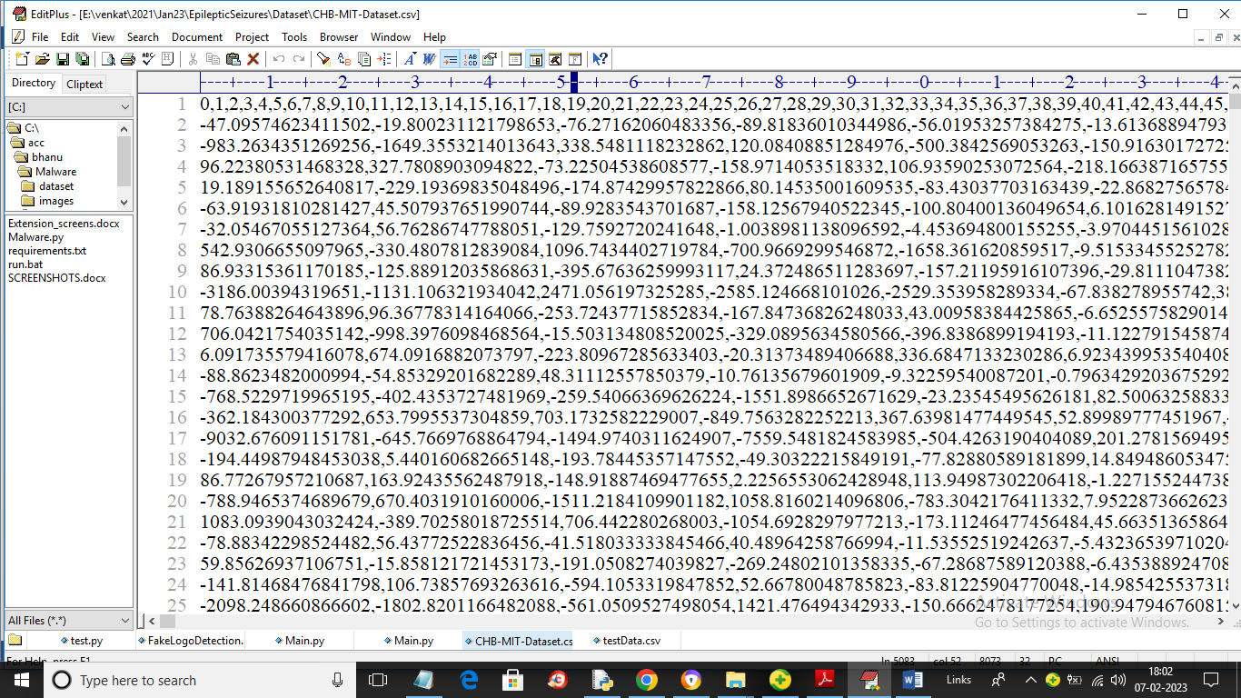

In above screen first row contains dataset column index and remaining rows contains dataset values and in last column we can see either class label as 0 or 1 like below screen

SCREEN SHOTS

To run project double click on ‘run.bat’ file to get below screen

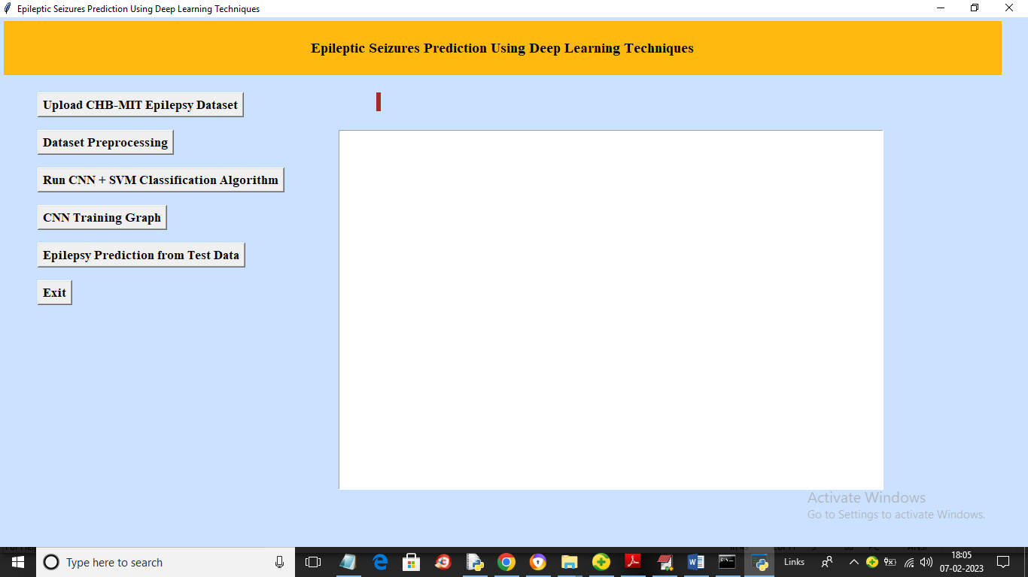

In above screen click on ‘Upload CHB-MIT Epilepsy Dataset’ button to load dataset and get below output

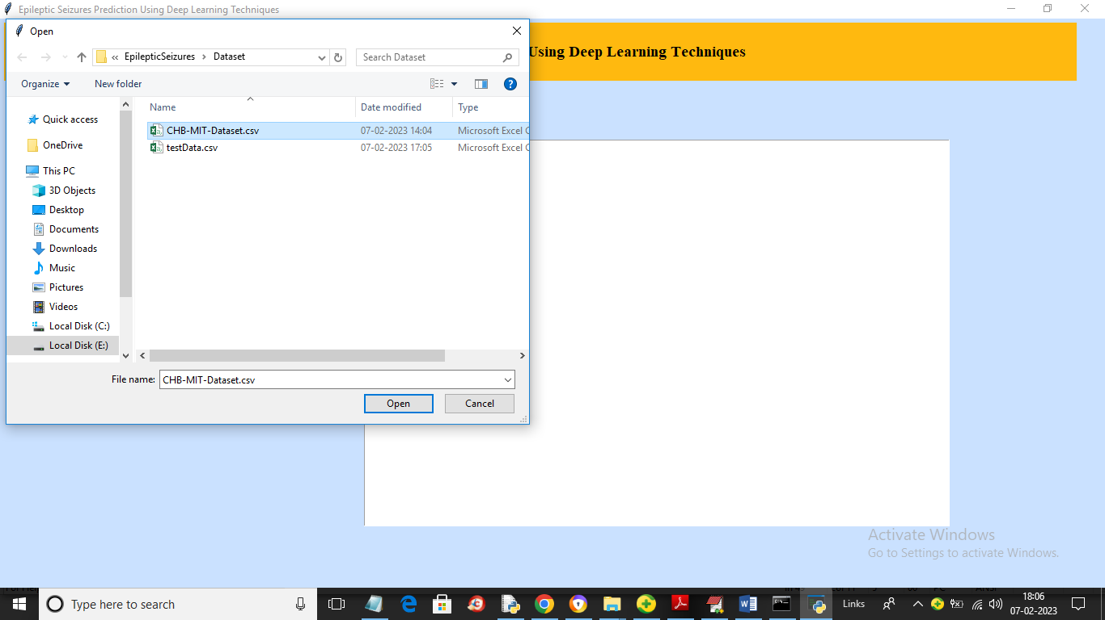

In above screen selecting and uploading dataset file and then click on ‘Open’ button to load dataset and get below output

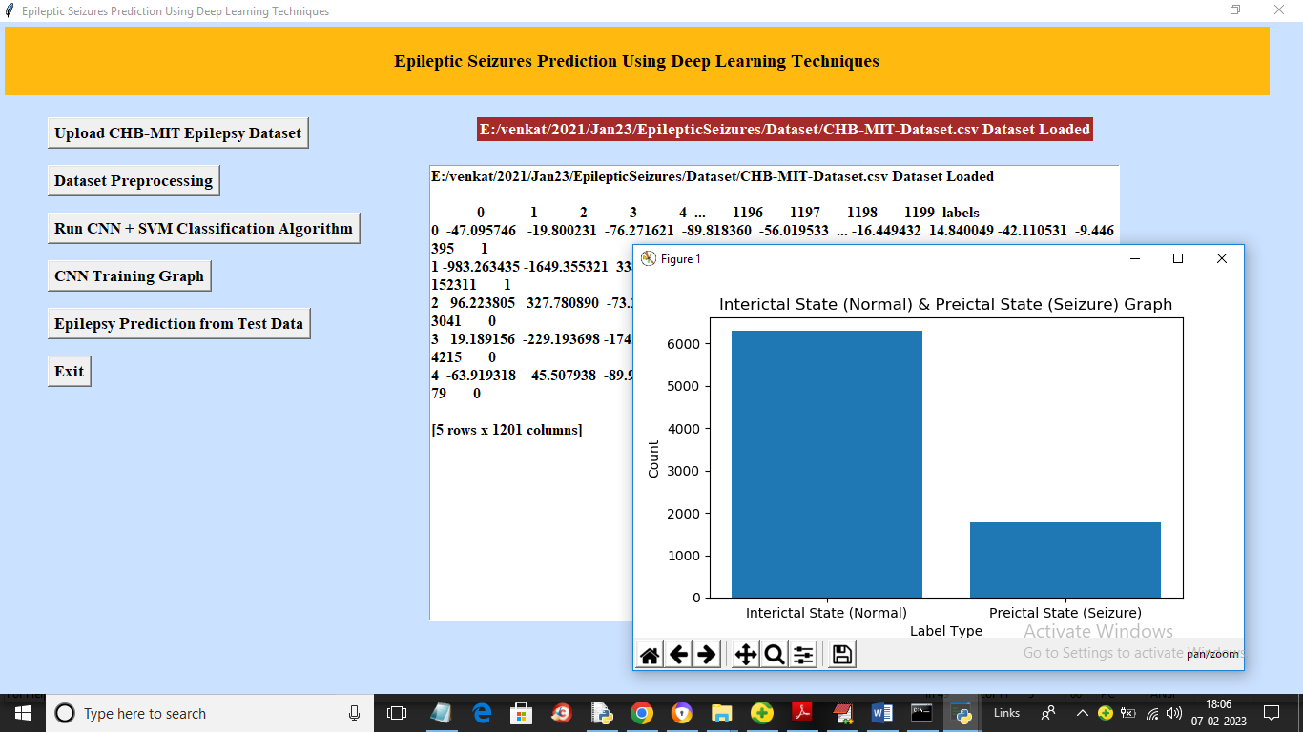

In above screen dataset loaded and values we can see in text area and in graph x-axis represents LABELS and y-axis represents count of those labels and now close above graph and then click on “Dataset Preprocessing” button to process dataset and get below output

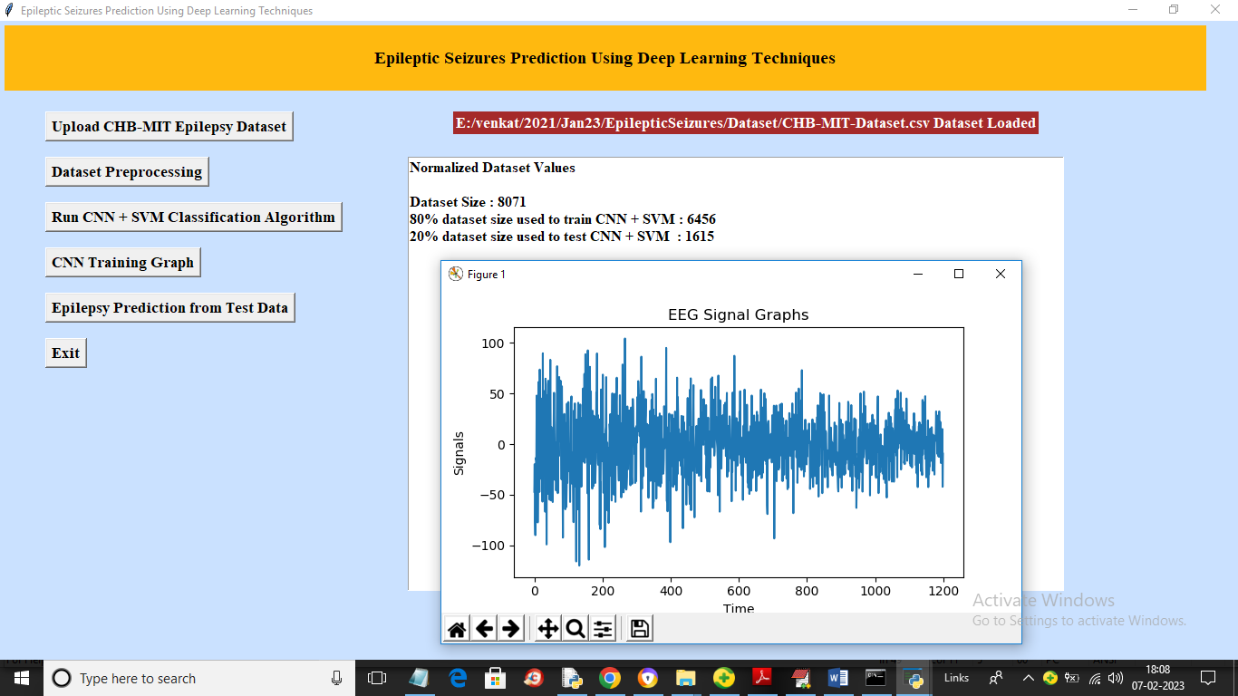

In above screen we can see dataset processing completed and application found 8071 records in dataset and using 80% (6456) records for training and 20% (1615) records for testing and in EEG graph x-axis contains signal time and y-axis contains signal values and in initially we can see big lines so that consider as abnormal state and small lines represents normal state and now close above graph and then click on ‘Run CNN + SVM Classification Algorithm’ button to train CNN + SVM and then get below output

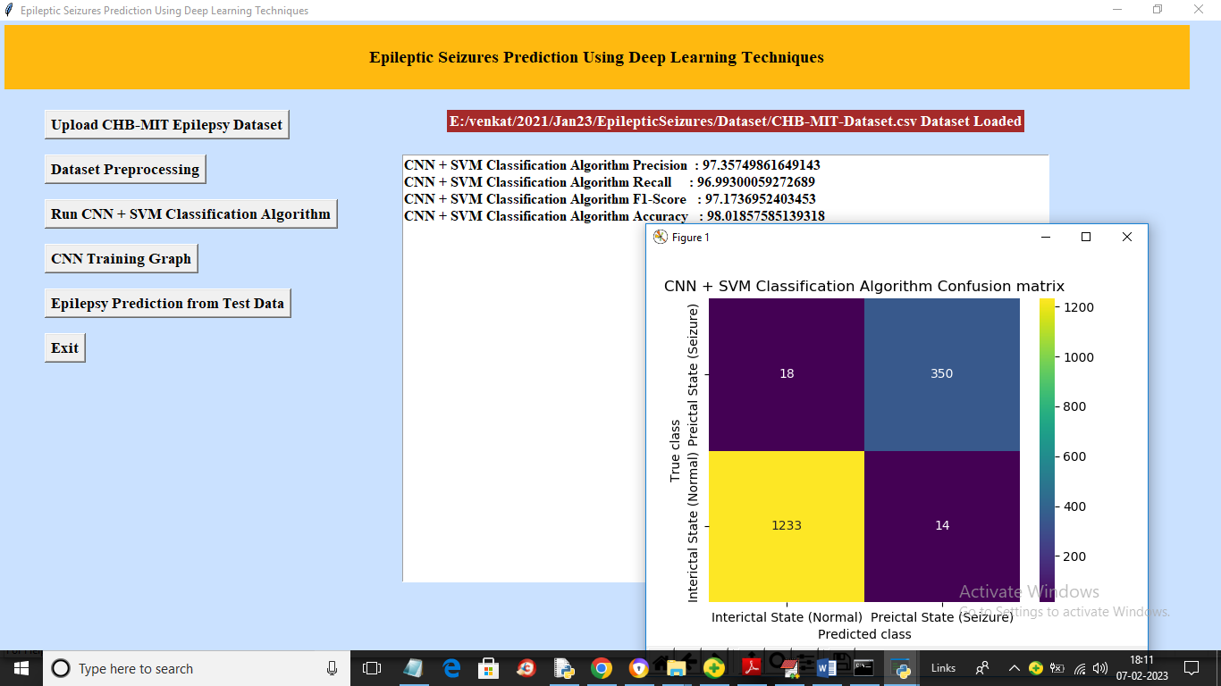

In above screen CNN and SVM training completed and we got its accuracy as 98% and we can see other metric like precision, recall and FSCORE and in confusion graph x-axis represents Predicted labels and y-axis represents True labels and blue colour boxes contains incorrect prediction count which are very few like 18 and 14. Yellow and dark grey contains CORRECT prediction count which are 1233 and 350. Now close above graph and click on ‘CNN Training Graph’ button to get below graph

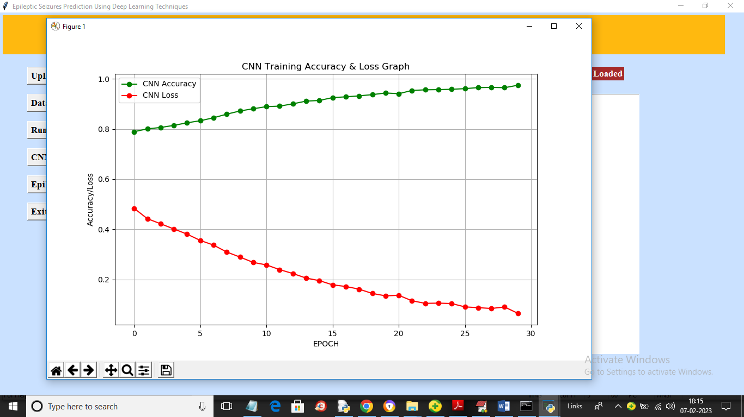

In above graph x-axis represents training epoch and y-axis represents accuracy and loss values and green line represents accuracy and red line represents loss and we can see with each increasing epoch accuracy got increase and reached closer to 1 and loss got decrease and reached closer to 0which proofs that model is accurate. Now close above graph and then click on ‘Epilepsy Prediction from Test Data’ button to upload test data and get below output

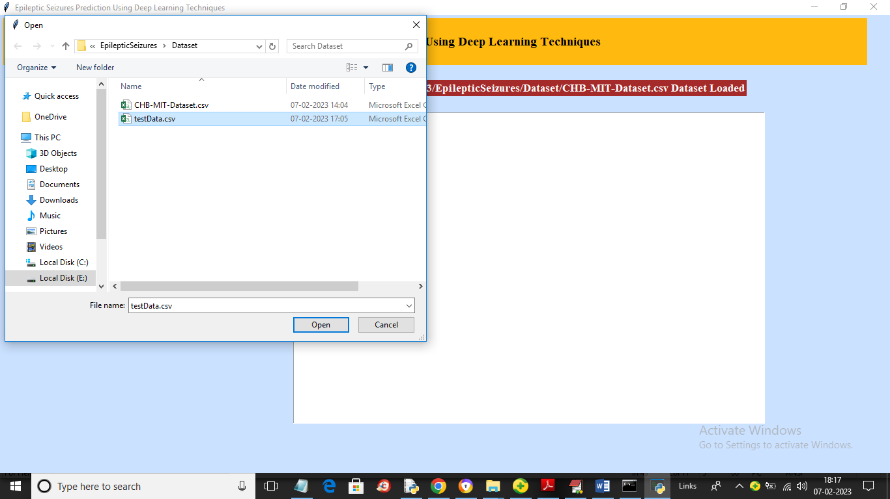

In above screen selecting and uploading ‘testData.csv’ file and then click on ‘Open’ button to load test data and get below prediction output

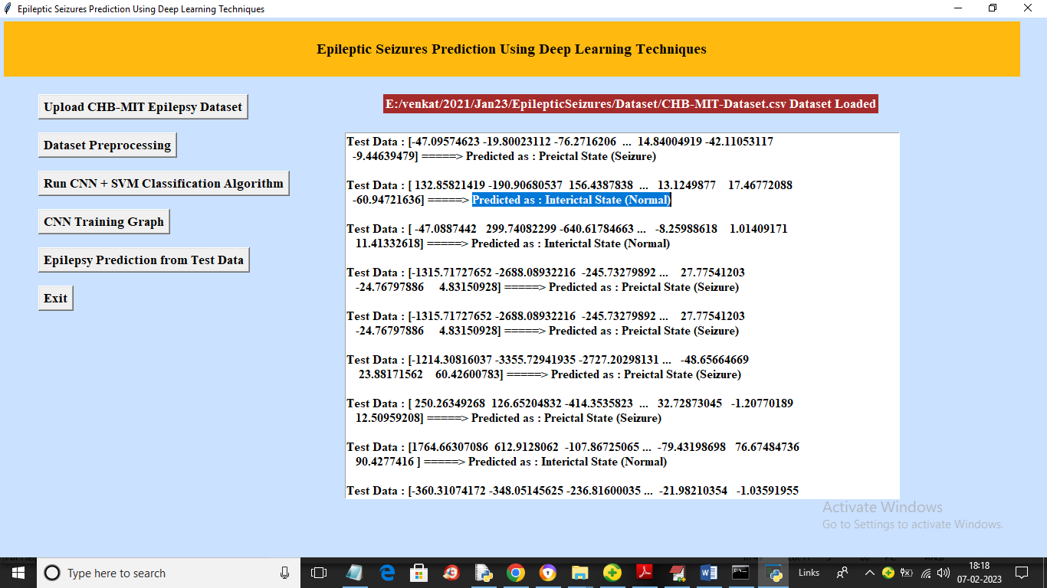

In above screen in square bracket we can see TEST data values and after arrow symbol =🡺 we can see predicted output as Normal or Seizure