task-1

Sai Lakshmi. R

2024-06-24

library(ggplot2)

## Warning: package 'ggplot2' was built under R version 4.3.2

library(dplyr)

## Warning: package 'dplyr' was built under R version 4.3.2

##   
## Attaching package: 'dplyr'

## The following objects are masked from 'package:stats':  
##   
## filter, lag

## The following objects are masked from 'package:base':  
##   
## intersect, setdiff, setequal, union

# Sample data similar to your screenshot  
data <- data.frame(  
 x1 = c(0.468861449, 0.590717878, 0.537981097, 0.184410598, 0.825696985, 0.184481577, 0.448853370, 0.549273324, 0.448738423, 0.772212302),  
 x2 = c(0.16375577, 0.42931947, 0.08237369, 0.71740383, 0.41466953, 0.08583760, 0.60512693, 0.72529901, 0.59790432, 0.71861464),  
 y = c(0, 0, 0, 1, 0, 1, 0, 1, 1, 0)  
)

data

## x1 x2 y  
## 1 0.4688614 0.16375577 0  
## 2 0.5907179 0.42931947 0  
## 3 0.5379811 0.08237369 0  
## 4 0.1844106 0.71740383 1  
## 5 0.8256970 0.41466953 0  
## 6 0.1844816 0.08583760 1  
## 7 0.4488534 0.60512693 0  
## 8 0.5492733 0.72529901 1  
## 9 0.4487384 0.59790432 1  
## 10 0.7722123 0.71861464 0

data$y==factor(data$y,labels=c("female","male"))

## [1] FALSE FALSE FALSE FALSE FALSE FALSE FALSE FALSE FALSE FALSE

data

## x1 x2 y  
## 1 0.4688614 0.16375577 0  
## 2 0.5907179 0.42931947 0  
## 3 0.5379811 0.08237369 0  
## 4 0.1844106 0.71740383 1  
## 5 0.8256970 0.41466953 0  
## 6 0.1844816 0.08583760 1  
## 7 0.4488534 0.60512693 0  
## 8 0.5492733 0.72529901 1  
## 9 0.4487384 0.59790432 1  
## 10 0.7722123 0.71861464 0

# Bar chart for the 'y' variable  
ggplot(data, aes(x = y)) +  
 geom_bar() +  
 theme_minimal() +  
 labs(title = "Bar Chart of Gender",  
 x = "Gender",  
 y = "Count")

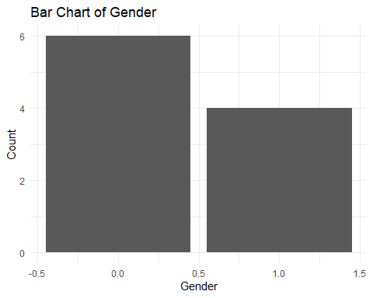

# Histogram for the 'x1' variable  
ggplot(data, aes(x = x1)) +  
 geom_histogram(binwidth = 0.1, fill = "blue", color = "black") +  
 theme_minimal() +  
 labs(title = "Histogram of x1 Variable",  
 x = "x1",  
 y = "Frequency")

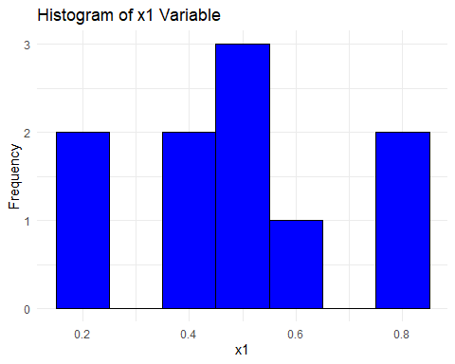

# Histogram for the 'x2' variable  
ggplot(data, aes(x = x2)) +  
 geom_histogram(binwidth = 0.1, fill = "blue", color = "black") +  
 theme_minimal() +  
 labs(title = "Histogram of x2 Variable",  
 x = "x2",  
 y = "Frequency")

