Analyzing the concepts of plots and applying it on the datasets

sailakshmi

January 16, 2017

# R markdown

I have choosen datasets called orchardsprays and infert. OrchardSprays contains the attributes named as decrease,rowpos,colpos,treatment Infert consists of attributes named as education,age,parity,induced,case spontaneous,stratum,pooled.stratum

head(OrchardSprays)

## decrease rowpos colpos treatment  
## 1 57 1 1 D  
## 2 95 2 1 E  
## 3 8 3 1 B  
## 4 69 4 1 H  
## 5 92 5 1 G  
## 6 90 6 1 F

summary(OrchardSprays)

## decrease rowpos colpos treatment   
## Min. : 2.00 Min. :1.00 Min. :1.00 A : 8   
## 1st Qu.: 12.75 1st Qu.:2.75 1st Qu.:2.75 B : 8   
## Median : 41.00 Median :4.50 Median :4.50 C : 8   
## Mean : 45.42 Mean :4.50 Mean :4.50 D : 8   
## 3rd Qu.: 72.00 3rd Qu.:6.25 3rd Qu.:6.25 E : 8   
## Max. :130.00 Max. :8.00 Max. :8.00 F : 8   
## (Other):16

OrchardSprays[1:20,]

## decrease rowpos colpos treatment  
## 1 57 1 1 D  
## 2 95 2 1 E  
## 3 8 3 1 B  
## 4 69 4 1 H  
## 5 92 5 1 G  
## 6 90 6 1 F  
## 7 15 7 1 C  
## 8 2 8 1 A  
## 9 84 1 2 C  
## 10 6 2 2 B  
## 11 127 3 2 H  
## 12 36 4 2 D  
## 13 51 5 2 E  
## 14 2 6 2 A  
## 15 69 7 2 F  
## 16 71 8 2 G  
## 17 87 1 3 F  
## 18 72 2 3 H  
## 19 5 3 3 A  
## 20 39 4 3 E

plot(OrchardSprays)

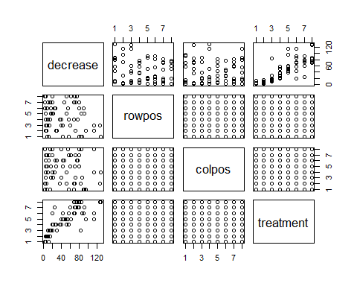

plot(OrchardSprays$decrease,OrchardSprays$treatment)

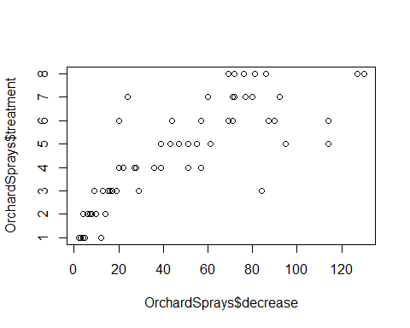

plot(OrchardSprays$decrease,xlab = 'xaxis', type="o", col="blue")  
 title(main="plot for the attribute decrease", col.main="red", font.main=4)  
lines(OrchardSprays$decrease, type="o", pch=22, lty=2, col="red")

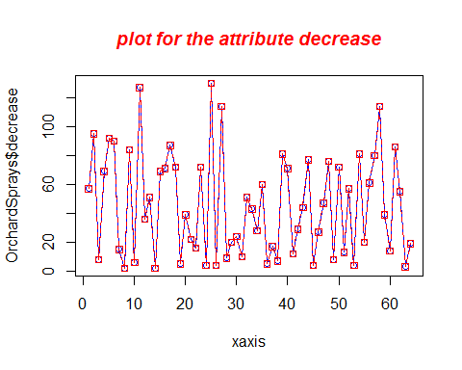

hist(OrchardSprays$colpos,xlim=c(1,10),ylim = c(1,10))

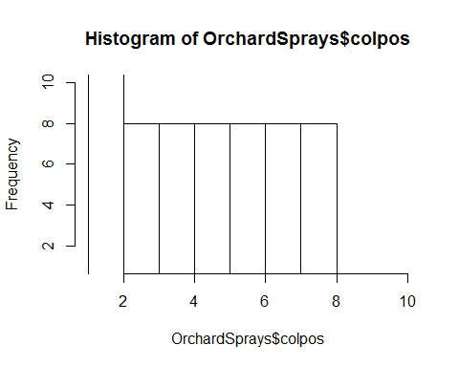

colors = c("red", "yellow", "green", "violet", "orange", "blue", "pink", "cyan")   
hist(OrchardSprays$colpos, col=colors, main="histogram for Orchard Sprays")

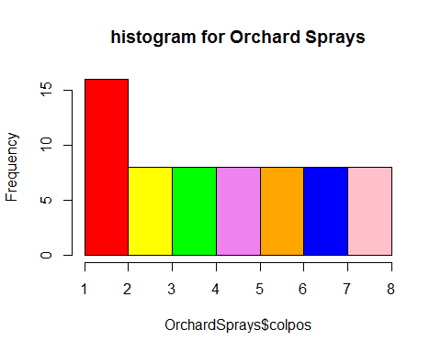

OrchardSprays$decrease<- factor(OrchardSprays$decrease)  
logistic<-glm(decrease~rowpos+colpos+treatment,data=OrchardSprays,family = "binomial")

## Warning: glm.fit: algorithm did not converge

## Warning: glm.fit: fitted probabilities numerically 0 or 1 occurred

summary(logistic)

##   
## Call:  
## glm(formula = decrease ~ rowpos + colpos + treatment, family = "binomial",   
## data = OrchardSprays)  
##   
## Deviance Residuals:   
## Min 1Q Median 3Q Max   
## -2.783e-05 2.110e-08 2.110e-08 2.110e-08 2.693e-05   
##   
## Coefficients:  
## Estimate Std. Error z value Pr(>|z|)  
## (Intercept) 27.680 68594.873 0.000 1.000  
## rowpos -11.348 13218.083 -0.001 0.999  
## colpos 9.367 12109.363 0.001 0.999  
## treatmentB 58.894 104905.671 0.001 1.000  
## treatmentC 66.215 102265.124 0.001 0.999  
## treatmentD 49.569 106140.213 0.000 1.000  
## treatmentE 34.393 105158.547 0.000 1.000  
## treatmentF 57.129 105544.806 0.001 1.000  
## treatmentG 68.215 104976.715 0.001 0.999  
## treatmentH 32.727 108939.960 0.000 1.000  
##   
## (Dispersion parameter for binomial family taken to be 1)  
##   
## Null deviance: 1.7800e+01 on 63 degrees of freedom  
## Residual deviance: 2.2264e-09 on 54 degrees of freedom  
## AIC: 20  
##   
## Number of Fisher Scoring iterations: 25

library(plotly)

## Loading required package: ggplot2

##   
## Attaching package: 'plotly'

## The following object is masked from 'package:ggplot2':  
##   
## last_plot

## The following object is masked from 'package:stats':  
##   
## filter

## The following object is masked from 'package:graphics':  
##   
## layout

qplot(OrchardSprays$decrease,OrchardSprays$rowpos,geom = c("point", "smooth"))

## `geom_smooth()` using method = 'loess'

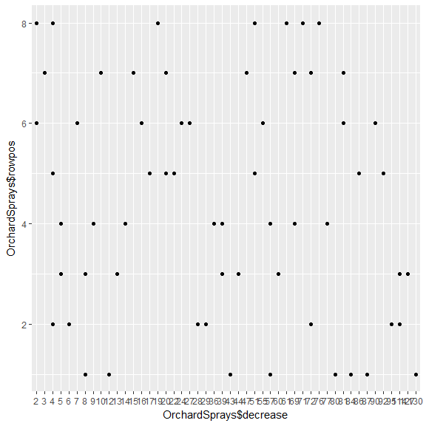

qplot(OrchardSprays$colpos,OrchardSprays$rowpos,geom = c("point", "smooth"))

## `geom_smooth()` using method = 'loess'

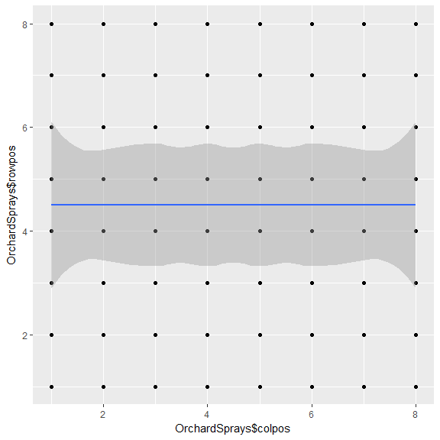

qplot(OrchardSprays$colpos,OrchardSprays$rowpos,geom = c("point", "smooth"),span=0.2)

## `geom_smooth()` using method = 'loess'

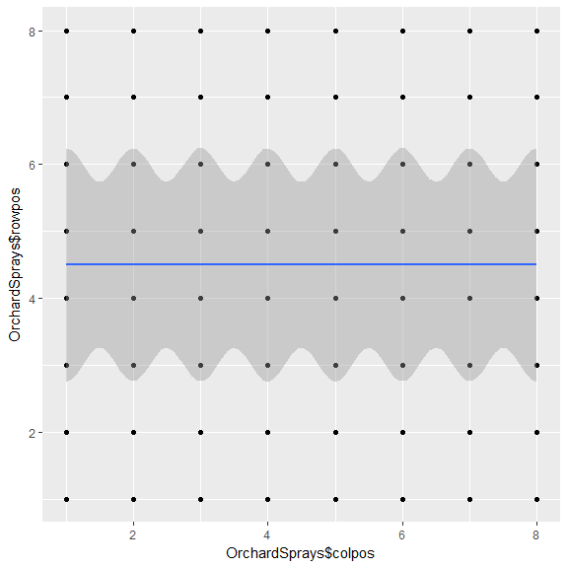

r boxplot(OrchardSprays$decrease,OrchardSprays$rowpos,OrchardSprays$colpos,OrchardSprays$treatment,main="boxplot") boxplot(OrchardSprays$colpos ~ OrchardSprays$rowpos,notch = TRUE, add = TRUE, col = "bisque")

## Warning in bxp(structure(list(stats = structure(c(1, 2.5, 4.5, 6.5, 8, 1, : ## some notches went outside hinges ('box'): maybe set notch=FALSE

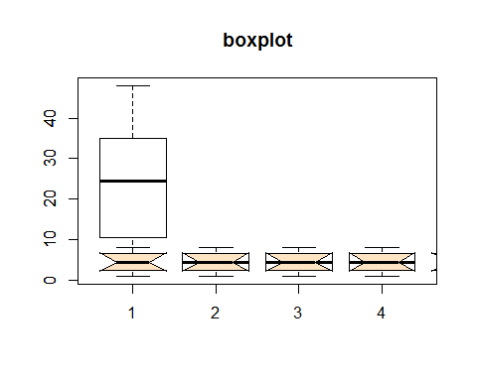

r attach(OrchardSprays) par(mfrow=c(2,2)) plot(OrchardSprays$decrease,OrchardSprays$rowpos, main="Scatterplot of decrease vs. rowpos") plot(OrchardSprays$rowpos,OrchardSprays$colpos, main="Scatterplot of rowpos vs colpos") hist(OrchardSprays$colpos, main="Histogram of colpos") boxplot(OrchardSprays$rowpos, main="Boxplot of rowpos")

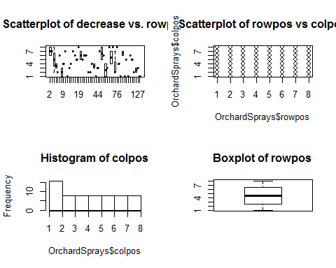

r pairs(OrchardSprays,main = "Pairs matrix", pch = 21, bg = c("red", "green3", "blue", "yellow"))

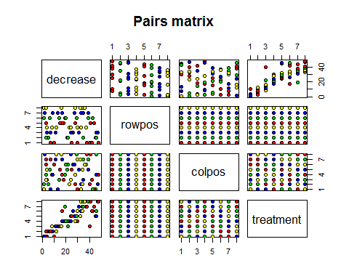

r library(scatterplot3d) attach(OrchardSprays)

## The following objects are masked from OrchardSprays (pos = 4): ## ## colpos, decrease, rowpos, treatment

r scatterplot3d(OrchardSprays$rowpos,OrchardSprays$colpos,OrchardSprays$decrease,main="scatterplot in 3d",pch=16, highlight.3d=TRUE,col.grid = "lightblue",type="h")

