

A Course End Project Report on
Employee Payroll System

A8602 -Object Oriented Programming Laboratory

Submitted by
Batch No. 4

Jatoth Sravani
(24881A05F5)
Vankalla Sai Lalitha Raam
(24881A05K1)
Mandaram Bhanu Prakash
(24881A0519)

Course Facilitator

Mr. K.Hari Babu
Assistant Professor

Department of Computer Science and Engineering
Vardhaman College of Engineering, Hyderabad
December 2025



Autonomous Institute, Affiliated to JNTUH,
Approved by AICTE, Accredited by NAAC with A++ Grade
Kacharam, Shamshabad, Hyderabad- 501 218,
Telangana, India.

DEPARTMENT OF COMPUTER SCIENCE AND ENGINEERING

This is to certify that the Course End Project titled “Employee Payroll System” is carried out by “Jatoth Sravani” , “Vankalla Sai Lalitha Raam” ,and “Mandaram Bhanu Prakash”, with Roll Numbers “24881A05F5”, “24881A05K1” ,and “24881A0519” towards A8602 -Object Oriented Programming Laboratory course in partial fulfillment of the requirements for the award of degree of Bachelor of Technology in Computer Science and Engineering during the Academic year 2025-26.

Signature of the HOD
Dr. Ramesh Karnati
Associate Professor, HOD, CSE

Signature of the Course Faculty
Mr. K Hari Babu
Assistant Professor, CSE

Contents
- Introduction 3
- Literature Review 3
- Objectives 3
- Methodology 3
  - Architectural Diagram 3
  - Hardware and Software Requirements 3
  - Working Principle 4
  - Software Implementation 4
- Results and Discussion 4
- Mapping POs and SDGs 5
  - Program Outcomes (POs) Mapping 5
  - Sustainable Development Goals (SDGs) Mapping 5
- Conclusion 5
Bibliography 6

Abstract

The Employee Payroll System is a Java-based Object-Oriented Programming (OOP) project designed to manage employee salary calculations and payslip generation efficiently. The system leverages abstraction, inheritance, encapsulation, and polymorphism to build a modular and maintainable structure. It automates the calculation of gross and net salaries for different categories of employees—permanent and contractual—using a simple graphical interface developed in Java Swing.

This project eliminates repetitive manual calculations by implementing automated formulas for HRA, DA, PF, and tax deductions. Through the integration of the iText library, the system can generate digital payslips in PDF format, promoting paperless operations. Overall, the project demonstrates the practical application of OOP concepts to real-world payroll systems.

Keywords: Java, Object-Oriented Programming, Payroll, Salary Automation, Encapsulation, Inheritance, Polymorphism, Swing, PDF Generation, iText.

Introduction

Payroll management is a core function of any organization that ensures employees are compensated accurately and on time. Traditional payroll processes often involve manual computations, spreadsheets, and human intervention, which may lead to data inconsistencies and inefficiencies. The Employee Payroll System aims to streamline this process using Java’s Object-Oriented Programming features and provide a desktop-based automation tool.

This system enables HR or administrative staff to enter employee details such as name, ID, and salary components. Depending on the employment type (Permanent or Contract), the system calculates the salary using predefined formulas. It applies various allowances and deductions, such as HRA, DA, PF, and taxes, to compute the final take-home salary. The GUI developed using Java Swing provides a friendly interface, while the backend logic applies OOP principles ensuring clarity and extensibility.

From an educational perspective, this project provides a practical demonstration of applying software design principles, modular coding, GUI programming, and file handling in Java.

Literature Review

Existing Payroll Systems:
Many organizations rely on spreadsheet-based or semi-manual payroll systems. These are prone to calculation errors, lack data validation, and are inefficient for handling multiple employee types. Previous systems were often hardcoded, offering little flexibility for modification or expansion.

Role of OOP in Payroll Automation:
Recent research and academic projects show that applying OOP concepts—such as inheritance and polymorphism—simplifies system extension. For example, when a new type of employee (e.g., part-time, intern) is introduced, it can be added by creating a subclass of the Employee class, reducing code duplication.

Use of Java Swing and iText:
Java Swing provides platform-independent GUI development, making it suitable for desktop applications. The iText or OpenPDF library is widely used for document generation, enabling professional PDF payslips that organizations can print or store digitally.

The literature suggests that combining GUI technology with strong OOP design yields efficient, user-friendly, and scalable payroll solutions..

Objectives

- To develop an object-oriented payroll management system using Java.

- To automate the calculation of gross and net salary for various employee categories.

- To design a Swing-based graphical user interface for data entry and salary display.

- To integrate PDF export functionality for payslip generation using iText.

- To demonstrate the real-world application of OOP principles in a business context.

Methodology

The methodology focuses on modular system development using Java and OOP principles.

Step 1: System Design

The architecture is built around an abstract Employee superclass with common attributes (ID, Name, Basic Salary).

Subclasses (PermanentEmployee, ContractEmployee) extend the base class to include specific attributes and salary computation logic.

Step 2: Salary Calculation Module

Each subclass implements its version of calculateGross() and calculateDeductions().

The calculateNet() method is inherited and used polymorphically.

Step 3: GUI Design (Java Swing)

A form-based interface allows users to enter details such as employee name, ID, salary, and type.

Buttons trigger calculation and PDF generation.

Step 4: Payslip Generation (iText/OpenPDF)

Data is formatted into a structured layout and exported as a PDF document.

Files are saved locally for record-keeping.

Step 5: Testing and Validation

The system is tested with multiple employee scenarios to verify correctness and stability.

Architectural Diagram

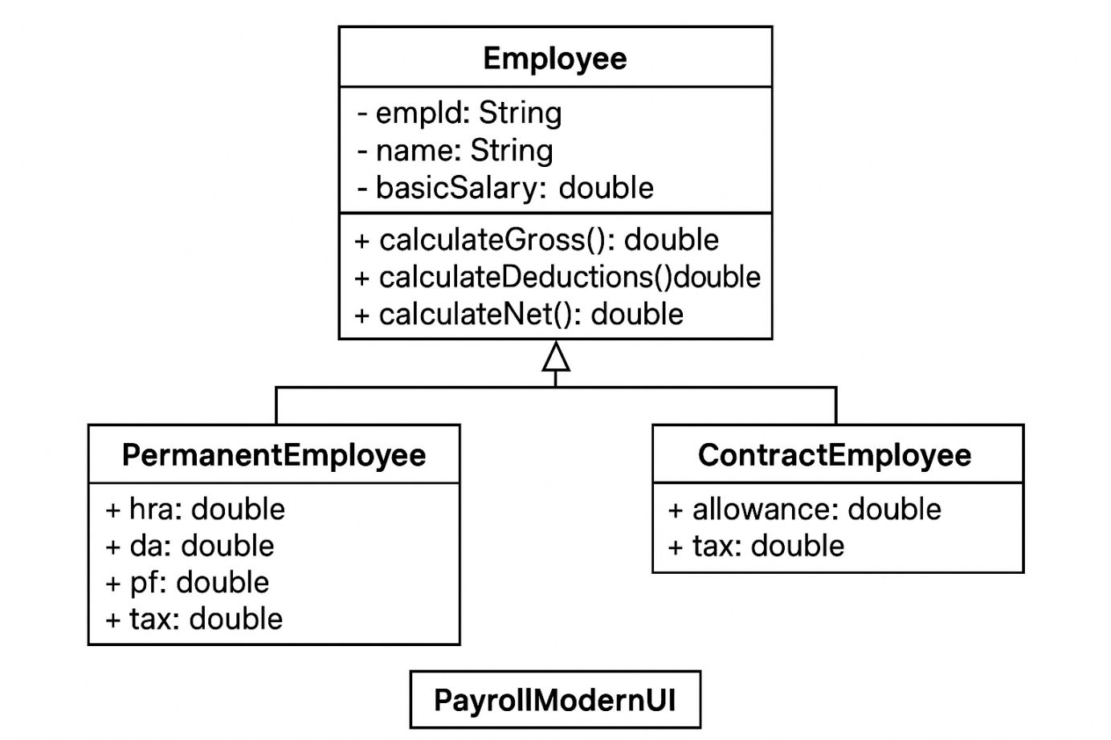

Figure 1: Architectural Diagram

Hardware and Software Requirements

Category | Specification
Processor | Intel i3 / AMD equivalent or higher
RAM | Minimum 4 GB
Storage | 500 MB available space
Operating System | Windows 10 / Ubuntu / macOS
IDE | VS Code / IntelliJ IDEA / NetBeans
Language | Java 8+
Libraries | iText / OpenPDF
Framework | Java Swing
Database (Optional) | MySQL or SQLite (future expansion)

Working Principle
User Input:
The admin enters employee details in the Swing GUI and selects the employee type (Permanent/Contractual).
Salary Calculation:

For Permanent Employees:
Gross = Basic + HRA + DA
Deductions = PF + Tax
Net = Gross - Deductions
For Contract Employees:

Gross = Basic + Allowance
Deductions = Tax
Net = Gross - Deductions
Data Display:
The computed values are displayed in real-time on the GUI.

Payslip Generation:
On clicking "Generate Payslip", the system uses iText to create a structured PDF with all details.

Software Implementation

import javax.swing.*;
import java.awt.*;

public class PayrollModernUI {
public static void main(String[] args) {
SwingUtilities.invokeLater(PayrollModernUI::new);
}

public PayrollModernUI() {
JFrame frame = new JFrame("Employee Payroll System");
frame.setDefaultCloseOperation(JFrame.EXIT_ON_CLOSE);
frame.setSize(900, 450);
frame.setLocationRelativeTo(null);

// Main Panel
JPanel mainPanel = new JPanel(new GridBagLayout());
mainPanel.setBackground(new Color(245, 249, 255));
GridBagConstraints gbc = new GridBagConstraints();
gbc.insets = new Insets(10, 20, 10, 20);
gbc.fill = GridBagConstraints.HORIZONTAL;

// LEFT SIDE (Employee Details)
JLabel titleLabel = new JLabel("Employee Payroll System");
titleLabel.setFont(new Font("Segoe UI", Font.BOLD, 20));
titleLabel.setForeground(new Color(40, 40, 90));
gbc.gridx = 0; gbc.gridy = 0; gbc.gridwidth = 2;
mainPanel.add(titleLabel, gbc);

gbc.gridwidth = 1;
JLabel idLabel = new JLabel("Employee ID:");
JTextField idField = new JTextField(15);
JLabel nameLabel = new JLabel("Name:");
JTextField nameField = new JTextField(15);
JLabel salaryLabel = new JLabel("Basic Salary:");
JTextField salaryField = new JTextField(15);
JLabel typeLabel = new JLabel("Employee Type:");
JComboBox<String> typeBox = new JComboBox<>(new String[]{"Permanent", "Contractual"});

gbc.gridy = 1; gbc.gridx = 0; mainPanel.add(idLabel, gbc);
gbc.gridx = 1; mainPanel.add(idField, gbc);
gbc.gridy++; gbc.gridx = 0; mainPanel.add(nameLabel, gbc);
gbc.gridx = 1; mainPanel.add(nameField, gbc);
gbc.gridy++; gbc.gridx = 0; mainPanel.add(salaryLabel, gbc);
gbc.gridx = 1; mainPanel.add(salaryField, gbc);
gbc.gridy++; gbc.gridx = 0; mainPanel.add(typeLabel, gbc);
gbc.gridx = 1; mainPanel.add(typeBox, gbc);

// BUTTONS
JButton generateButton = new JButton("Generate Payslip");
JButton clearButton = new JButton("Clear");
generateButton.setBackground(new Color(70, 130, 255));
generateButton.setForeground(Color.WHITE);
clearButton.setBackground(new Color(220, 80, 80));
clearButton.setForeground(Color.WHITE);
generateButton.setFocusPainted(false);
clearButton.setFocusPainted(false);

JPanel buttonPanel = new JPanel();
buttonPanel.setBackground(mainPanel.getBackground());
buttonPanel.add(generateButton);
buttonPanel.add(clearButton);

gbc.gridy++; gbc.gridx = 0; gbc.gridwidth = 2;
mainPanel.add(buttonPanel, gbc);

// (Payslip Display)
JTextArea payslipArea = new JTextArea(12, 25);
payslipArea.setFont(new Font("Consolas", Font.PLAIN, 14));
payslipArea.setEditable(false);
payslipArea.setBorder(BorderFactory.createTitledBorder("Payslip"));
payslipArea.setBackground(Color.WHITE);

gbc.gridx = 2; gbc.gridy = 1;
gbc.gridheight = 5; gbc.gridwidth = 1;
gbc.fill = GridBagConstraints.BOTH;
mainPanel.add(payslipArea, gbc);

//ACTIONS
generateButton.addActionListener(e -> {
try {
String name = nameField.getText();
double basic = Double.parseDouble(salaryField.getText());
String type = (String) typeBox.getSelectedItem();

double gross, deductions, net;
if ("Permanent".equals(type)) {
gross = basic + (basic * 0.30);
deductions = basic * 0.10;
} else {
gross = basic + (basic * 0.10);
deductions = basic * 0.05;
}
net = gross - deductions;

payslipArea.setText("===== PAYSLIP =====\n" +
"Employee ID : " + idField.getText() + "\n" +
"Name : " + name + "\n" +
"Type : " + type + "\n\n" +
"Gross Salary: ₹" + gross + "\n" +
"Deductions : ₹" + deductions + "\n" +
"Net Salary : ₹" + net + "\n====================");
} catch (Exception ex) {
JOptionPane.showMessageDialog(frame, "Please enter valid details!");
}
});

clearButton.addActionListener(e -> {
idField.setText("");
nameField.setText("");
salaryField.setText("");
typeBox.setSelectedIndex(0);
payslipArea.setText("");
});

frame.add(mainPanel);
frame.setVisible(true);
}
}

GUI Component:
Text fields for employee ID, name, salary.
Dropdown for employee type.
Buttons for “Calculate Salary” and “Generate Payslip.”

Results and Discussion

Key Achievements:

Automated salary computation for both employee types.

Generated accurate payslips in PDF format.

Demonstrated modular, scalable OOP architecture.

Benefits:
Eliminates manual errors and computation delays.

Enhances data management and digital documentation.

GUI makes interaction intuitive for non-technical staff.

Limitations:

Lacks database connectivity (currently file-based).

Only desktop version; not web or cloud-enabled.

Future Scope:

Add a database (MySQL) for employee record storage.

Include authentication for admin and HR users.

Enable cloud synchronization for remote access.

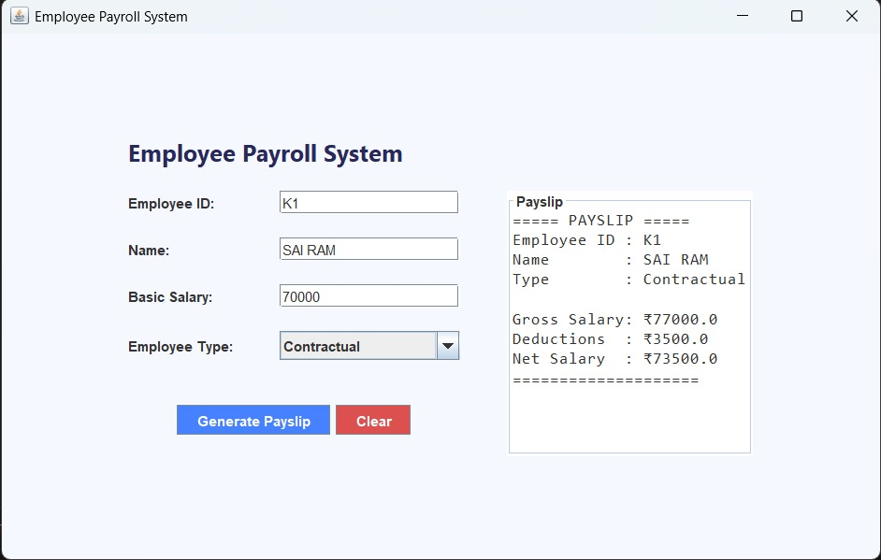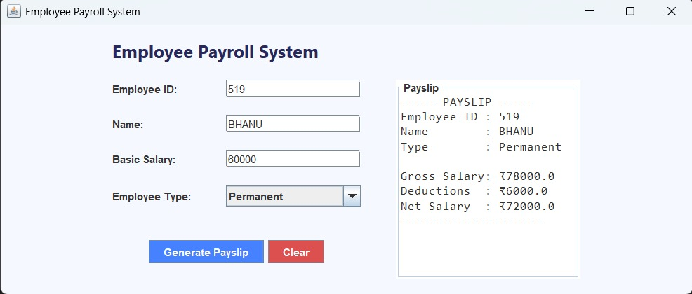

Mapping POs and SDGs

Program Outcomes (POs) Mapping

PO | Outcome | Relevance to Project
PO1 | Engineering Knowledge | Applied core OOP concepts and software design techniques.
PO2 | Problem Analysis | Analyzed manual payroll challenges and developed an automated solution.
PO3 | Design/Development of Solutions | Designed scalable class hierarchies using inheritance and abstraction.
PO4 | Investigations of Complex Problems | Tested logic for multiple salary configurations.
PO5 | Engineering Tool Usage | Used Java Swing and iText libraries effectively.
PO6 | The Engineer and The World | Provides practical automation for local businesses.
PO8 | Team Work | Encouraged collaboration in design and implementation.
PO10 | Project Management and Finance | Automated payroll operations, contributing to better financial control.
PO11 | Life-Long Learning | Builds skills applicable to enterprise software development.

Sustainable Development Goals (SDGs) Mapping

SDG No. | Goal | Relevance
SDG 4 | Quality Education | Serves as an educational model for applying OOP in real-world systems.
SDG 8 | Decent Work and Economic Growth | Supports fair and efficient payroll management.
SDG 9 | Industry, Innovation, and Infrastructure | Promotes software-driven innovation in business operations.

Conclusion

The Employee Payroll System successfully integrates object-oriented design and Java technologies to automate employee salary management. The use of abstraction and inheritance ensures reusability, while Swing provides an interactive user interface. This project demonstrates how software engineering principles can solve practical business problems. Future improvements can include database integration, multi-user login, and cloud-based storage for enhanced scalability.

Bibliography

- Schildt, Herbert. Java: The Complete Reference, McGraw-Hill Education.

- Oracle Java Documentation – https://docs.oracle.com/javase

- TutorialsPoint – Java Swing Tutorial.

- iText PDF Library – https://itextpdf.com/

- OpenPDF Documentation – https://github.com/LibrePDF/OpenPDF

