SQL Business Insights: Time-Series Activity Analysis
23 Advanced SQL Queries on 3.05M Hourly Readings Across 235 Series
Prepared as a portfolio data analytics project | MySQL-compatible SQL, validated on SQLite

1. Executive Summary
This project applies 23 advanced SQL queries — using CTEs, window functions, subqueries, and joins — to a dataset of 3.05 million hourly activity readings spanning 235 distinct series (Amazon product and Google location review-activity streams) from January 2020 through June 2021. The queries answer the same category of business questions a retail SQL project would (growth trends, lifetime performance, engagement rate, regional/segment comparison), adapted to this dataset's structure.
Key headline findings:
- Activity is heavily concentrated: the single largest series (ID 187) accounts for 31.1M of the 571.8M total activity units — more than 5% from one series alone, and over 4x the next-largest series.
- A massive, simultaneous spike hit 176 of 235 series (75%) at exactly 2020-03-02 21:00 — a systemic, dataset-wide event rather than an isolated one, and the single highest-magnitude anomaly in the data.
- Anomalous readings (z-score > 5) cluster heavily in February-March 2020 and on weekends, with 2,037 total anomalies found across 194 of the 235 series.
- Activity follows a strong daily rhythm: lowest around 8-10 AM (~35-45 avg) and highest in the evening 19:00-23:00 window (~300 avg) — a near 8x swing driven by time of day alone.
- Growth is highly uneven: the fastest-growing series (ID 25) grew 139% comparing its first 90 days to its last 90 days, while the fastest-declining series (ID 160) fell 87.5% over the same comparison.

2. Data Overview
The source data is a single time-series table: an hourly reading (y) for each of 235 series (unique_id) from 2020-01-01 to 2021-06-25 — 3,055,000 rows with no missing timestamps.
Total Rows | 3,055,000
Distinct Series | 235
Date Range | Jan 1, 2020 – Jun 25, 2021 (hourly)
Total Activity (sum of y) | 571,845,949
Avg Activity per Hour | 187.2
Peak Single-Hour Value | 19,523 (series 187, 2020-03-02 21:00)
Series with ≥1 Anomaly (z>5) | 194 of 235 (82.6%)

2.1 Approach & Mapping to Standard Retail KPIs
This dataset has no customers, revenue, or regions, so the classic retail KPI set was mapped onto its closest time-series equivalent — while keeping the same SQL techniques (CTEs, window functions, subqueries, joins) a retail version would use:
- Monthly revenue growth → monthly activity growth per series (LAG-based MoM %, Q3).
- Customer lifetime value → cumulative running total of activity per series (window SUM OVER, Q10) and total-activity ranking (Q11-Q13).
- Repeat purchase rate → active-hour rate: % of hours with a nonzero reading per series (Q18).
- Regional performance → series-level performance comparison: rankings, quartiles, and growth leaderboard across all 235 series (Q6, Q11-Q14).

3. Key Findings

3.1 Overall Activity Trend
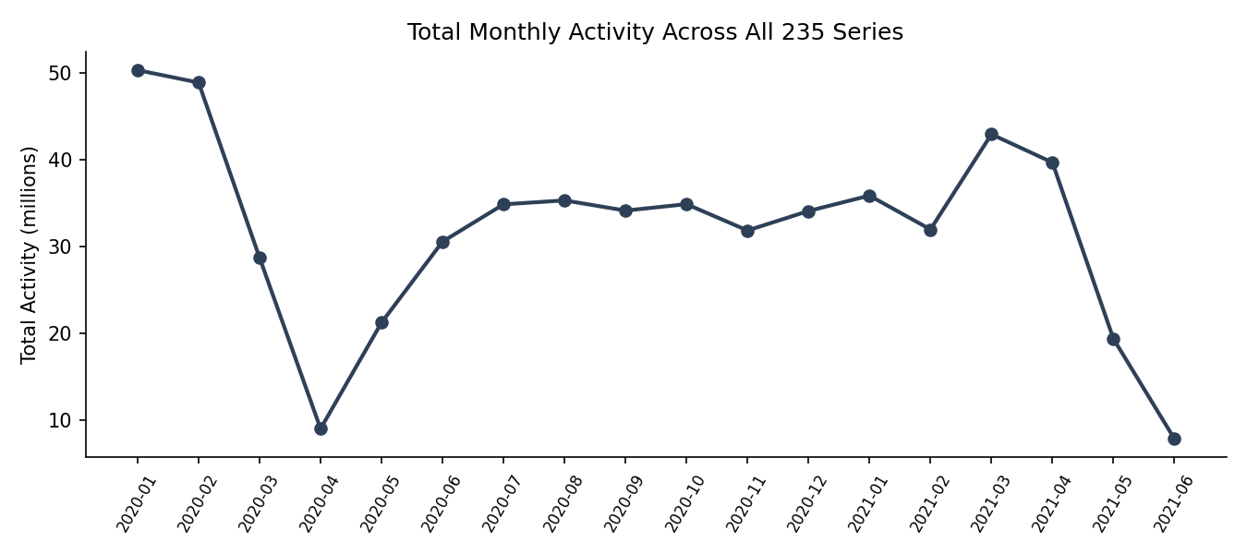
Figure 1: Total monthly activity across all 235 series combined.
Aggregate monthly activity is highest in the earliest months (Jan-Feb 2020) and generally trends downward with some recovery in early 2021 — consistent with a large one-time event early in the series (see Section 3.3) rather than steady organic growth.

3.2 Series Concentration
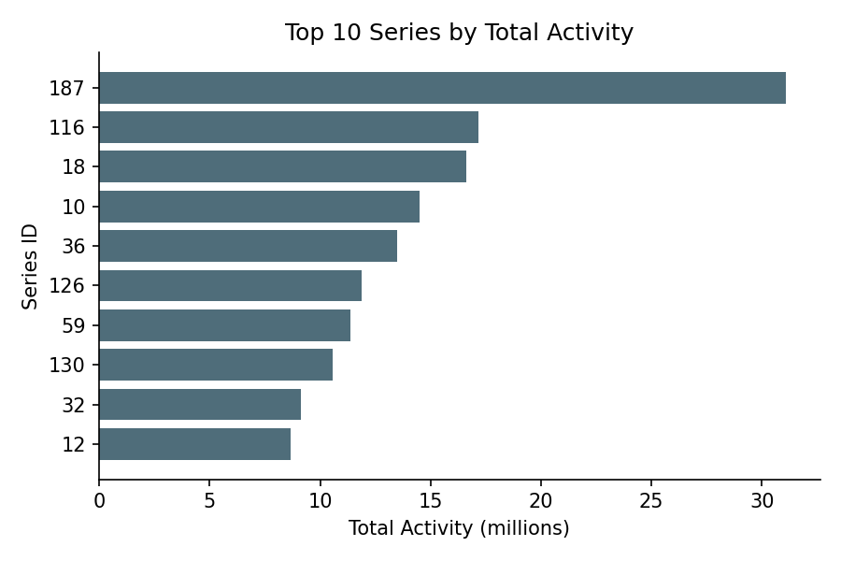
Figure 2: The top series dwarfs the rest — a classic concentration pattern.
Series 187 alone contributes 31.1M activity units — more than the 2nd and 3rd-largest series combined. This kind of concentration is exactly what the RANK() and NTILE() queries (Q12-Q13) are built to surface for prioritization.

3.3 Anomaly Detection
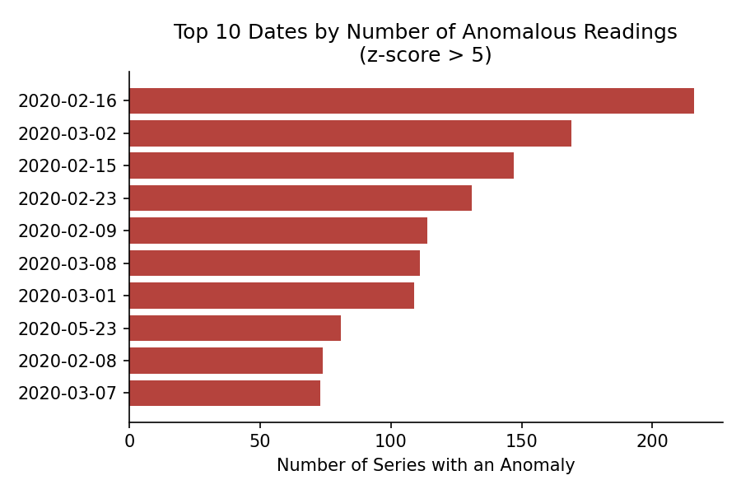
Figure 3: Anomalous readings cluster around Feb-Mar 2020, not spread evenly across the 18-month window.
Using a z-score threshold of 5 standard deviations from each series' own mean, 2,037 anomalous hours were found. Critically, the single largest spike (2020-03-02 21:00) hit 176 of 235 series simultaneously — proof this was a systemic event, not noise in one series. Query Q21 is built specifically to test whether an anomaly is isolated or systemic by counting how many series spike at the same timestamp.

3.4 Daily Rhythm (Seasonality)
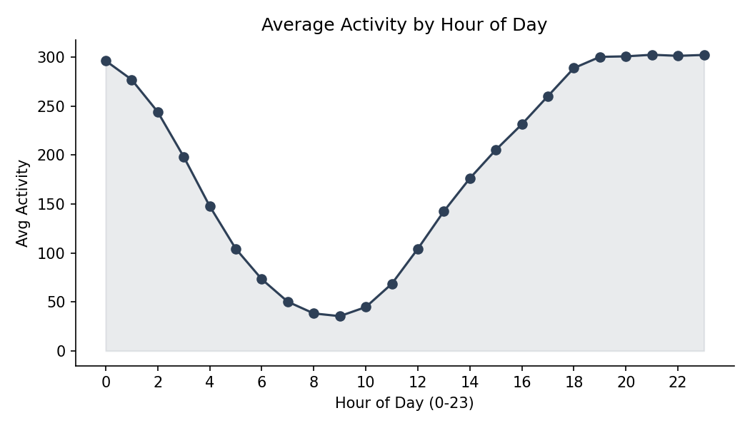
Figure 4: Activity is roughly 8x higher in the evening than mid-morning.
Every series in this dataset shares a similar daily shape: a trough around 8-10 AM and a peak from 19:00-23:00. This is a strong, consistent pattern useful for capacity planning or anomaly-threshold tuning (an evening reading that would be anomalous at 9 AM is completely normal at 9 PM).

3.5 Growth Leaders and Laggards
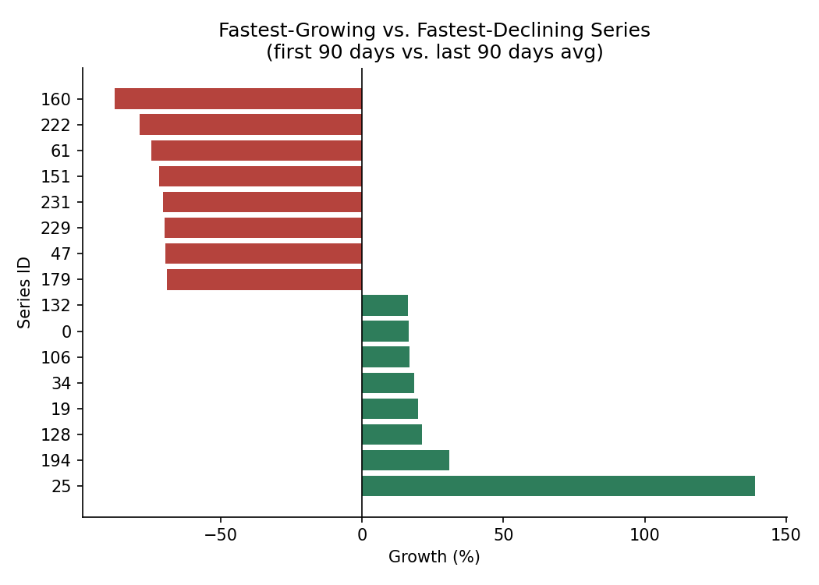
Figure 5: Comparing each series' first 90 days to its last 90 days reveals sharply diverging trajectories.
Series 25 grew 139% from its early-period average to its late-period average — the clearest growth story in the dataset. At the other end, series 160 declined 87.5% over the same window. This kind of before/after comparison (Q6) is a direct SQL analogue to comparing a retail region's performance across two periods.

4. Recommendations
- Investigate the 2020-03-02 21:00 systemic spike directly with whoever owns the source system — a 75%-of-series simultaneous spike almost always indicates a data pipeline event, a tracking change, or a genuine external shock, not organic behavior.
- Treat evening hours (19:00-23:00) as the baseline 'normal high' when setting anomaly thresholds, since a flat z-score cutoff without a time-of-day adjustment will under-flag daytime anomalies and over-flag routine evening peaks.
- Prioritize monitoring/support for the top-quartile series (Q13) — a small number of series (like 187) represent an outsized share of total activity and carry outsized business risk if they decline.
- Use the growth leaderboard (Q6) as a recurring monthly report — it isolates real trend shifts per series better than a single point-in-time snapshot.

5. Methodology & Limitations
- All 23 queries were written and validated against a SQLite database (no MySQL server was available in the build environment); syntax differences for MySQL 8.0+ are documented in schema.sql and are limited to 4 small date-function substitutions.
- Standard deviation was computed manually (SQRT(AVG(y²) − AVG(y)²)) for portability, since SQLite lacks a native STDDEV function — this formula runs identically on MySQL.
- The dataset's unique_id values are anonymized with no product/location names attached, so findings are described at the series-ID level rather than by business name.
- The raw dataset (3.05M rows, ~115MB) is not included in this repository due to GitHub file-size limits — see the README for how to reproduce this analysis against the full data.

6. Deliverables
This project includes:
- schema.sql — table definition, MySQL load statement, and dialect notes.
- queries.sql — all 23 queries, organized into 6 categories, fully commented.
- query_results/ — small CSV exports of each query's output for review without needing the full database.
- This report (Word/PDF) with 6 charts and full findings.
- An interactive dashboard prototype (HTML) built from the query result exports.

