Global Supply Chain Performance Analysis
Exploratory Data Analysis & Business Insights Report
Prepared as a portfolio data analytics project | Dataset: 100 SKUs across cosmetics, skincare, and haircare product lines

1. Executive Summary
This report analyzes a supply chain dataset covering 100 SKUs across three product categories (skincare, haircare, cosmetics), tracking the full chain from manufacturing and supplier performance through shipping and final revenue. The goal is to identify where cost, quality, and delivery-time risks are concentrated, and to surface opportunities to improve margins and reliability.
Key headline findings:
- Skincare drives the most total revenue ($241.6K) despite not having the highest margin, because of volume — it sold ~21K units, well above haircare (13.6K) and cosmetics (11.8K).
- Average profit margin across all SKUs is strong at 87.4%, but it ranges widely (48.5% to 98.9%), meaning a subset of products are far less profitable than the rest.
- Supplier 5 has the highest average defect rate (2.67%) while Supplier 1 has the lowest (1.80%) — a ~48% gap between best and worst supplier.
- 77% of inspected batches are not yet passed (41% Pending, 36% Fail, only 23% Pass), pointing to a quality-control bottleneck worth investigating operationally.
- Air freight is the most expensive shipping mode on average ($6.02) while sea freight is cheapest ($4.97), a gap relevant to cost-to-serve decisions.

2. Data Overview
The dataset contains 100 records and 24 original columns spanning product attributes, sales, supplier and manufacturing details, quality inspection outcomes, and logistics costs. No missing values or duplicate rows were found.
Total Records | 100 SKUs
Product Categories | Skincare, Haircare, Cosmetics
Suppliers | 5 (Supplier 1–5)
Locations | Mumbai, Delhi, Bangalore, Chennai, Kolkata
Transportation Modes | Road, Air, Rail, Sea
Total Revenue (dataset) | $577,604.82
Total Cost (dataset) | $52,924.58
Missing Values | None
Duplicate Rows | None

2.1 Cleaning Notes
- The source file contains two similarly-named columns — "Lead times" and "Lead time" — that are NOT duplicates (correlation ≈ 0); they were renamed to "Supplier Lead Time (days)" and "Order Lead Time (days)" respectively to avoid ambiguity for anyone building on this dataset.
- Added calculated fields: Profit, Profit Margin %, Revenue per Unit, Cost per Unit, Total Lead Time (sum of supplier + manufacturing + shipping lead time), a Stockout Risk flag (stock levels below order quantity), and a High Defect flag (above-average defect rate).
- All numeric fields were validated as non-negative and within plausible ranges (e.g., defect rates 0–5%, prices $4–$100).

3. Key Findings

3.1 Revenue by Product Type
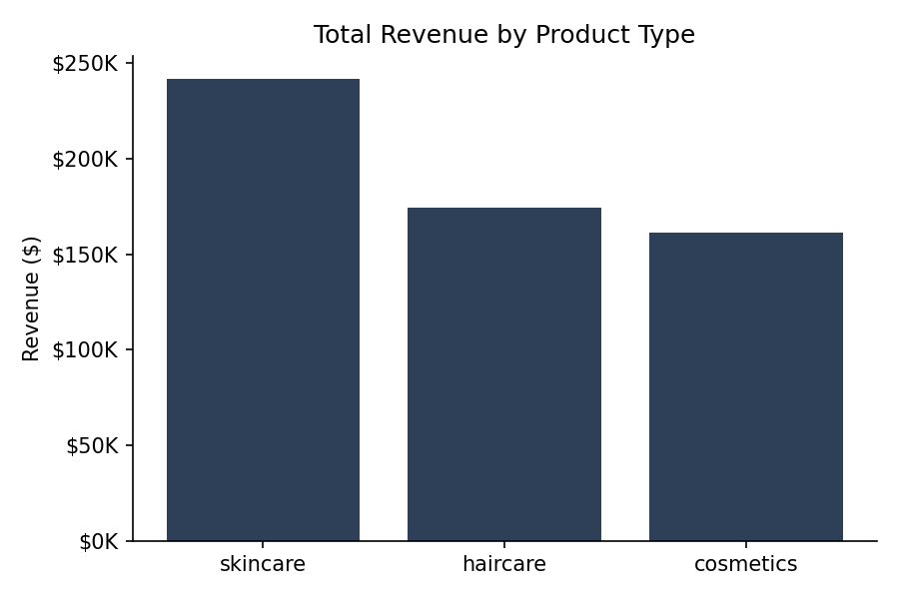
Figure 1: Skincare leads total revenue on the strength of unit volume, not premium pricing.
Skincare generated $241.6K in revenue (42% of the total), ahead of haircare ($174.5K) and cosmetics ($161.5K). Interestingly, cosmetics has the highest average profit per unit sold despite the lowest total revenue — suggesting a smaller but more profitable line.

3.2 Supplier Quality Performance
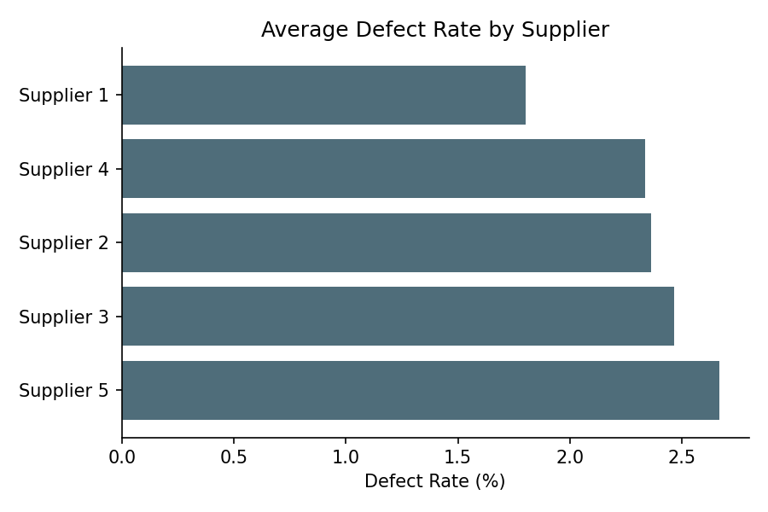
Figure 2: Defect rate spread across the five suppliers.
Supplier 1 is the clear quality leader at a 1.80% average defect rate; Supplier 5 trails at 2.67%. Since defect rate directly affects rework cost and customer returns, this ~0.9pt gap is a natural place to start supplier renegotiation or increased inspection sampling.

3.3 Shipping Cost by Transportation Mode
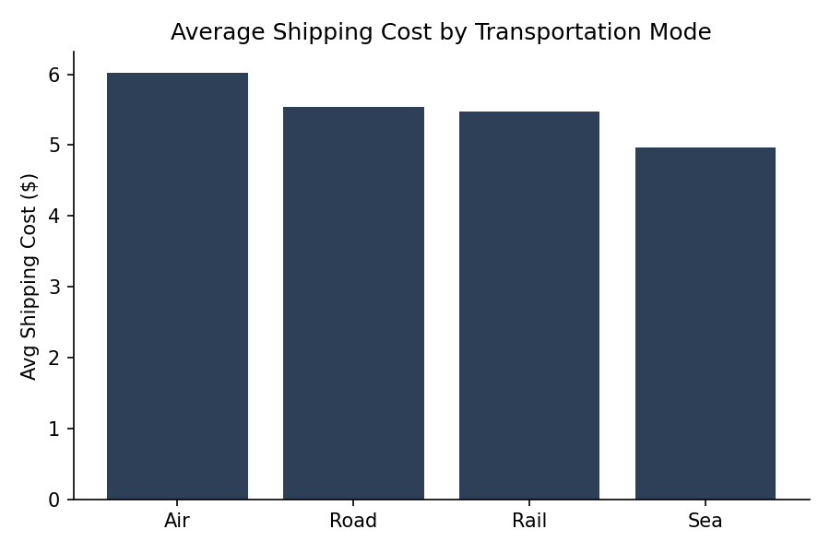
Figure 3: Sea freight is the cheapest mode on average; air is the most expensive.
Air freight costs ~21% more per shipment than sea freight on average. Where lead-time requirements allow, shifting volume from air to rail or sea is the most direct lever for cutting logistics cost.

3.4 Inspection Outcomes
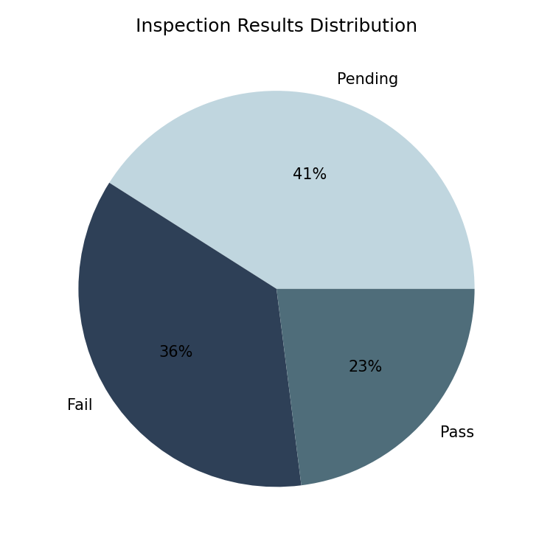
Figure 4: Only 23% of inspected batches have a confirmed Pass.
36% of batches failed inspection outright, and 41% remain Pending. This is the single largest operational flag in the dataset — a large pending backlog can mask real fail rates and delay time-to-market.

3.5 Revenue by Location
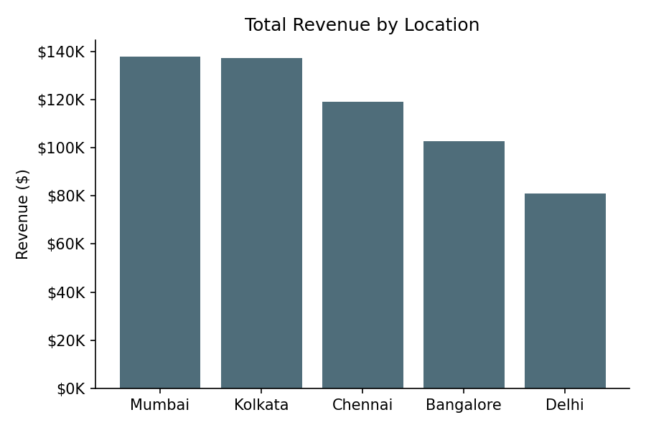
Figure 5: Mumbai and Kolkata are the top two revenue-generating locations.
Mumbai ($137.8K) and Kolkata ($137.1K) are nearly tied for the top revenue location, while Delhi trails at $81.0K — a ~41% gap between the top and bottom location worth investigating (demand, distribution reach, or local supplier mix).

3.6 Price vs. Defect Rate
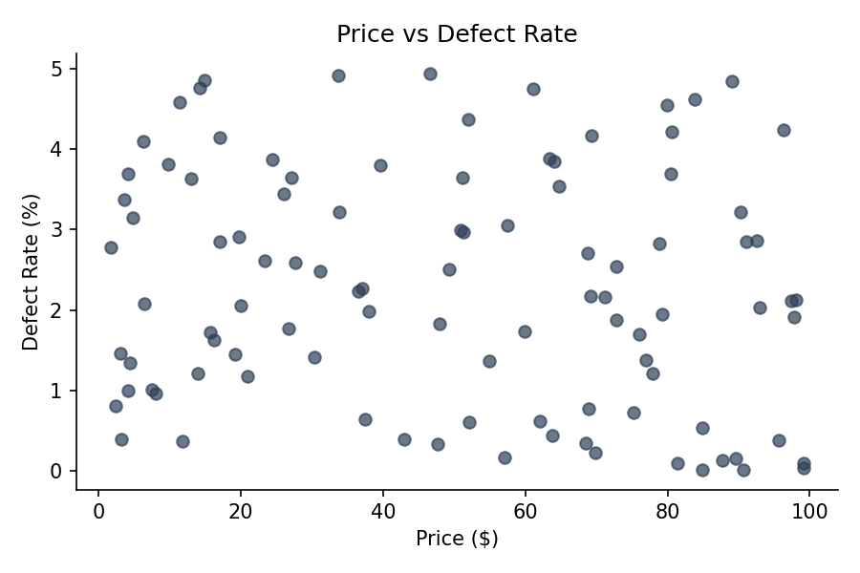
Figure 6: No strong linear relationship between price and defect rate in this sample.
Price and defect rate show no strong correlation in this dataset, indicating that higher-priced SKUs are not automatically higher quality — quality drivers here are more closely tied to supplier and inspection process than to price point.

4. Recommendations
- Investigate Supplier 5's process or renegotiate terms — closing even half the gap to Supplier 1's defect rate would meaningfully cut rework/return costs.
- Audit the inspection pipeline: a 41% Pending rate suggests a bottleneck. Clarify SLAs for inspection turnaround so 'Pending' doesn't silently mask failures.
- Reassess transportation mix: shift non-urgent shipments from Air to Rail/Sea to reduce average shipping cost.
- Protect and expand the Cosmetics line — highest per-unit profitability with room to grow in volume.
- Study Delhi's underperformance relative to Mumbai/Kolkata to see if it's a demand, distribution, or supplier-mix issue.

5. Methodology & Limitations
- Analysis performed in Python (pandas) for cleaning and aggregation, matplotlib for visualization.
- Sample size is 100 SKUs — a single snapshot, not a time series, so trend claims are not possible from this dataset alone.
- Categorical breakdowns (by supplier, location, mode) are based on averages/sums across the available rows and should be validated against a larger, time-stamped dataset before use in operational decisions.

6. Deliverables
This project includes:
- Cleaned dataset (Excel & CSV) with calculated fields, ready to import into Power BI or Tableau.
- This EDA report (Word/PDF).
- An interactive dashboard prototype (HTML) and a step-by-step Power BI build guide with exact fields, chart types, and DAX measures.
- A GitHub-ready README for portfolio presentation.

