**JAVA SWING BASED – IPL DATA BASE MANAGEMENT SYSTEM-SQL**

**CONNECTIVITY USING JDBC**

*A*

*Report*

*Submitted in partial fulfilment of the*

*Requirements for the award of the Degree of*

***BACHELOR OF TECHNOLOGY***

***IN***

**INFORMATION TECHNOLOGY**

By

**M. SAILAXMI <1602-20-737-034>**

**Under the Guidance of**

**B. Leelavathy**



**Department of Information Technology**

**Vasavi College of Engineering (Autonomous)**

**(Affiliated to Osmania University)**

**Ibrahimbagh, Hyderabad-31**

**2021-2022**

# BONAFIDE CERTIFICATE

This to Certify that the project report titled **IPL DATA BASE MANAGEMENT SYSTEM”**

project work of M.SAILAXMI bearing Roll.no:1602-20-737-034 who carried out this project under my supervision in the IV semester for the academic year 2021-2022.

*Signature*   *Signature*   *external examiner internal examiner*

**ABSTRACT:**

Indian premier League database system utilizes ipl database that allow analyst to incorporate functions that are used by ipl application to fetch and view information. As Ipl gains more popularity, it attracts more endorsement for each team. So prediction of a match result is very crucial to a point. In this project we build a Logistic model by which it has been shown that for a particular team,best winning strategty , player roles, scoring as many run as a possible with a good strike rate and no of winnings per team.

**Introduction: REQUIREMENT ANALYSIS**

List of tables:

1. Owner ipl

2.Team

3.Player

4.rolls

5.Staff

6.Match

7.Venue

8.performance

List of attributes with their domain types:

owner ipl

* ownerid number(5)
* oname varchar2(15)
* oaddress varchar2(15)

Team

* Teamid number(5)
* Tname varchar2(10)
* ownerid number(5)
* noplayers number(2)

player

* playerid number(5)
* pname varchar2(15)
* pnationality varchar2(10)
* pexperience number(2)
* teamid number(5)

Helping staff

* staffid number(5)
* workname varchar2(9)
* nostaff number(2)

Rolls

* playerid number(5)
* rollplayed varchar2(10)

Match

* matchid number(5)
* teamid number(5)

Venue

* venueid number(5)
* vname varchar2(10)
* vaddress varchar2(10)

Performance

* pid number(5)
* matchid number(5)
* runsavg number(5)
* wktavg number(5)
* catchesavg number(5)

Date : day-date **THROUGH THE PROJECT:**

This project helps to store data in a efficient way and it can be achieved through various sql commands and we can also store this for any future use and also we can save our data in a many different areas so we cannot lost all the data at once it gives us a clear picture about ipl data base regarding players teams winnings to retrive the data through data base at any point.

**ARCHITECTURE AND TECHNOLOGY USED:**

**SOFTWARE USED:**

Java Eclipse, Oracle 11g Database, Java SE version 8,SQL Plus.

**Java SWING:**

**Swing** is a GUI widget toolkit for Java. It is part of Oracle's Java Foundation Classes (JFC) – an API for providing a graphical user interface (GUI) for Java programs.

Swing was developed to provide a more sophisticated set of GUI components than the earlier AWT. Swing provides a look and feel that emulates the look and feel of several platforms, and also supports a pluggable look and feel that allows applications to have a look and feel unrelated to the underlying platform. It has more powerful and flexible components than AWT. In addition to familiar components such as buttons, check boxes and labels, Swing provides several advanced components such as tabbed panel, scroll panes, trees, tables, and lists.

**SQL:**

Structure Query Language (SQL) is a database query language used for storing and managing data in Relational DBMS. SQL was the first commercial language introduced for E.F Codd's **Relational** model of database. Today almost all RDBMS (MySql, Oracle, Infomix, Sybase, MS Access) use **SQL** as the standard database query language. SQL is used to perform all types of data operations in RDBMS.

**Java-SQL Connectivity using JDBC:**

**Java Database Connectivity** (**JDBC**) is an application programming interface (API) for the programming language Java, which defines how a client may access a database. It is a Java-based data access technology used for Java database connectivity. It is part of the Java Standard Edition platform, from Oracle Corporation. It provides methods to query and update data in a database and is oriented towards relational databases.

The connection to the database can be performed using Java programming (JDBC API) as:

Thus, the connection from Java to Oracle database is performed and therefore, can be used for updating tables in the database directly.

**package** ipl;

**import** java.sql.Connection;

**import** java.sql.DriverManager;

**import** java.sql.SQLException;

**import** javax.swing.JOptionPane;

**import** java.sql.*;

**public** **class** demo {

Connection con=**null**;

**public** **static** Connection db() {

**try**{

//step1 load the driver class

Class.*forName*("oracle.jdbc.driver.OracleDriver");

//step2 create the connection sailobject

Connection con=DriverManager.*getConnection*("jdbc:oracle:thin:@localhost:1521/XE","sailaxmi","vasavi");

//JOptionPane.showMessageDialog(null, "success");

**return** con;

}**catch**(Exception e){ System.***out***.println(e);

**return** **null**;}

}

}

**Table Created in SQL for above mentioned purpose is as:**

SQL> create table owneripl (ownerid number(5) primary key,oname varchar(15),oaddress varchar(15));

Table created.

SQL> .create table team(teamid number(5) primary key,tname varchar(10),ownerid number(5) references owneripl(ownerid),noplayers number(2));

Table created.

SQL> create table player(playerid number(5) primary key,pname varchar(15),pnationality varchar(10),pexperience number(2),teamid number(5) references team(teamid));

Table created.

SQL> create table helpingstaff(staffid number(5) primary key, workname varchar(9),nostaff number(2));

Table created.

SQL> create table rolls(playerid number(5) references player(playerid),rollplayed varchar(10));

Table created.

SQL> create table match(matchid number(5) primary key,teamid number(5) references team(teamid));

Table created.

SQL> create table venue(venueid number(5) primary key,vname varchar(10), vaddress varchar(10));

Table created.

SQL> .create table performance(pid number(5) references player(playerid),matchid number(5) references match(matchid),runsavg number(5),wktavg number(5),catchesavg number(5));

Table created.

SQL>

Table altered.

SQL>

Table altered.

SQL>

Table altered.

**DESIGN:**

**ER DIAGRAM:**

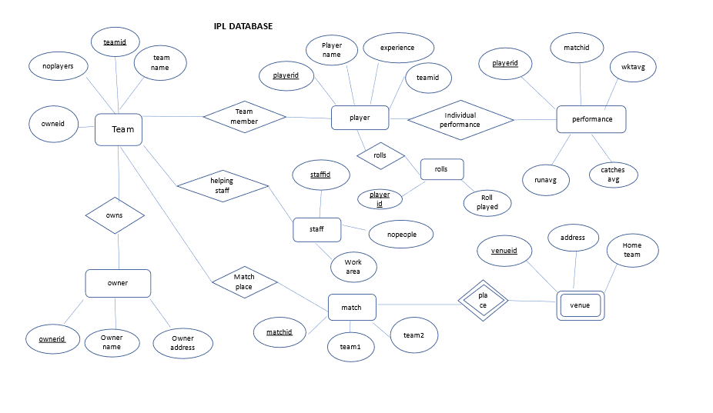

**Database Design:**

SQL> select * from tab;

TNAME TABTYPE CLUSTERID

------------------------------ ------- ----------

ASSESS TABLE

COMPANY TABLE

FEEDBACK TABLE

GIVES TABLE

PRODUCT TABLE

SENDS TABLE

TEST TABLE

7 rows selected.

SQL> desc team

Name Null? Type

----------------------------------------- -------- ----------------------------

TEAMID NOT NULL NUMBER(5)

TNAME VARCHAR2(10)

OWNERID NUMBER(5)

NOPLAYERS NUMBER(2)

HOME VARCHAR2(10)

SQL> desc winnings

Name Null? Type

----------------------------------------- -------- ----------------------------

TEAMID NUMBER(5)

HIGHSCORE NUMBER(4)

NWINNINGS NUMBER(3)

SQL> desc rolls

Name Null? Type

----------------------------------------- -------- ----------------------------

PLAYERID NUMBER(5)

ROLLPLAYED VARCHAR2(10)

SQL> desc player

Name Null? Type

----------------------------------------- -------- ----------------------------

PLAYERID NOT NULL NUMBER(5)

PNAME VARCHAR2(15)

PNATIONALITY VARCHAR2(10)

PEXPERIENCE NUMBER(2)

TEAMID NUMBER(5)

SQL> desc performance

Name Null? Type

----------------------------------------- -------- ----------------------------

PID NUMBER(5)

MATCHID NUMBER(5)

RUNSAVG NUMBER(5)

WKTAVG NUMBER(5)

CATCHESAVG NUMBER(5)

SQL> desc match

Name Null? Type

----------------------------------------- -------- ----------------------------

MATCHID NOT NULL NUMBER(5)

TEAMID NUMBER(5)

SQL> desc helpingstaff

Name Null? Type

----------------------------------------- -------- ----------------------------

STAFFID NOT NULL NUMBER(5)

WORKNAME VARCHAR2(9)

NOSTAFF NUMBER(2)

SQL> desc venue

Name Null? Type

----------------------------------------- -------- ----------------------------

VENUEID NOT NULL NUMBER(5)

VNAME VARCHAR2(10)

VADDRESS VARCHAR2(10)

SQL> desc owneripl

Name Null? Type

----------------------------------------- -------- ----------------------------

OWNERID NOT NULL NUMBER(5)

ONAME VARCHAR2(15)

OADDRESS VARCHAR2(15)

**Implementation:**

**Program:**

**Options.java**

**package** ipl;

**import** java.awt.EventQueue;

**import** javax.swing.JFrame;

**import** javax.swing.JLabel;

**import** javax.swing.JOptionPane;

**import** java.awt.Font;

**import** javax.swing.JButton;

**import** javax.swing.ImageIcon;

**import** java.awt.event.ActionListener;

**import** java.awt.event.ActionEvent;

**public** **class** options {

**private** JFrame frame;

/**

* Launch the application.

*/

**public** **static** **void** main(String[] args) {

EventQueue.*invokeLater*(**new** Runnable() {

**public** **void** run() {

**try** {

options window = **new** options();

window.frame.setVisible(**true**);

} **catch** (Exception e) {

e.printStackTrace();

}

}

});

}

/**

* Create the application.

*/

**public** options() {

initialize();

}

/**

* Initialize the contents of the frame.

*/

**private** **void** initialize() {

frame = **new** JFrame();

frame.setBounds(100, 100, 1064, 689);

frame.setDefaultCloseOperation(JFrame.***EXIT_ON_CLOSE***);

frame.getContentPane().setLayout(**null**);

JLabel lblNewLabel = **new** JLabel("WELCOME");

lblNewLabel.setFont(**new** Font("Times New Roman", Font.***BOLD***, 30));

lblNewLabel.setBounds(370, 39, 192, 53);

frame.getContentPane().add(lblNewLabel);

JButton btnNewButton_1 = **new** JButton("PLAYER DETAILS");

btnNewButton_1.addActionListener(**new** ActionListener() {

**public** **void** actionPerformed(ActionEvent e) {

owner o=**new** owner();

o.setVisible(**true**);

JOptionPane.*showMessageDialog*(**null**, "enter plyerse id");

}

});

btnNewButton_1.setFont(**new** Font("Times New Roman", Font.***BOLD***, 20));

btnNewButton_1.setBounds(167, 204, 219, 67);

frame.getContentPane().add(btnNewButton_1);

JLabel lblNewLabel_1 = **new** JLabel("");

lblNewLabel_1.setIcon(**new** ImageIcon("C:\\Users\\MURALI\\Pictures\\Saved Pictures\\ipl2.jpg"));

lblNewLabel_1.setBounds(584, 184, 281, 200);

frame.getContentPane().add(lblNewLabel_1);

JButton btnNewButton_3 = **new** JButton("EXIT");

btnNewButton_3.addActionListener(**new** ActionListener() {

**public** **void** actionPerformed(ActionEvent e) {

frame.dispose();

}

});

btnNewButton_3.setFont(**new** Font("Times New Roman", Font.***BOLD***, 20));

btnNewButton_3.setBounds(735, 524, 152, 53);

frame.getContentPane().add(btnNewButton_3);

JButton btnNewButton_4 = **new** JButton("TEAM WINNING");

btnNewButton_4.addActionListener(**new** ActionListener() {

**public** **void** actionPerformed(ActionEvent e) {

winnings w= **new** winnings();

w.setVisible(**true**);

JOptionPane.*showMessageDialog*(**null**, "enter team id");

}

});

btnNewButton_4.setFont(**new** Font("Times New Roman", Font.***BOLD***, 20));

btnNewButton_4.setBounds(167, 378, 219, 61);

frame.getContentPane().add(btnNewButton_4);

}

}

**Owner.java :**

package ipl;

import java.awt.BorderLayout;

import java.awt.EventQueue;

import javax.swing.JFrame;

import javax.swing.JPanel;

import javax.swing.border.EmptyBorder;

import javax.swing.JLabel;

import javax.swing.JOptionPane;

import java.awt.Font;

import javax.swing.ImageIcon;

import javax.swing.JTextField;

import javax.swing.JButton;

import java.awt.event.ActionListener;

import java.awt.event.ActionEvent;

import java.sql.*;

public class owner extends JFrame {

private JPanel contentPane;

private JTextField pid;

private JTextField tname;

private JTextField pname;

private JTextField role;

private JTextField wic;

private JTextField runs;

private JTextField natio;

/**

* Launch the application.

*/

Connection con=null;

public static void main(String[] args) {

EventQueue.invokeLater(new Runnable() {

public void run() {

try {

owner frame = new owner();

frame.setVisible(true);

} catch (Exception e) {

e.printStackTrace();

}

}

});

}

/**

* Create the frame.

*/

public owner() {

con=demo.db();

setDefaultCloseOperation(JFrame.EXIT_ON_CLOSE);

setBounds(100, 100, 1043, 705);

contentPane = new JPanel();

contentPane.setBorder(new EmptyBorder(5, 5, 5, 5));

setContentPane(contentPane);

contentPane.setLayout(null);

JLabel lblNewLabel = new JLabel("PLAYER DETAILS");

lblNewLabel.setFont(new Font("Times New Roman", Font.BOLD, 30));

lblNewLabel.setBounds(322, 38, 276, 59);

contentPane.add(lblNewLabel);

JLabel lblNewLabel_1 = new JLabel("PLAYER ID");

lblNewLabel_1.setFont(new Font("Times New Roman", Font.BOLD, 20));

lblNewLabel_1.setBounds(107, 167, 131, 30);

contentPane.add(lblNewLabel_1);

JLabel lblNewLabel_2 = new JLabel("TEAM");

lblNewLabel_2.setFont(new Font("Times New Roman", Font.BOLD, 22));

lblNewLabel_2.setBounds(107, 227, 115, 35);

contentPane.add(lblNewLabel_2);

JLabel lblNewLabel_3 = new JLabel("PLAYER NAME");

lblNewLabel_3.setFont(new Font("Times New Roman", Font.BOLD, 20));

lblNewLabel_3.setBounds(107, 299, 150, 35);

contentPane.add(lblNewLabel_3);

JLabel lblNewLabel_4 = new JLabel("ROLE");

lblNewLabel_4.setFont(new Font("Times New Roman", Font.BOLD, 20));

lblNewLabel_4.setBounds(107, 378, 115, 25);

contentPane.add(lblNewLabel_4);

JLabel lblNewLabel_5 = new JLabel("WICKETS");

lblNewLabel_5.setFont(new Font("Times New Roman", Font.BOLD, 20));

lblNewLabel_5.setBounds(112, 452, 94, 30);

contentPane.add(lblNewLabel_5);

JLabel lblNewLabel_6 = new JLabel("RUNS");

lblNewLabel_6.setFont(new Font("Times New Roman", Font.BOLD, 20));

lblNewLabel_6.setBounds(107, 509, 94, 30);

contentPane.add(lblNewLabel_6);

JLabel lblNewLabel_7 = new JLabel("");

lblNewLabel_7.setIcon(new ImageIcon("C:\\Users\\MURALI\\Pictures\\Saved Pictures\\ipl7.jpg"));

lblNewLabel_7.setBounds(695, 79, 250, 340);

contentPane.add(lblNewLabel_7);

pid = new JTextField();

pid.setFont(new Font("Times New Roman", Font.BOLD, 20));

pid.setBounds(305, 167, 164, 30);

contentPane.add(pid);

pid.setColumns(10);

tname = new JTextField();

tname.setFont(new Font("Times New Roman", Font.BOLD, 20));

tname.setBounds(302, 227, 167, 35);

contentPane.add(tname);

tname.setColumns(10);

pname = new JTextField();

pname.setFont(new Font("Times New Roman", Font.BOLD, 20));

pname.setBounds(305, 309, 178, 30);

contentPane.add(pname);

pname.setColumns(10);

role = new JTextField();

role.setFont(new Font("Times New Roman", Font.BOLD, 20));

role.setBounds(302, 383, 181, 30);

contentPane.add(role);

role.setColumns(10);

wic = new JTextField();

wic.setFont(new Font("Times New Roman", Font.BOLD, 20));

wic.setBounds(302, 452, 181, 38);

contentPane.add(wic);

wic.setColumns(10);

runs = new JTextField();

runs.setFont(new Font("Times New Roman", Font.BOLD, 20));

runs.setBounds(307, 517, 175, 35);

contentPane.add(runs);

runs.setColumns(10);

JButton btnNewButton = new JButton("EXIT");

btnNewButton.addActionListener(new ActionListener() {

public void actionPerformed(ActionEvent e) {

dispose();

}

});

btnNewButton.setFont(new Font("Times New Roman", Font.BOLD, 20));

btnNewButton.setBounds(837, 495, 105, 58);

contentPane.add(btnNewButton);

JButton btnNewButton_1 = new JButton("DISPLAY");

btnNewButton_1.addActionListener(new ActionListener() {

public void actionPerformed(ActionEvent arg0) {

try{

String query="select * from player where playerid=?";

PreparedStatement pst=con.prepareStatement(query);

//JOptionPane.showMessageDialog(null, "enter your admin id details will be displayed");

pst.setString(1, pid.getText() );

ResultSet rs=pst.executeQuery();

rs.next();

pname.setText(rs.getString(2));

natio.setText(rs.getString(3));

rs.close();

pst.close();

}catch(Exception e1){

JOptionPane.showMessageDialog(null, e1);

}

try{

String query="select * from performance where pid=?";

PreparedStatement pst=con.prepareStatement(query);

//JOptionPane.showMessageDialog(null, "enter your admin id details will be displayed");

pst.setString(1, pid.getText() );

ResultSet rs=pst.executeQuery();

rs.next();

runs.setText(rs.getString(3));

wic.setText(rs.getString(4));

rs.close();

pst.close();

}catch(Exception e1){

JOptionPane.showMessageDialog(null, e1);

}

try{

String query="select * from rolls where playerid=?";

PreparedStatement pst=con.prepareStatement(query);

//JOptionPane.showMessageDialog(null, "enter your admin id details will be displayed");

pst.setString(1, pid.getText() );

ResultSet rs=pst.executeQuery();

rs.next();

role.setText(rs.getString(2));

rs.close();

pst.close();

}catch(Exception e1){

JOptionPane.showMessageDialog(null, e1);

}

try{

String query="select t.tname from team t, player p where p.playerid=? and p.teamid=t.teamid";

PreparedStatement pst=con.prepareStatement(query);

//JOptionPane.showMessageDialog(null, "enter your admin id details will be displayed");

pst.setString(1, pid.getText() );

ResultSet rs=pst.executeQuery();

rs.next();

tname.setText(rs.getString(1));

rs.close();

pst.close();

}catch(Exception e1){

JOptionPane.showMessageDialog(null, e1);

}

}

});

btnNewButton_1.setFont(new Font("Times New Roman", Font.BOLD, 20));

btnNewButton_1.setBounds(657, 495, 131, 59);

contentPane.add(btnNewButton_1);

JLabel lblNewLabel_8 = new JLabel("NATIONALITY");

lblNewLabel_8.setFont(new Font("Times New Roman", Font.BOLD, 20));

lblNewLabel_8.setBounds(107, 582, 150, 30);

contentPane.add(lblNewLabel_8);

natio = new JTextField();

natio.setFont(new Font("Times New Roman", Font.BOLD, 20));

natio.setBounds(305, 582, 188, 30);

contentPane.add(natio);

natio.setColumns(10);

JButton btnNewButton_2 = new JButton("UPDATE");

btnNewButton_2.addActionListener(new ActionListener() {

public void actionPerformed(ActionEvent e) {

try{

String query="update team set tname=? where teamid=?";

PreparedStatement pst=con.prepareStatement(query);

pst.setString(1,tname.getText() );

pst.executeUpdate();

pst.close();

// JOptionPane.showMessageDialog(null, "succesfully updated");

}catch(Exception e1){

JOptionPane.showMessageDialog(null, e1);

}

}});

btnNewButton_2.setFont(new Font("Times New Roman", Font.BOLD, 20));

btnNewButton_2.setBounds(744, 563, 121, 53);

contentPane.add(btnNewButton_2);

}

}

Winnings.java:

package ipl;

import java.awt.BorderLayout;

import java.awt.EventQueue;

import javax.swing.JFrame;

import javax.swing.JPanel;

import javax.swing.border.EmptyBorder;

import javax.swing.JLabel;

import javax.swing.JOptionPane;

import java.awt.Font;

import javax.swing.JTextField;

import javax.swing.JButton;

import javax.swing.ImageIcon;

import java.awt.event.ActionListener;

import java.sql.PreparedStatement;

import java.sql.ResultSet;

import java.awt.event.ActionEvent;

import java.sql.Connection;

import java.sql.DriverManager;

import java.sql.SQLException;

import javax.swing.JOptionPane;

import java.sql.*;

public class winnings extends JFrame {

private JPanel contentPane;

private JTextField tid;

private JTextField tname;

private JTextField nw;

private JTextField hs;

/**

* Launch the application.

*/

public static void main(String[] args) {

EventQueue.invokeLater(new Runnable() {

public void run() {

try {

winnings frame = new winnings();

frame.setVisible(true);

} catch (Exception e) {

e.printStackTrace();

}

}

});

}

/**

* Create the frame.

*/

Connection con=null;

public winnings() {

con=demo.db();

setDefaultCloseOperation(JFrame.EXIT_ON_CLOSE);

setBounds(100, 100, 985, 658);

contentPane = new JPanel();

contentPane.setBorder(new EmptyBorder(5, 5, 5, 5));

setContentPane(contentPane);

contentPane.setLayout(null);

JLabel lblNewLabel = new JLabel("TEAM WINNINGS");

lblNewLabel.setFont(new Font("Times New Roman", Font.BOLD, 25));

lblNewLabel.setBounds(322, 38, 228, 54);

contentPane.add(lblNewLabel);

JLabel lblNewLabel_1 = new JLabel("TEAM ID");

lblNewLabel_1.setFont(new Font("Times New Roman", Font.BOLD, 20));

lblNewLabel_1.setBounds(35, 146, 173, 45);

contentPane.add(lblNewLabel_1);

JLabel lblNewLabel_2 = new JLabel("TEAM NAME");

lblNewLabel_2.setFont(new Font("Times New Roman", Font.BOLD, 20));

lblNewLabel_2.setBounds(35, 230, 173, 45);

contentPane.add(lblNewLabel_2);

JLabel lblNewLabel_3 = new JLabel("NUMBER OF WINNINGS");

lblNewLabel_3.setFont(new Font("Times New Roman", Font.BOLD, 18));

lblNewLabel_3.setBounds(10, 428, 228, 45);

contentPane.add(lblNewLabel_3);

JLabel lblNewLabel_4 = new JLabel("HIGH SCORE");

lblNewLabel_4.setFont(new Font("Times New Roman", Font.BOLD, 20));

lblNewLabel_4.setBounds(40, 341, 151, 40);

contentPane.add(lblNewLabel_4);

tid = new JTextField();

tid.setFont(new Font("Times New Roman", Font.BOLD, 20));

tid.setBounds(218, 146, 195, 37);

contentPane.add(tid);

tid.setColumns(10);

tname = new JTextField();

tname.setFont(new Font("Times New Roman", Font.BOLD, 20));

tname.setBounds(218, 238, 195, 33);

contentPane.add(tname);

tname.setColumns(10);

nw = new JTextField();

nw.setFont(new Font("Times New Roman", Font.BOLD, 20));

nw.setBounds(254, 436, 195, 34);

contentPane.add(nw);

nw.setColumns(10);

hs = new JTextField();

hs.setFont(new Font("Times New Roman", Font.BOLD, 20));

hs.setBounds(225, 344, 198, 40);

contentPane.add(hs);

hs.setColumns(10);

JButton btnNewButton = new JButton("DISPLAY");

btnNewButton.addActionListener(new ActionListener() {

public void actionPerformed(ActionEvent e) {

try{

String query="select t.tname,w.highscore,w.nwinnings from team t,winnings w where w.teamid=? and t.teamid=w.teamid";

PreparedStatement pst=con.prepareStatement(query);

//JOptionPane.showMessageDialog(null, "enter your admin id details will be displayed");

pst.setString(1, tid.getText() );

ResultSet rs=pst.executeQuery();

rs.next();

tname.setText(rs.getString(1));

hs.setText(rs.getString(2));

nw.setText(rs.getString(3));

rs.close();

pst.close();

}catch(Exception e1){

JOptionPane.showMessageDialog(null, e1);

}

}

});

btnNewButton.setFont(new Font("Times New Roman", Font.BOLD, 20));

btnNewButton.setBounds(194, 513, 121, 54);

contentPane.add(btnNewButton);

JButton btnNewButton_1 = new JButton("EXIT");

btnNewButton_1.addActionListener(new ActionListener() {

public void actionPerformed(ActionEvent e) {

dispose();

}

});

btnNewButton_1.setFont(new Font("Times New Roman", Font.BOLD, 20));

btnNewButton_1.setBounds(730, 506, 98, 68);

contentPane.add(btnNewButton_1);

JLabel lblNewLabel_5 = new JLabel("");

lblNewLabel_5.setIcon(new ImageIcon("C:\\Users\\MURALI\\Pictures\\Saved Pictures\\ipl12.jpg"));

lblNewLabel_5.setBounds(498, 127, 446, 308);

contentPane.add(lblNewLabel_5);

JButton btnNewButton_2 = new JButton("UPDATE");

btnNewButton_2.addActionListener(new ActionListener() {

public void actionPerformed(ActionEvent e) {

try{

String query="update team set tname=? where teamid=?";

PreparedStatement pst=con.prepareStatement(query);

pst.setString(1,tname.getText() );

pst.setString(2,tid.getText() );

pst.executeUpdate();

pst.close();

// JOptionPane.showMessageDialog(null, "succesfully updated");

}catch(Exception e1){

JOptionPane.showMessageDialog(null, e1);

}

try{

String query="update winnings set highscore=?,nwinnings=? where teamid=?";

PreparedStatement pst=con.prepareStatement(query);

pst.setString(1,hs.getText() );

pst.setString(2,nw.getText() );

pst.setString(3,tid.getText() );

JOptionPane.showMessageDialog(null, "succesfully updated");

}catch(Exception e1){

JOptionPane.showMessageDialog(null, e1);

}

}

});

btnNewButton_2.setFont(new Font("Times New Roman", Font.BOLD, 20));

btnNewButton_2.setBounds(461, 520, 151, 45);

contentPane.add(btnNewButton_2);

}

}

Oracle.java:

**package** ipl;

**import** java.sql.*;

**public** **class** OracleCon

{

**public** **static** **void** main(String args[]){

**try**{

//step1 load the driver class

Class.*forName*("oracle.jdbc.driver.OracleDriver"); // or Class.forName("oracle.jdbc.OracleDriver");

//step2 create the connection object

Connection con=DriverManager.*getConnection*(

"jdbc:oracle:thin:@localhost:1521:XE","sailaxmi ","vasavi");

//step3 create the statement object

Statement stmt=con.createStatement();

//step4 execute query

ResultSet rs=stmt.executeQuery("select * from sailors");

**while**(rs.next())

System.***out***.println(rs.getInt(1)+" "+rs.getString(2)+" "+rs.getString(3));

//step5 close the connection object

con.close();

}**catch**(Exception e){ System.***out***.println(e);}

}

}

## GitHub links and folder structure

[sailaxmisingh/IPL-DATABASE-MANAGEMENT-SYSTEM (github.com)](https://github.com/sailaxmisingh/IPL-DATABASE-MANAGEMENT-SYSTEM)

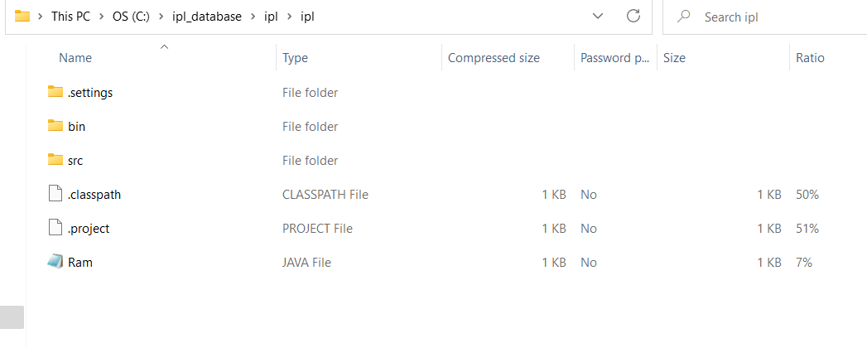

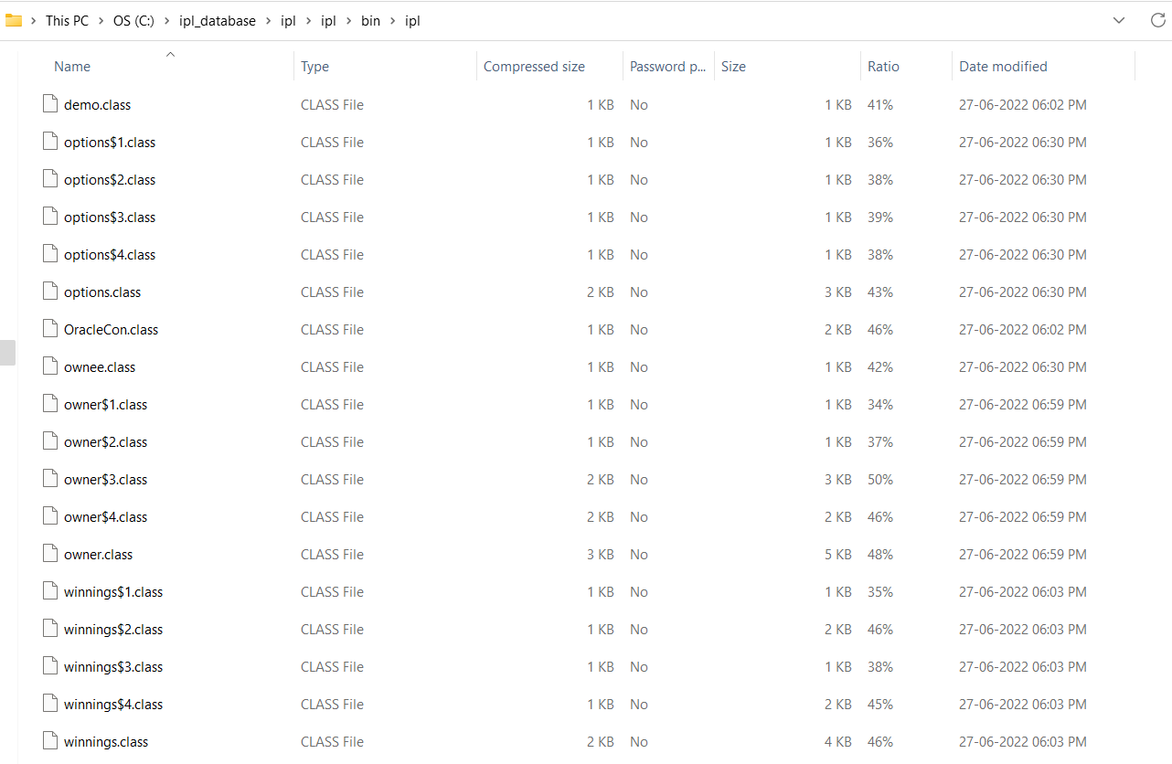

**Testing:**

**Java GUI Testing:**

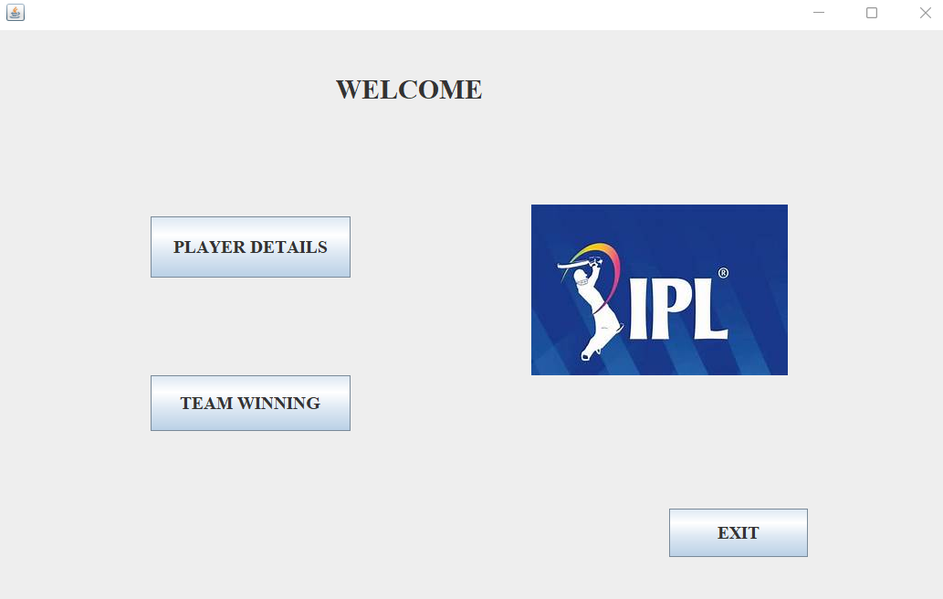

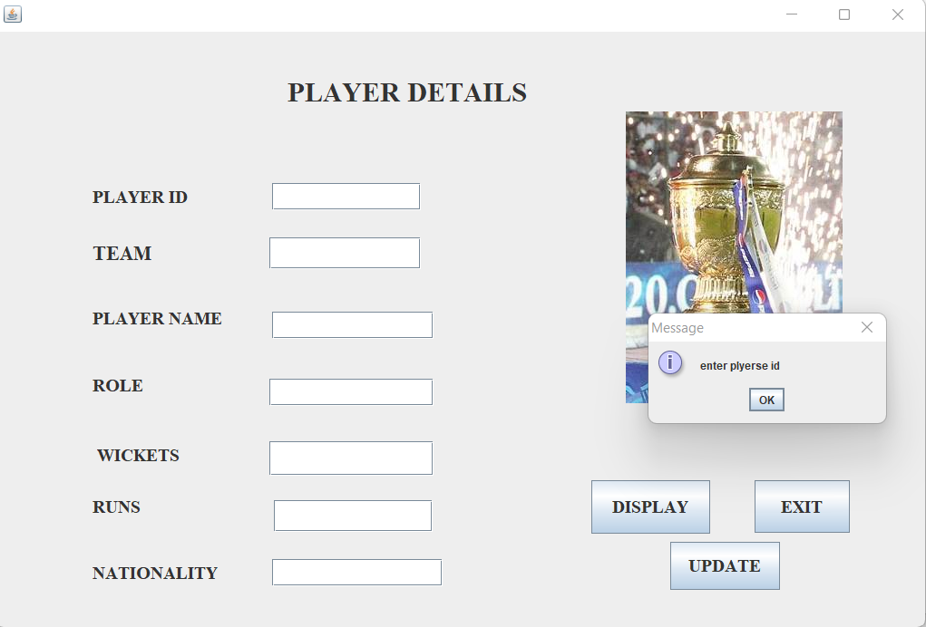

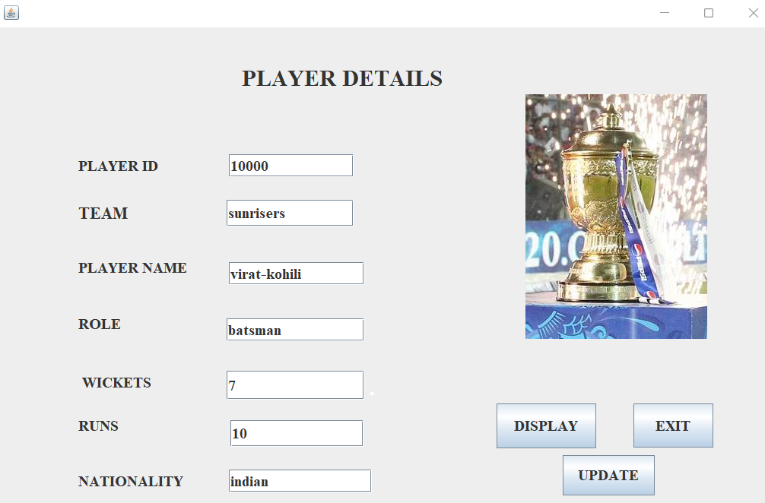

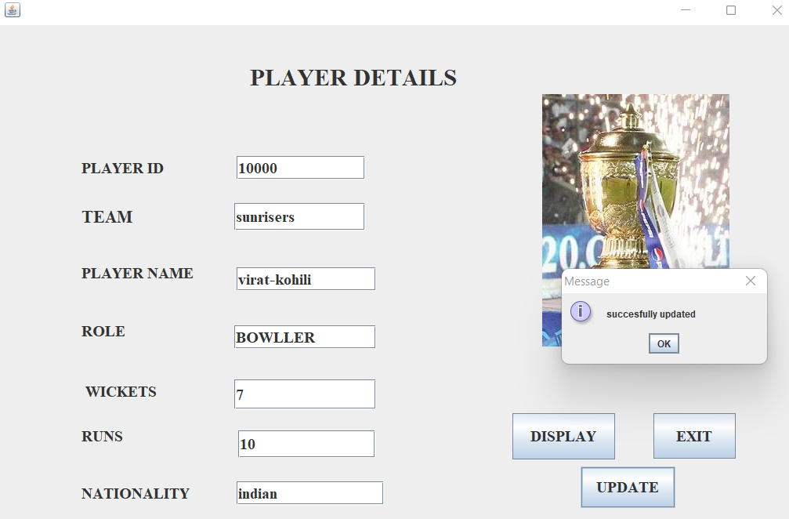

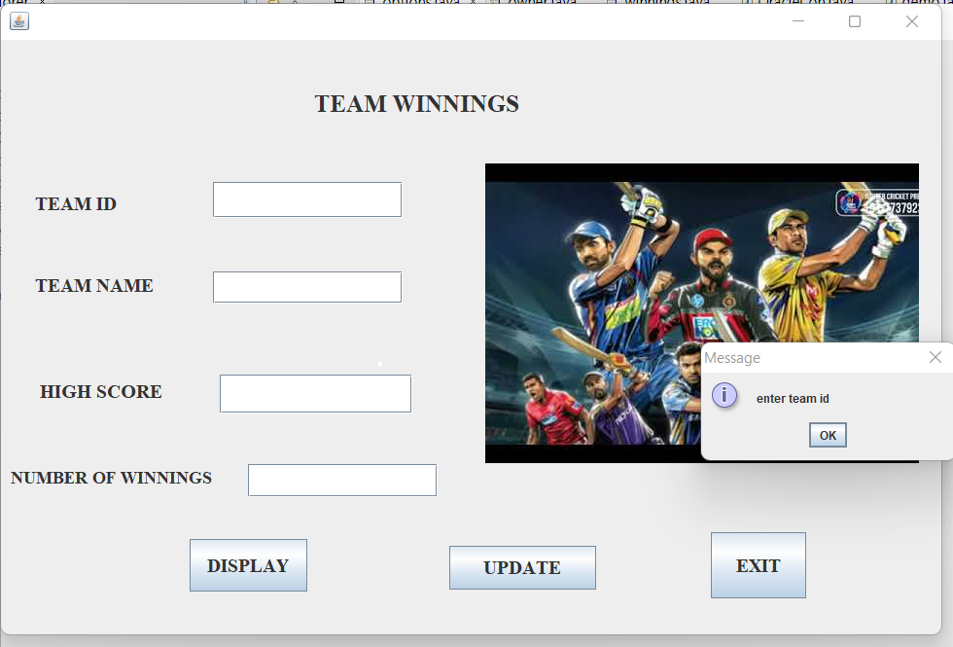

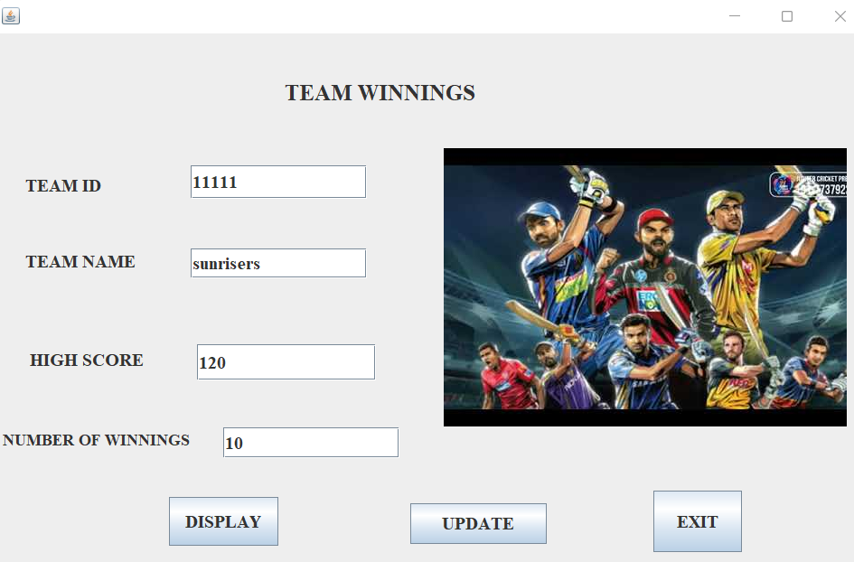

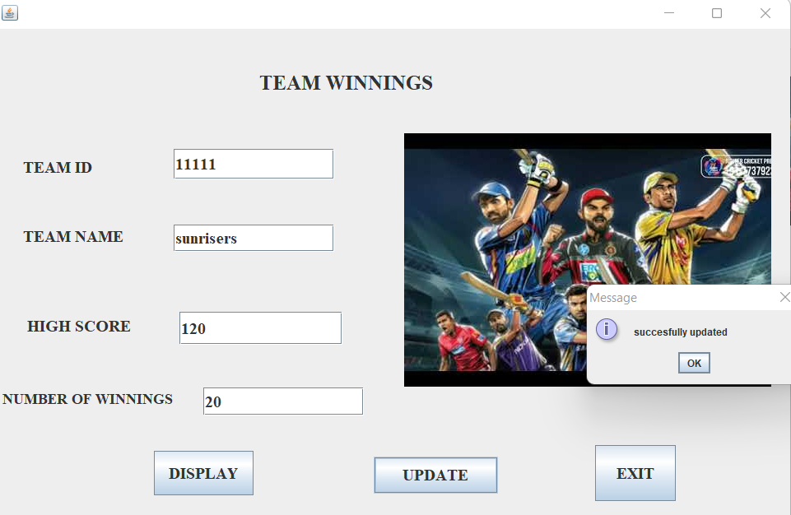

**Results:**

I successfully completed this MINI PROJECT “IPL

data base Management system”.

## Discussion and Future work

While doing this project I got new ideas I understood how to work on projects. Now to further extend this project I want to create a android app by which I can control my project on my hand and connect to it.

**References:**

* [https://www.academia.edu/36893248/Ramakrishnan_-](https://www.academia.edu/36893248/Ramakrishnan_-_Database_Management_Systems_3rd_Edition)

[_Database_Management_Systems_3rd_Edition](https://www.academia.edu/36893248/Ramakrishnan_-_Database_Management_Systems_3rd_Edition) ▪ <https://docs.oracle.com/javase/7/docs/index.html>

* <https://www.javatpoint.com/dbms-tutorial>
* <http://www.sqlines.com/articles/java/sql_server_jdbc_connection>