CARE CAN CURE(3C)

It is hard to deny the amazing technologic impact on every sphere of our life. Healthcare field has not remained aloof from the progress as well. The ecosystem of every health facility requires making a vast amount of vital decisions in a very short time. Hospital mobile app development is an also a step that helps to increase rates of the hospital among patients and adds value to the reputation. The users receive different roles in the application depending on their needs. The hospital admin can update hospital details in real-time mode; the patients can view their status, select desired hospital and book appointments, ambulances, medicines and the administration will be getting all the information.

**Care Can Cure (3C)** is Android-Web based **Hospital Management System**an end to end cutting edge solution and modern innovative solutions designed to automate all hospital operations such as Appointment, Patient registration, Hospital rating and about, Doctor management, Pharmacy, Ambulance booking etc. 3C help you get better results for your healthcare organization. It provides customized dashboards and analytics to track hospitals. 3C transform your data into a single, consolidated workflow for care teams, identify best hospital for a particular disorder. 3C will be a most trusted brand in delivering end-to-end solutions in a better and affordable way. It is an innovative and advance integrated software to reduce the usage of time and money involved in the healthcare industry, information sharing etc. It is designed to manage all aspects of hospital operations.

***USE CASE DIAGRAM***

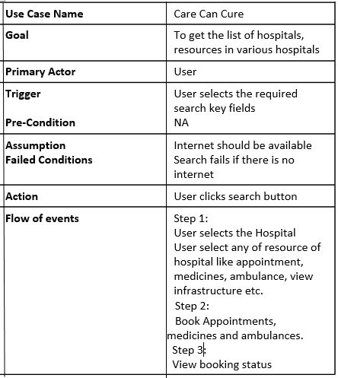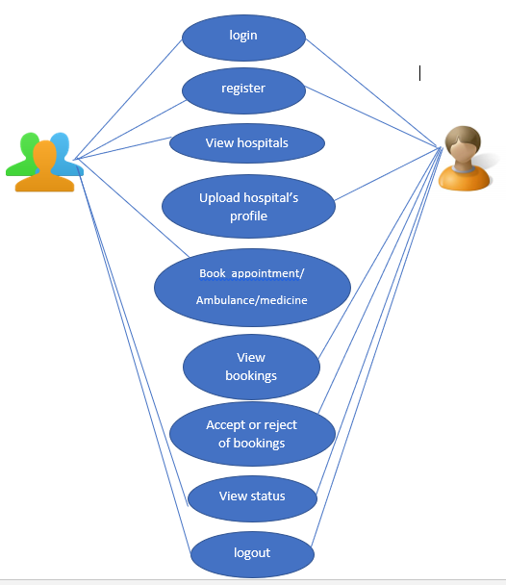

***FLOW DIAGRAM***

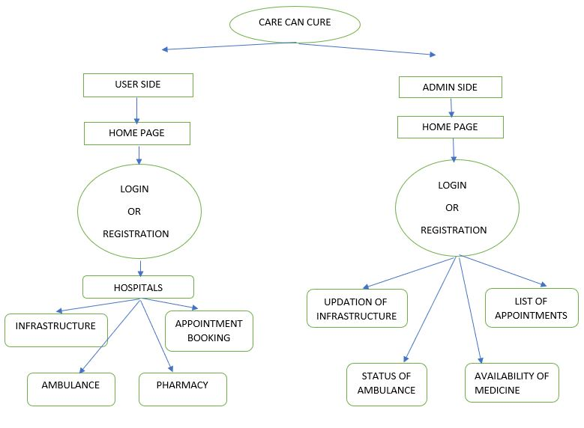

**Contents:**

* Code
* PPT
* Documentation

**Ways to launch:**

<http://localhost/hospital/a.html>