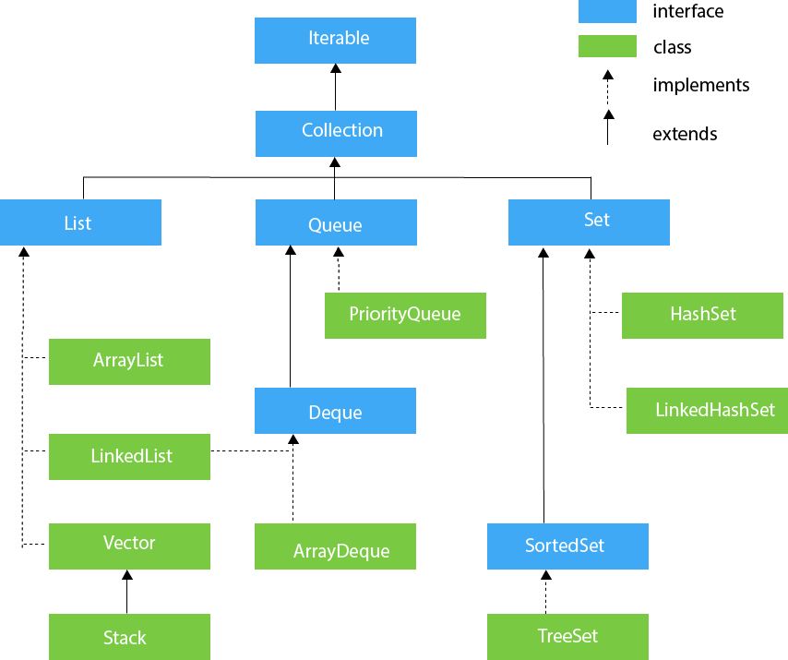

|  |  |  |
| --- | --- | --- |
| 5 | default boolean removeIf(Predicate<? super E> filter) | It is used to delete all the elements of the collection that satisfy the specified predicate. |