Exploratory Data Analysis Report
Home Credit Default Risk (HCDR) & HMDA Mortgage Data

QM640 Capstone Project — Credit Default Prediction: Explainable AI & Bias Mitigation
Datasets: data/external/HCDR, data/external/HMDA
Report date: 2026-07-21

Table of Contents
Right-click and choose 'Update Field' to generate the table of contents.

1. Introduction & Objectives
This report presents a detailed exploratory data analysis (EDA) of the two raw external datasets used by the capstone credit-default pipeline:
- HCDR (data/external/HCDR) — Kaggle's Home Credit Default Risk competition data, the primary dataset used for the full model-training / explainability / fairness pipeline (target: TARGET, loan default).
- HMDA (data/external/HMDA) — CFPB Home Mortgage Disclosure Act legacy nationwide LAR extracts (2007-2017), used in this project for a fairness-audit-only pipeline (target: high_cost_flag, a higher-priced-loan proxy).
The goal of this EDA is to characterize each dataset's structure, completeness, distributions, and target/protected-attribute relationships in enough detail to justify the feature-engineering and fairness-audit decisions made later in the pipeline (see docs/DEVELOPER_GUIDE.md). It documents, for both datasets: row/column counts, memory footprint, missingness, numeric and categorical distributions, correlation with target, known data-quality anomalies, and target-rate breakdowns by protected attribute (gender/age for HCDR; race/sex for HMDA).

Scope note
HMDA is audited for fairness only, not modeled for default risk: this legacy extract contains originated loans only (action_taken == 1 for every row), so there is no approval/denial signal to predict. The binary target used here, high_cost_flag, is a standard pre-2018 Reg Z proxy for a higher-priced mortgage loan (rate_spread was only reported when APR exceeded the HOEPA/Reg Z threshold). It should not be compared apples-to-apples with HCDR's TARGET (loan default).

2. Data Pipeline Overview
Both datasets ship as compressed archives under data/external/ and are prepared into flat, model-ready CSVs under data/raw/ before any analysis. The diagram below traces that flow through to this document.
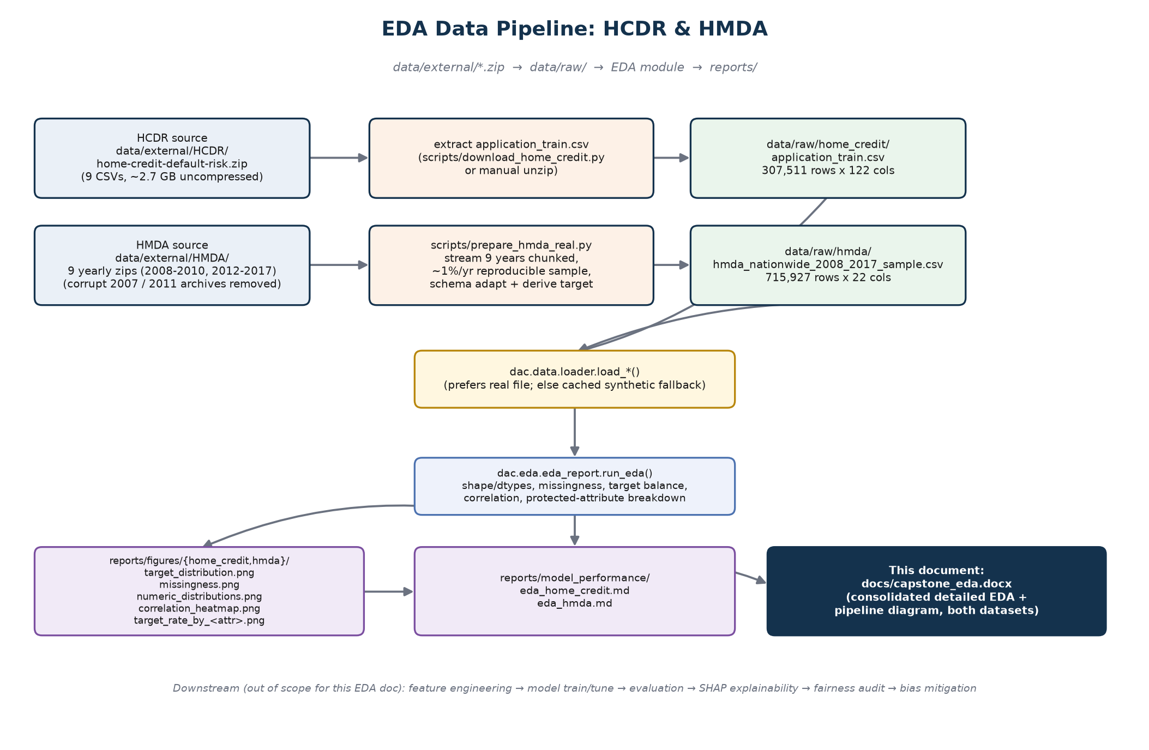
Figure 2.1 — EDA data pipeline: external archives → prepared data/raw files → dac.eda.eda_report → reports/ → this document.

2.1 HCDR source archive contents
data/external/HCDR/home-credit-default-risk.zip is the full Kaggle competition download. Only application_train.csv (the sole file carrying the TARGET label) is extracted and used by the pipeline; the remaining relational tables describe borrowers' bureau credit history, prior applications, and repayment behavior and are cataloged here for completeness but are out of scope for the current MVP pipeline.
File | Uncompressed size | Role
application_train.csv | 166.1 MB | Main table used by this pipeline — 1 row per loan application, carries TARGET
application_test.csv | 26.6 MB | Kaggle competition test set (unlabeled) — not used
bureau.csv | 170.0 MB | Prior credits reported to the credit bureau, keyed by SK_ID_CURR — not used
bureau_balance.csv | 375.6 MB | Monthly balance history for bureau.csv credits — not used
previous_application.csv | 405.0 MB | Client's previous applications at Home Credit — not used
POS_CASH_balance.csv | 392.7 MB | Monthly snapshots of previous POS/cash loans — not used
credit_card_balance.csv | 424.6 MB | Monthly snapshots of previous credit-card balances — not used
installments_payments.csv | 723.1 MB | Repayment history for previous credits — not used
HomeCredit_columns_description.csv | 0.04 MB | Data dictionary for all tables
sample_submission.csv | 0.5 MB | Kaggle submission template — not used

Total archive footprint is roughly 2.7 GB uncompressed across 9 CSVs plus the data dictionary. Kaggle competition data carries redistribution restrictions, so raw CSVs are gitignored, not committed.

2.2 HMDA source archives
data/external/HMDA/ ships one zip per year, each containing a single nationwide "originated-records" LAR CSV. The dataset originally shipped 11 yearly archives (2007-2017); the 2007 and 2011 archives were confirmed corrupt/truncated (via zipfile — no valid end-of-central-directory record, unreadable by scripts/prepare_hmda_real.py) and have since been removed from data/external/HMDA/, leaving the 9 usable years below. Each is streamed in 1,000,000-row chunks directly out of its zip and reproducibly subsampled at ~1% per year (seeded per year with numpy's default RNG) — full nationwide volume is roughly 60M+ rows across the decade, too large to load in memory on a typical dev machine and unnecessary for stable EDA/fairness signal.
Year | Zip size | Uncompressed CSV size | Status
2008 | 360.4 MB | 5,543.0 MB | Sampled
2009 | 416.7 MB | 6,873.3 MB | Sampled
2010 | 419.3 MB | 6,051.7 MB | Sampled
2012 | 529.5 MB | 7,520.5 MB | Sampled
2013 | 476.5 MB | 6,700.0 MB | Sampled
2014 | 331.4 MB | 4,674.6 MB | Sampled
2015 | 461.1 MB | 5,738.6 MB | Sampled
2016 | 457.1 MB | 6,506.6 MB | Sampled
2017 | 247.2 MB | 5,630.6 MB | Sampled

The 9 usable years total roughly 55 GB uncompressed nationwide; the ~1%-per-year sample yields the 715,927-row working file described in Section 4. Column renaming to a modern-schema-style naming convention (derived_race, derived_sex, income, loan_amount, etc.) and target derivation (high_cost_flag = rate_spread.notna()) happen at this stage; rate_spread/hoepa_status are dropped from the feature set entirely afterward to avoid leaking the label.

2.3 Prepared file summary
Dataset | Prepared file | Rows | Columns | In-memory size
HCDR | data/raw/home_credit/application_train.csv | 307,511 | 122 | 341.0 MB
HMDA | data/raw/hmda/hmda_nationwide_2008_2017_sample.csv | 715,927 | 22 | 294.1 MB

3. Home Credit Default Risk (HCDR) — Detailed EDA

3.1 Structure & Data Types
Metric | Value
Rows | 307,511
Columns | 122
Duplicate rows | 0
Numeric columns | 106
Categorical (object) columns | 16
In-memory footprint | 341.0 MB
Columns with any missing values | 67 of 122
Columns with >50% missing | 41
Overall missing-cell rate | 24.40%

The dtype mix is 65 × float64, 41 × int64, 16 × str.

3.2 Target Variable (TARGET)
TARGET = 1 indicates a client with payment difficulties (late payment beyond a defined threshold on at least one of the first several installments); TARGET = 0 covers all other cases. The dataset is heavily imbalanced, which is why the downstream pipeline reports PR-AUC and Brier score alongside ROC-AUC, not accuracy.
TARGET | Count | Proportion
0 | 282,686 | 91.93%
1 | 24,825 | 8.07%

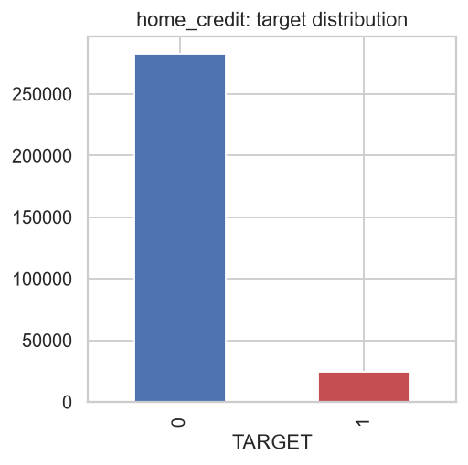
Figure 3.1 — TARGET class distribution.

3.3 Missingness
67 of 122 columns have at least one missing value; 41 columns are missing in more than half of rows — dominated by building/apartment characteristic fields (COMMONAREA_*, NONLIVINGAPARTMENTS_*, LIVINGAPARTMENTS_*, FLOORSMIN_*, YEARS_BUILD_*), which are optional third-party enrichment fields, not universally populated for every applicant.
Column | Missing fraction
COMMONAREA_AVG | 69.87%
COMMONAREA_MODE | 69.87%
COMMONAREA_MEDI | 69.87%
NONLIVINGAPARTMENTS_MEDI | 69.43%
NONLIVINGAPARTMENTS_MODE | 69.43%
NONLIVINGAPARTMENTS_AVG | 69.43%
FONDKAPREMONT_MODE | 68.39%
LIVINGAPARTMENTS_AVG | 68.35%
LIVINGAPARTMENTS_MEDI | 68.35%
LIVINGAPARTMENTS_MODE | 68.35%
FLOORSMIN_MODE | 67.85%
FLOORSMIN_AVG | 67.85%
FLOORSMIN_MEDI | 67.85%
YEARS_BUILD_AVG | 66.50%
YEARS_BUILD_MODE | 66.50%
YEARS_BUILD_MEDI | 66.50%
OWN_CAR_AGE | 65.99%
LANDAREA_MEDI | 59.38%
LANDAREA_AVG | 59.38%
LANDAREA_MODE | 59.38%

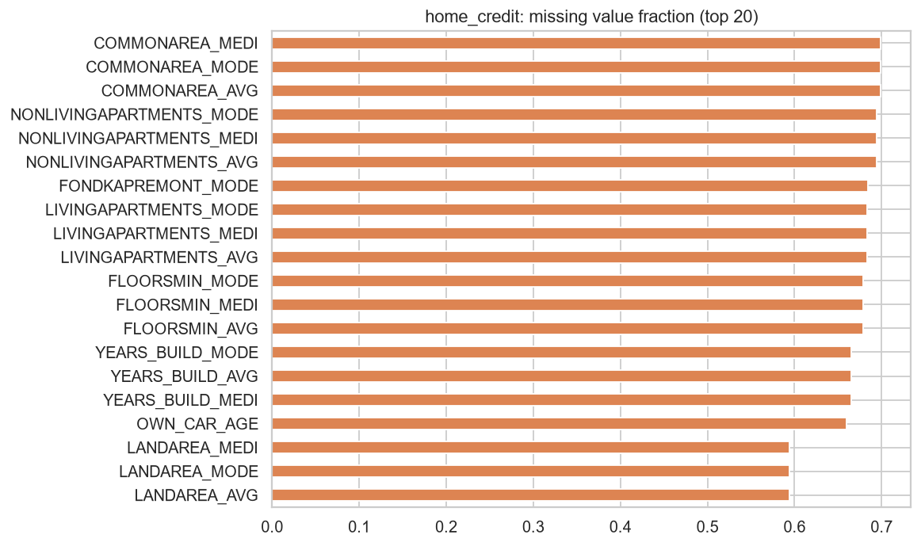
Figure 3.2 — Top-20 columns by missing-value fraction.

3.4 Numeric Feature Summary Statistics
Descriptive statistics for the key numeric fields (financial amounts, tenure/day fields, and external bureau scores):
Column | Mean | Std | Min | 25% | Median | 75% | Max
AMT_INCOME_TOTAL | 168,797.92 | 237,123.15 | 25,650.00 | 112,500.00 | 147,150.00 | 202,500.00 | 117,000,000.00
AMT_CREDIT | 599,026.00 | 402,490.78 | 45,000.00 | 270,000.00 | 513,531.00 | 808,650.00 | 4,050,000.00
AMT_ANNUITY | 27,108.57 | 14,493.74 | 1,615.50 | 16,524.00 | 24,903.00 | 34,596.00 | 258,025.50
AMT_GOODS_PRICE | 538,396.21 | 369,446.46 | 40,500.00 | 238,500.00 | 450,000.00 | 679,500.00 | 4,050,000.00
DAYS_BIRTH | -16,037.00 | 4,363.99 | -25,229.00 | -19,682.00 | -15,750.00 | -12,413.00 | -7,489.00
DAYS_EMPLOYED | 63,815.05 | 141,275.77 | -17,912.00 | -2,760.00 | -1,213.00 | -289.00 | 365,243.00
CNT_CHILDREN | 0.42 | 0.72 | 0.00 | 0.00 | 0.00 | 1.00 | 19.00
CNT_FAM_MEMBERS | 2.15 | 0.91 | 1.00 | 2.00 | 2.00 | 3.00 | 20.00
EXT_SOURCE_1 | 0.50 | 0.21 | 0.01 | 0.33 | 0.51 | 0.68 | 0.96
EXT_SOURCE_2 | 0.51 | 0.19 | 0.00 | 0.39 | 0.57 | 0.66 | 0.85
EXT_SOURCE_3 | 0.51 | 0.19 | 0.00 | 0.37 | 0.54 | 0.67 | 0.90
OWN_CAR_AGE | 12.06 | 11.94 | 0.00 | 5.00 | 9.00 | 15.00 | 91.00

DAYS_BIRTH and DAYS_EMPLOYED are negative day-counts relative to the application date (Home Credit's convention). Converting DAYS_BIRTH to years gives an applicant age range of 20.5–69.1 years (mean 43.9).

Known anomaly: DAYS_EMPLOYED sentinel value
DAYS_EMPLOYED contains a widely documented Home Credit data-quality artifact: the sentinel value 365,243 (≈ 1,000 years), used to flag unemployed/pensioner/non-working applicants rather than a true tenure. This affects 55,374 rows (18.01% of the dataset) and should be treated as a missing/categorical flag rather than a numeric outlier during feature engineering.

3.5 Numeric Distributions
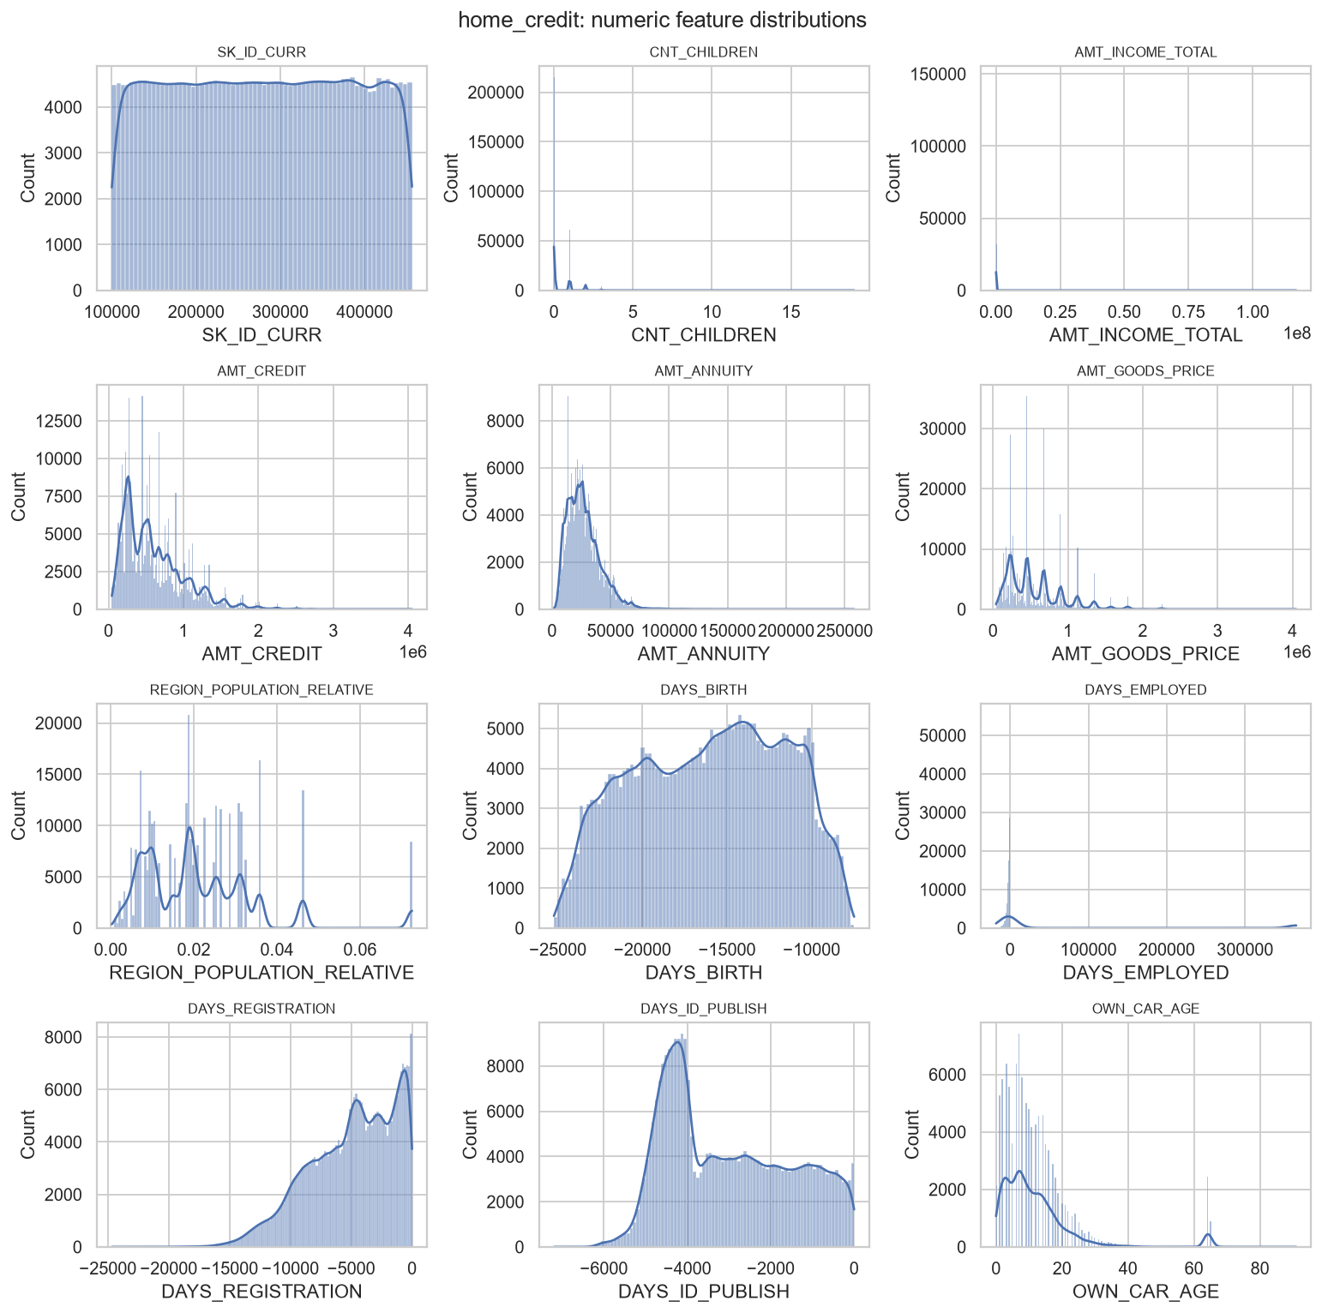
Figure 3.3 — Distributions of key numeric features.

3.6 Categorical Feature Distributions
Top categories for the primary categorical fields (dropna=False, so missing values appear as NaN where present):

NAME_CONTRACT_TYPE
Value | Count | Share of shown
Cash loans | 278,232 | 90.48%
Revolving loans | 29,279 | 9.52%

CODE_GENDER
Value | Count | Share of shown
F | 202,448 | 65.83%
M | 105,059 | 34.16%
XNA | 4 | 0.00%

FLAG_OWN_CAR
Value | Count | Share of shown
N | 202,924 | 65.99%
Y | 104,587 | 34.01%

FLAG_OWN_REALTY
Value | Count | Share of shown
Y | 213,312 | 69.37%
N | 94,199 | 30.63%

NAME_INCOME_TYPE
Value | Count | Share of shown
Working | 158,774 | 51.63%
Commercial associate | 71,617 | 23.29%
Pensioner | 55,362 | 18.00%
State servant | 21,703 | 7.06%
Unemployed | 22 | 0.01%
Student | 18 | 0.01%
Businessman | 10 | 0.00%
Maternity leave | 5 | 0.00%

NAME_EDUCATION_TYPE
Value | Count | Share of shown
Secondary / secondary special | 218,391 | 71.02%
Higher education | 74,863 | 24.34%
Incomplete higher | 10,277 | 3.34%
Lower secondary | 3,816 | 1.24%
Academic degree | 164 | 0.05%

NAME_FAMILY_STATUS
Value | Count | Share of shown
Married | 196,432 | 63.88%
Single / not married | 45,444 | 14.78%
Civil marriage | 29,775 | 9.68%
Separated | 19,770 | 6.43%
Widow | 16,088 | 5.23%
Unknown | 2 | 0.00%

NAME_HOUSING_TYPE
Value | Count | Share of shown
House / apartment | 272,868 | 88.73%
With parents | 14,840 | 4.83%
Municipal apartment | 11,183 | 3.64%
Rented apartment | 4,881 | 1.59%
Office apartment | 2,617 | 0.85%
Co-op apartment | 1,122 | 0.36%

3.7 Correlation with Target
Pearson correlation of numeric columns with TARGET (top 20 by absolute value). The strongest signals are the three external bureau-score fields (EXT_SOURCE_1/2/3), all negatively correlated with default — higher external score, lower default risk — consistent with these being purpose-built risk scores from other data sources.
Column | Correlation with TARGET
EXT_SOURCE_3 | -0.1789
EXT_SOURCE_2 | -0.1605
EXT_SOURCE_1 | -0.1553
DAYS_BIRTH | +0.0782
REGION_RATING_CLIENT_W_CITY | +0.0609
REGION_RATING_CLIENT | +0.0589
DAYS_LAST_PHONE_CHANGE | +0.0552
DAYS_ID_PUBLISH | +0.0515
REG_CITY_NOT_WORK_CITY | +0.0510
FLAG_EMP_PHONE | +0.0460
DAYS_EMPLOYED | -0.0449
REG_CITY_NOT_LIVE_CITY | +0.0444
FLAG_DOCUMENT_3 | +0.0443
FLOORSMAX_AVG | -0.0440
FLOORSMAX_MEDI | -0.0438
FLOORSMAX_MODE | -0.0432
DAYS_REGISTRATION | +0.0420
AMT_GOODS_PRICE | -0.0396
OWN_CAR_AGE | +0.0376
REGION_POPULATION_RELATIVE | -0.0372

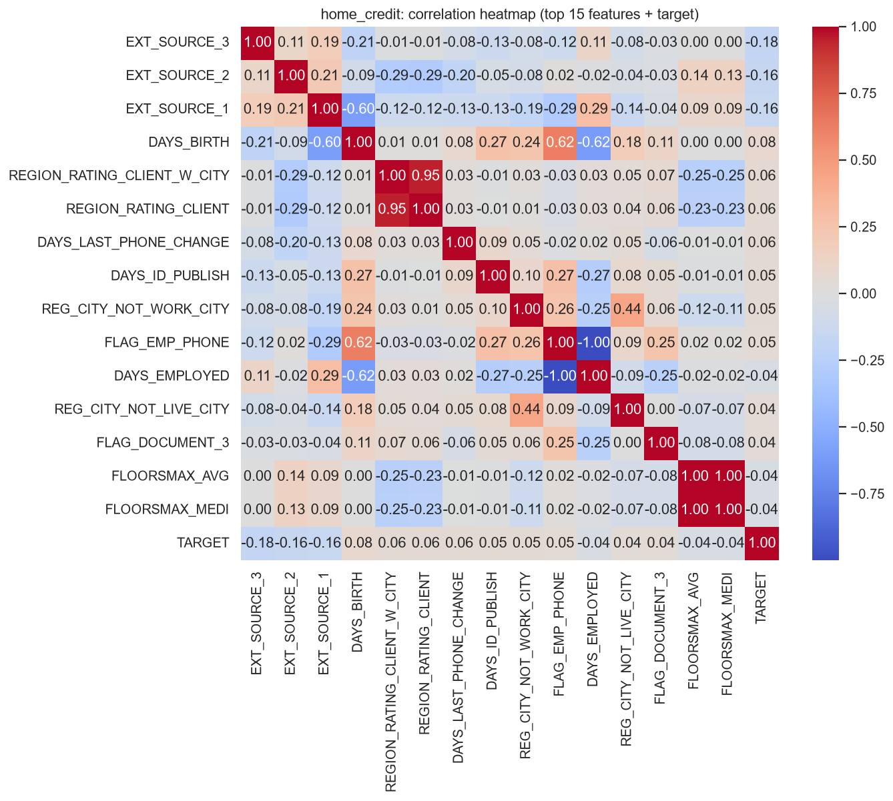
Figure 3.4 — Correlation heatmap, top-15 correlated features + TARGET.

3.8 Target Rate by Protected Attribute
The pipeline audits fairness on CODE_GENDER and a derived AGE_GROUP (bucketed from DAYS_BIRTH). The EDA-level group default rates below are the early-warning signal that motivates the fairness audit / bias-mitigation stages later in the pipeline.

CODE_GENDER
Group | Default rate (mean TARGET) | Count
M | 10.14% | 105,059
F | 7.00% | 202,448
XNA | 0.00% | 4

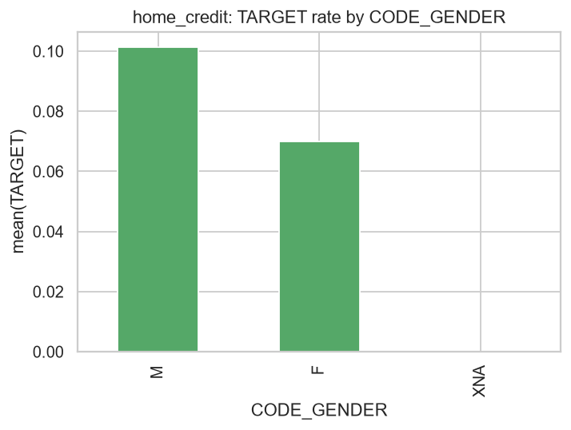
Figure — TARGET rate by CODE_GENDER.

AGE_GROUP
Group | Default rate (mean TARGET) | Count
<25 | 12.29% | 12,233
25-34 | 10.66% | 72,429
35-44 | 8.41% | 84,261
45-54 | 7.05% | 70,190
55-64 | 5.42% | 60,522
65+ | 3.66% | 7,876

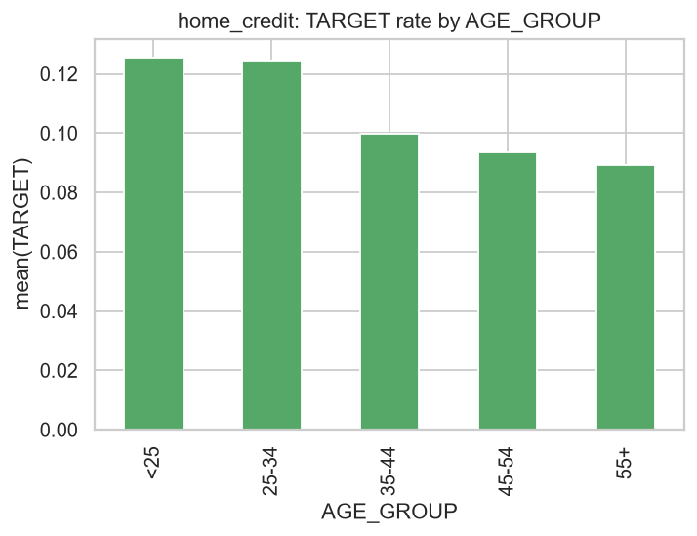
Figure — TARGET rate by AGE_GROUP.

Note on CODE_GENDER = 'XNA'
A small number of rows (4) carry CODE_GENDER = 'XNA' (gender not recorded / not applicable), all with TARGET = 0 in this sample — too few rows to be a stable group-fairness signal and typically dropped or grouped into 'Other' during modeling.

4. HMDA — Detailed EDA

4.1 Structure & Data Types
Metric | Value
Rows | 715,927
Columns | 22
Duplicate rows | 0
Numeric columns | 10
Categorical (object) columns | 12
In-memory footprint | 294.1 MB
Columns with any missing values | 9 of 22
Overall missing-cell rate | 0.54%

Rows by origination year (as_of_year) in the ~1%-per-year sample:
Year | Sampled rows
2008 | 71,614
2009 | 89,200
2010 | 79,294
2012 | 97,785
2013 | 87,163
2014 | 60,300
2015 | 73,604
2016 | 83,888
2017 | 73,079

4.2 Target Variable (high_cost_flag)
high_cost_flag = 1 marks a higher-priced/HOEPA-reportable loan (rate_spread was reported, meaning APR exceeded the pre-2018 Reg Z threshold); 0 otherwise. Like HCDR's TARGET, this is a minority-class target.
high_cost_flag | Count | Proportion
0 | 674,625 | 94.23%
1 | 41,302 | 5.77%

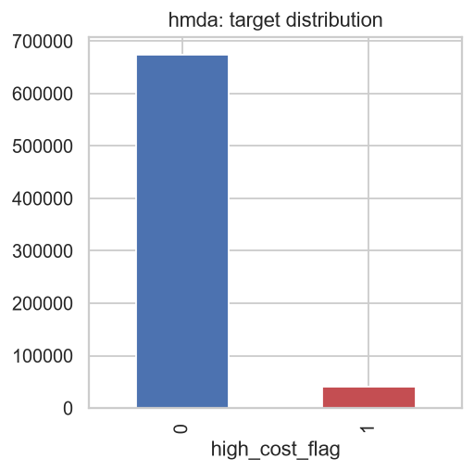
Figure 4.1 — high_cost_flag class distribution.

4.3 Missingness
All 9 columns with missing data have low missing fractions (under 8%); the largest gaps are in applicant-reported income and census-tract enrichment fields:
Column | Missing fraction
income | 7.25%
number_of_owner_occupied_units | 0.72%
number_of_1_to_4_family_units | 0.71%
tract_to_msamd_income | 0.71%
minority_population | 0.70%
population | 0.70%
hud_median_family_income | 0.69%
state_code | 0.47%
loan_amount | 0.00%

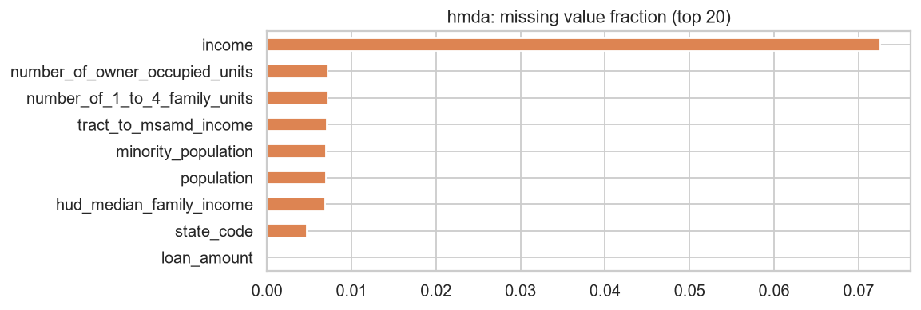
Figure 4.2 — Missing-value fraction by column.

4.4 Numeric Feature Summary Statistics
Column | Mean | Std | Min | 25% | Median | 75% | Max
loan_amount | 225,499.51 | 557,065.25 | 1,000.00 | 107,000.00 | 173,000.00 | 272,000.00 | 99,999,000.00
income | 111.62 | 201.30 | 1.00 | 53.00 | 82.00 | 126.00 | 69,000.00
population | 5,534.71 | 2,790.09 | 0.00 | 3,802.00 | 5,075.00 | 6,636.00 | 53,812.00
minority_population | 26.59 | 24.05 | 0.00 | 8.38 | 18.23 | 37.10 | 100.00
hud_median_family_income | 68,856.55 | 14,447.93 | 14,400.00 | 59,700.00 | 66,900.00 | 75,500.00 | 131,500.00
tract_to_msamd_income | 117.98 | 40.60 | 0.00 | 92.11 | 111.69 | 136.54 | 499.35
number_of_owner_occupied_units | 1,494.48 | 794.94 | 0.00 | 983.00 | 1,378.00 | 1,849.00 | 19,529.00
number_of_1_to_4_family_units | 1,932.55 | 979.68 | 0.00 | 1,315.00 | 1,777.00 | 2,353.00 | 25,391.00

loan_amount is reported in whole dollars (converted from the raw loan_amount_000s field). income is applicant-reported annual income in thousands of dollars, per HMDA convention.

4.5 Numeric Distributions
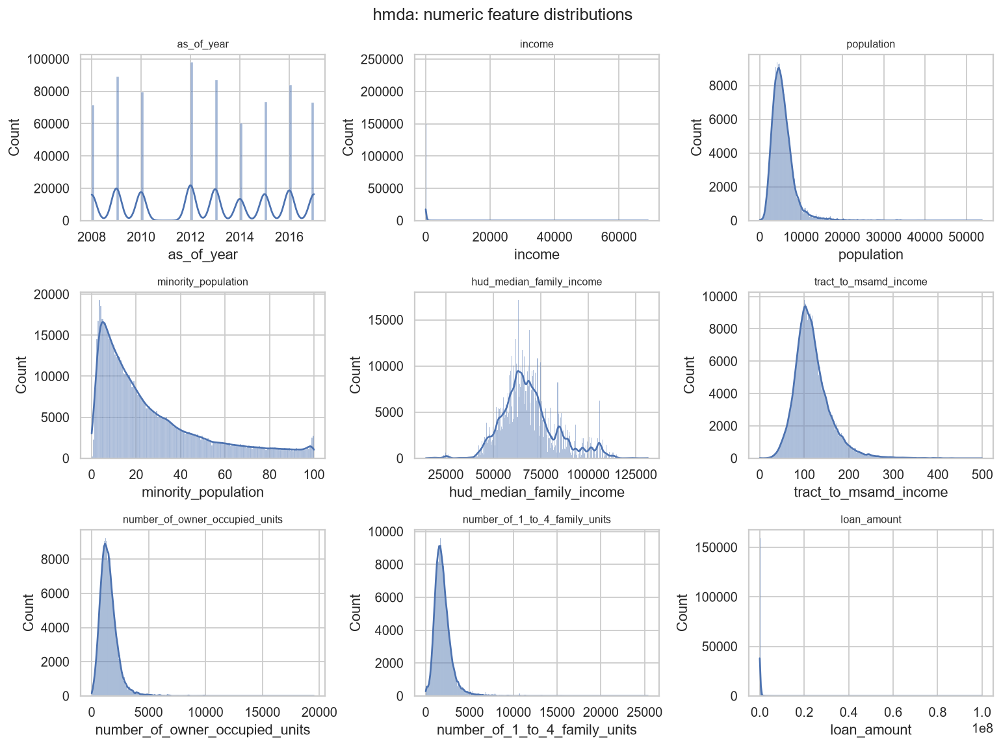
Figure 4.3 — Distributions of key numeric features.

4.6 Categorical Feature Distributions

loan_type
Value | Count | Share of shown
Conventional | 545,411 | 76.18%
FHA-insured | 114,853 | 16.04%
VA-guaranteed | 45,283 | 6.33%
FSA/RHS-guaranteed | 10,380 | 1.45%

property_type
Value | Count | Share of shown
One-to-four family dwelling (other than manufactured housing) | 700,400 | 97.83%
Manufactured housing | 12,530 | 1.75%
Multifamily dwelling | 2,997 | 0.42%

loan_purpose
Value | Count | Share of shown
Refinancing | 379,251 | 52.97%
Home purchase | 295,612 | 41.29%
Home improvement | 41,064 | 5.74%

occupancy_type
Value | Count | Share of shown
Owner-occupied as a principal dwelling | 639,316 | 89.30%
Not owner-occupied as a principal dwelling | 72,832 | 10.17%
Not applicable | 3,779 | 0.53%

preapproval
Value | Count | Share of shown
Not applicable | 591,607 | 82.64%
Preapproval was not requested | 103,067 | 14.40%
Preapproval was requested | 21,253 | 2.97%

lien_status
Value | Count | Share of shown
Secured by a first lien | 679,901 | 94.97%
Secured by a subordinate lien | 22,227 | 3.10%
Not secured by a lien | 13,799 | 1.93%

purchaser_type
Value | Count | Share of shown
Loan was not originated or was not sold in calendar year covered by register | 186,880 | 26.10%
Fannie Mae (FNMA) | 149,547 | 20.89%
Freddie Mac (FHLMC) | 95,037 | 13.27%
Ginnie Mae (GNMA) | 75,427 | 10.54%
Commercial bank, savings bank or savings association | 74,164 | 10.36%
Life insurance company, credit union, mortgage bank, or finance company | 54,570 | 7.62%
Other type of purchaser | 50,689 | 7.08%
Affiliate institution | 25,498 | 3.56%
Private securitization | 4,063 | 0.57%
Farmer Mac (FAMC) | 52 | 0.01%

agency
Value | Count | Share of shown
HUD | 249,196 | 34.81%
CFPB | 150,569 | 21.03%
OCC | 112,916 | 15.77%
FDIC | 83,564 | 11.67%
NCUA | 52,992 | 7.40%
FRS | 36,840 | 5.15%
OTS | 29,850 | 4.17%

Geographic spread (state_code, top 10)
State | Count
CA | 89,526
TX | 48,591
FL | 36,486
IL | 30,149
PA | 27,685
OH | 24,155
NC | 23,050
VA | 22,984
NY | 22,589
GA | 21,618

4.7 Correlation with Target
Pearson correlation of numeric columns with high_cost_flag (top of list by absolute value). hud_median_family_income and tract_to_msamd_income (both proxies for local-area income level) show the strongest (negative) relationships — higher-income areas see fewer higher-priced loans — while minority_population shows a positive relationship, an EDA-level signal consistent with the documented literature on mortgage pricing disparities and the reason this dataset is used for a fairness audit.
Column | Correlation with high_cost_flag
hud_median_family_income | -0.1074
tract_to_msamd_income | -0.0925
loan_amount | -0.0417
minority_population | +0.0416
income | -0.0412
number_of_owner_occupied_units | -0.0200
as_of_year | -0.0170
population | -0.0132
number_of_1_to_4_family_units | +0.0056

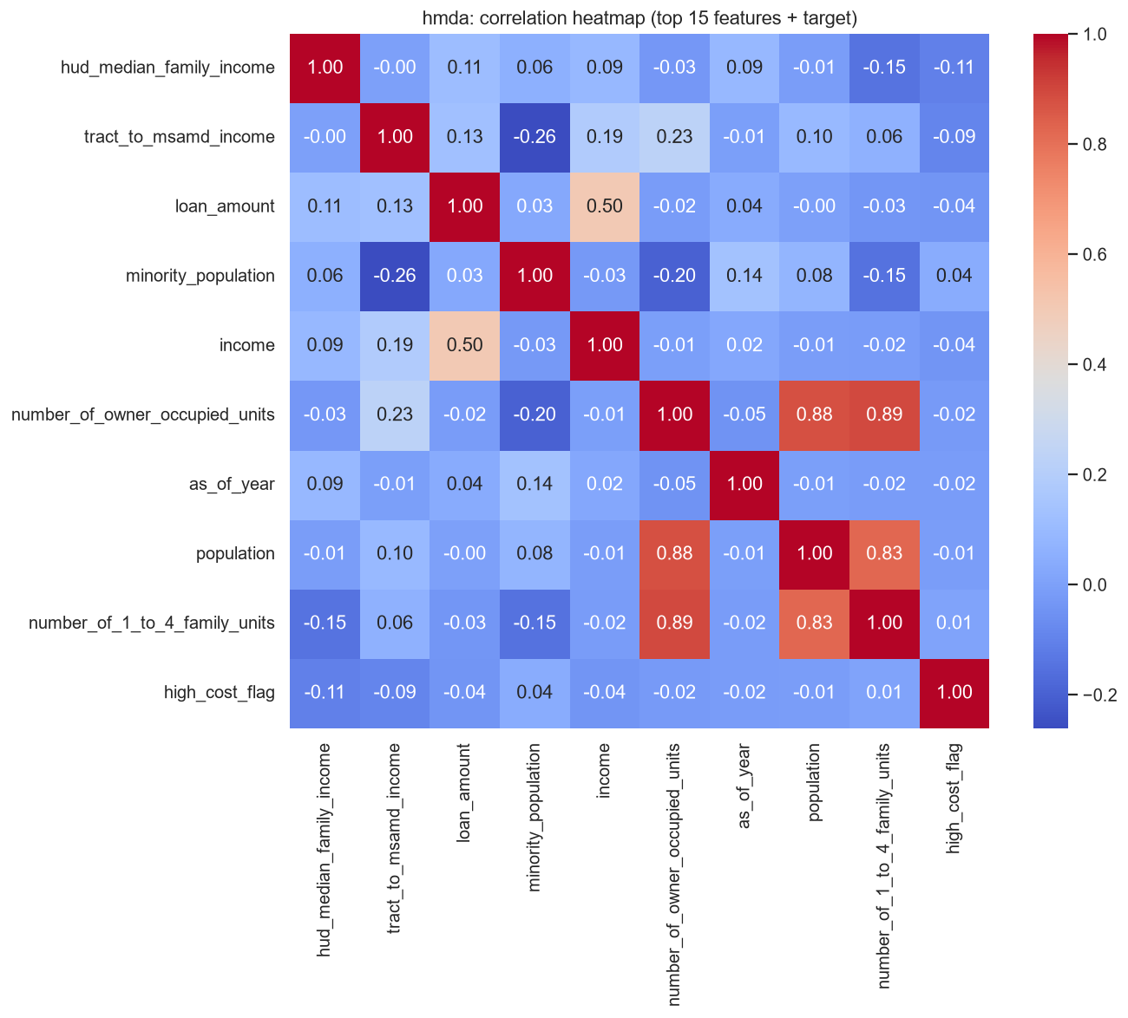
Figure 4.4 — Correlation heatmap, correlated features + high_cost_flag.

4.8 Target Rate by Protected Attribute
derived_race and derived_sex are the two protected attributes audited for this dataset. As with HCDR, these EDA-level gaps are the early-warning signal for the downstream fairness audit — note protected attributes are excluded from model features entirely and used only for post-hoc auditing.

derived_race
Group | high_cost_flag rate | Count
Black or African American | 11.59% | 35,683
American Indian or Alaska Native | 9.13% | 3,963
White | 5.88% | 556,574
Native Hawaiian or Other Pacific Islander | 5.40% | 2,648
Race Not Available | 3.83% | 79,691
Asian | 2.34% | 37,368

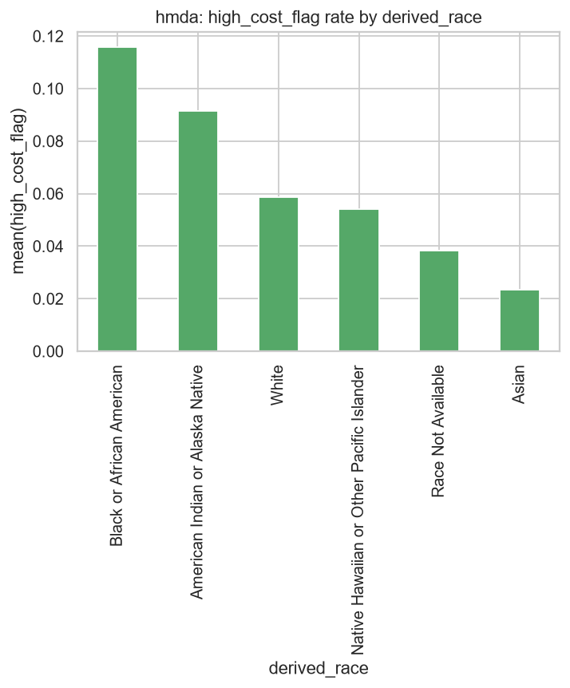
Figure — high_cost_flag rate by derived_race.

derived_sex
Group | high_cost_flag rate | Count
Female | 7.11% | 188,295
Male | 5.52% | 476,971
Sex Not Available | 3.16% | 50,661

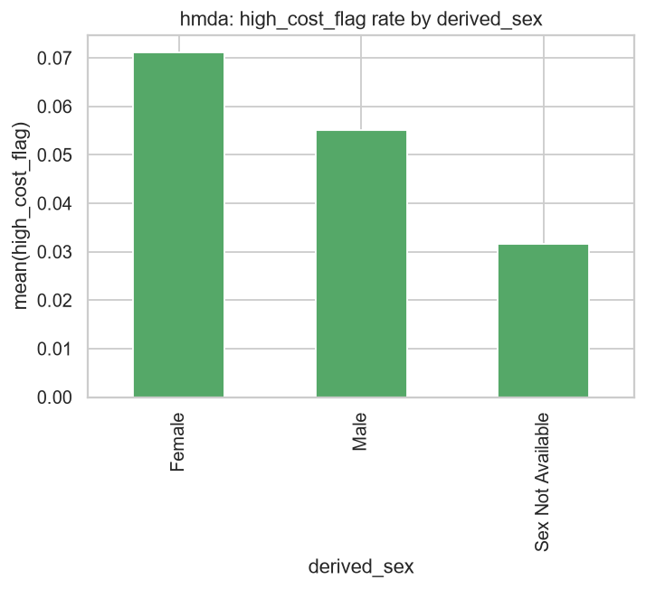
Figure — high_cost_flag rate by derived_sex.

5. Cross-Dataset Comparison
Aspect | HCDR | HMDA
Rows / Columns | 307,511 / 122 | 715,927 / 22
Target | TARGET (loan default, binary) | high_cost_flag (higher-priced loan proxy, binary)
Target positive rate | 8.07% | 5.77%
Missingness profile | 67 cols affected, up to ~70% in some cols | 9 cols affected, all under 8%
Protected attributes | CODE_GENDER, AGE_GROUP | derived_race, derived_sex
Granularity | 1 row per loan application | 1 row per originated mortgage loan
Time coverage | Single snapshot (no explicit date range) | 2008–2017 (9 usable years, ~1%/yr sample)
Pipeline role | Full pipeline: EDA → features → train/tune → evaluate → SHAP → fairness audit → mitigation | Fairness audit only (no default/approval model)

Both datasets exhibit class imbalance in their respective targets (~8% for TARGET, ~5.8% for high_cost_flag) and both show a measurable target-rate gap across at least one protected attribute at the raw EDA level, which is the empirical justification for running a fairness audit on each.

6. Data Quality Notes & Recommendations

6.1 HCDR
- DAYS_EMPLOYED = 365243 sentinel — Impute or flag separately (do not treat as a valid tenure); the value ≈1,000 years marks unemployed/pensioner/non-working applicants.
- High missingness in building-characteristic columns — A cluster of building/apartment characteristic columns (COMMONAREA_*, NONLIVINGAPARTMENTS_*, LIVINGAPARTMENTS_*, FLOORSMIN_*, YEARS_BUILD_*) are missing in 65-70% of rows; treat as optional third-party enrichment, consider missingness-indicator features rather than aggressive imputation.
- CODE_GENDER 'XNA' category — Only 4 rows carry CODE_GENDER = 'XNA'; too small a group for a stable fairness signal — typically excluded or merged during modeling.
- No duplicate rows — Zero exact duplicate rows found — no deduplication needed.
- EXT_SOURCE_* predictive dominance — EXT_SOURCE_1/2/3 (external bureau scores) are the strongest predictors of TARGET and themselves have missingness (EXT_SOURCE_1 in particular); their availability should be checked before relying on them as primary model features.

6.2 HMDA
- Originated-loans-only extract — This extract's action_taken is always 1 (originated); there is no approval/denial variance, so this dataset cannot support an approval-decision model — only a pricing-based fairness audit via the derived high_cost_flag.
- Target leakage risk (rate_spread) — rate_spread/hoepa_status were used only to derive the target and then dropped from the feature set, to avoid label leakage.
- Sampling, not full population — Each year is subsampled at ~1% (seeded per year) rather than a true random sample of the full decade; results should be read as directionally representative, not as exact population statistics.
- 2 of 11 years unavailable — 2007 and 2011 source zips were confirmed corrupt/truncated and have been removed from data/external/HMDA/; the sample covers the remaining 9 years (2008-2010, 2012-2017).
- Non-disclosure categories — derived_race and derived_sex include 'Race Not Available' / 'Sex Not Available' categories for applicants who did not disclose — these should be reported separately, not merged into a modeled group, when interpreting fairness metrics.

7. Conclusion
Both HCDR and HMDA are well-structured, real-world tabular datasets with manageable, well-understood data-quality issues (a known sentinel value in HCDR, moderate optional-field missingness in HCDR, sampling and two missing years in HMDA). Both show class-imbalanced binary targets and measurable target-rate gaps across protected attributes at the raw EDA level — gender/age for HCDR, race/sex for HMDA — which is the direct empirical motivation for the fairness-audit and bias-mitigation stages that follow this EDA in the capstone pipeline (see docs/DEVELOPER_GUIDE.md, Sections 2 and 6).

Appendix A — Figure Manifest
Dataset | Figure file | Description
HCDR | reports/figures/home_credit/target_distribution.png | TARGET class balance
HCDR | reports/figures/home_credit/missingness.png | Top-20 missing-value fraction by column
HCDR | reports/figures/home_credit/numeric_distributions.png | Histogram grid, key numeric features
HCDR | reports/figures/home_credit/correlation_heatmap.png | Correlation heatmap, top features + TARGET
HCDR | reports/figures/home_credit/target_rate_by_CODE_GENDER.png | TARGET rate by gender
HCDR | reports/figures/home_credit/target_rate_by_AGE_GROUP.png | TARGET rate by age group
HMDA | reports/figures/hmda/target_distribution.png | high_cost_flag class balance
HMDA | reports/figures/hmda/missingness.png | Missing-value fraction by column
HMDA | reports/figures/hmda/numeric_distributions.png | Histogram grid, key numeric features
HMDA | reports/figures/hmda/correlation_heatmap.png | Correlation heatmap, features + high_cost_flag
HMDA | reports/figures/hmda/target_rate_by_derived_race.png | high_cost_flag rate by race
HMDA | reports/figures/hmda/target_rate_by_derived_sex.png | high_cost_flag rate by sex

All figures were generated by dac.eda.eda_report.run_eda() against the real prepared data files (data/raw/home_credit/application_train.csv, data/raw/hmda/hmda_nationwide_2008_2017_sample.csv), sourced from data/external/HCDR and data/external/HMDA respectively. Underlying source: reports/model_performance/eda_home_credit.md, reports/model_performance/eda_hmda.md.

