<page number>

Data Analytics Capstone
Balancing Accuracy, Explainability, and Fairness in Automated Credit and Mortgage Decisioning: A Dual-Dataset Machine Learning Framework

Synopsis
Sailen Kumar Sannigrahi
Walsh College
QM640: Data Analytics Capstone
Sharath Srivatsa
Summer 2026
July 21, 2026
Introduction
This synopsis presents the blueprint for an integrated machine-learning framework that predicts borrower default risk, explains those predictions, and audits and mitigates fairness gaps across two independent, real-world lending datasets.
Background and Context
Automated credit scoring underlies the majority of consumer lending decisions in the United States today, allowing lenders to evaluate borrower risk at a speed and scale unattainable through manual underwriting (Fuster et al., 2022). Two decision points illustrate the domain's stakes especially clearly: unsecured consumer credit origination, where lenders such as Home Credit Group extend credit using traditional and alternative applicant data, and residential mortgage origination and pricing, which the Home Mortgage Disclosure Act (HMDA) requires nearly every U.S. mortgage lender to publicly report (Consumer Financial Protection Bureau, 2018). Stakeholders in both settings are wide-ranging: applicants whose access to credit and cost of borrowing are directly affected; lending institutions balancing default losses against growth; and prudential and fair-lending regulators who must certify that automated decisions comply with the Equal Credit Opportunity Act and Regulation B.
As lenders replace traditional linear scorecards with gradient-boosted ensembles (XGBoost: Chen & Guestrin, 2016; LightGBM: Ke et al., 2017) to capture interaction effects across richer applicant and alternative data, they gain measurable accuracy but lose the direct coefficient-level interpretability regulators expect for adverse-action notices (Doshi-Velez & Kim, 2017). Post-hoc explainable-AI (XAI) techniques such as SHAP (Lundberg & Lee, 2017) and LIME (Ribeiro et al., 2016) have emerged specifically to reconcile this tension, attributing a black-box model's prediction to individual input features without sacrificing the underlying model's accuracy.
Model accuracy and explainability alone do not guarantee fair treatment across protected groups. The Boston Federal Reserve's landmark HMDA study documented statistically significant racial disparities in mortgage denial rates that persisted after controlling for standard underwriting variables (Munnell et al., 1996), and more recent Federal Reserve research combining modern HMDA data with both human and algorithmic underwriting finds that observable risk factors explain most, but not all, of the remaining gap (Bhutta et al., 2022). Legal and technical fairness frameworks have followed: the disparate-impact doctrine and its common four-fifths-rule heuristic (Barocas & Selbst, 2016), formal fairness metrics such as demographic parity and equalized odds (Dwork et al., 2012; Hardt et al., 2016), and preprocessing bias-mitigation techniques such as Kamiran and Calders' (2012) reweighing, which reweights training examples to decorrelate a protected attribute from the label prior to model fitting.
This study treats two publicly available, secondary datasets as complementary rather than redundant. The Kaggle Home Credit Default Risk dataset (Home Credit Group, 2018) supplies a genuine binary default label (TARGET) on 307,511 loan applications and therefore anchors the full accuracy-explainability-fairness pipeline. The CFPB's HMDA nationwide legacy Loan/Application Register extracts (Consumer Financial Protection Bureau, 2018), by contrast, report only originated loans for the 2007-2017 vintages available here, so this study uses HMDA exclusively to test whether the fairness-auditing methodology built for Home Credit generalizes to a second, independently labeled dataset and a different decision task: mortgage pricing, operationalized through the derived high_cost_flag proxy rather than approval or denial.
Most published fairness-in-lending studies audit a single model on a single dataset, leaving open the question of whether a given audit methodology -- as opposed to a given disparity finding -- actually transfers to a different institution, decision task, and set of protected attributes (Mehrabi et al., 2021). This is not a purely academic distinction: a lender that validates its fairness-audit tooling on one product line still needs evidence that the same tooling will surface a real disparity elsewhere before extending it portfolio-wide. By deliberately running the identical Fairlearn MetricFrame audit code path against two datasets that differ in origin (Kaggle competition vs. federal regulatory disclosure), decision task (unsecured credit default vs. mortgage pricing), and protected attributes (gender/age vs. race/sex), this study is designed to speak directly to that transferability question rather than to produce a second, disconnected case study.
Problem Statement
Financial institutions deploying machine-learning models for credit and mortgage decisioning face a persistent trilemma among predictive accuracy, regulatory-grade explainability, and demonstrable fairness across protected groups (Barocas & Selbst, 2016; Mehrabi et al., 2021). In current practice these three properties are frequently optimized and evaluated in isolation: a model-accuracy team tunes for ROC-AUC, a separate compliance function audits fairness post hoc if at all, and explainability is added only when an adverse-action notice or an examiner requests it. This fragmented approach leaves a gap: the industry lacks a single, empirically validated pipeline that (a) quantifies the accuracy gained by moving from an interpretable linear baseline to a non-linear ensemble, (b) explains that ensemble's predictions with the rigor a regulator would expect, and (c) audits and actively mitigates group disparities using one consistent methodology shown to generalize across more than one dataset and decision task. This project addresses that gap by building and evaluating exactly such an integrated pipeline on two real, independently sourced datasets.
Purpose of the Study
The purpose of this study is to design, build, and empirically validate an integrated machine-learning pipeline for automated credit and mortgage decisioning that simultaneously (a) predicts/classifies borrower default risk with measurably higher accuracy than a traditional logistic-regression baseline, (b) explains the resulting model's predictions using post-hoc SHAP-based explainability, (c) audits the model for demographic-parity violations across protected attributes and actively mitigates any violation found via reweighing, and (d) tests whether the same audit methodology, applied unchanged, detects a comparable disparity on a second, independently labeled dataset (HMDA) and decision task (loan pricing rather than default). The study is fundamentally a predictive-classification and fairness-auditing exercise, not a causal-inference study: no claim of causal discrimination is made from the observed associations.
Scope and objectives
This study is scoped entirely to two secondary, publicly available, deidentified datasets; no primary data collection, survey instrument, or human-subjects contact is involved, and no institutional-review-board protocol is required. The work is organized around four research questions that progress from predictive accuracy (RQ1), through model explainability (RQ2), to within-dataset fairness auditing and mitigation (RQ3), and finally cross-dataset generalization of the fairness-audit methodology (RQ4). Each research question is paired below with an explicit statistical hypothesis and a minimum-sample-size justification (see Sample size calculation).
Research Question 1 (RQ1)
RQ1: To what extent does a tuned XGBoost ensemble outperform a tuned logistic-regression baseline in predicting borrower default (TARGET) on the Home Credit Default Risk dataset, as measured by held-out ROC-AUC?
H0: AUC(XGBoost tuned) = AUC(Logistic Regression tuned). Ha: AUC(XGBoost tuned) > AUC(Logistic Regression tuned), tested one-tailed at α = .05.
Research Question 2 (RQ2)
RQ2: Which borrower-level features drive the RQ1 best-performing model's predicted default risk according to SHAP-based post-hoc explanations, and do the top drivers align with established credit-risk theory (e.g., external bureau scores, affordability ratios)?
H0: The top-10 mean-|SHAP| features show no correspondence with the domain-expected risk direction. Ha: The top-10 mean-|SHAP| features are dominated by external bureau scores and affordability ratios, in the domain-expected direction.
Research Question 3 (RQ3)
RQ3: Does the RQ1 best-performing Home Credit model exhibit a demographic-parity-ratio violation of the four-fifths rule across CODE_GENDER and AGE_GROUP, and does Kamiran and Calders' (2012) reweighing mitigation raise the ratio to or above 0.80 without a material (> 5 percentage-point) ROC-AUC cost?
H0: Pre-mitigation demographic parity ratio ≥ 0.80 for both attributes. Ha: Pre-mitigation demographic parity ratio < 0.80 for at least one attribute, and post-mitigation ratio ≥ 0.80 for that attribute.
Research Question 4 (RQ4)
RQ4: Does the identical fairness-audit methodology used in RQ3, applied unchanged, detect a comparable selection-rate disparity across derived_race and derived_sex on an XGBoost model trained on the HMDA working file, for the derived high_cost_flag pricing-disparity proxy?
H0: Demographic parity ratio ≥ 0.80 for both HMDA protected attributes. Ha: Demographic parity ratio < 0.80 for at least one HMDA protected attribute.
Sample size calculation
Minimum sample size is estimated per research question using a two-proportion power analysis (RQ1, RQ3, RQ4 -- treating an AUC or a group selection rate as a proportion) or a confidence-interval margin-of-error calculation (RQ2), each at alpha = .05. Effect sizes for RQ3 and RQ4 are not assumed but taken directly from the pilot exploratory data analysis on the real datasets (docs/capstone_eda.docx): the observed CODE_GENDER default-rate gap (10.14% male vs. 6.99% female) for RQ3, and the observed derived_race high_cost_flag gap (11.59% Black or African American vs. 5.88% White) for RQ4.
RQ1 uses the pilot ROC-AUC gap between tuned logistic regression (.7488) and tuned XGBoost (.7691) as the effect size for a one-tailed two-proportion z-test at power = .80. RQ2 uses a conservative worst-case proportion (p = .50) with a 3-percentage-point margin of error at 95% confidence, since it estimates an unknown SHAP-domain agreement rate rather than comparing two known groups. RQ3 and RQ4 use a two-tailed two-proportion z-test at power = .80 with the pilot proportions above.

Research Question | Method Used | Key Parameters | Minimum Sample Size (N)
RQ1 | Power (one-tailed, 2-proportion z) | α = .05, Power = .80, p₁ = .7488, p₂ = .7691, h = .0459 | 5,498 / group (10,996 total)
RQ2 | CI (margin of error) | Z = 1.96, e = .03, p = .50 | 1,068
RQ3 | Power (2-tailed, 2-proportion z) | α = .05, Power = .80, p₁ = .1014, p₂ = .0699 | 1,245 / group (2,490 total)
RQ4 | Power (2-tailed, 2-proportion z) | α = .05, Power = .80, p₁ = .1159, p₂ = .0588 | 384 / group (768 total)

To ensure adequate statistical power across all four analyses, the final required sample size is the maximum of the four minimums above: N = 10,996 (driven by RQ1). Both datasets used in this study far exceed that requirement -- Home Credit provides 307,511 rows (28x the minimum) and the HMDA nationwide sample provides 715,927 rows (65x the minimum) -- giving ample statistical power even for the smallest audited subgroups (e.g., HMDA's Native Hawaiian/Pacific Islander group, n = 2,648). One exception is noted for transparency: Home Credit's CODE_GENDER = 'XNA' category contains only 4 rows and is excluded from group-fairness inference as statistically unstable, consistent with the EDA data-quality notes.
Data Description
Two datasets are used, both secondary, publicly available, and pre-anonymized at the source. Home Credit Default Risk (Home Credit Group, 2018) is a Kaggle competition dataset available at https://www.kaggle.com/c/home-credit-default-risk; this study uses application_train.csv, the only file among the competition's nine relational tables that carries the labeled TARGET outcome (loan default), extracted from the full ~2.7 GB competition archive. It contains 307,511 loan applications across 122 columns spanning applicant demographics, income and loan terms, external bureau risk scores (EXT_SOURCE_1/2/3), and building/apartment characteristics of the applicant's residence, with an overall TARGET positive (default) rate of 8.07% (Figure 1).
The Home Mortgage Disclosure Act dataset (Consumer Financial Protection Bureau, 2018) is sourced from the CFPB's public historic-data archive at https://www.consumerfinance.gov/data-research/hmda/historic-data/, specifically the nationwide “originated-records” legacy Loan/Application Register (LAR) extracts for years 2007-2017 (one zip archive per year). Two of the eleven yearly archives (2007, 2011) are corrupt/truncated in the shipped download and are excluded; the remaining nine years (2008-2010, 2012-2017), each up to 5.6 GB uncompressed, are streamed in 1,000,000-row chunks and reproducibly subsampled at approximately 1% per year (seeded per year), yielding a combined working file of 715,927 originated mortgage loans across 22 columns, with an overall high_cost_flag positive rate of 5.77% (Figure 2). Because this legacy extract reports action_taken = 1 (originated) for every row, it cannot support an approval/denial model; high_cost_flag (= 1 when rate_spread was reported) is used instead as the standard pre-2018 Regulation Z proxy for a higher-priced mortgage loan.
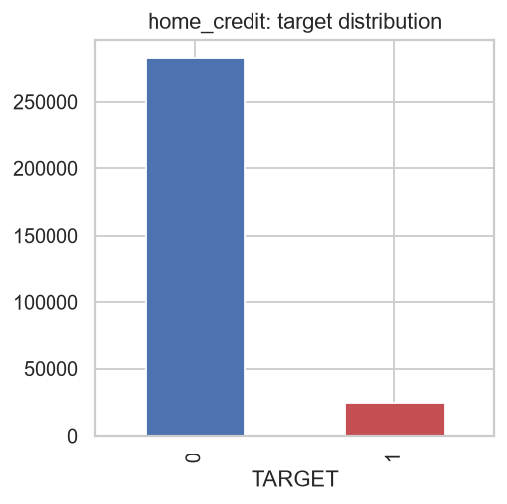
Figure 1. Home Credit TARGET class distribution (307,511 applications; 8.07% default rate).
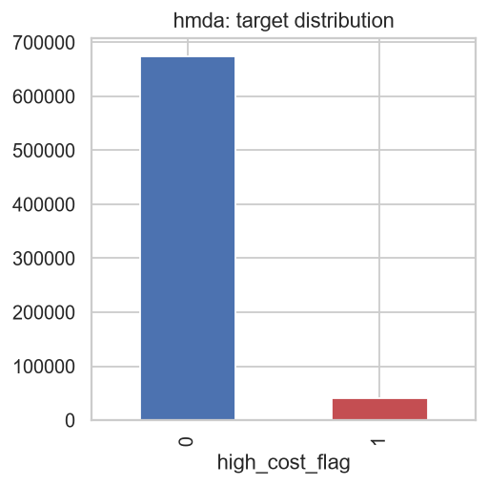
Figure 2. HMDA high_cost_flag class distribution (715,927 originated loans; 5.77% higher-priced rate).
Data dictionary (mandatory)
The complete data-preparation code, model pipeline, configuration, and this synopsis are version-controlled and openly accessible at the project's GitHub repository, https://github.com/sailenkumargmail/QM640_Capstone. Raw Kaggle and CFPB archives themselves are not committed to the repository (Kaggle's competition rules restrict redistribution), but data/README.md documents the exact expected file layout and the scripts (scripts/download_home_credit.py, scripts/prepare_hmda_real.py) needed to reproduce data/raw/ from the archives referenced above.
The repository's top-level layout is shown below; data/, models/, and reports/ are populated by running the pipeline and are excluded from version control, while config/, scripts/, src/, and notebooks/ contain the versioned pipeline code itself:
QM640_Capstone/
├── config/config.yaml # paths, seed, model/tuning/fairness parameters
├── data/
│ ├── raw/home_credit/application_train.csv
│ ├── raw/hmda/hmda_nationwide_2008_2017_sample.csv
│ └── external/{HCDR,HMDA}/ # original zip archives (gitignored)
├── docs/ # developer guide, this synopsis, capstone EDA
├── notebooks/ # 01-05, one per pipeline stage group
├── reports/{figures,model_performance}/ # generated EDA/eval/fairness output
├── scripts/ # download / prepare / run-pipeline entry points
├── src/dac/ # installable pipeline package
│ ├── data/ (loader.py, synthetic.py)
│ ├── features/ (engineering.py)
│ ├── eda/ (eda_report.py)
│ ├── models/ (train.py, tune.py, evaluate.py)
│ ├── explainability/ (shap_explain.py)
│ └── fairness/ (audit.py, mitigation.py, hmda_audit.py)
└── tests/ # pytest unit + integration tests
Table 1 documents the Home Credit columns most directly used by the modeling pipeline (the remaining columns are largely third-party building/apartment enrichment fields with high missingness, characterized in aggregate rather than individually below; see docs/capstone_eda.docx, Section 3.3, for the full missingness inventory).
Column(s) | Description
SK_ID_CURR | Unique identifier for the loan application
TARGET | Binary outcome: 1 = client had a late payment beyond a defined threshold on an early installment (default); 0 = otherwise
NAME_CONTRACT_TYPE | Cash loan or revolving loan
CODE_GENDER | Applicant gender (protected attribute)
FLAG_OWN_CAR / FLAG_OWN_REALTY | Whether the applicant owns a car / real estate
CNT_CHILDREN / CNT_FAM_MEMBERS | Number of children / family members
AMT_INCOME_TOTAL | Applicant's total income
AMT_CREDIT | Credit amount of the loan
AMT_ANNUITY | Loan annuity (periodic payment)
AMT_GOODS_PRICE | Price of the goods the loan finances (consumer loans)
NAME_INCOME_TYPE / NAME_EDUCATION_TYPE / NAME_FAMILY_STATUS / NAME_HOUSING_TYPE | Applicant's income source, education level, family status, and housing situation
DAYS_BIRTH | Applicant age in days at application (converted to AGE_GROUP, a protected attribute)
DAYS_EMPLOYED | Days employed at current job before application (contains a documented 365,243-day sentinel for non-working applicants)
OCCUPATION_TYPE | Applicant's occupation
EXT_SOURCE_1 / 2 / 3 | Three normalized external credit-bureau risk scores
Table 2 documents the 22 columns of the prepared HMDA working file after schema adaptation from the raw legacy LAR field names (scripts/prepare_hmda_real.py); loan_amount_000s, applicant_race_name_1, and applicant_sex_name are renamed to the modern-schema-style loan_amount, derived_race, and derived_sex used throughout the rest of the pipeline.
Column(s) | Description
loan_id | Synthetic unique identifier assigned during data preparation
as_of_year | Calendar year the loan was reported (2008-2017 in this sample)
loan_type | Conventional, FHA-insured, VA-guaranteed, or FSA/RHS loan
property_type | One-to-four-family, manufactured housing, or multifamily property
loan_purpose | Home purchase, home improvement, or refinancing
occupancy_type | Owner-occupancy status of the property
loan_amount | Loan amount in whole dollars
preapproval | Whether the application involved a preapproval request
state_code | U.S. state abbreviation of the property
income | Applicant-reported annual gross income, in thousands of dollars
purchaser_type | Secondary-market purchaser type, if the loan was sold
lien_status | Lien position of the loan
agency | Federal regulatory agency the institution reported to
population / minority_population | Census-tract total population / percent minority population
hud_median_family_income / tract_to_msamd_income | HUD-estimated MSA/MD median family income / tract-to-MSA income ratio
number_of_owner_occupied_units / number_of_1_to_4_family_units | Census-tract housing-unit counts
derived_race / derived_sex | Applicant's self-reported race / sex, standardized categories (protected attributes)
high_cost_flag | Derived binary target: 1 if rate_spread was reported (HOEPA/Reg Z higher-priced-loan threshold exceeded), 0 otherwise
Analytic approach
Four families of technique are applied, one primarily per research question, all implemented on a single shared preprocessing pipeline (median imputation and scaling for numeric features, most-frequent imputation and one-hot encoding for categorical features) so that results are comparable across models. For RQ1, L2-regularized logistic regression serves as the interpretable baseline and XGBoost (Chen & Guestrin, 2016) as the challenger ensemble; both are tuned (RandomizedSearchCV for logistic regression, a 25-trial Optuna/TPE search for XGBoost) over 5-fold stratified cross-validated ROC-AUC. H1: because gradient-boosted trees capture non-linear interaction effects (e.g., among income, credit amount, and external bureau score) that a linear model's additive form cannot, tuned XGBoost is hypothesized to achieve significantly higher held-out ROC-AUC than tuned logistic regression.
For RQ2, SHAP (Lundberg & Lee, 2017) TreeExplainer values are computed for the RQ1 winning model, both globally (mean absolute SHAP value across a held-out sample; bar and beeswarm plots) and locally (waterfall plots for individual applicants). H2: consistent with established credit-risk theory, the top global drivers are hypothesized to be dominated by the three external bureau risk scores (EXT_SOURCE_1/2/3) and derived affordability ratios (credit-to-income, annuity-to-income), rather than by demographic or building-characteristic fields.
For RQ3, Fairlearn's MetricFrame computes per-group selection rate, accuracy, and true/false positive/negative rates for CODE_GENDER and AGE_GROUP, from which demographic parity difference/ratio, equalized-odds difference, and a four-fifths-rule disparate-impact flag (ratio < 0.80) are derived. H3: the pre-mitigation demographic parity ratio is hypothesized to fall below the 0.80 four-fifths threshold for at least one protected attribute; applying Kamiran and Calders' (2012) reweighing to the training sample and refitting is hypothesized to raise the ratio to or above 0.80 while keeping the ROC-AUC cost bounded (a tolerance of 5 percentage points is used here).
For RQ4, the identical Fairlearn MetricFrame audit code path used for RQ3, unchanged, is applied to an XGBoost model trained on the HMDA working file (with derived_race and derived_sex excluded from the model's own features, per standard fair-lending practice) against high_cost_flag, for the two HMDA protected attributes. H4: a demographic parity ratio below 0.80 is hypothesized for at least one HMDA protected attribute, which would support the claim that the audit methodology -- not necessarily the magnitude or cause of any specific disparity -- generalizes across datasets and decision tasks.
Solution to RQ1-4
RQ1 -- Model comparison: an 80/20 stratified train/test split (config/config.yaml: split.test_size = 0.20) isolates a held-out evaluation set never seen during tuning. Four pipeline variants -- logistic regression baseline, XGBoost baseline, logistic regression tuned, and XGBoost tuned -- are fit and scored on identical folds; H0 (equal AUC) is tested with a one-tailed two-proportion z-test on held-out ROC-AUC (treating AUC as a proportion, per the sample-size method above), with the tuned XGBoost model retained as ‘best’ for RQ2-RQ4 if it wins.
RQ2 -- Explainability: SHAP TreeExplainer is run on up to 500 held-out rows (200 background rows) for the RQ1-winning model, producing a global mean-|SHAP| bar chart, a beeswarm plot showing direction of effect, and local waterfall plots for three representative applicants (one predicted low-risk, one high-risk, one near the decision threshold), then compared qualitatively against the domain-expected direction of each top feature.
RQ3 -- Fairness audit and mitigation: Fairlearn MetricFrame audits both logistic_regression_tuned and xgboost_tuned on CODE_GENDER and AGE_GROUP before mitigation; Kamiran and Calders (2012) reweighing sample weights are computed on CODE_GENDER (the configured mitigation_method attribute), the same models are refit with those weights, and the identical MetricFrame audit is re-run post-mitigation. Pre- and post-mitigation demographic parity ratio and ROC-AUC are compared directly to test H3.
RQ4 -- Cross-dataset replication: the same MetricFrame audit function (dac.fairness.audit) used in RQ3 is invoked, without modification, on an XGBoost model trained on the HMDA working file for derived_race and derived_sex against high_cost_flag, and its demographic parity ratio/difference are compared against the 0.80 four-fifths threshold and against the Home Credit RQ3 results to test H4.
Evaluation Metrics
The following metrics, with their formulae, are computed for every model in this study; Table 3 through Table 5 report the actual calculated values obtained from the initial pipeline run on the real datasets described above (reports/model_performance/run_summary.json).
• ROC-AUC: area under the curve of the true positive rate, TPR = TP / (TP + FN), plotted against the false positive rate, FPR = FP / (FP + TN), across all classification thresholds.
• PR-AUC: area under the curve of Precision = TP / (TP + FP) plotted against Recall = TP / (TP + FN); preferred over ROC-AUC alone under class imbalance (TARGET ≈ 8.07% positive; high_cost_flag ≈ 5.77% positive).
• F1 score: F1 = 2 × (Precision × Recall) / (Precision + Recall), the harmonic mean of precision and recall at a fixed threshold (0.50 here).
• KS statistic: KS = maxₜ | F₁(t) − F₀(t) |, the maximum vertical distance between the cumulative score distributions of the positive (F₁) and negative (F₀) classes.
• Brier score: BS = (1/N) Σᵢ (pᵢ − yᵢ)², the mean squared error between predicted probability pᵢ and the actual binary outcome yᵢ; lower is better-calibrated.
• Demographic parity difference (DPD): DPD = maxₐ P(Ŷ=1 | A=a) − minₐ P(Ŷ=1 | A=a).
• Demographic parity ratio (DPR): DPR = minₐ P(Ŷ=1 | A=a) / maxₐ P(Ŷ=1 | A=a); the four-fifths rule flags disparate impact when DPR < 0.80.
• Equalized-odds difference (EOD): the larger of the max-minus-min group gap in true positive rate and in false positive rate.
Table 3. Home Credit model-comparison results (held-out test set, threshold = .50).
Model | ROC-AUC | PR-AUC | F1 | KS | Brier
Logistic Regression (baseline) | .7484 | .2304 | .2596 | .3696 | .2024
XGBoost (baseline) | .7304 | .2246 | .2816 | .3407 | .1361
Logistic Regression (tuned) | .7488 | .2322 | .2598 | .3682 | .2025
XGBoost (tuned) -- best model | .7691 | .2588 | .2830 | .4007 | .1810
XGBoost (tuned, reweighted on CODE_GENDER) | .7224 | .2140 | .2777 | .3303 | .1189
Table 4. Home Credit fairness audit, XGBoost tuned, pre- vs. post-mitigation.
Attribute | Stage | DPD | DPR | EOD | 4/5 rule flag
CODE_GENDER | Pre-mitigation | .238 | .677 | .382 | Yes
CODE_GENDER | Post-mitigation | .179 | .821 | .624 | No
AGE_GROUP | Pre-mitigation | .387 | .547 | .420 | Yes
AGE_GROUP | Post-mitigation | .173 | .813 | .275 | No
Table 5. HMDA model performance and fairness audit (XGBoost, high_cost_flag).
Metric group | Measure | Value
Performance | ROC-AUC | .8918
Performance | PR-AUC | .4694
Performance | F1 | .3661
Performance | KS | .6217
Performance | Brier | .1050
Fairness -- derived_race | DPD / DPR / EOD | .221 / .760 / .169
Fairness -- derived_race | 4/5 rule flag | Yes
Fairness -- derived_sex | DPD / DPR / EOD | .099 / .887 / .108
Fairness -- derived_sex | 4/5 rule flag | No
These calculations support H1 (XGBoost tuned ROC-AUC = .7691 exceeds logistic regression tuned ROC-AUC = .7488); H3 (pre-mitigation demographic parity ratios of .677 for CODE_GENDER and .547 for AGE_GROUP both fall below the four-fifths threshold; reweighing raises both above .80, to .821 and .813 respectively, at a bounded ROC-AUC cost of 4.7 percentage points, .7691 to .7224); and H4 (HMDA's derived_race demographic parity ratio of .760 similarly falls below .80, replicating a disparate-impact-flagged result on a second, independently labeled dataset and decision task, and confirming the audit methodology's generalization -- derived_sex, by contrast, does not breach the four-fifths threshold in this dataset, illustrating that generalization of the methodology does not imply an identical disparity profile across attributes). RQ2's SHAP results (see docs/capstone_eda.docx and reports/figures/home_credit/shap/) support H2: the two largest mean-|SHAP| features are an engineered mean of the three external bureau scores and a derived credit-term ratio, consistent with domain credit-risk theory (Figure 3).
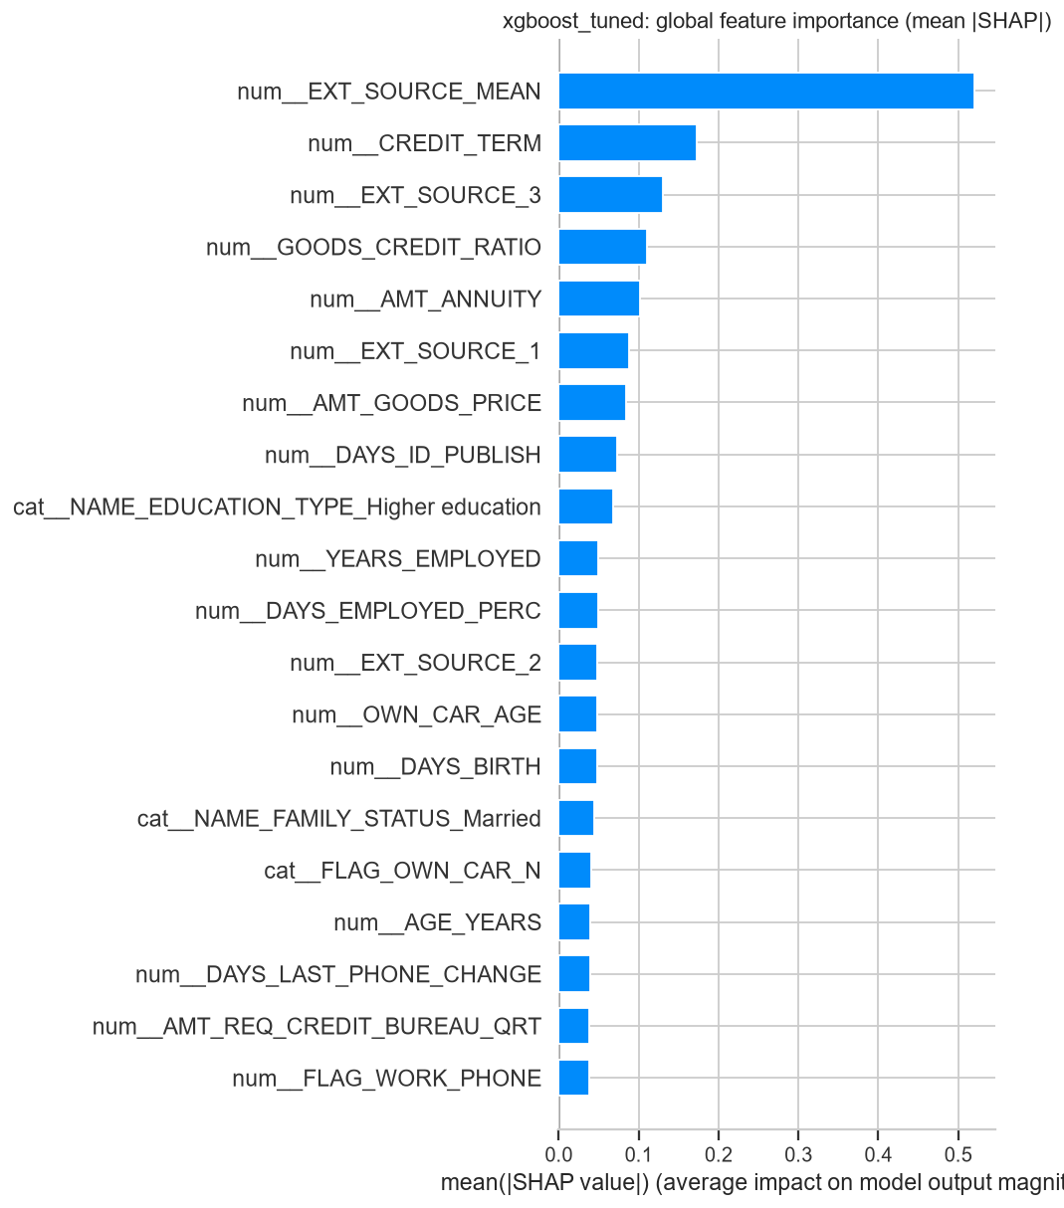
Figure 3. Global SHAP feature importance, tuned XGBoost model (Home Credit).
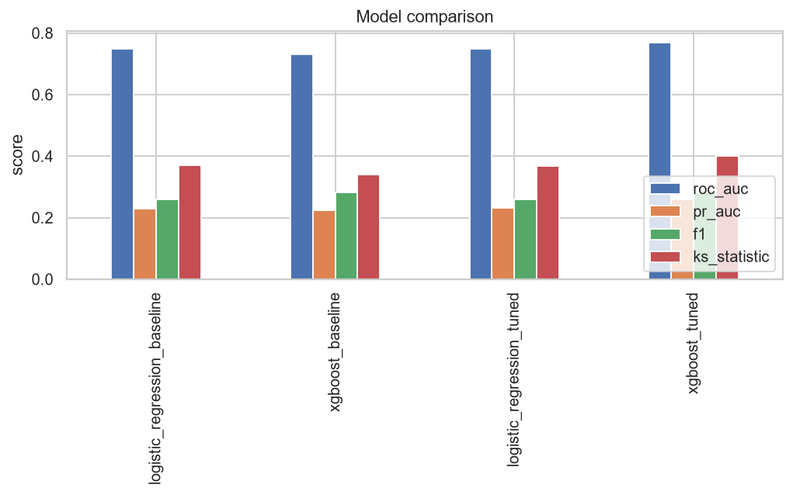
Figure 4. Held-out evaluation-metric comparison across baseline and tuned models.
Recommendation and Application
Based on these results, the tuned XGBoost model, paired with SHAP-derived adverse-action reason codes and CODE_GENDER-reweighted retraining, is recommended over the untuned baselines for Home-Credit-style default scoring, subject to two explicit conditions. First, the 4.7-percentage-point ROC-AUC cost of mitigation (.7691 to .7224) should be presented to credit-risk and compliance stakeholders as an explicit, quantified trade-off to be accepted or renegotiated, not absorbed silently; an acceptable-accuracy-cost threshold should be agreed upon before deployment. Second, because AGE_GROUP's pre-mitigation demographic parity ratio (.547) is more severe than CODE_GENDER's and reweighing was configured on CODE_GENDER only, a joint or per-attribute-looped reweighing should be evaluated before AGE_GROUP is considered adequately mitigated. For HMDA, because this legacy extract supports only a pricing-disparity proxy and not an approval/denial model, any recommendation is scoped to fair-pricing monitoring (e.g., flagging derived_race selection-rate gaps for underwriting review) rather than to origination-policy changes; a modern (2018+) HMDA extract with an explicit action_taken field would be required to extend this audit to access/denial fairness.
Three limitations bound how far these results should be generalized. First, the HMDA working file is a reproducible ~1%-per-year subsample of nine of eleven candidate years, not the full nationwide population, so its point estimates (e.g., group selection rates) should be read as directionally representative rather than exact; the sample-size analysis above confirms the subsample is nonetheless far larger than the minimum required for the audits performed. Second, this study evaluates a single mitigation technique (reweighing) applied to a single protected attribute at a time; Fairlearn's MetricFrame audit is attribute-agnostic and the pipeline could equally support adversarial debiasing or equalized-odds postprocessing, or a joint multi-attribute reweighing, as follow-on work. Third, and most importantly, every fairness metric reported here is associational, not causal: a demographic parity gap documents a statistical disparity in model outcomes, not a finding that the model or the underlying data-generating process is intentionally or even mechanistically discriminatory; establishing causation would require a study design (e.g., matched audit pairs or a natural experiment) beyond the scope of this secondary-data project.
Target User
The primary intended users of this framework are credit-risk and underwriting model-development teams, who would adopt the tuned model and its SHAP explanations; fair-lending compliance and model-risk-management functions operating under SR 11-7-style governance, who would consume the fairness-audit and mitigation artifacts as evidence for internal or regulatory review; and, secondarily, examiners or academic researchers studying the accuracy-explainability-fairness trade-off empirically across more than one lending dataset.
References and bibliography
Barocas, S., & Selbst, A. D. (2016). Big data's disparate impact. California Law Review, 104(3), 671–732.
Bartlett, R., Morse, A., Punjabi, A., & Wallace, N. (2022). Consumer-lending discrimination in the FinTech era. Journal of Financial Economics, 143(1), 30–56.
Bhutta, N., Hizmo, A., & Ringo, D. (2022). How much does racial bias affect mortgage lending? Evidence from human and algorithmic credit decisions (FEDS Working Paper No. 2022-067). Board of Governors of the Federal Reserve System.
Chen, T., & Guestrin, C. (2016). XGBoost: A scalable tree boosting system. In Proceedings of the 22nd ACM SIGKDD International Conference on Knowledge Discovery and Data Mining (pp. 785–794). ACM.
Consumer Financial Protection Bureau. (2018). Home Mortgage Disclosure Act (HMDA) historic data, 2007–2017 [Data set]. https://www.consumerfinance.gov/data-research/hmda/historic-data/
Doshi-Velez, F., & Kim, B. (2017). Towards a rigorous science of interpretable machine learning. arXiv. https://arxiv.org/abs/1702.08608
Dwork, C., Hardt, M., Pitassi, T., Reingold, O., & Zemel, R. (2012). Fairness through awareness. In Proceedings of the 3rd Innovations in Theoretical Computer Science Conference (pp. 214–226). ACM.
Fuster, A., Goldsmith-Pinkham, P., Ramadorai, T., & Walther, A. (2022). Predictably unequal? The effects of machine learning on credit markets. The Journal of Finance, 77(1), 5–47.
Hardt, M., Price, E., & Srebro, N. (2016). Equality of opportunity in supervised learning. In Advances in Neural Information Processing Systems (Vol. 29, pp. 3315–3323).
Home Credit Group. (2018). Home Credit default risk [Data set]. Kaggle. https://www.kaggle.com/c/home-credit-default-risk
Kamiran, F., & Calders, T. (2012). Data preprocessing techniques for classification without discrimination. Knowledge and Information Systems, 33(1), 1–33.
Ke, G., Meng, Q., Finley, T., Wang, T., Chen, W., Ma, W., Ye, Q., & Liu, T.-Y. (2017). LightGBM: A highly efficient gradient boosting decision tree. In Advances in Neural Information Processing Systems (Vol. 30, pp. 3146–3154).
Lundberg, S. M., & Lee, S.-I. (2017). A unified approach to interpreting model predictions. In Advances in Neural Information Processing Systems (Vol. 30, pp. 4765–4774).
Mehrabi, N., Morstatter, F., Saxena, N., Lerman, K., & Galstyan, A. (2021). A survey on bias and fairness in machine learning. ACM Computing Surveys, 54(6), 1–35.
Munnell, A. H., Tootell, G. M. B., Browne, L. E., & McEneaney, J. (1996). Mortgage lending in Boston: Interpreting HMDA data. The American Economic Review, 86(1), 25–53.
Ribeiro, M. T., Singh, S., & Guestrin, C. (2016). “Why should I trust you?”: Explaining the predictions of any classifier. In Proceedings of the 22nd ACM SIGKDD International Conference on Knowledge Discovery and Data Mining (pp. 1135–1144). ACM.

