CYBER THREAT ANALYTICS PLATFORM
with Incident Visualization System
Internship Project Report
Name: Saileshbabu T S
Program: Infosys Springboard Internship 7.0 — Data Visualization
Tool Used: Microsoft Power BI

Milestone 1: Advance Threat Incidents Analytics and Security Visualization Framework

1. Objective
The objective of this milestone is to build the foundational incident-analytics dashboard for the Cyber Threat Analytics Platform. This dashboard consolidates raw crime and incident records into a single classification view, allowing initial exploration of incident volume by category, geographic area, victim demographics, and case status before the platform is scaled to deeper geospatial, temporal, and predictive analysis in later milestones.

2. Data Preparation and Modelling
The dataset consists of approximately 277,000 recorded incidents spanning 132 distinct crime types across 21 covered areas. Key fields prepared and modelled in Power BI include Crime ID, Crime Type, Area Name, Victim Gender, Victim Age Group, Case Result/Status, and Crime Date. A Year–Month–Day date hierarchy was built to support time-based slicing, and victim ages were bucketed into four groups — Child, Young Adult, Adult, and Senior — to enable demographic-level analysis. Relationships between the fact table (incident records) and supporting dimension tables were established to allow consistent filtering across all visuals on the page.

3. Dashboard
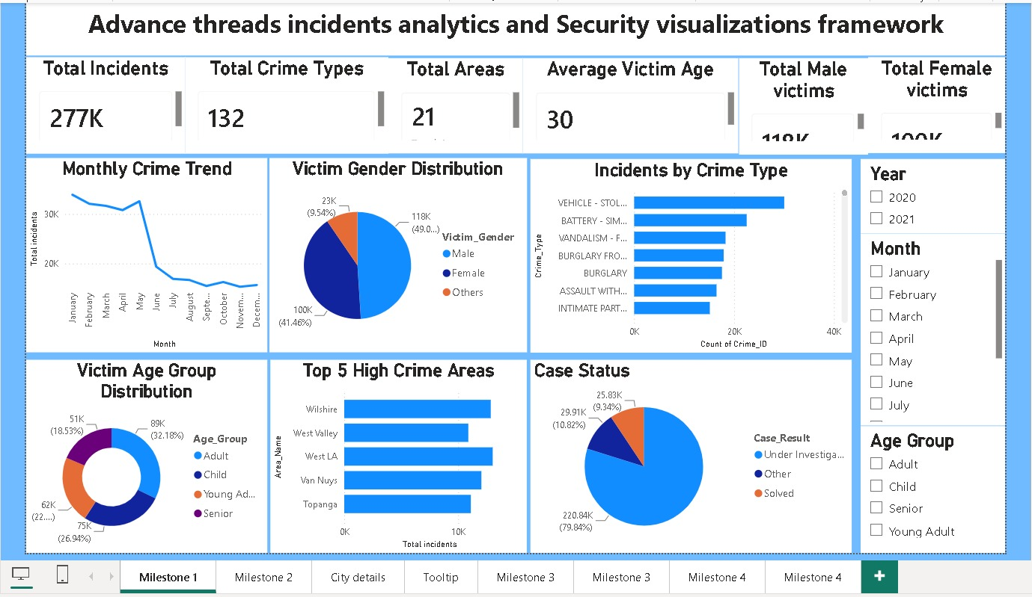
Figure 1: Advance Threat Incidents Analytics and Security Visualization Framework

4. Key Insights
- Vehicle theft (Vehicle – Stolen) is the leading incident category, followed by Battery – Simple Assault and Vandalism – Felony.
- Victim gender split is close to even: Male victims account for 49.0% (118K) and Female victims 41.46% (100K), with 9.54% (23K) recorded as Others.
- Adults form the largest victim age group at 32.18% (89K), closely followed by Child at 26.94% (75K) and Young Adult at 22% (62K); Seniors are the smallest group at 18.53% (51K).
- Wilshire, West Valley, West LA, Van Nuys, and Topanga are the Top 5 high-crime areas by incident count.
- Monthly trend shows sustained high incident volume from January through May, followed by a sharp decline from June onward.
- Case status reveals a significant backlog: about 79.84% (220.84K) of incidents remain 'Under Investigation', while only 9.34% (25.83K) are marked 'Solved'.

5. Business Recommendations
- Prioritize patrol and prevention resources toward the Top 5 high-crime areas identified (Wilshire, West Valley, West LA, Van Nuys, Topanga).
- Investigate the low case-closure rate (~9%) and strengthen the investigation-to-resolution workflow to reduce the 'Under Investigation' backlog.
- Launch targeted prevention programs for vehicle theft and assault-related categories, since these dominate incident volume.
- Align staffing and monitoring schedules with the January–May peak period observed in the monthly trend.

Milestone 2: Threat Intelligence and Geospatial Risk Analytics

1. Objective
This milestone extends the initial classification view into full-scale geospatial threat intelligence. The goal is to map incident hotspots across all 21 covered areas, benchmark reporting-time performance city-by-city, and identify the highest-risk zones — turning raw incident classification into location-aware, actionable intelligence for security planning.

2. Dashboard
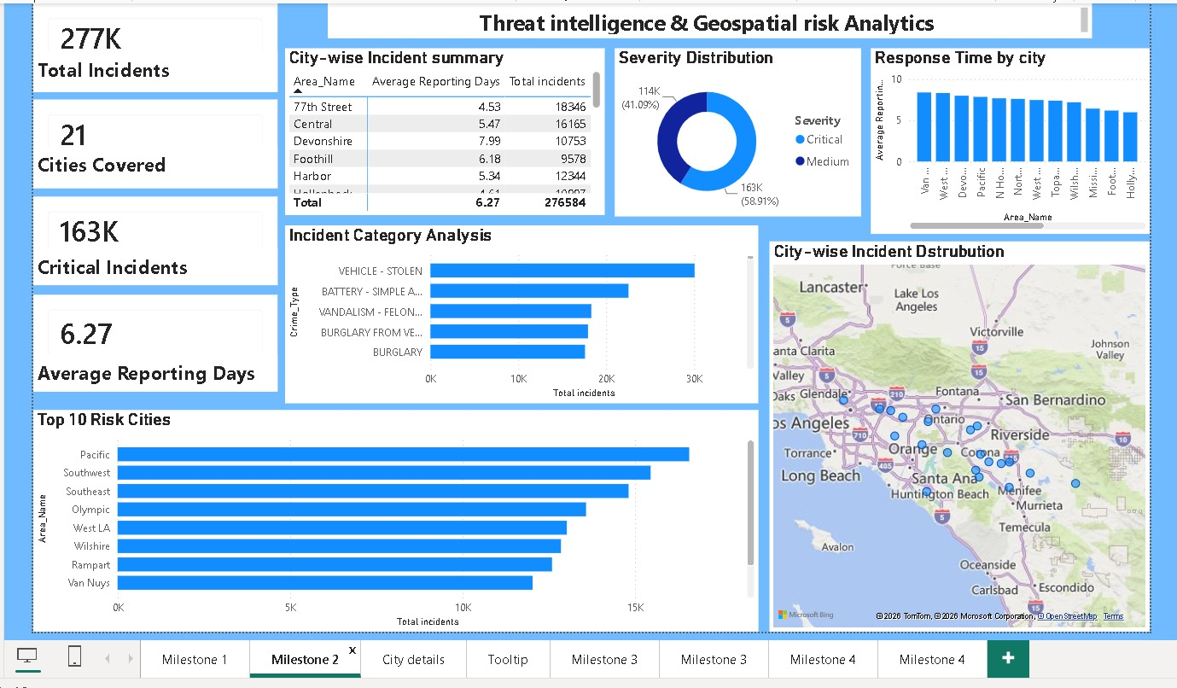
Figure 2: Threat Intelligence & Geospatial Risk Analytics — Main View
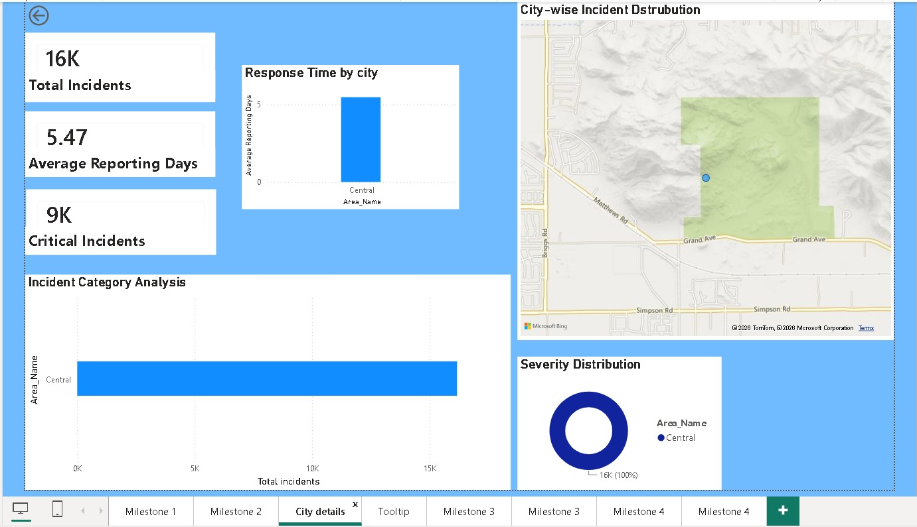
Figure 3: City Details Drill-Through View
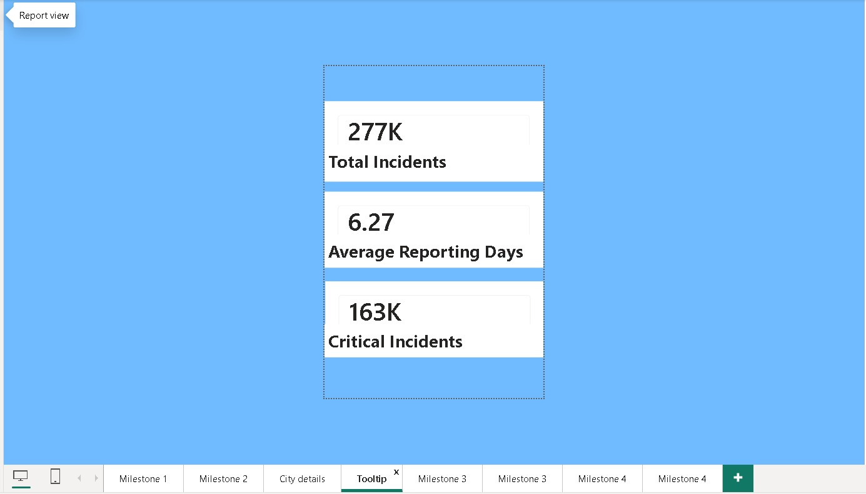
Figure 4: Quick-Glance Tooltip Summary

3. Key Insights
- Across all 21 cities, the platform tracks 277,000 total incidents with an overall average reporting delay of 6.27 days.
- Critical-severity incidents (163K, 58.91%) outnumber Medium-severity incidents (114K, 41.09%) — indicating the majority of tracked incidents are high-severity rather than following a typical low-to-high severity pyramid.
- Pacific, Southwest, Southeast, Olympic, and West LA emerge as the Top 5 riskiest cities by total incident volume.
- 77th Street records the highest incident count among all areas (18,346) with a below-average reporting delay of 4.53 days, while Devonshire has fewer incidents (10,753) but the longest reporting delay (7.99 days) — showing that reporting speed does not necessarily correlate with incident volume.
- The City Details drill-through (using Central as an example) shows 16K incidents with 9K (56%) classified Critical, confirming that risk concentration varies significantly from area to area rather than being uniform.

4. Business Recommendations
- Investigate the root cause behind Devonshire's longer reporting delay (7.99 days) despite its comparatively lower incident volume — this may point to a resourcing or process gap.
- Direct additional geospatial-based patrol resources toward the Top 10 Risk Cities identified on the hotspot map.
- Standardize reporting-time targets across areas, since current delays vary widely without a clear link to incident volume.
- Enable area commanders to use the City Details drill-through operationally as a self-service view for their own zone's performance.

Milestone 3: Temporal Incident Analytics and Incident Response Analytics

1. Objective
This milestone analyzes the incident data through the time dimension — daily, weekly, monthly, and seasonal patterns — and evaluates case-response and closure performance. The combined view supports staffing decisions and highlights operational efficiency gaps in how incidents are being resolved.

2. Dashboard
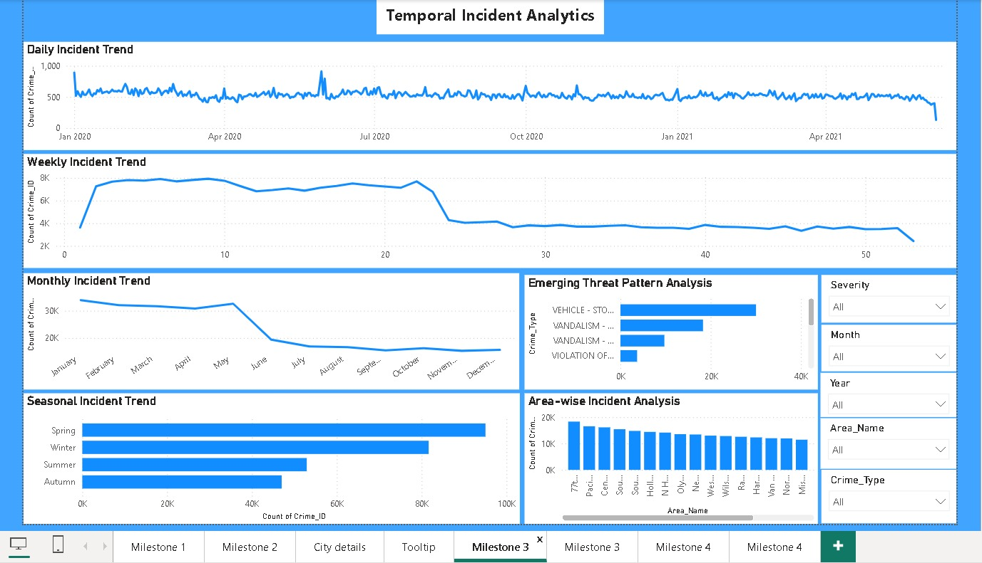
Figure 5: Temporal Incident Analytics
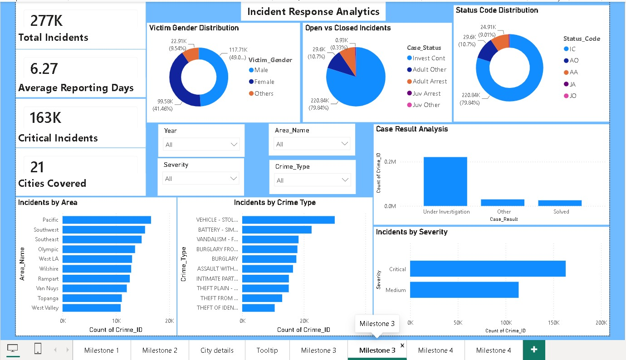
Figure 6: Incident Response Analytics

3. Key Insights
- Spring is the peak season for incidents (~90K), nearly double the volume of Autumn, the lowest season (~40K) — a clear seasonal pattern relevant for staffing plans.
- The daily trend holds a steady baseline of roughly 500 incidents per day with occasional spikes, and shows a visible decline toward the end of the tracked window (April 2021), which should be validated against data completeness in the next refresh.
- Case-handling status mirrors the Milestone 1 finding: about 79.84% of incidents remain 'Investigation Continued', while arrests (Adult Arrest + Juvenile Arrest) account for only a small fraction of outcomes — confirming a case-closure bottleneck.
- Vehicle theft and vandalism-related categories dominate the Emerging Threat Pattern view, consistent with the top crime categories identified in earlier milestones.
- Incidents by Severity confirms Critical-severity cases (~163K) exceed Medium-severity cases (~114K), reinforcing the severity skew seen in Milestone 2.

4. Business Recommendations
- Reallocate staffing to align with the Spring peak period and scale down monitoring resources during the lower-volume Autumn season.
- Given the low arrest/closure rate, review investigative capacity and case-management workflow to improve resolution throughput.
- Monitor the declining trend at the end of the data window in the next refresh to confirm whether it reflects a genuine drop or incomplete recent data.
- Use the Incidents-by-Area and Incidents-by-Crime-Type views to cross-check resource allocation against the geospatial hotspots identified in Milestone 2.

Milestone 4: Security Risk Assessment, Predictive Intelligence and Executive Analytics

1. Objective
The final milestone consolidates the platform into risk-scoring and forward-looking predictive views. It gives analysts and executives a single, unified perspective on current risk exposure and forecasted risk trends across all 21 covered locations, layering historical analysis with predictive intelligence.

2. Dashboard
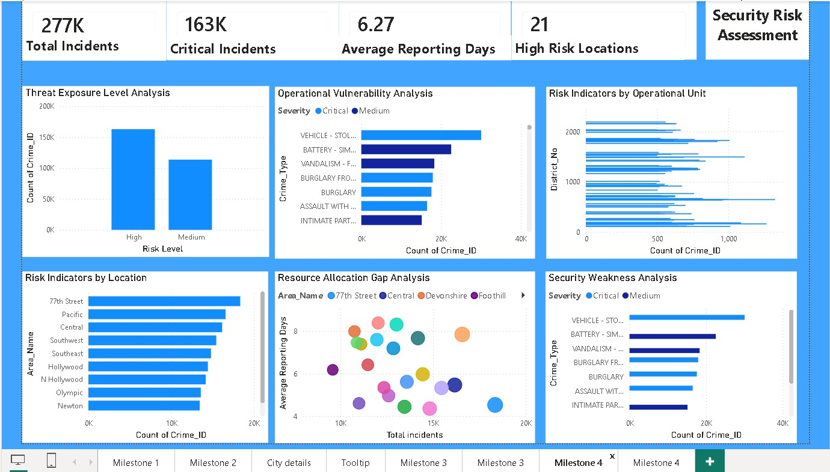
Figure 7: Security Risk Assessment
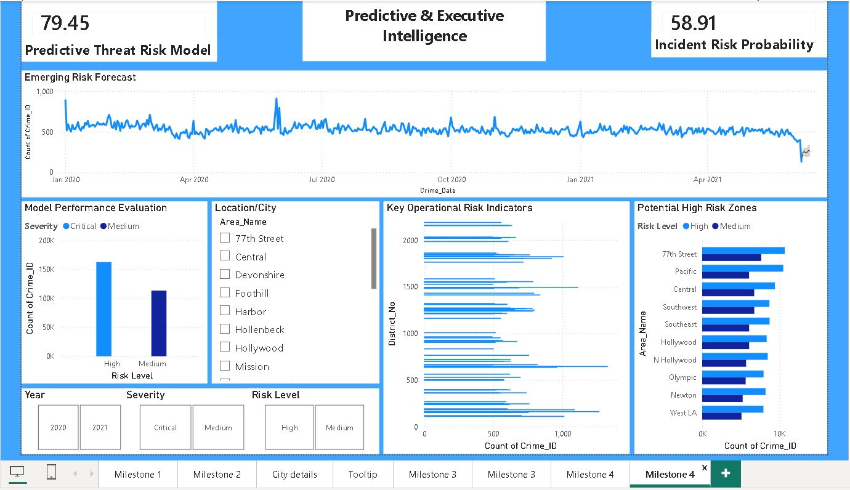
Figure 8: Predictive & Executive Intelligence

3. Five Key Insights
- Threat Exposure Level Analysis confirms High-risk incidents (163K) outnumber Medium-risk incidents (114K), consistent with the severity skew observed in Milestone 2 and Milestone 3.
- The Predictive Threat Risk Model returns a score of 79.45 out of 100, indicating an elevated overall risk posture across the covered areas.
- Incident Risk Probability is calculated at 58.91%, meaning there is a majority likelihood of continued high-severity incident occurrence going forward.
- 77th Street, Pacific, and Central consistently rank among the Potential High-Risk Zones, matching the Top Risk Cities identified in the Milestone 2 geospatial dashboard — confirming that risk concentration is stable across dashboards rather than shifting.
- The Resource Allocation Gap Analysis scatter plot shows several areas combining both high incident volume and above-average reporting delay — these represent the highest-priority gap areas for resource reallocation.

4. Predictive Findings
- The Emerging Risk Forecast (Jan 2020 – Apr 2021) stays largely range-bound around a steady baseline, with a sharp dip visible at the very end of the tracked window; this should be monitored to confirm whether it reflects a genuine easing of risk or a data-completeness artifact at the edge of the dataset.
- Given a Risk Probability of 58.91% and a Risk Score of 79.45, the platform currently classifies the overall period as elevated-risk, supporting continued heightened monitoring.

5. Strategy Recommendations
- Direct additional patrol and investigation resources toward the confirmed persistent high-risk zones — 77th Street, Pacific, and Central.
- Track the Predictive Threat Risk Model score as a recurring monthly KPI to detect early shifts in overall risk trend.
- Close the resource-allocation gap identified in the scatter analysis by adjusting staffing in areas with both high incident volume and long reporting delay.
- Integrate the case-closure improvements recommended in Milestone 3 with the risk-scoring model, since persistently low closure rates are likely inflating the platform's standing risk score.

Conclusion
Together, the four milestones form a complete incident-intelligence pipeline — from initial classification and geospatial mapping, through temporal and response analysis, to risk assessment and predictive forecasting. This layered design allows different stakeholders, from area-level analysts to executive leadership, to work from the same underlying incident data at the level of detail relevant to their role.

