**DEPARTMENT OF INFORMATION TECHNOLOGY**

**SUNWAY INTERNATIONAL BUSINESS SCHOOL**

**MAITIDEVI, KATHMANDU**

**APPROVAL**

This is to certify that the project entitled " **Entrance Examination Record System** " submitted by Mr. Abhimanyu Neupane, Mr. Sizar Awale, Mr. Sesil Chakradhar and Mr. Sailesh Khadka in a partial fulfillment of the requirements for the award of the Degree of Bachelor of Computer Science first semester of Infrastructure University Kuwala Lampur(IUKL), is a bonafide work to the best of our knowledge and may be placed before the examination Board for their consideration.

|  |  |  |
| --- | --- | --- |
|  |  |  |



**Subject: Programming Fundamentals(CSC 1510)**

**Project Title: Entrance Examination Record System**

**SUBMITED TO: Sunway International Business School**

**Maitidevi, Kathmandu**

**Investigator: Mr.Som Shrestha**

**Mr. Prakash Ranabhat**

**Project Group Members: Mr. Sailesh Khadka**

**Mr. Abhimanyu Neupane**

**Mr. Sizar Awale**

**Mr. Sesil Chakradhar**

**Submission Date: 09/24/2018**

**ACKNOWLEDGEMENT**

We are very thankful to everyone who helped us selecting the topic “**Entrance Examination Record System**” and more over we have completed our proposal on time.

We would like to express gratitude towards each and every members of Department of Computer Science, "Sunway International Business School" and friends for their kind co-operation & encouragement. They gave us moral support and guided us in different matters regarding the topic. They have been very kind and patient while suggesting us the outline of this proposal and correcting our doubts. We thank all teachers and friends for overall supports.

Last but not the least, we would like to thank our parents who helped us a lot in gathering different information, collecting data and guiding us from time to time and sharing us their valuable ideas in selecting project title as “**Entrance Examination Record System**” despite of their busy schedules.

**ABSTRACT**

In aspect of today’s education system, Examination has become an important system. An examination is an exam that applicants must pass with great scores for access to an institution of higher education in universities. Each and every of the universities or colleges are conducting their exams to be a part of this fastest growing world. Student Entrance Examination System is a software application that allows a particular institute to arrange, conduct and manage the objective examination via computerized way. It is an application that establishes a network between the institutes and the students. This system is helpful for educational purpose to conduct logic test besides the subjective on a regular basis. It also reduces the administrator’s load and helps provide the flexibility to teacher’s need for mass evaluation. This Examination system can be conducted at the same time at different centers located at different parts of country. There will be an invigilator at each center for the purpose of Examination system.

Table of Contents

Approvalii

Cover Pageiii

Acknowledgementiv

Abstract v

Content vi

Chapter Title Page

1 Introduction1

1.1 Background

1.2 Objectives

1.3 Scopes

1.4 Problem Statement

2 Literature review2

2.1 Background

2.2 Existing System3

3 Methodology4

3.1 Background

3.2 Waterfall Model

3.2.1 Requirement Gathering and System Analysis

3.2.2 System Design

3.3.3 Implementation5

3.3.4 Integration and Testing

3.3.5 Deployment of System

3.3.6 Maintenance

4 Design6

4.1 Tools and Platform

4.1.1 C-Programming

4.1.2 Code-Blocks

4.1.3 Algorithm

4.1.4 Flowchart7

4.2 Project Plan8

4.2.1 Table Design Project Planning

5 Conclusion9

5.1 Conclusion

6 Reference10

**CHAPTER 1**

**INTRODUCTION**

# 1.1 Background

Examination has become an important aspect of today’s education system. The importance of Exam is increasing day by day from the starting process of admission and to getting more transparent. The Exams qualify only those students who will manage to crack it with high grade. The seat will be awarded to students on basis of their ranking in exams. Institutes are adopting entrance exam as part of their admission process to identify the right students for their colleges. Within this system, institutes can register and host online exams. Students can give exams and view their results. This system is an attempt to remove the existing flaws in the manual system of conducting exams. With response to the growing number of students entering universities, many universities and colleges prefer to conduct online examinations for their course, which are suitable for mass evaluation. This method could evaluate student’s achievement, and helps to give fair scores. The main objective of Entrance Examination System is to efficiently evaluate and register the candidate thoroughly through a fully automated system that not only saves lot of time but also gives fast results. This system also focuses on how to provide a secure environment for Entrance Examination System. This software is targeted for the BCS entrance. At each center, there will be an invigilator for the purpose of identification of candidates appearing for examination.

**1.2 Objectives**

This encloses the needs and scope of the development of the project. The main objective of Entrance Examination Record System is to conduct entrance examination record in automated way.

**1.3 Scopes**

This can be used in educational institutions as well as in corporate world. This system helps to efficiently reduce the load of administrator’s mass educational evaluation. It gives quick result and forbids the unfair scores. It is focused on the benefit of both the student and exam conduction section.

**1.4 Problem Statement**

Also like other online systems, it will help students by:

Student does not need to wait too long for their result which reduces the waste of time of candidates.

**CHAPTER 2**

**LITERATURE REVIEW**

**2.1 Background**

Today’s world is computer dominated world. Each and every field is dependent on computer to perform the task ranging from simple to complex one. Computer has been applied in almost every field among which Education field is one of them. So we intended to develop an “Entrance Examination Record System” that will help in smoothening the BCS entrance. BCS entrance examination is one of the competitive exams conducted in Nepal. Many candidates target for this examination from all over the places of Nepal. As for this mass evaluation our proposed system “Entrance Examination System” can stand a better way. The present exam conducting format includes the paper way system in different processes like:-

Sit arrangement

Printing questions & answers

Question/answer sheet

Admit card checking

Candidate’s confirmation

This process being done manually, it requires more time and manpower. For this extra consumption of time, this system provides the better solution. Since there are many candidates for BCS entrance, there are different center’s chosen for conducting the entrance exam. The main risk in keeping record in paper format is the probability of losing the records of students or other damage may arise. This system converts all the paper work into computer work. Each candidate will be provided with a unique record for the security while appearing the exam to prevent the unauthorized access. So this system will stand as the helping hand for the BCS exam. of Infrastructure University Kuwala Lampur(IUKL), has implemented similar system in present days. In that system, the student has to register their name firstly in paper or document and then they provides the record of students but this system will keep the record in computer and displays the record in systematic order. The student has to visit the particular exam center and give the details of their for keeping record . Later on, the institute publishes the score into the website.

**2.2 Existing System**

Sunway International Business School affiliated to Infrastructure University Kuwala Lampur(IUKL), is a leading college of Nepal. Every year many candidates apply for the BCS entrance examination. Presently, Sunway college is using the paper based record system for managing BCS entrance exam. It has so many problems. So we introduce a new system, which is fully computerized. Existing system is a large man power process and is difficult to implement. Working of existing system is given below:-

Student Registration is the first process. As the part of the registration, the student has to enter his name, address etc. into the registration form. The question papers contain total mark, subject, duration, question paper etc. A group of person does evaluation of answer sheet. After the evaluation of the Answer sheet, the result is published in paper. And also make the mark list. The paperwork has provided them with a lot of confusion and conflicts during the decision making so that some of their decision remains pending and some are decided under bad consequences. The alternative is the online examination system that has been designed especially for the purpose of BCS entrance. The paper based works are replaced by the computerized semi-automatic system which is an efficient method in under developed country such as Nepal.

**CHAPTER 3**

**METHODOLOGY**

**3.1 Background**

In this project we are going developing interface of the entrance examination. This system will be capable of registering the students, provide the digital record, and display the individual scores of the entrance exam instantly after the completion the exam. In order to replace the existing methods, this system has been developed “Entrance Examination Record System”.

**3.2 Waterfall Model**

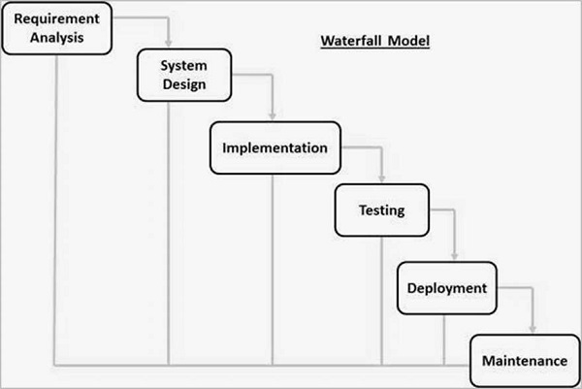

The sequential phases in Waterfall model are:

**3.2.1 Requirement Gathering and analysis:**

All possible requirements of the system to be developed are captured in this phase and documented in a requirement specification document.

**3.2.2 System Design:**

The requirement specifications from first phase are studied in this phase and the system design is prepared. This system design helps in specifying hardware and system requirements and helps in defining the overall system architecture.

**3.3.3 Implementation:**

With inputs from the system design, the system is first developed in small programs called units, which are integrated in the next phase. Each unit is developed and tested for its functionality, which is referred to as Unit Testing.

**3.3.4 Integration and Testing:**

All the units developed in the implementation phase are integrated into a system after testing of each unit. Post integration the entire system is tested for any faults and failures.

**3.3.5 Deployment of system:**

Once the functional and non-functional testing is done; the product is deployed in the customer environment or released into the market.

**3.3.6 Maintenance:**

There are some issues which come up in the client environment. To fix those issues, patches are released. Also to enhance the product some better versions are released. Maintenance is done to deliver these changes in the customer environment.

**Chapter-4**

**Design**

**4.1 Tools and Platform**

As there should be efficient platform under which we can easily proceed our work. Platform determines each and every action of the work. So platform should be choose to keep time and knowledge in mind. Some of the platform is discussed in the sub heading for the development of our projects.

**4.1.1 C-programming**

C is a high-level and general-purpose programming language that is ideal for developing firmware or portable applications. It is proven, flexible and powerful and may be used for a variety of different applications.

**4.1.2 Code-Blocks**

Code-Blocks are a free C, C++ and Fortran IDE built to meet the most demanding needs of its users. It is designed to be very extensible and fully configurable.

**4.1.3 Algorithm**

This system is based on the following algorithms given below:

1. Start
2. Display Option students record details
3. Choose Options
4. If exist

a. Enter Students detail

v. If input complete

vi. Display Results

vii If new record

a. Go to step (ii)

b. Else Stop (Exit)

viii. Else go to step (iii)

**4.1.4 Flowchart**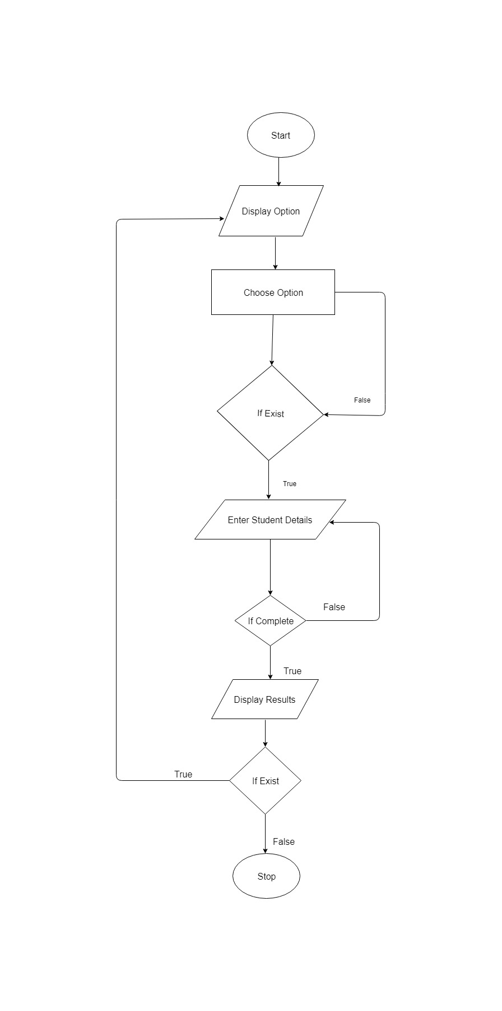

**4.2 Project Plan**

This project is fairly simple and easy to use. A successful project plan starts with relationships and conversation. Good project plans are clear, complete and carefully planned. This means good negotiation is a necessary part of a successful project plan.

This system takes around 10 days of proposal statement planning as given below in simple Gantt chart table 4.2.1.

4.2.1 Table design project planning

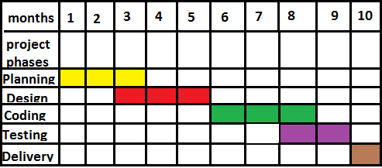

**Chapter 5**

**Conclusion**

**5. Conclusion**

“Entrance Examination Record System” is a Computer based application that provides facility to conduct Computer based entrance examination record at a certain center. It saves time as it allows number students to give the exam at a time and displays the results as the test gets over, so no need to wait for keeping record and details of students who appeared in entrance exam. Administrator will have a privilege to add, modify and delete the test papers and its particular records. User will be able to register and give the test with his specific id, and can see the record after the results is published.

**6. References**

<https://www.techopedia.com/definition/24068/c-programming-language-c>

<https://www.tutorialspoint.com/sdlc/sdlc_waterfall_model.htm>

<http://www.codeblocks.org/>

<https://www.workzone.com/blog/project-plan-success/>

<https://www.draw.io/>

<https://www.google.com.np/search?q=simple+project+plan+gantt+chart&num=100&source=lnms&tbm=isch&sa=X&ved=0ahUKEwiaj7fSsJrdAhWVfisKHToACm0Q_AUICigB&biw=1366&bih=631>