**EXAMINATION RECORD SYSTEM**

**PROJECT PROPOSAL**

SUBMITED BY

ABHIMANYU NEUPANE

SIZAR AWALE

SESIL CHAKRADHAR

SAILESH KHADKA

Sunway International Business School

**Infrastructure University Kuala Lumpur**

Maitidevi, Kathmandu, Nepal

SUBMITED TO

Sunway International Business School

**Infrastructure University Kuala Lumpur**

Maitidevi, Kathmandu, Nepal

Title : Examination Record System

Date Submitted : February 7, 2019

Investigator : Er. Amar Subedi

Signed:

____________________________

Investigator:

Er. Amar Subedi

**ACKNOWLEDGEMENT**

First of all, I am grateful to the Sunway International Business School for providing such a good platform to practically enhance the things we learned throughout the semester by giving us this wonderful project and also providing us with all the resources needed for this project.

I would like to express sincere gratitude to our respected lecturers Mr. Som Prasad Shrestha sir and Mr. Amar Subedi Sir for all the support and guidance that you provided us till date. Thank you for helping us make this project successful.

I also take this opportunity to express a deep sense of gratitude and appreciation to my family for the utmost support and encouragement, without them this would not be possible. Lastly, many thanks to all my friends for helping me with a lot of ideas, motivation and encouragements.

**ATTRIBUTES**

In aspect of today’s education system, Examination has become an important system. **Examination record system** subjectallows different schools and institutes to keep the record of examination conducted by them in a managed way. It even makes calculation easier for marking grades. This system is designed to efficiently handle processes like inputting scores, storing results, classifying the grade points automatically calculated and showing the overall results of the student. This system is made with the view of saving time and accurately calculating the overall result of the student. It reduces the time span and process of declaring grade points. This computerized record system had been developed which is capable of capturing, storing and displaying the information generated during comprehensive general examinations. This system helps to keep the record of various students for future use too. It is an application that establishes n network between the institutes and the students. This examination system can be conducted at the same time at different centers located at different parts of country. There will be an invigilator at each center for the purpose of examination system.

**TABLE OF CONTENTS**

**CHAPTER 1…………………………………………………………………………8**

INTRODUCTION…………………………………………………………………8

**1.1 Background** 8

**1.2 Objectives** 8

**1.3 Scopes** 8

**1.4 Problem Statement** 8

CHAPTER 2…………………………………………………………………………..9

LITERATURE REVIEW........................................................................................9

**2.1 Background** 9

**2.2 Existing System** 9

**CHAPTER 3………………………………………………………………………….11**

METHODOLOGY………………………………………………………………11

**3.1 Waterfall Model** 11

**3.1.1 Requirement Gathering and analysis:** 11

**3.1.2 System Design** 11

**3.1.3 Implementation:** 11

**3.1.4 Testing:** 12

**3.1.5 Deployments:** 12

**3.1.6 Maintenance:** 12

CHAPTER 4………………………………………………………………………….13

**TECHNOLOGY AND TOOLS………………………………………………….13**

**4.1.1 C** 13

**4.2 Tools** 13

**4.2.1 Code blocks** 13

**4.2.2 Creately** 13

**CHAPTER 5…………………………………………………………………………..15**

**SYSTEM DESIGN………………………………………………………………15**

**5.1 Use case Diagram**

**5.2 Activity Diagram** 15

**5.3 Flow Chart** 15

**CHAPTER 6………………………………………………………………………….18**

**DELIVERIABLE…………………………………………………………………18**

**6.1** **Gantt Chart** 18

**6.2** **Project Code** 18

**6.3 System Snapshot** 19

CHAPTER 7………………………………………………………………………….22

TESTING AND VERIFICATION…………………………………………………22

**7.1 Testing** 22

**7.2 Verification** 22

CHAPTER 8…………………………………………………………………………23

Conclusion 23

**8.1 Conclusion** 23

**8.2** **References:** 23

Table of figures

Figure 1 Waterfall model………………………………………………11

Figure 2 Use-Case Diagram…………………………………………….14

Figure 3 Activity Diagram……………………………………………..15

Figure 4 Flow Chart…………………………………………………….16

Figure 5 Algorithm…………………………………………………….17

Figure 6 Gantt chart………………………………………………………18

Figure 7 Login………………………………………………………………………………………20

# Figure 8 Show options………………………………………………….21

Figure 9 Enter records…………………………………………………………………………..21

Table of abbreviations

1. UML :- Unified Modelling Language
2. C language :- [Compiled Language](https://simple.wikipedia.org/wiki/Compiled_language)

**CHAPTER 1**

## **INTRODUCTION**

### **1.1 Background**

Examination has become an important aspect of today’s education system. The importance of Exam is increasing day by day from the starting process of admission and to getting more transparent. The Exams qualify only those students who will manage to crack it with high grade. The seat will be awarded to students on basis of their ranking in exams. Institutes are adopting entrance exam as part of their admission process to identify the right students for their colleges. Within this system, institutes can register and host online exams. Students can give exams and view their results. This system is an attempt to remove the existing flaws in the manual system of conducting exams. With response to the growing number of students entering universities, many universities and colleges prefer to conduct online examinations for their course, which are suitable for mass evaluation. This method could evaluate student’s achievement, and helps to give fair scores. The main objective of Entrance Examination System is to efficiently evaluate and register the candidate thoroughly through a fully automated system that not only saves lot of time but also gives fast results. This system also focuses on how to provide a secure environment for Entrance Examination System. This software is targeted for the BCS entrance. At each center, there will be an invigilator for the purpose of identification of candidates appearing for examination.

### **1.2 Objectives**

This encloses the needs and scope of the development of the project. The main objective of Entrance Examination Record System is to conduct entrance examination record in automated way.

### **1.3 Scopes**

This system is developing in C so it is short term used but this system includes file system which is the main advantages for everyone to know their detail in a time so this system will run for long time.

### **1.4 Problem Statement**

Also, like other online systems, it will help students by:

Student does not need to wait too long for their result which reduces the waste of time of candidates.

## **CHAPTER 2**

## **LITERATURE REVIEW**

### **2.1 Background**

Today’s world is computer dominated world. Each and every field is dependent on computer to perform the task ranging from simple to complex one. Computer has been applied in almost every field among which Education field is one of them. So we intended to develop an “**Entrance Examination Record System**” that will help in smoothening the BCS entrance. BCS entrance examination is one of the competitive exams conducted in Nepal. Many candidates target for this examination from all over the places of Nepal. As for this mass evaluation our proposed system “Entrance Examination System” can stand a better way. The present exam conducting format includes the paper way system in different processes like:-

Sit arrangement

Printing questions & answers

Question/answer sheet

Admit card checking

Candidate’s confirmation

This process being done manually, it requires more time and manpower. For this extra consumption of time, this system provides the better solution. Since there are many candidates for BCS entrance, there are different center’s chosen for conducting the entrance exam. The main risk in keeping record in paper format is the probability of losing the records of students or other damage may arise. This system converts all the paper work into computer work. So this system will stand as the helping hand for the BCS exam of Infrastructure University Kuala Lumpur (IUKL), has implemented similar system in present days. In that system, the student has to register their name firstly in paper or document and then they provides the record of students but this system will keep the record in computer and displays the record in systematic order. The student has to visit the particular exam center and give the details of there for keeping record. Later on, the institute publishes the score into the website.

### **2.2 Existing System**

Sunway International Business School affiliated to Infrastructure University Kuala Lumpur (IUKL), is a leading college of Nepal. Every year many candidates apply for the BCS entrance examination. Presently, Sunway College is using the paper based record system for managing BCS entrance exam. It has so many problems. So we introduce a new system, which is fully computerized. Existing system is a large man power process and is difficult to implement. Working of existing system is given below:-

Student Registration is the first process. As the part of the registration, the student has to enter his name, address etc. into the registration form. The question papers contain total mark, subject, duration, question paper etc. The paperwork has provided them with a lot of confusion and conflicts during the decision making so that some of their decision remains pending and some are decided under bad consequences. The alternative is the online examination system that has been designed especially for the purpose of BCS entrance. The paper based works are replaced by the computerized semi-automatic system which is an efficient method in under developed country such as Nepal.

**CHAPTER 3**

## **Methodology**

### **3.1 Waterfall Model**

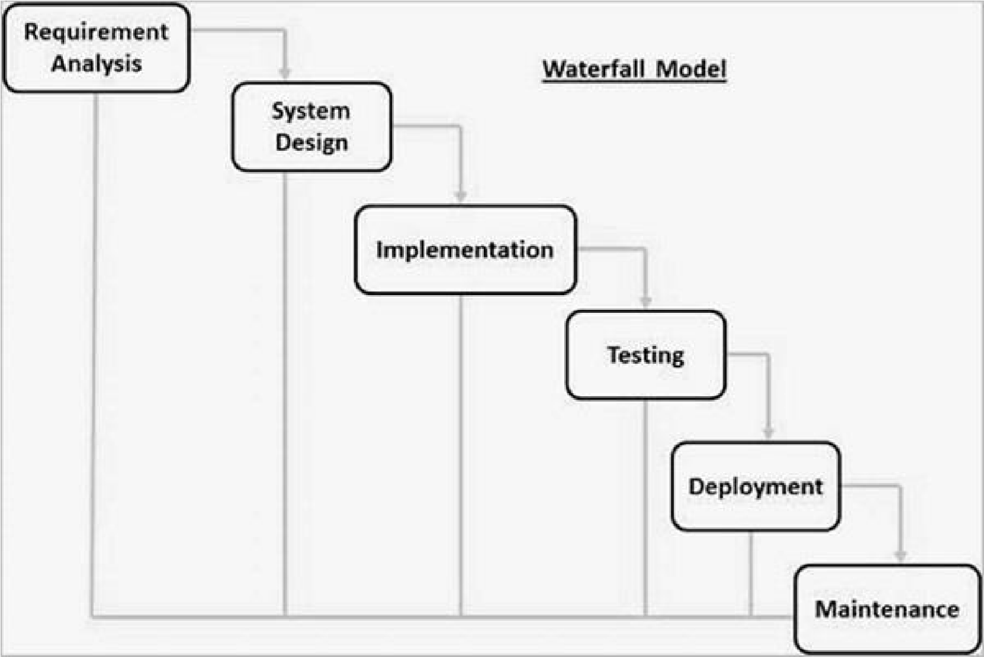

Figure 1 Waterfall model

The sequential phases in Waterfall model are:

### **3.1.1 Requirement Gathering and analysis:**

All possible requirements of the system to be developed are captured in this phase and documented in a requirement specification document.

#### **3.1.2 System Design:**

The requirement specifications from first phase are studied in this phase and the system design is prepared. This system design helps in specifying hardware and system requirements and helps in defining the overall system architecture

### **3.1.3 Implementation:**

With inputs from the system design, the system is first developed in small programs called units, which are integrated in the next phase. Each unit is developed and tested for its functionality, which is referred to as Unit Testing.

### **3.1.4 Testing:**

All the units developed in the implementation phase are integrated into a system after testing of each unit. Post integration the entire system is tested for any faults and failures.

### **3.1.5 Deployments:**

Once the functional and non-functional testing is done; the product is deployed in the customer environment or released into the market.

### **3.1.6 Maintenance:**

There are some issues which come up in the client environment. To fix those issues, patches are released. Also to enhance the product some better versions are released. Maintenance is done to deliver these changes in the customer environment.

# Chapter 4

### **Technology and Tools**

### **4.1.1** **C**

C programming language is a computer programming language that was developed to do system programming for the [operating system](https://simple.wikipedia.org/wiki/Operating_system) [UNIX](https://simple.wikipedia.org/wiki/UNIX) and is an imperative programming language. C was developed in the early 1970s by [Ken Thompson](https://simple.wikipedia.org/wiki/Ken_Thompson) and [Dennis Ritchie](https://simple.wikipedia.org/wiki/Dennis_Ritchie)at [Bell Labs](https://simple.wikipedia.org/wiki/Bell_Labs). It is a procedural language which means that people can write their [programs](https://simple.wikipedia.org/wiki/Computer_program) as a series of step-by-step instructions. C is a [compiled language](https://simple.wikipedia.org/wiki/Compiled_language).

#### **4.1.2 UML**

A UML diagram is a diagram based on the UML (Unified Modeling Language) with the purpose of visually representing a system along with its main actors, roles, actions, artefacts or classes, in order to better understand, alter, maintain, or document information about the system.

### **4.2 Tools**

### **4.2.1 Code blocks**

Code-Blocks are a free C, C++ and Fortran IDE built to meet the most demanding needs of its users. It is designed to be very extensible and fully configureurable.

### **4.2.2 Creately**

Creately is an online diagramming and collaboration tool that will help you to visualize your ideas Draw flowcharts, UML, Mind maps, UI mock-ups, Sitemaps, network diagram and more with amazing ease. Work together with clients and team using our real-time collaboration features.

Creately is an award-winning diagramming tool renowned for its ease of use. Our uncluttered interface combined with unique features like 1-click create and connect helps you draw diagram up to 3 times faster compared to traditional diagram software.

**Chapter 5**

## **System Design**

### **5.1 Use-Case Diagram**

A use case diagram is a graphic depiction of the interactions among the elements of a system. A use case is a methodology used in system analysis to identify, clarify, and organize system requirements.

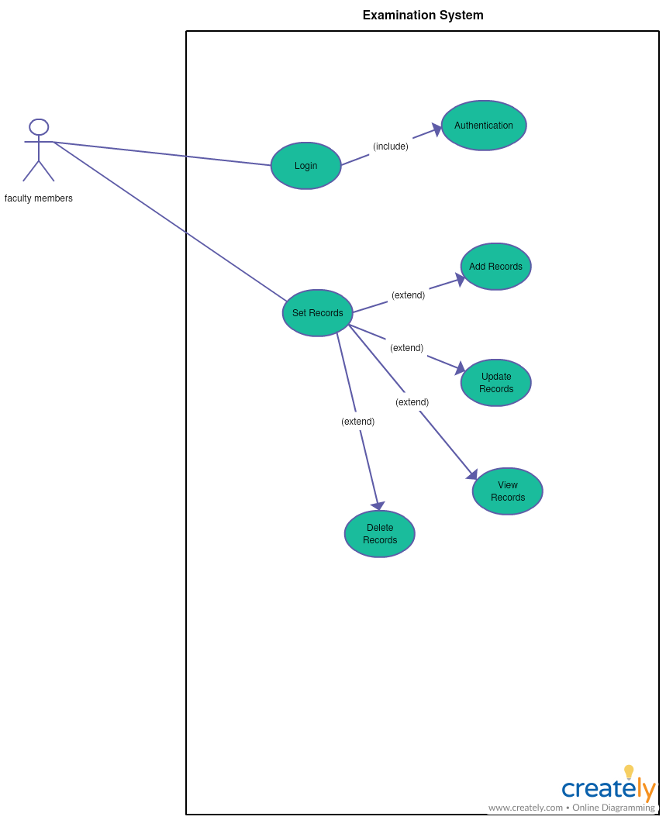

Figure 2 Use-Case Diagram

### **5.2 Activity Diagram**

Activity diagram is another important diagram in UML to describe the dynamic aspects of the system. Activity diagram is basically a flowchart to represent the flow from one activity to another activity. The activity can be described as an operation of the system.

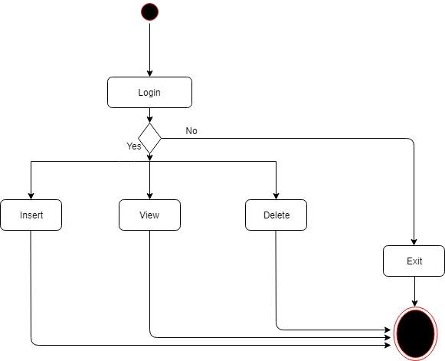

Figure 3 Activity Diagram

### **5.3 Flow Chart**

A flowchart is a type of diagram that represents an algorithm, workflow or process. The flowchart shows the steps as boxes of various kinds by connecting the boxes with arrows. This diagrammatic representation illustrates a solution model to a given problem.

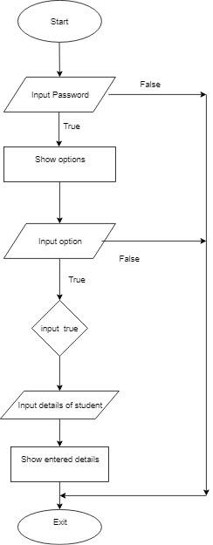

Figure 4 Flow Chart

#### **5.4 Algorithm**

It is the sequence of number where it tells the how the program is working.

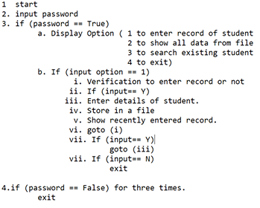

Figure 5 Algorithm

**Chapter 6**

## **Deliverable**

### **Gantt Chart**

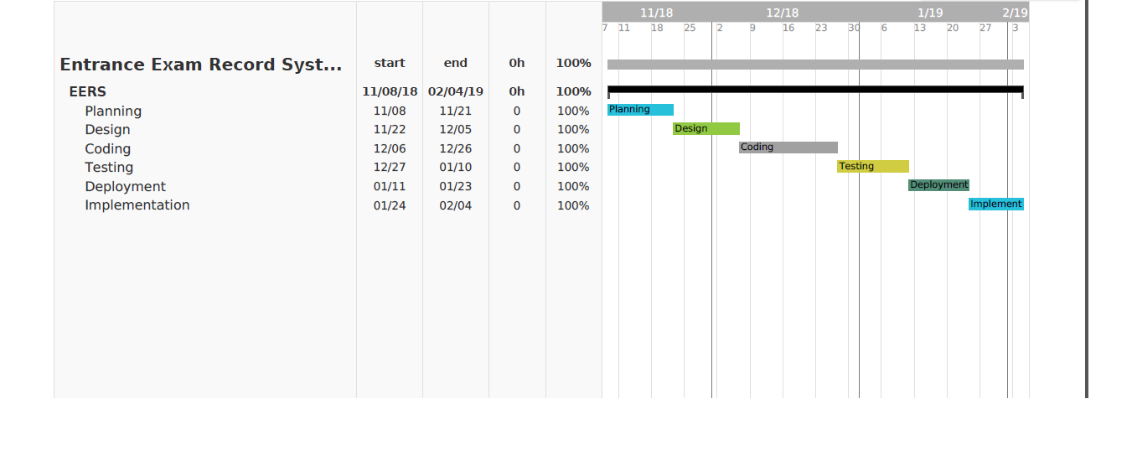

Figure 6 Gantt chart

### **6.2** **Project Code**

This system contains different function with their own features some demo code are below:

struct Data

{

int id,s_marks,e_marks,m_marks,n_marks;

char name[20];

float percentage;

char grade;

}save_d[50],read_d[50];

//***************************************************************

// FUNCTION USED IN PROJECT

//****************************************************************

void getdata();

void read_data();

void option();

void showdata();

void case_default();

void searchdata();

void deletedata();

//username and password//

void login() //login//

{

int num,count=0;

do

{

system("cls");

if(count>0)

{

printf("-------------------\n");

printf("****Invalid pin****\n");

printf("-------------------\n");

}

printf("Enter the password: \n");

scanf("%d",&num);

count++;

}while((num!=1234)&&(count<3)); //boundary value//

if((count<=3) && (num==1234))

{

system("cls");

printf("-------------------------------------------------\n");

printf(" ***Welcome To Entrance Exam Record System ***\n");

printf("-------------------------------------------------\n");

option();

}

else

{

printf("----------------------------\n");

printf("****Invalid login attempt***\n");

printf("----------------------------\n");

exit(0);

}

}

//main function//

main()

{

login();

}

### **6.3 System Snapshot**

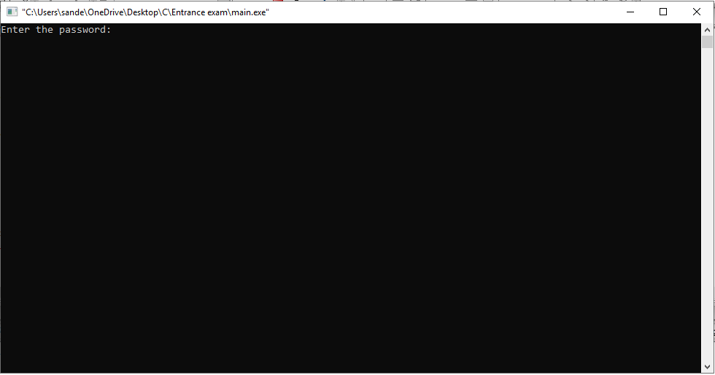

Figure 7. login

# 

# Figure 8 show options

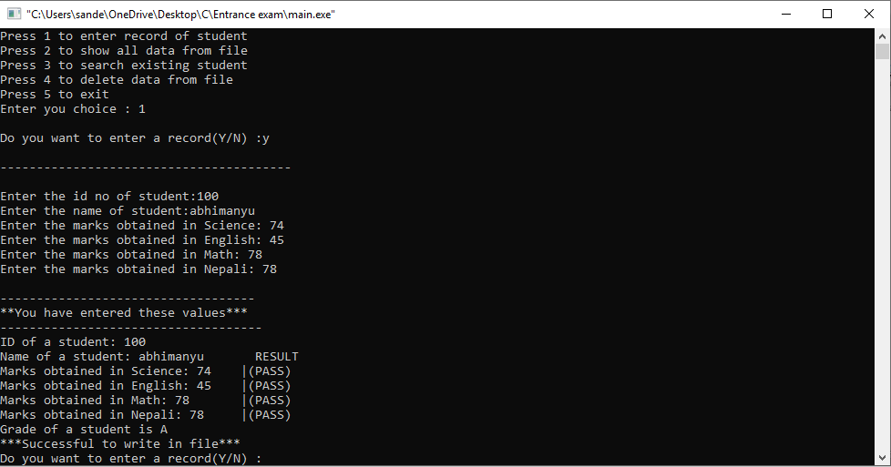Figure 9 Enter records

# Chapter 7

## **Testing and Verification**

### **7.1 Testing**

After building the code, this system has been tested by passing different details and different function on the main function to make it easy to use and reliable can install in the given configureuration. This system is tested in the given configureuration:

1. Windows 7/8/8.1/10
2. Dual core CPU
3. 2 or more than 2 GB RAM
4. Dev C++ or Code-blocks

### **7.2 Verification**

This system will be verified from our college to make more research and make fully compatible as per the user requirements

# 

# Chapter 8

## **Conclusion**

### **8.1 Conclusion**

This system works in windows environment. This system is developed with user friendly. The system provides user to change the data of the student who have appeared exam and manage and store in file. This project may help the user to manage the student exam information.

### **References:**

[1]. <https://app.teamweek.com/#timeline/399706/groups/362773?zoom=monthg>

[2]. https://prod.teamgantt.com/gantt/schedule/?ids=1470332

[3]. <https://www.tutorialspoint.com/cprogramming/c_structures.htm>