Lab 1: Requirements Engineering & UML Use-Case Modelling
Problem Statement #06 — Alumni Mentorship & Mock Interview Platform
Target Stakeholders / Actors: Student Mentee (Primary), Alumni Mentor (Secondary)
1. Requirements Table
ID | Type | Description | Priority | Acceptance Criteria | Rationale
FR-001 | Functional | The system shall recommend Alumni Mentors to Student Mentees based on domain matching (e.g., Embedded Systems, Cloud Computing) and facilitate one-click session booking. | High | Pass: Mentorship session is added to both calendars with a meeting link. Fail: Double-booking of mentor slots occurs. | Reduces manual search overhead for mentees and increases the relevance of mentor-mentee pairing, which is the core value proposition of the platform.
FR-002 | Functional | The system shall allow a Student Mentee to create and maintain a profile (academic year, branch, resume/LinkedIn link) and set ranked domain preferences used as input to mentor matching. | High | Pass: Profile/preference changes are saved and reflected in the matching results within 5 seconds. Fail: Updated preferences are not persisted or matching results remain unchanged after an update. | Accurate, current profile data is a precondition for FR-001's domain-matching algorithm to return relevant mentor recommendations.
FR-003 | Functional | The system shall allow an Alumni Mentor to define, edit, and block recurring or one-off availability slots on a calendar that is synchronized in real time with incoming booking requests. | High | Pass: A slot booked by one student is immediately marked unavailable to all other students. Fail: Two students are able to book the same time slot. | Real-time synchronization directly prevents the double-booking failure condition defined in FR-001 and gives mentors control over their volunteered time.
FR-004 | Functional | The system shall allow an Alumni Mentor to submit a structured post-interview feedback scorecard (rated criteria plus free-text comments) within 48 hours of a completed mock-interview session, visible to the corresponding Student Mentee. | Medium | Pass: Scorecard is stored, timestamped, and displayed in the student's session history. Fail: Scorecard is lost, delayed beyond 48 hours, or linked to the wrong session. | Structured feedback is the primary learning outcome for the student and closes the mentorship loop opened by FR-001.
FR-005 | Functional | The system shall send automated notifications (email and in-app) to both the mentee and mentor for booking confirmation, a 24-hour reminder, and any reschedule or cancellation event. | Medium | Pass: Notification is delivered within 1 minute of the triggering event. Fail: No notification is sent, or duplicate notifications are sent for the same event. | Timely reminders reduce no-show rates and keep both parties informed of last-minute changes to a booked session.
NFR-001 | Performance & Security | All user profile data and feedback scorecards shall adhere to data-privacy guidelines and support soft-deletion of a user's data within 24 hours of a verified deletion request. | High | Pass: Benchmarking tests confirm target latency and security standards are met under simulated peak load. Fail: Deletion is not completed within 24 hours, or data remains accessible after soft-deletion. | Alumni and student personal data (contact details, interview feedback) is sensitive; timely erasure and secure handling are required for institutional and legal compliance.
NFR-002 | Reliability & Scalability | The system shall support at least 500 concurrent booking requests during peak periods (e.g., placement season) with a maximum booking-transaction latency of 2 seconds and zero double-bookings under concurrent access. | High | Pass: A load test with 500 concurrent users shows 95th-percentile latency under 2 seconds and 0 double-booked slots. Fail: Latency exceeds 2 seconds or any double-booking occurs under load. | Booking demand spikes sharply during placement season; the platform must remain responsive and consistent precisely when student demand for mock interviews is highest.

2. UML Use-Case Diagram
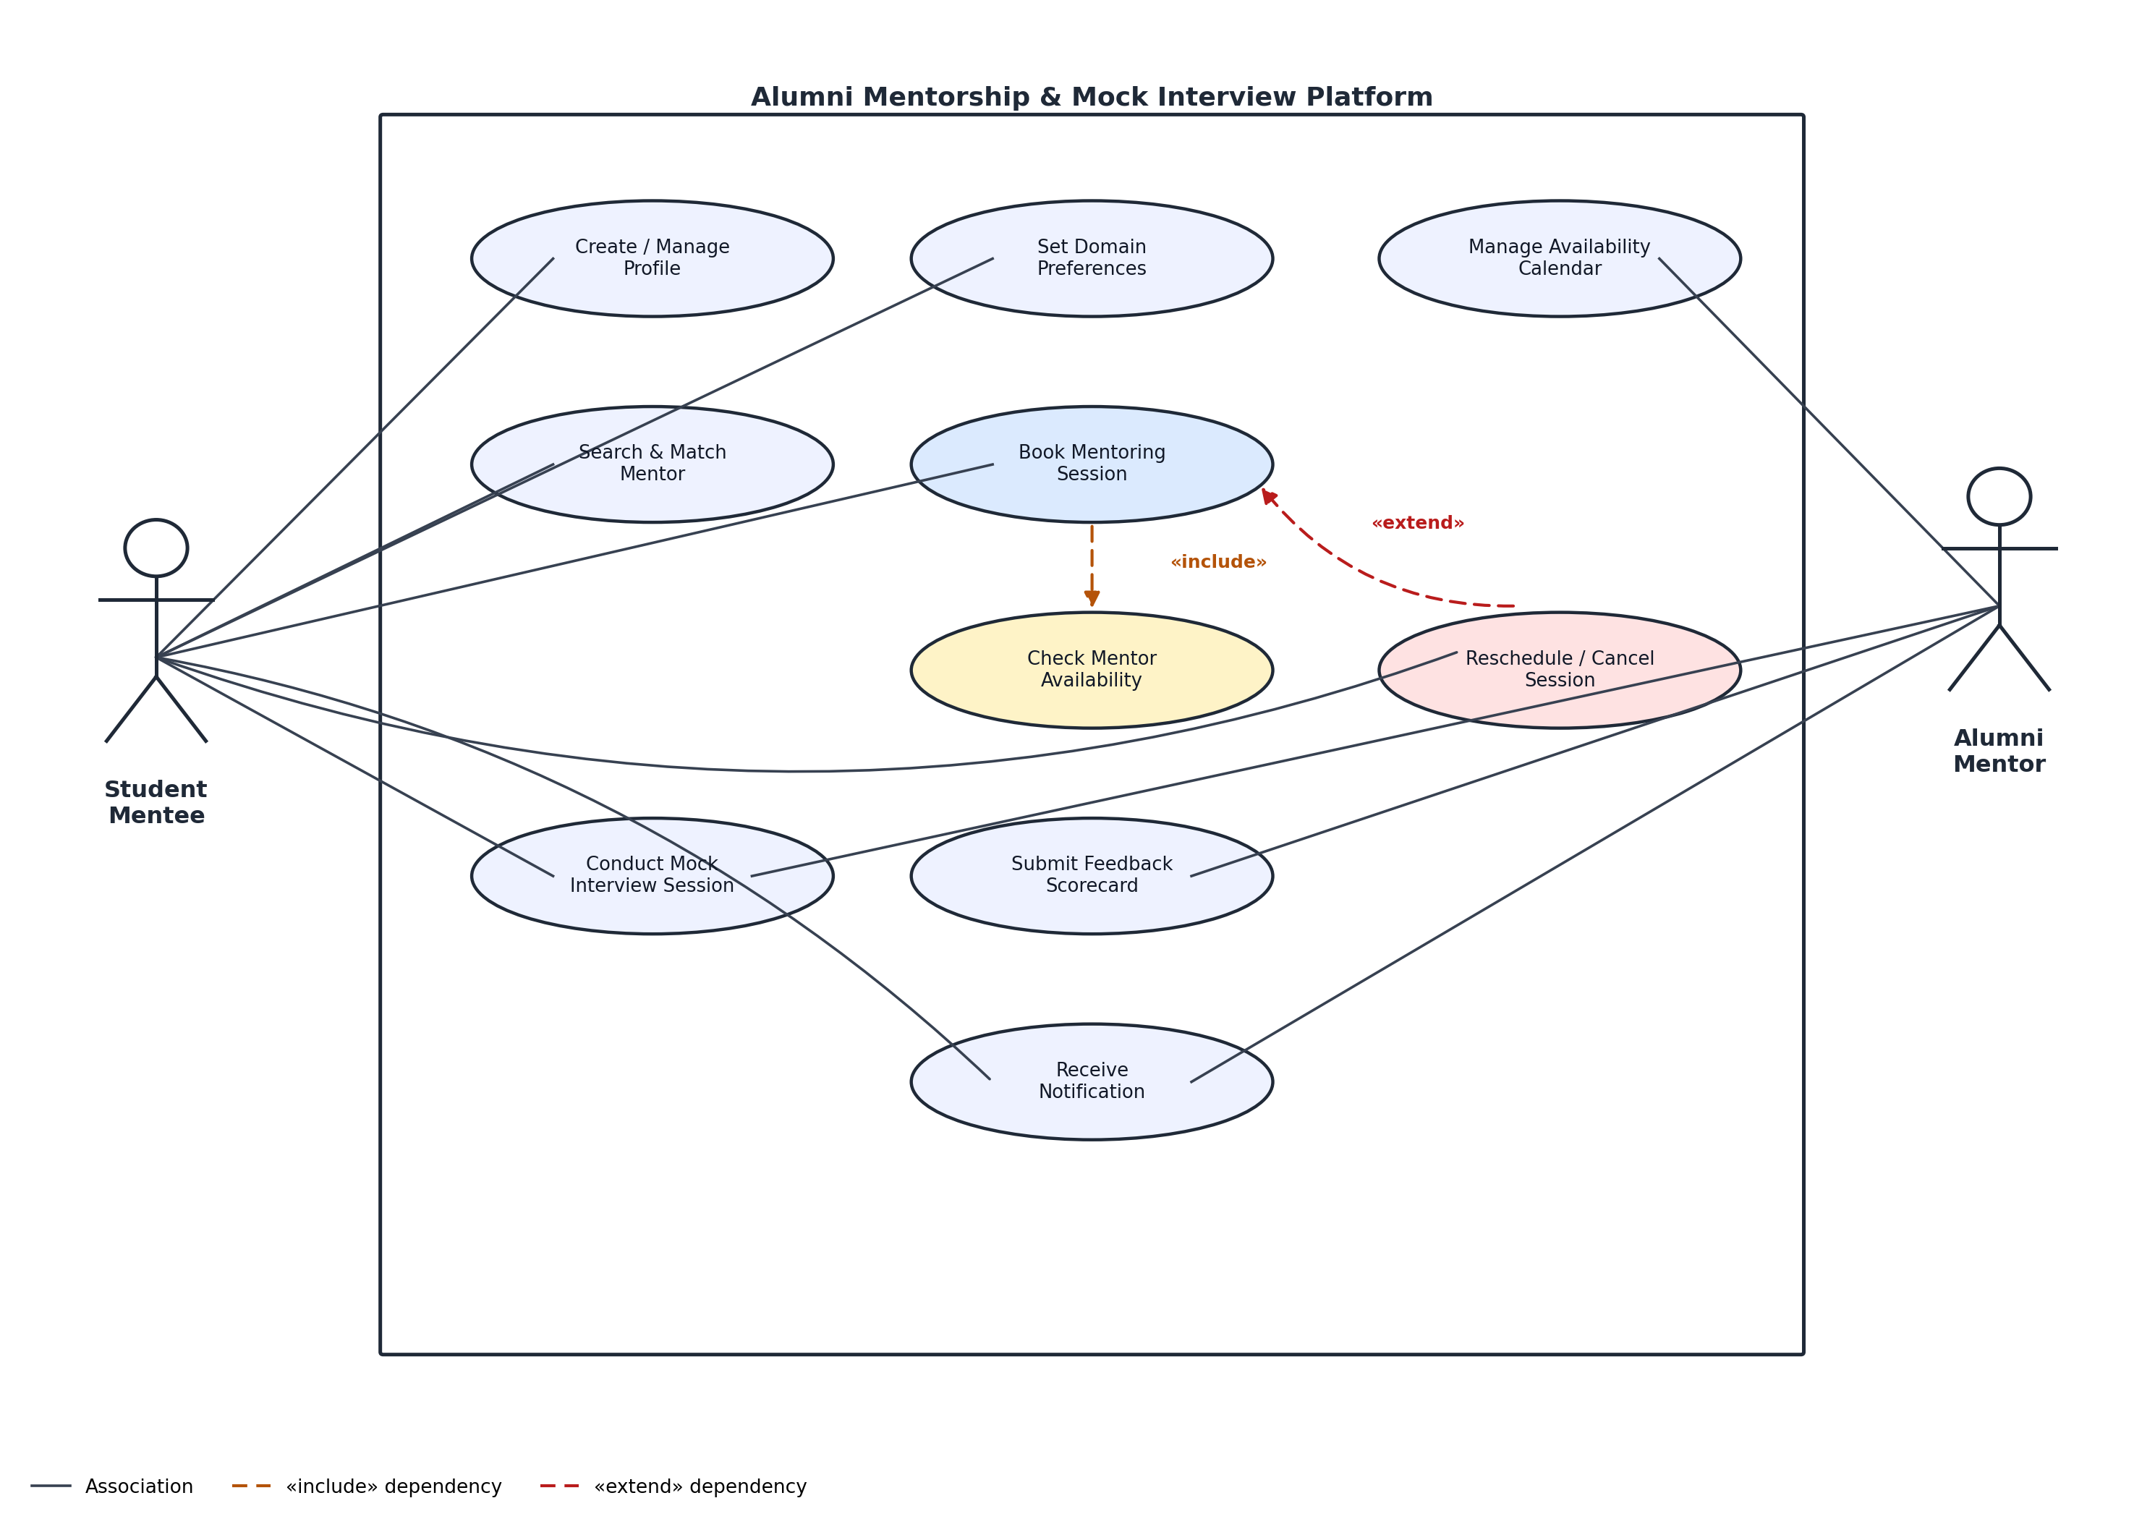
Actors
Primary Actor: Student Mentee — initiates profile setup, mentor search, session booking, rescheduling, and receives notifications.
Secondary Actor: Alumni Mentor — manages availability calendar, participates in the mock interview, submits the feedback scorecard, and receives notifications.
Relationships
«include»: Book Mentoring Session always includes Check Mentor Availability — the availability check is a mandatory sub-step of every booking attempt.
«extend»: Reschedule/Cancel Session extends Book Mentoring Session — it is an optional flow triggered only when a chosen slot is unavailable or the student wants to change an existing booking.

3. Use-Case Flow Specification
Problem Statement #06 — Alumni Mentorship & Mock Interview Platform
Use Case ID | UC-04 | Related FR | FR-001
Use Case Name | Book Mentoring Session | Priority | High
Primary Actor | Student Mentee | Secondary Actor | Alumni Mentor
Trigger | Student Mentee selects a recommended Alumni Mentor and requests to book a session. | Includes | Check Mentor Availability
Preconditions
- The Student Mentee is registered and authenticated on the platform.
- The Student Mentee has created a profile and set at least one domain preference (FR-002).
- At least one Alumni Mentor has published availability that matches the mentee's domain preference (FR-003).
Postconditions
Success: A confirmed session record exists, linked to both the Student Mentee and the Alumni Mentor, with a generated meeting link; the booked slot is marked unavailable in the mentor's calendar; and confirmation notifications have been sent to both parties (FR-005).
Failure: No session record is created and the mentor's calendar remains unchanged from its pre-use-case state.
Main Success Scenario
- Student Mentee logs in and navigates to the “Find a Mentor” screen.
- System retrieves the mentee's domain preferences from their profile (FR-002).
- System runs the domain-matching algorithm and displays a ranked list of Alumni Mentors.
- Student Mentee selects a mentor and requests to view their availability — the system executes the included use case «include» Check Mentor Availability.
- System displays the mentor's open calendar slots.
- Student Mentee selects a slot and confirms the booking request.
- System re-validates that the slot is still open, creates the session record, and generates a meeting link.
- System marks the slot unavailable and adds the session to both the mentee's and the mentor's calendars.
- System triggers confirmation notifications to both the Student Mentee and the Alumni Mentor (FR-005).
- Use case ends successfully.
Alternate Flow A1: Slot No Longer Available (Booking Conflict)
Trigger: At step 7, the slot selected in step 6 was booked by another student in the interval between steps 5 and 6.
- System detects that the selected slot is no longer available and does not create a session record.
- System displays a message informing the Student Mentee that the slot has just been taken.
- System refreshes and re-displays the Alumni Mentor's current available slots.
- Student Mentee selects a different available slot; flow resumes at step 6 of the Main Success Scenario.
- If no compatible slot remains with this mentor, the Student Mentee may invoke «extend» Reschedule/Cancel Session to search for an alternate mentor; the use case then ends without a booking.

