LAB 3
SOFTWARE ENGINEERING
Jira Agile / Scrum Simulation Report

Name | Sai Likhith S
SRN | PES1UG24AM239
Project | Alumni Mentorship & Mock Interview Platform (AMIP)
Submitted as evidence of backlog creation, sprint planning and execution, burndown analysis, timeline tracking, and Scrum reflection.

Contents
1. Backlog, Priorities & Story Points
2. Sprint 1 Execution
3. Sprint 2 Execution
4. Burndown Charts & Sprint Reports
5. Timeline / Roadmap
6. Jira Summary
7. Final Active Sprint State
8. Reflection
9. Conclusion

Project Epics
• AMIP-1 — Alumni Mentorship
• AMIP-2 — Mock Interview Management
• AMIP-3 — Mentor & Session Management

1. Backlog, Priorities & Story Points
The Jira backlog contains the AMIP user stories together with their Epic associations, priorities, and story-point estimates. This backlog forms the basis for sprint planning and effort estimation.
Figure 1. Jira backlog showing the AMIP user stories, Epic associations, priorities, and story points.
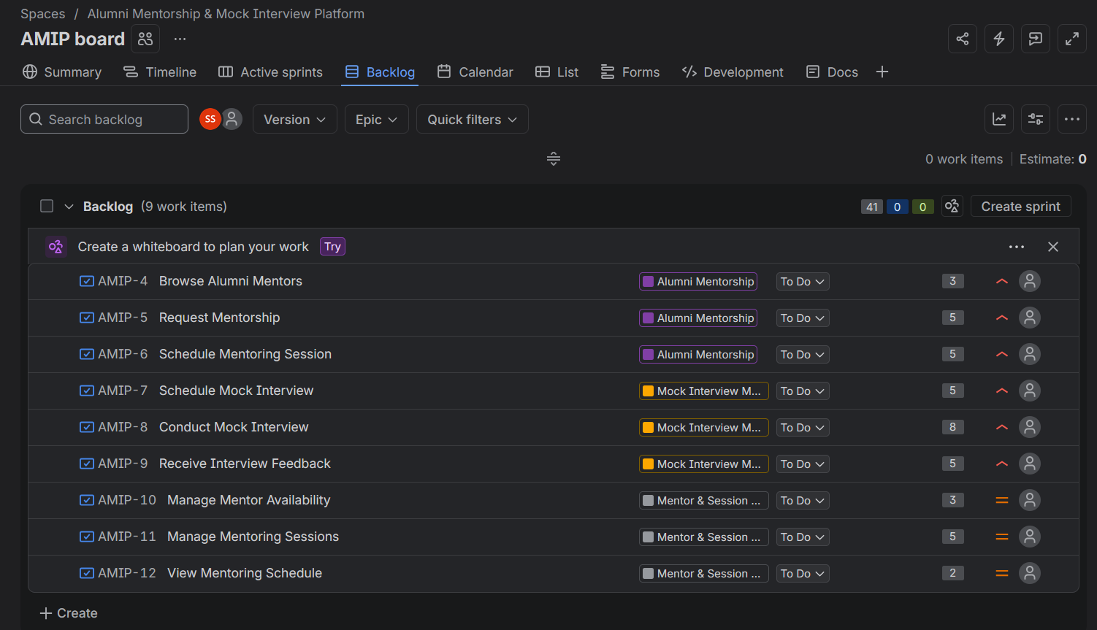
The Epic panel confirms the three functional Epics created for the AMIP project.
Figure 2. Jira Epic panel showing AMIP-1, AMIP-2, and AMIP-3.
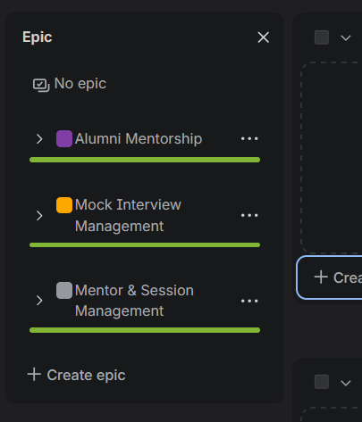

2. Sprint 1 Execution
The selected user stories were moved from the backlog into Sprint 1. After the sprint was started, the Active Sprint board displayed the selected work in the Scrum workflow.
Figure 3. Sprint 1 Active Sprint board after Sprint 1 was started.
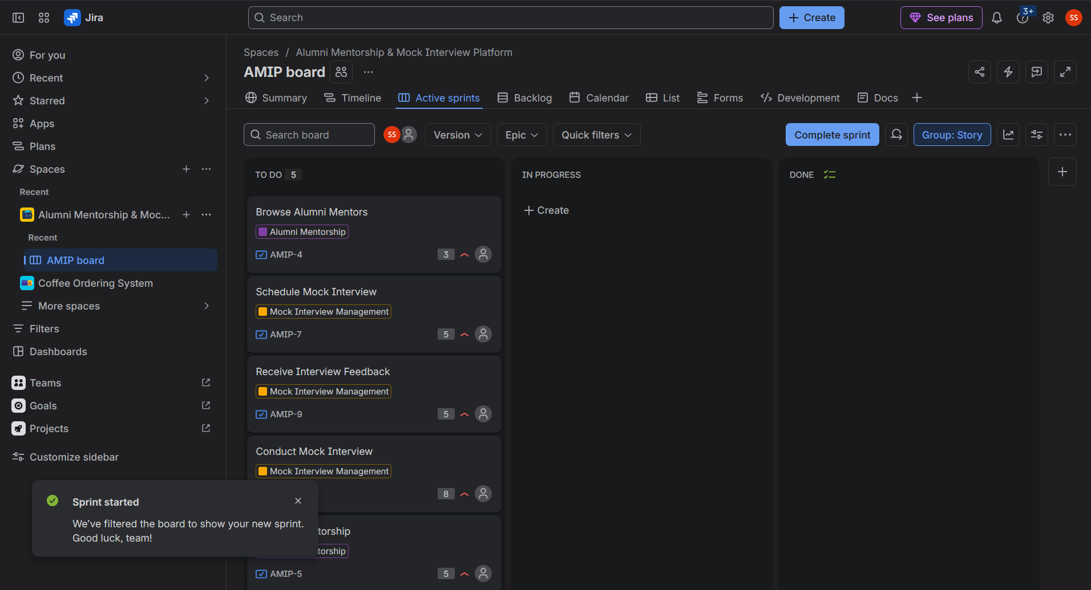
At the end of Sprint 1, the selected work items were completed and moved to the Done column.
Figure 4. Sprint 1 board showing the completed Sprint 1 work.
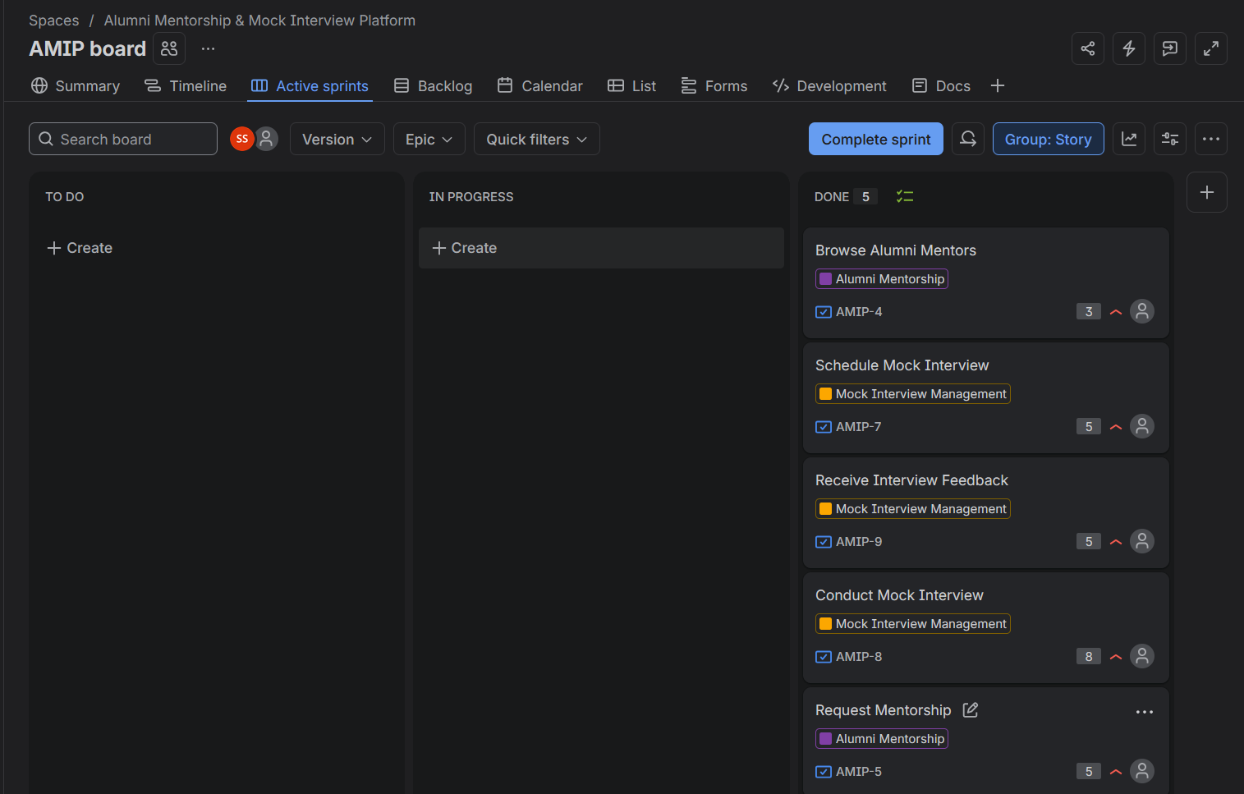

3. Sprint 2 Execution
The remaining work was planned into Sprint 2 after Sprint 1 was completed. The screenshot below shows the Sprint 2 planning state and the remaining backlog.
Figure 5. Sprint 2 planning view showing the four selected work items and their story-point estimates.
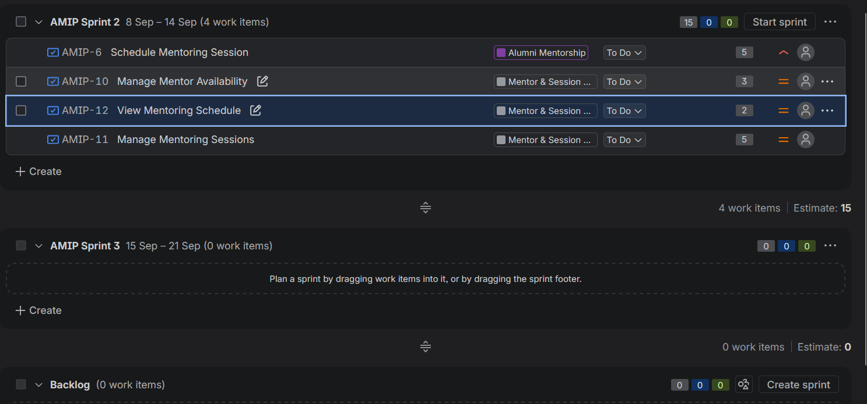
Sprint 2 was then executed on the Active Sprint board, with the selected work items progressing through the workflow.
Figure 6. Sprint 2 Active Sprint board showing the completed Sprint 2 work.
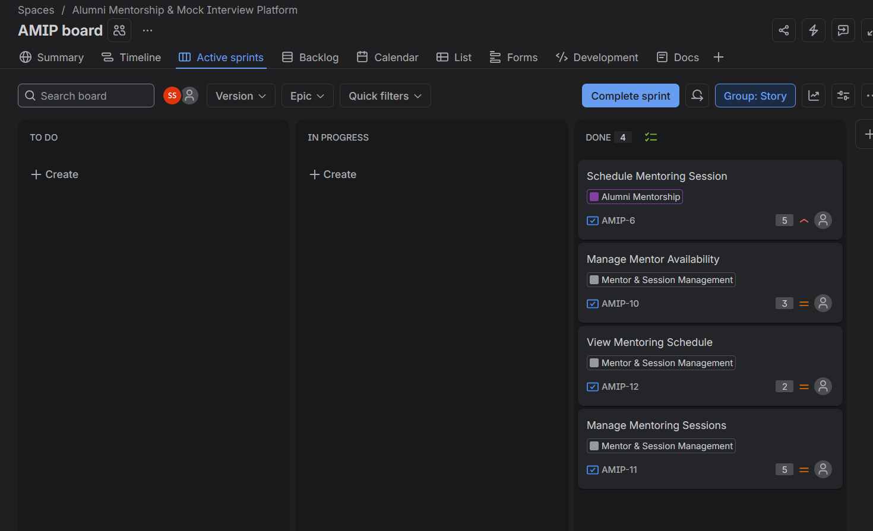

4. Burndown Charts & Sprint Reports

4.1 Sprint 1 Burndown Chart
The Sprint 1 Burndown Chart shows the planned guideline and the remaining story points over time. It provides a visual indication of sprint progress.
Figure 7. Sprint 1 Burndown Chart.
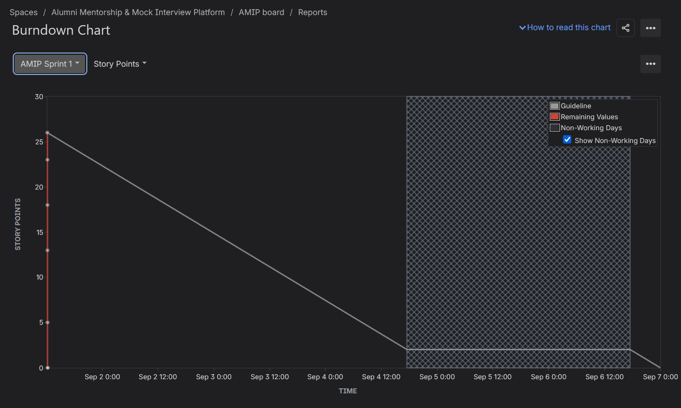

4.2 Sprint 1 Report
The Sprint 1 report records the completed issues and summarizes their status, priority, and story points.
Figure 8. Sprint 1 report showing the completed issues and status summary.
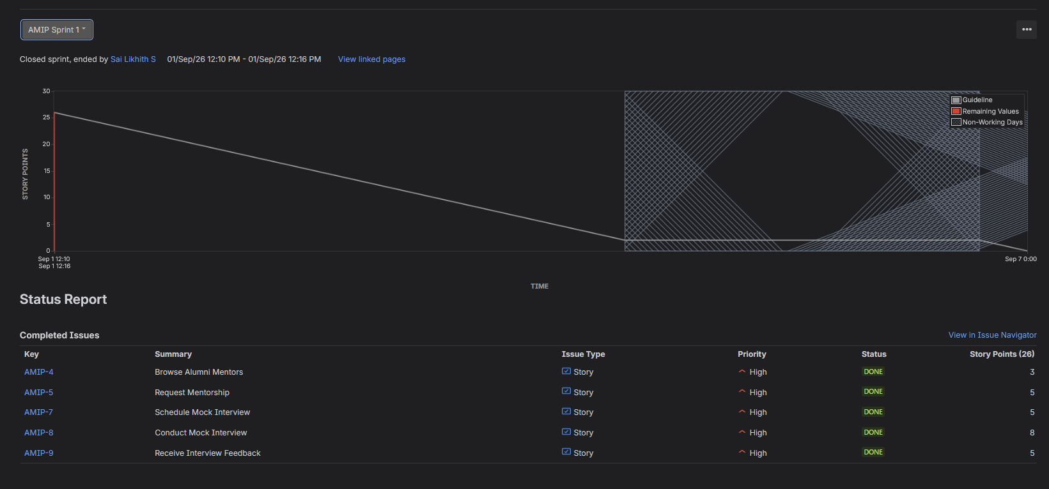

4.3 Sprint 2 Burndown Chart
The Sprint 2 Burndown Chart provides the corresponding view of remaining story points against the sprint guideline.
Figure 9. Sprint 2 Burndown Chart.
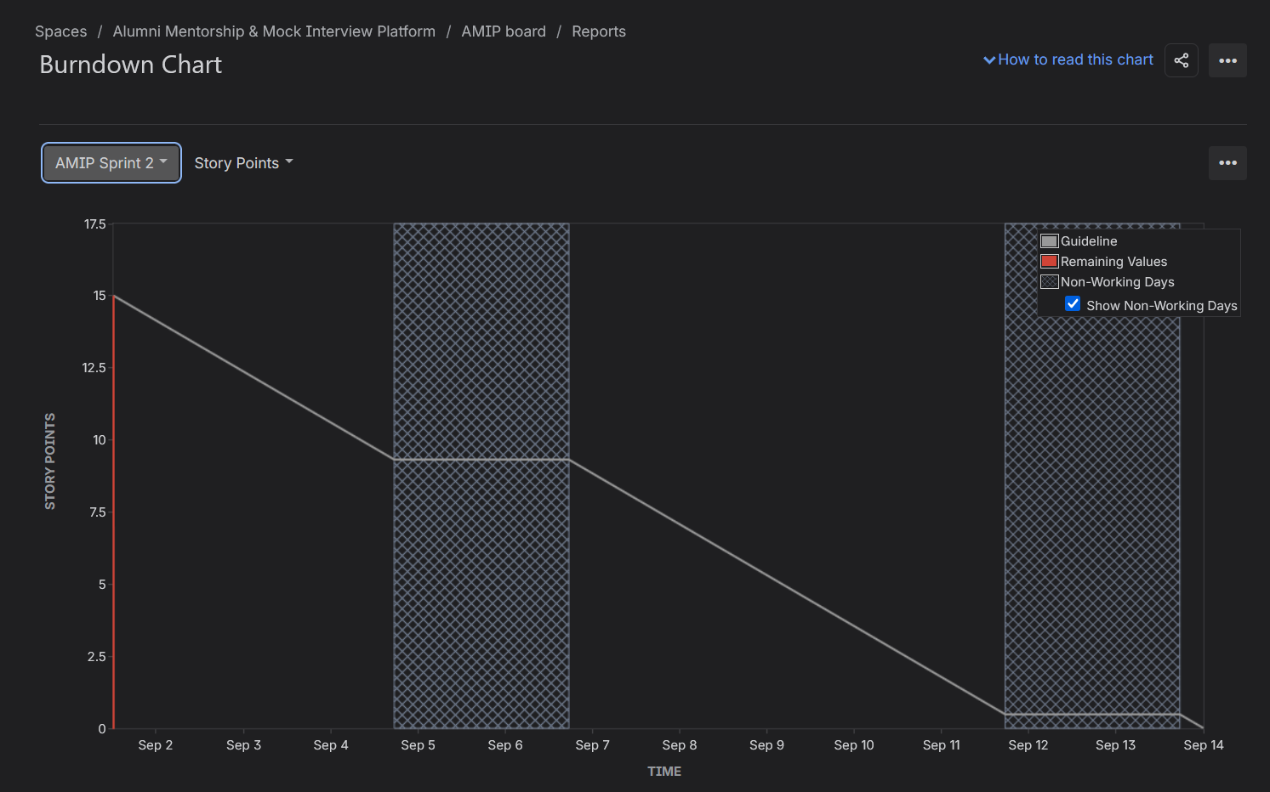

4.4 Sprint 2 Report
The Sprint 2 report records the completed Sprint 2 issues and their final status.
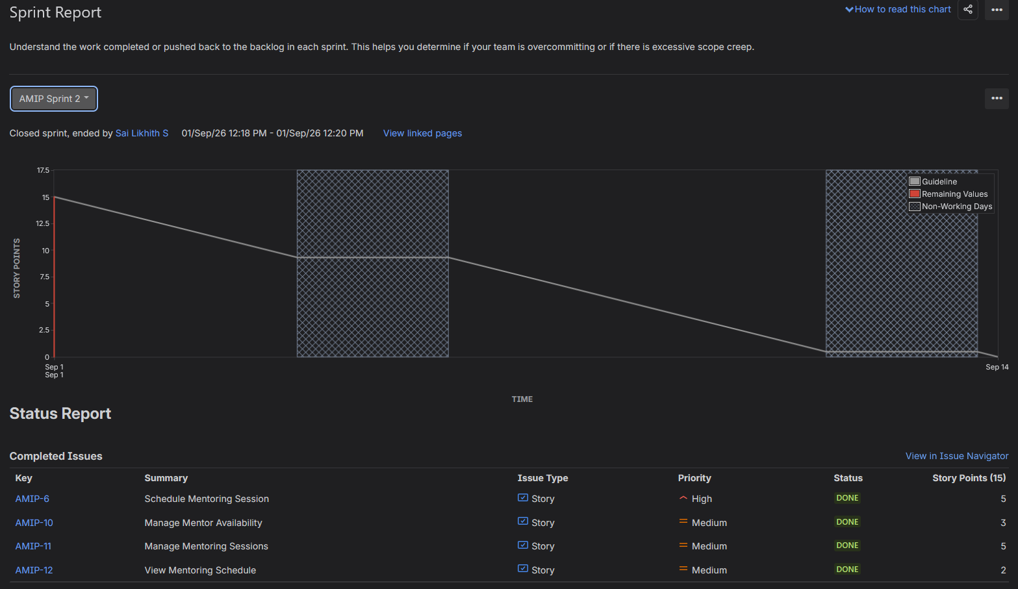

5. Timeline / Roadmap
The Jira Timeline provides a high-level view of the three AMIP Epics across the project calendar.
Figure 11. Jira Timeline / Roadmap showing the AMIP Epics.
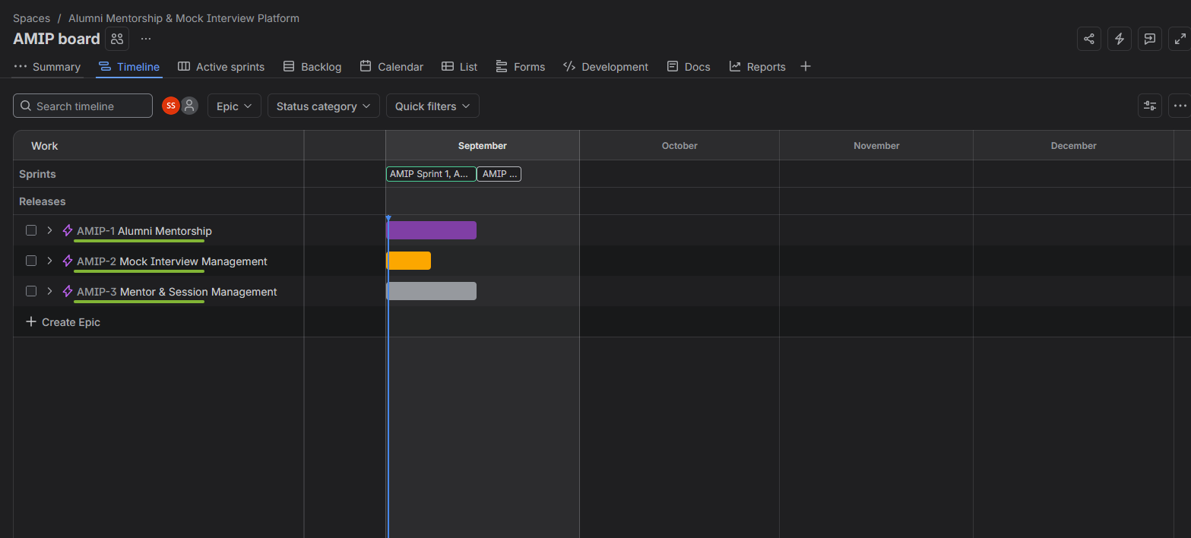

6. Jira Summary
The Jira Summary provides an overall snapshot of project activity, including work-item status, recent activity, priority distribution, workload, and Epic progress.
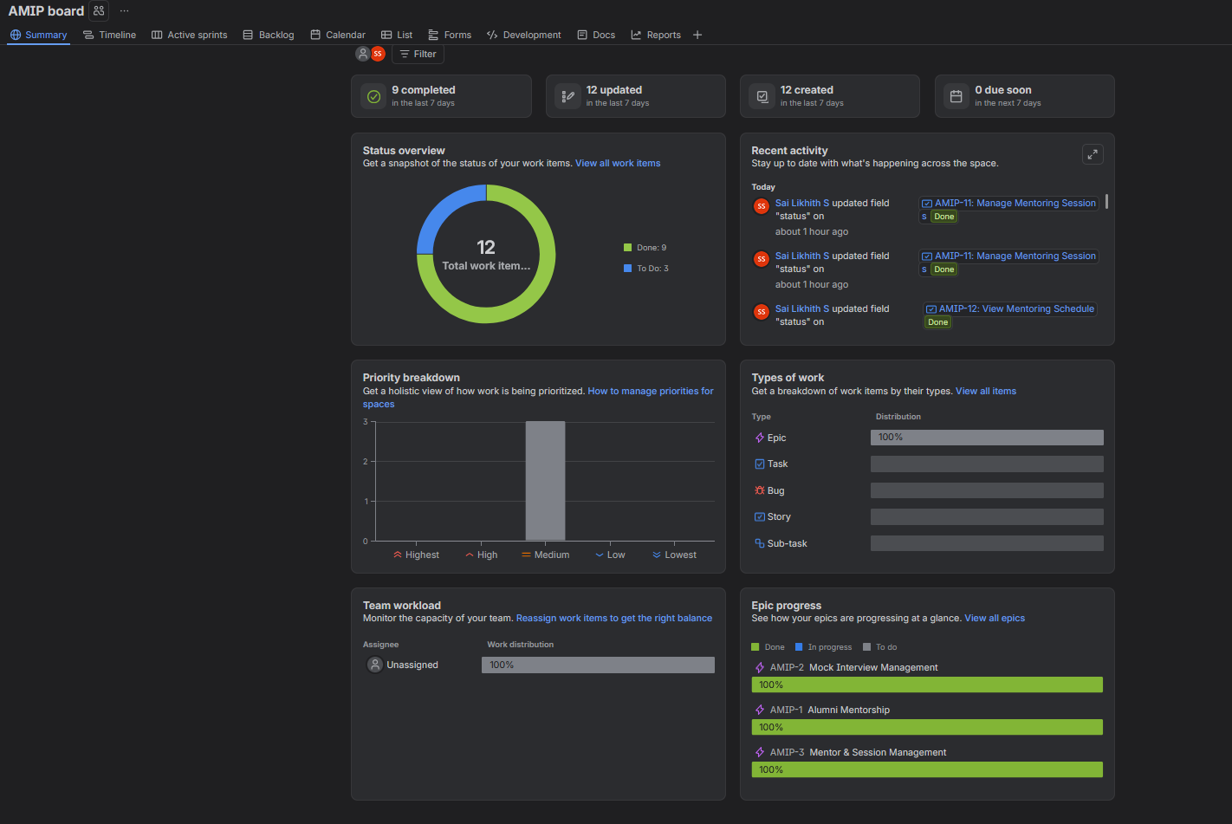

7. Final Active Sprint State
The final Active Sprints view shows the board after the sprint work was completed, with no remaining active work displayed in the To Do or In Progress columns.
Figure 13. Final Active Sprints board state after sprint completion.
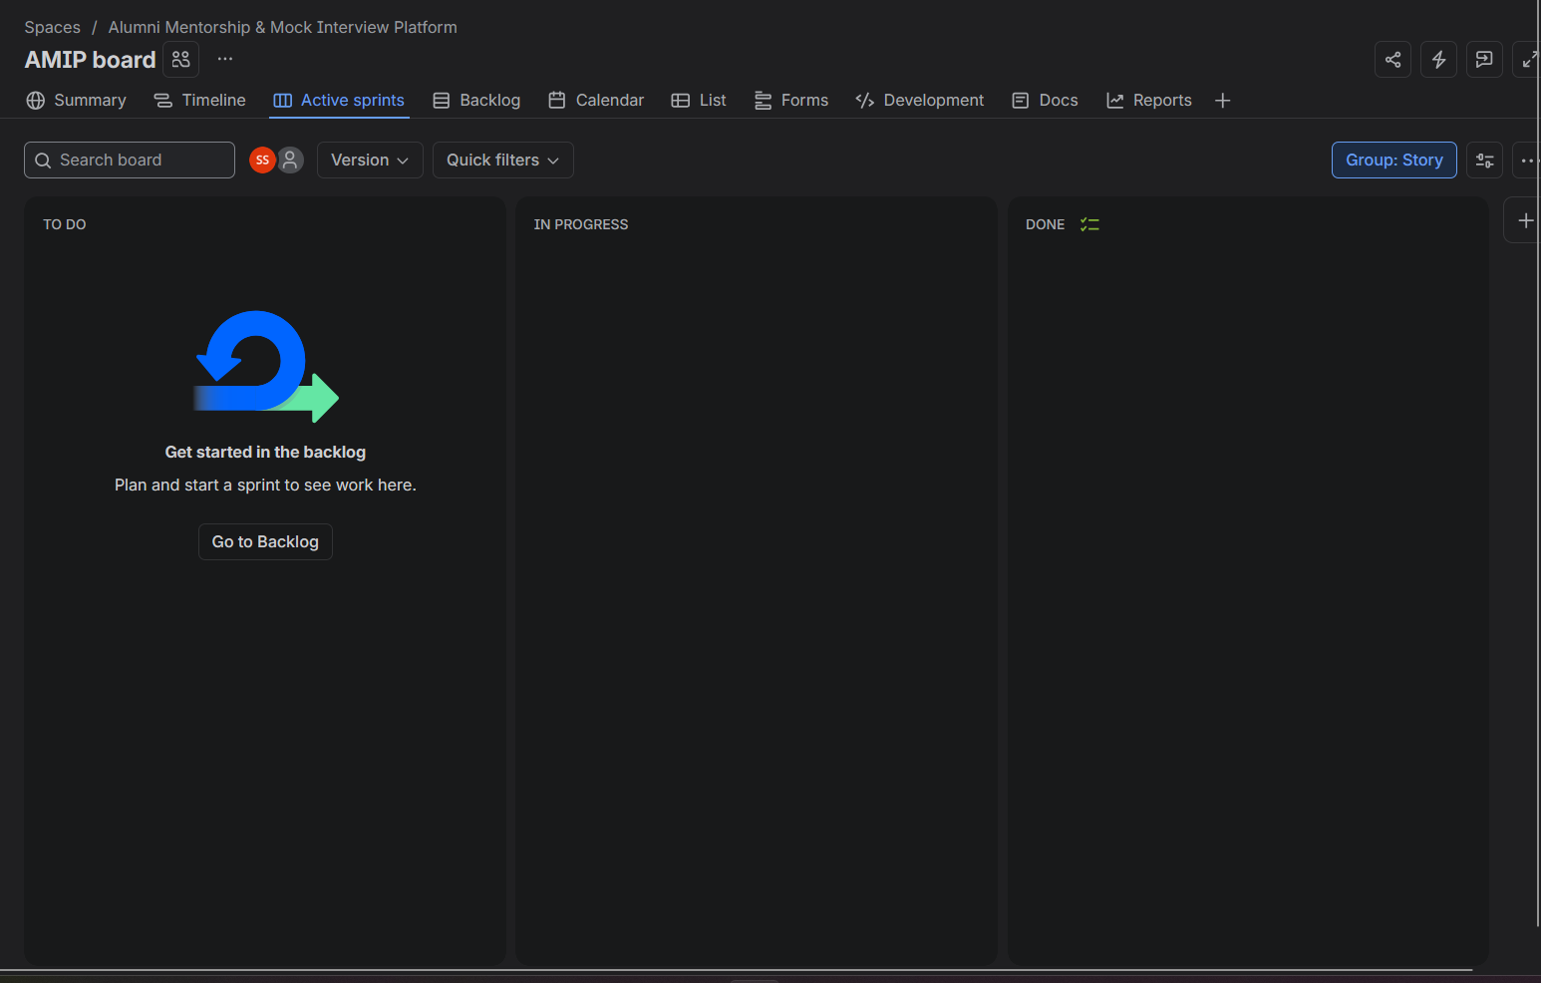

8. Reflection
1. Did your estimations reflect the actual effort?
Yes. The story-point estimates provided a reasonable representation of the relative effort required for the user stories. More complex activities, such as conducting a mock interview, were assigned higher points, while simpler activities, such as browsing mentors, received fewer points. This helped compare the effort and complexity of the stories during sprint planning.
2. Was your backlog well-prioritized?
Yes. The backlog was prioritized according to the importance and user impact of the features. Important student-facing activities such as browsing alumni mentors, requesting mentorship, and scheduling mock interviews were given higher priority. This helped select valuable work for the sprint first.
3. How did your simulated sprint align with your plan?
The simulated sprints followed the planned Agile workflow. User stories were selected from the backlog, planned into the sprint, the sprint was started, and the work items were moved through To Do → In Progress → Done. The completed stories were then used to close the sprint. Overall, the simulation matched the planned Scrum process and demonstrated how sprint work is managed from planning to completion.
4. What insights did the burndown chart give about your team’s capacity?
The burndown chart showed how the remaining story points changed as work was completed. It provided a visual indication of whether the team was progressing toward completing the planned sprint work. It also showed that story points and sprint capacity can be used to judge whether the team has committed to a realistic amount of work. The chart is useful for identifying delays, uneven progress, or large changes in remaining work.

9. Conclusion
The Jira simulation demonstrated the Agile Scrum workflow by connecting functional requirements to Epics and User Stories, prioritizing and estimating the backlog, planning and executing two sprints, and analysing progress using Burndown Charts and sprint reports. The Jira Timeline and Summary views also provided a project-level view of the work and its progress.

