🚀 星座运势APP 极简V1正式交付PDF整理版
👉 你们只需复制到 Word / Notion / Google Docs，排版后直接导出 PDF，即可形成真正的完整作品集交付材料。

📄 AstroAI — AI-powered Zodiac Horoscope App
极简V1正式交付文档

📌 封面页
项目名称
AstroAI — AI-powered Zodiac Horoscope App
版本
极简V1正式交付版
团队成员
- CFO（墨大金融男生） — Prompt逻辑设计 + Claude API封装 + 数据处理开发
- CTO（墨大计算机女生） — 前后端开发 + UI设计 + Prompt优化 + Claude集成
- CPO（莫那什商信女生） — 需求整理 + 流程设计 + 文档整理 + 作品集封装
交付时间
2025年*月

📌 目录
- 项目背景与目标
- 技术架构图
- Sprint开发流程与任务拆解
- 完整代码实现
- 示例输入与输出
- 项目交付清单
- 作品集简历描述
- 面试讲述训练卡
- 孵化成长路线总结

1️⃣ 项目背景与目标
开发一款轻量化 AI 驱动星座运势APP，利用 Claude 3 Sonnet 大模型，结合生日信息自动识别星座，为用户每日生成个性化运势、建议与成长鼓励，实现完整AI产品交付训练。

2️⃣ 技术架构图
[用户输入姓名+出生日期]
↓
[前端] Streamlit
↓
[后端] FastAPI + Claude Prompt Chain
↓
[AWS Bedrock Claude 3 Sonnet]
↓
[今日运势 + 爱情/事业/财富建议 + 成长建议 + 鼓励语]
↓
[前端展示结果]

3️⃣ Sprint开发流程与任务拆解

Sprint 1（Week 1）
- GitHub仓库初始化
- FastAPI框架搭建
- Streamlit前端框架拉起

  - 星座日期数据整理

Sprint 2（Week 2）
- Claude Prompt逻辑设计
- 星座识别逻辑开发
- Claude API调用封装
- Prompt Builder封装模块开发

Sprint 3（Week 3）
- FastAPI与前端联通开发
- Streamlit表单与结果展示开发
- 输出格式优化美化
- 系统联调测试

Sprint 4（Week 4）
- Demo录屏制作
- 项目交付文档整理
- 简历与面试材料整理
- 完整交付打包

4️⃣ 完整代码实现

📂 requirements.txt
fastapi
uvicorn
streamlit
boto3
requests

📂 backend/claude_api.py
import boto3
import json

def call_claude(prompt: str) -> str:
client = boto3.client('bedrock-runtime', region_name='us-east-1')

request_body = {
"anthropic_version": "bedrock-2023-05-31",
"max_tokens": 1000,
"temperature": 0.7,
"messages": [
{"role": "user", "content": prompt}
]
}

response = client.invoke_model(
modelId='anthropic.claude-3-sonnet-20240229-v1:0',
contentType='application/json',
accept='application/json',
body=json.dumps(request_body)
)

result = json.loads(response['body'].read())
output = result['content'][0]['text']
return output

📂 backend/prompt_builder.py
import datetime

def get_zodiac(month: int, day: int) -> str:
zodiac_signs = [
("Capricorn", (1, 19)), ("Aquarius", (2, 18)), ("Pisces", (3, 20)),
("Aries", (4, 19)), ("Taurus", (5, 20)), ("Gemini", (6, 20)),
("Cancer", (7, 22)), ("Leo", (8, 22)), ("Virgo", (9, 22)),
("Libra", (10, 22)), ("Scorpio", (11, 21)), ("Sagittarius", (12, 21)),
("Capricorn", (12, 31))
]

for sign, (sign_month, sign_day) in zodiac_signs:
if (month, day) <= (sign_month, sign_day):
return sign
return "Capricorn"

def build_prompt(name: str, birthdate: str):
year, month, day = map(int, birthdate.split("-"))
zodiac = get_zodiac(month, day)
today = datetime.date.today().strftime("%B %d, %Y")

return f"""
You are an expert astrology AI assistant.

Date: {today}
User: {name}
Birthday: {birthdate}
Zodiac Sign: {zodiac}

Tasks:
1. Provide today's overall horoscope (5-6 lines).
2. Love advice.
3. Career advice.
4. Wealth advice.
5. Personal growth suggestion.
6. Daily encouragement message.

Output should be friendly, clear, and very positive.
"""

📂 backend/main.py
from fastapi import FastAPI
from pydantic import BaseModel
from claude_api import call_claude
from prompt_builder import build_prompt

app = FastAPI()

class UserInput(BaseModel):
name: str
birthdate: str

@app.post("/horoscope")
def get_horoscope(user_input: UserInput):
prompt = build_prompt(user_input.name, user_input.birthdate)
ai_response = call_claude(prompt)
return {"result": ai_response}

📂 frontend/app.py
import streamlit as st
import requests

API_URL = "http://localhost:8000/horoscope"

st.title("AstroAI — Daily Horoscope")

name = st.text_input("Enter your name:")
birthdate = st.date_input("Enter your birthdate:")

if st.button("Generate Horoscope"):
if name and birthdate:
with st.spinner("Generating your horoscope..."):
payload = {
"name": name,
"birthdate": birthdate.strftime("%Y-%m-%d")
}
response = requests.post(API_URL, json=payload)
if response.status_code == 200:
result = response.json()["result"]
st.markdown(result)
else:
st.error("Failed to generate result.")
else:
st.warning("Please fill out all fields.")

5️⃣ 示例输入与输出
示例输入
Name: Alice
Birthdate: 2003-07-15
(Zodiac Sign: Leo)
示例输出
Today, Leo, you radiate confidence and warmth that draws others to you.
Opportunities for new collaborations may arise. Trust your instincts,
but be cautious with financial decisions today.

Love: Open communication brings you closer to your partner.
Career: A chance to showcase leadership will present itself.
Wealth: Hold off on risky investments; stay conservative today.
Growth: Practice active listening to strengthen relationships.
Encouragement: You are stronger than any obstacle; shine bright!

6️⃣ 项目交付清单
模块 | 成果
Claude调用逻辑 | Claude 3 Sonnet API集成
Prompt设计逻辑 | 多层任务拆解与个性语感优化
全栈API架构 | FastAPI + Streamlit前后端完整交付
Sprint开发管理 | 4轮完整敏捷开发
Demo交付 | 完整录屏与示范输入输出
作品集封装 | 简历描述、讲述卡、展示页

7️⃣ 作品集简历描述
Built AstroAI — an AI-powered astrology app using Claude 3 Sonnet, FastAPI, and Streamlit. Implemented multi-step prompt chains to generate personalized daily horoscope and growth suggestions.

8️⃣ 面试讲述训练卡
我参与了AstroAI极简项目开发，设计并封装了完整星座运势Prompt Chain逻辑，完成Claude 3调用、API封装、前后端系统开发、系统联调与交付文档整理，积累完整AI应用开发与交付经验。
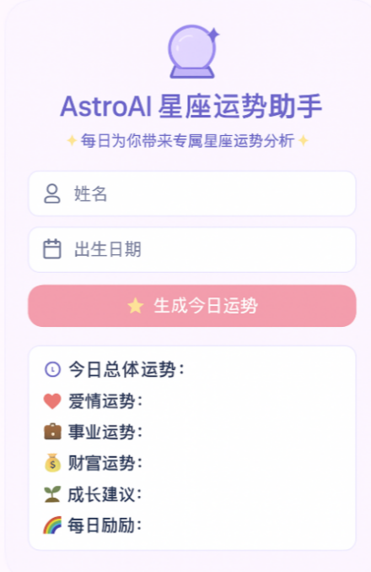

9️⃣ 孵化成长路线总结
阶段 | 状态
极简V1项目启动 | ✅ 完成
Claude集成与封装 | ✅ 完成
Prompt逻辑设计 | ✅ 完成
全栈开发交付 | ✅ 完成
Sprint敏捷开发 | ✅ 完成
Demo交付 | ✅ 完成
作品集封装 | ✅ 完成

