# Title

Mapping lesion-related human aggression to a common brain network

# Authors and Affiliations

## Authors

Shaoling Peng1,2, Frederic L. W. V. J. Schaper2,3, Shira Cohen-Zimerman4,5, Gillian N. Miller1, Jing Jiang6,7, Rob P.W. Rouhl8,9, Yasin Temel10, Shan H. Siddiqi2,11, Jordan Grafman4,5,12, Michael D. Fox2,3,13, Alexander L. Cohen1,2,14

## Affiliations

1Department of Neurology, Boston Children’s Hospital, Harvard Medical School, Boston, MA, USA. 2Center for Brain Circuit Therapeutics, Brigham and Women’s Hospital, Harvard Medical School, Boston, MA, USA. 3Department of Neurology, Brigham and Women’s Hospital, Harvard Medical School, Boston, MA, USA. 4Cognitive Neuroscience Laboratory, Brain Injury Research, Shirley Ryan Ability Lab, Chicago, IL, USA. 5Department of Physical Medicine and Rehabilitation, Feinberg School of Medicine, Northwestern University, Chicago, IL, USA. 6Stead Family Department of Pediatrics, University of Iowa Carver College of Medicine, Iowa City, IA, USA. 7Iowa Neuroscience Institute, University of Iowa Carver College of Medicine, Iowa City, IA, USA. 8Department of Neurology and School for Mental Health and Neuroscience, Maastricht University Medical Center, Maastricht, the Netherlands. 9Academic Center for Epileptology Kempenhaeghe/Maastricht University Medical Center, Heeze & Maastricht, the Netherlands. 10Department of Neurosurgery and School for Mental Health and Neuroscience, Maastricht University Medical Center, Maastricht, the Netherlands. 11Department of Psychiatry, Brigham and Women’s Hospital, Harvard Medical School, Boston, MA, USA. 12Department of Psychiatry, Feinberg School of Medicine and Department of Psychology, Weinberg College of Arts and Sciences, Northwestern University, Chicago, IL, USA. 13Department of Psychiatry, Brigham and Women’s Hospital, Harvard Medical School, Boston, MA, USA. 14Computational Radiology Laboratory, Department of Radiology, Boston Children’s Hospital, Harvard Medical School, Boston, MA, USA.

# Introduction

Aggression exacts a significant toll on human societies and is highly prevalent among neuropsychiatric patients, yet treatment options are limited. While the neural mechanisms leading to aggression are unclear, it can occur following focal brain damage. Such cases provide unique insight into brain regions causally responsible for aggression symptoms and may identify therapeutic targets. The most famous case of lesion-induced aggression comes from Phineas Gage, which provides the first clinical evidence showing the causal role of the PFC in regulating aggression. However, later studies have demonstrated that lesions causing aggression are located in different parts of the brain, not just PFC, thus leaving the localization of aggression unclear. Recently, it has become possible to map complex behavior to human brain circuits based on locations of brain damage that modulate the behavior by leveraging a wiring diagram of the human brain termed the human connectome [1, 2]. This technique, termed lesion network mapping, is particularly helpful when lesions causing similar symptoms occur in multiple different brain locations.

# Methods

We analyzed 182 patients who had suffered penetrating head injuries during their service in the Vietnam War [3]. Aggression was assessed with the aggression/agitation subscale of the Neurobehavioral Rating Scale (NBR-A). Lesion locations were mapped to a common brain atlas. The network of brain regions connected to each lesion location was identified utilizing resting state functional connectivity from healthy participants (n = 1000). Lesion-connections associated with increased aggression were then identified.

To validate whether our lesion-derived aggression regions and network are relevant to neuropsychiatric symptoms associated with aggression, we utilized three independent datasets. The first dataset is the lesion location of the historic case of Phineas Gage extracted from Damasio’s study [4]. The second dataset is a cohort of 25 patients who received anterior thalamic deep brain stimulation (DBS) as a treatment for drug-resistant focal epilepsy, in which irritability and aggression are frequently shown as side effects [5]. The third dataset is the Harvard Lesion Repository, which contains 928 symptom-causing lesions spanning 25 independent lesion datasets.

# Results

We found that lesions associated with aggression occurred in many different brain locations but were characterized by a specific pattern of brain connectivity to a hub region (termed LNM node) in the right prefrontal cortex. This identified hub partially overlaps Gage’s lesion (Fig. 1a). Functional connectivity between Gage’s lesion (Fig. 1b) and lesions in our VHIS cohort can significantly predict the patients’ aggression scores (*r* = 0.15, *p* = 0.041; Fig. 1c).

Connectivity with our identified hub also predicted improvement in irritability in the independent DBS dataset, suggesting potential therapeutic relevance. This predictive ability was most specific to irritability, as functional connectivity between DBS stimulation sites and our LNM node was significantly distinct between irritability and the remaining 20 symptoms measured (*t*19 = -10.44, *p* = 2.59 × 10-9; Fig. 2a).

Similar to prior studies [2, 5], We derived an “aggression network” based on functional connectivity to our hub region and validated it using the Harvard Lesion Repository. We showed that lesions associated with criminal behavior demonstrated the most alignment with our aggression network amongst these 25 symptoms (Fig. 2b). Not only is the intersection of criminality significantly higher than zero (*t*16 = 2.20, p = 0.043), but it also exhibited the highest intersection with our lesion-derived aggression network.

# Conclusions

We conclude that brain lesions associated with aggression map to a specific human brain circuit, and that the hub of this circuit provides a testable target for therapeutic neuromodulation.

# Figures

Fig. 1 Relevance to the notable case of Phineas Gage. a, The aggression-associated node we identified using LNM overlapped the location of brain injury that led to Gage’s transformation into an irritable, hostile, and verbally aggressive individual. b,c, Functional connectivity between the location of patients’ lesion and Gage’s lesion (b) significantly predicted the patients’ aggression score (c).

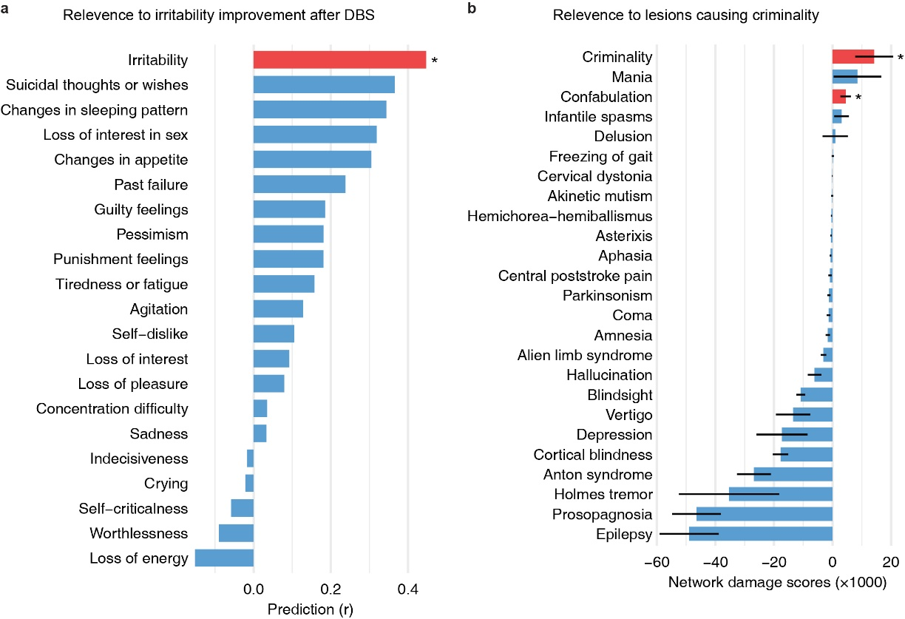

Fig. 2 Relevance to deep brain stimulations improving irritability and lesion locations causing criminal behavior. a, Functional connectivity between DBS stimulation sites and the LNM node in right PFC significantly predicts the improvements in irritability before and after DBS treatment. Notably, this prediction was specific to irritability as the same functional connectivity failed to predict any of the remaining 20 symptoms assessed in BDI-II. Red bar represents significant prediction, whereas blue bars represent non-significant prediction. BDI-II, Beck Depression Inventory - Second Edition. b, Network damage scores, which represent intersection of each lesion with the aggression network based on functional connectivity to our LNM node, was significantly higher for participants with criminality than with the remaining 24 neuropsychiatric symptoms (t23 = -7.26, p = 2.19 × 10-7). Furthermore, not only is the intersection of criminality significantly higher than zero ( t16 = 2.20, p = 0.043), but it also exhibited the highest intersection with our lesion-derived aggression network among all the 25 symptoms. Red bars represent significant positive intersections, whereas blue bars represent negative or non-significant positive intersections. Error bars represent standard error across lesions included in each of the 25 symptoms. * p < 0.05.

# References

1. Boes, A.D., et al., *Network localization of neurological symptoms from focal brain lesions.* Brain, 2015. **138**(Pt 10): p. 3061-75.

2. Fox, M.D., *Mapping Symptoms to Brain Networks with the Human Connectome.* N Engl J Med, 2018. **379**(23): p. 2237-2245.

3. Raymont, V., et al., *"Studying injured minds" - the Vietnam head injury study and 40 years of brain injury research.* Front Neurol, 2011. **2**: p. 15.

4. Damasio, H., et al., *The return of Phineas Gage: clues about the brain from the skull of a famous patient.* Science, 1994. **264**(5162): p. 1102-5.

5. Schaper, F., et al., *Mapping Lesion-Related Epilepsy to a Human Brain Network.* JAMA Neurol, 2023. **80**(9): p. 891-902.

# Poster

## Title

Mapping lesion-related human aggression to a common brain network

## Authors and Affiliations

### Authors

Shaoling Peng1,2, Frederic L. W. V. J. Schaper2,3, Shira Cohen-Zimerman4,5, Gillian N. Miller1, Jing Jiang6,7, Rob P.W. Rouhl8,9, Yasin Temel10, Shan H. Siddiqi2,11, Jordan Grafman4,5,12, Michael D. Fox2,3,13, Alexander L. Cohen1,2,14

### Affiliations

1Department of Neurology, Boston Children’s Hospital, Harvard Medical School, Boston, MA, USA. 2Center for Brain Circuit Therapeutics, Brigham and Women’s Hospital, Harvard Medical School, Boston, MA, USA. 3Department of Neurology, Brigham and Women’s Hospital, Harvard Medical School, Boston, MA, USA. 4Cognitive Neuroscience Laboratory, Brain Injury Research, Shirley Ryan Ability Lab, Chicago, IL, USA. 5Department of Physical Medicine and Rehabilitation, Feinberg School of Medicine, Northwestern University, Chicago, IL, USA. 6Stead Family Department of Pediatrics, University of Iowa Carver College of Medicine, Iowa City, IA, USA. 7Iowa Neuroscience Institute, University of Iowa Carver College of Medicine, Iowa City, IA, USA. 8Department of Neurology and School for Mental Health and Neuroscience, Maastricht University Medical Center, Maastricht, the Netherlands. 9Academic Center for Epileptology Kempenhaeghe/Maastricht University Medical Center, Heeze & Maastricht, the Netherlands. 10Department of Neurosurgery and School for Mental Health and Neuroscience, Maastricht University Medical Center, Maastricht, the Netherlands. 11Department of Psychiatry, Brigham and Women’s Hospital, Harvard Medical School, Boston, MA, USA. 12Department of Psychiatry, Feinberg School of Medicine and Department of Psychology, Weinberg College of Arts and Sciences, Northwestern University, Chicago, IL, USA. 13Department of Psychiatry, Brigham and Women’s Hospital, Harvard Medical School, Boston, MA, USA. 14Computational Radiology Laboratory, Department of Radiology, Boston Children’s Hospital, Harvard Medical School, Boston, MA, USA.

## Introduction

1. Aggression exacts a significant toll on human societies and is highly prevalent among neuropsychiatric patients.
2. Aggression can occur following focal brain damage. The most famous case of lesion-induced aggression comes from Phineas Gage.
3. However, later studies have demonstrated that lesions causing aggression are located in different parts of the brain, not just PFC, thus leaving the localization of aggression unclear.
4. Lesion Network Mapping (LNM) can be used to map complex behavior to human brain circuits.
5. Here, we apply lesion network mapping to assess whether lesion locations associated with aggression map to specific brain regions and networks.
6. This technique is particularly helpful when lesions causing similar symptoms occur in multiple different brain locations
7. , which provides the first clinical evidence showing the causal role of the PFC in regulating aggression
8. Such cases provide unique insight into brain regions causally responsible for aggression symptoms and may identify therapeutic targets
9. Recently, it has become possible to by leveraging a wiring diagram of the human brain termed the human connectome.
10. based on locations of brain damage that modulate the behavior.

## Methods

1. We analyzed 182 patients who had suffered penetrating head injuries during their service in the Vietnam War [3].
2. Aggression was assessed with the aggression/agitation subscale of the Neurobehavioral Rating Scale (NBR-A).
3. The network of brain regions connected to each lesion location was identified utilizing resting state functional connectivity from healthy participants (n = 1000).
4. Lesion-connections associated with increased aggression were then identified.
5. Functional connectivity to the resulting lesion network node defines a distributed brain network of aggression.
6. To validate whether our lesion-derived aggression node and network are relevant to neuropsychiatric symptoms associated with aggression, we utilized three independent datasets:
   1. The first dataset is the lesion location of the historic case of Phineas Gage.
   2. The second dataset is a cohort of 25 patients who received anterior thalamic deep brain stimulation (DBS) as a treatment for drug-resistant focal epilepsy, in which irritability and aggression are frequently shown as side effects.
   3. The third dataset is the Harvard Lesion Repository, which contains 928 symptom-causing lesions spanning 25 independent lesion datasets.

## Results

1. lesions associated with aggression occurred in many different brain locations but were characterized by a specific pattern of brain connectivity to a hub region in the right prefrontal cortex.
2. This identified hub partially overlaps Gage’s lesion. Functional connectivity between Gage’s lesion and lesions in our VHIS cohort can significantly predict the patients’ aggression scores.
3. Connectivity with our identified hub specifically predicted improvement in irritability in the independent DBS dataset, suggesting potential therapeutic relevance.
4. Lesions associated with criminal behavior demonstrated the most alignment with our aggression network amongst 25 symptoms.

## Figures

## Conclusions

1. Brain lesions associated with aggression map to a specific human brain circuit, and that the hub of this circuit provides a testable target for therapeutic neuromodulation.

## References