

IDM Plugin

Message of the Day Manual

Created by:

Ventum Consulting GmbH

Adam Mazurkiewicz - Madej

[adam.mazurkiewicz@ventum.com](mailto:adam.mazurkiewicz@ventum.com)

T: +43 664 88478 197

Table of Contents

1 Overview 2

1.1 Pre-requisites 2

1.2 How it works 2

2 Installation Steps 3

2.1 Optional Manual Steps After Installation 3

2.1.1 Assign Message of the Day Plugin Capability 3

3 Overall Functionality 4

3.1 QuickLink 4

3.2 Widget 5

3.3 Settings Page 5

3.3.1 Setting the message as active 6

4 Logging 7

# Overview

Ventum Consulting GmbH team has created a plugin for displaying various HTML messages as a widget on the IdentityIQ homepage. For more information, reach out to [[office@ventum.com](mailto:office@ventum.com)](mailto:office@ventum.com).

## Pre-requisites

* JDK 8
* IdentityIQ 8.1+ installed
* Plugin Installed
* **The following options have to be set in the iiq.properties file.**
  + plugins.enabled has to be set to **true**
  + plugins.importObjects has to be set to **true**
  + plugins.angularSnippetEnabled has to be set to **true**

## How it works

Message Of The Day Settings page allows the users to create and edit messages using HTML.

The settings page is only available to users who have the **Message of the Day Plugin Admin** capability and administrators.

Create a message and set it as active to make it appear on a homepage widget available to all users.

# Installation Steps

As an Administrator, navigate to **Gear** > **Plugins** menu and click **+ New** button.

Select or drop **message-of-the-day-<version**>.**zip** file (installer) into the Drag and Drop area.

A message will be displayed momentarily to confirm plugin was installed successfully, then Plugins page will be automatically refreshed to display the newly added plugin.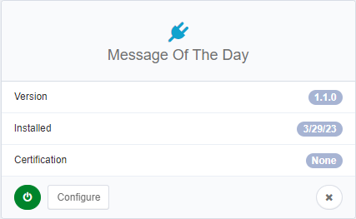

## Optional Manual Steps After Installation

After installation is complete, optional manual steps can be completed.

### Assign Message of the Day Plugin Capability

The ability to configure the messages displayed on the widget is limited to identities with the **Message of the Day Plugin Admin** capability.

To assign the capability to an identity, edit an identity, go to the User Rights tab, select the **Message of the Day Plugin Admin** capability and save.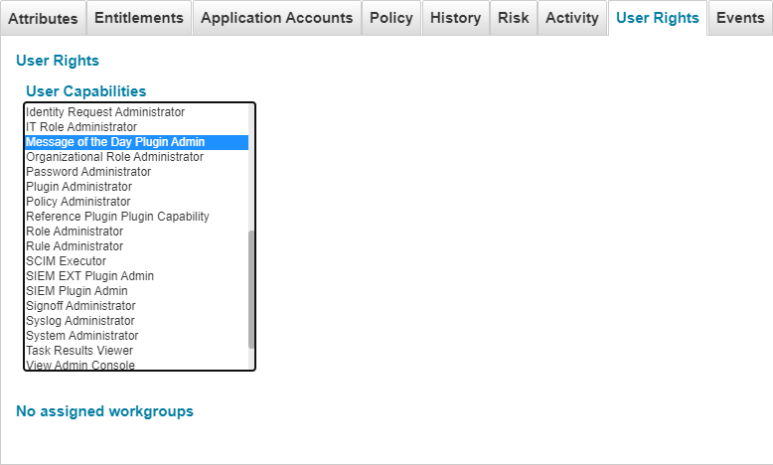

# Overall Functionality

## QuickLink

There is one quicklink located under the **'Gear'** dropdown menu. It is only visible to administrators and users who possess the **Message of the Day Plugin Admin** capability.

This link opens the plugin settings page.

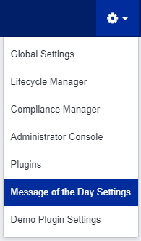

## Widget

The plugin allows you to view the message of the day from the homepage widget.

To add this widget to your homepage, go to the homepage, click the **Edit** button, click **+ Add Widget**, select **the Message of the Day**, click **Save** and the **Save** again.

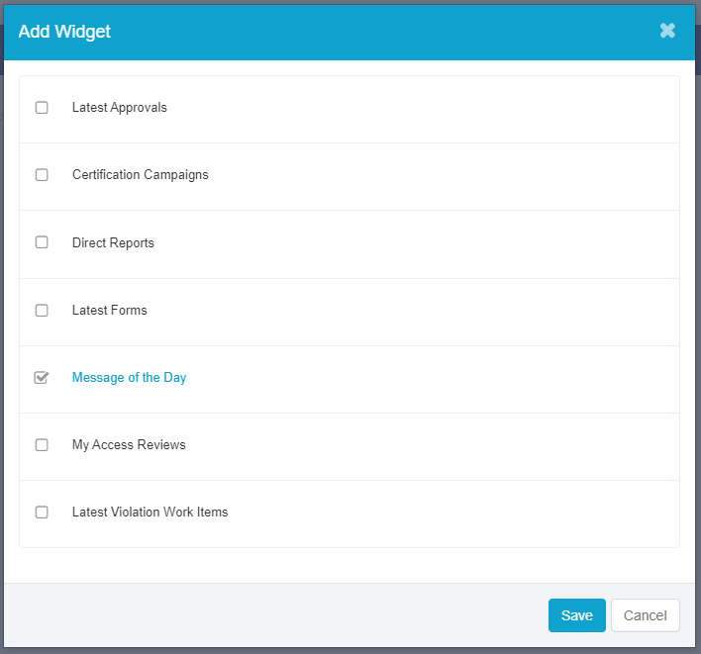

## Settings Page

This page allows you to create, edit and set active status for messages.

Under **Select the message** section you can select the message you want to edit or set as active. If there are no messages saved yet, this box will be empty.

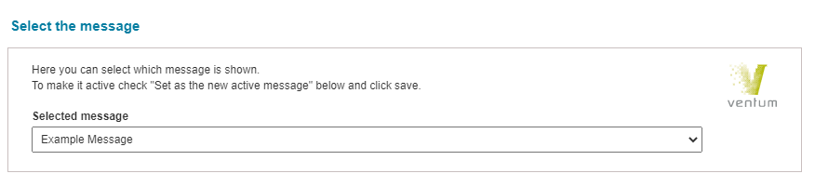

Below you can find the **Create or edit a message** section, which contains the input fields for the name, body and optional footer of the message as well as the checkbox to set the currently selected message as active.

Any changes you make to the message will be displayed in the **Live Preview**.

### Setting the message as active

Open the setting page, select the message you want to be displayed on the widget from the **Selected** message box. This box will be populated with the currently active message.

After selecting the message check the **Set as the new active message** checkbox and click **Save**.

The select message will now be displayed on the widget.

# Logging

For IdentityIQ 8.0 and higher, use the following line to turn Plugin's logs on in your **log4j2.properties** file and set the debug or trace level as needed.

logger.messageOfTheDayPlugin.name=com.ventum.iiq.plugins.motd  
logger.messageOfTheDayPlugin.level=debug