**CHAPTER-1**

**INTRODUCTION**

1. **INTRODUCTION**

**1.1 INTRODUCTION**

In today’s world, maintaining a healthy diet can be a challengingtask. With the plenty of food options available, it's easy to get overwhelmed and make unhealthy choices. More over individual differences in dietary needs, preferences, and lifestyle. This is where a nutrition recommendation system comes in – a personalized solution to provide tailored dietary advice.

A nutrition recommendation system that uses a combination of user input, and nutritional expertise to provide personalized dietary recommendations. The system takes into account various factors such as the user's age, weight, height, and health goals to generate a customized meal plan. The goal of such a system is to empower individuals to make informed food choices, improve their overall health and well-being.5

#### 1.2 MOTIVATION

The motivation behind the nutrition recommendation system from the growing need for personalized dietary guidance in a world where health and wellness are increasingly prioritized. Many individuals struggle to navigate the overwhelming amount of nutritional information available, leading to confusion and misinformation about what constitutes a healthy diet. The system aims to simplify this process by providing tailored recommendations that consider each person's unique circumstances, including their health goals, and dietary preferences. By employing machine learning techniques like Random Forest classification and K-means clustering, the system focuses on critical nutritional features.

Additionally, rising rates of obesity, diabetes, and other diet-related health issues highlight the importance of effective nutrition management. By leveraging advanced technology and data analysis, the system seeks to empower users to make informed food choices that align with their health objectives, whether that’s weight loss, muscle gain, or overall well-being

#### 1.3 Scope

The scope of the nutrition recommendation system is broad and impactful, encompassing various aspects of health, lifestyle, and technological. It can be applied to create personalized meal plans that adapt to diverse dietary preferences, health conditions, and individual goals, serving users from health-conscious individuals to patients with specific nutritional needs. The system enhances healthcare by supporting medical professionals in developing evidence-based dietary interventions. Additionally, it can optimize restaurant menus and guide food industry product development towards healthier options, while also supporting public health initiatives by providing accessible nutrition advice to larger populations. revolutionizing daily nutrition management and making healthy eating intuitive and effortless in our digital age.

**1.4 Project Outline**

1 Abstract

2 Introduction

3 Literature Survey

4 System Study and Analysis

5 System Design

6 Technologies

7 Implementation

8 Testing

9 Screenshots

10 Conclusion and Future Work

11 References

**CHAPTER-2**

**LITERATURE SURVEY**

**2 LITERATURE SURVEY**

**1. Title: A Personalized Nutrition Recommendation System Based on Dietary Patterns**

**Authors**:M.M.M.A.Rahman,M.M.H.M.A.Rahman,S.A.M.A.Rahman  
**Summary**: This study presents a personalized nutrition recommendation system that utilizes dietary patterns derived from user data. By applying clustering algorithms, the authors identify distinct dietary patterns among users and recommend modifications based on health goals such as weight loss or improved metabolic health. The effectiveness of the system highlights the importance of understanding individual dietary habits for personalized nutrition.

**2. Title: Machine Learning Approaches for Personalized Nutrition Recommendations**

**Authors**:Y.Zhang,J.Wang,L.Zhang  
**Summary**: This paper explores the application of various machine learning algorithms, including decision trees and neural networks, to develop personalized nutrition recommendations. The authors analyze user demographic data, dietary preferences, and health conditions to create predictive models. The results indicate that machine learning can significantly enhance the accuracy and relevance of nutrition recommendations, adapting to individual user needs.

**3. Title: A Nutrition Recommendation System Using Collaborative Filtering**

**Author:**A.Kumar,B.Gupta,R.Sharma  
**Summary**: This research introduces a nutrition recommendation system based on collaborative filtering techniques, which analyze user interactions to generate personalized meal suggestions. By leveraging data from similar users, the system can recommend foods and recipes that align with individual preferences. The study demonstrates the effectiveness of collaborative filtering in understanding user behavior and enhancing user satisfaction with nutrition recommendations.

**4. Title: Development of a Mobile Application for Personalized Nutrition Recommendations**

**Authors**:S.J.Park,H.J.Lee,J.Y.Kim  
**Summary**: This paper discusses the development of a mobile application designed to provide personalized nutrition recommendations based on user input regarding dietary habits and health goals. The application incorporates features such as meal tracking, recipe suggestions, and real-time feedback. The authors emphasize the role of mobile technology in promoting healthy eating behaviors and improving adherence to personalized dietary recommendations.

**CHAPTER-3**

**SYSTEM STUDY AND ANALYSIS**

**3 SYSTEM STUDY AND ANALYSIS**

#### 3.1 Problem Statement

Today's health-conscious era, Individuals struggle to make informed food choices to their unique characteristics, preferences, and health goals. Lack of personalized guidance hinder individuals from achieving their wellness objectives. To tackle this challenge, we propose System that can provide tailored dietary advice to individuals based on their distinct profiles. Our System aims to revolutionize the way people approach healthy eating, promoting a more sustainable and personalized approach to nutrition. By reducing the complexity and uncertainty associated with diet planning, we enable individuals to achieve their health and wellness objectives, leading to a better quality of life.

#### 3.2 Existing System

The existing nutrition recommendation system consists of a basic personalized expert approach that primarily focuses on direct-to-consumer grocery product filtering and recommendations. This system provides straightforward suggesting grocery products based on basic user preferences, but lacks comprehensive personalization and advanced features for detailed dietary planning. While it offers a foundation for making food choices, it doesn't take into account detailed factors like age, weight, height, or specific health goals, limiting its effectiveness in providing truly personalized nutrition recommendations.

#### 3.3 Limitations of the Existing System

The existing nutrition recommendation system suffers from several significant limitations that restrict its effectiveness in providing comprehensive dietary guidance. It lacks advanced personalization features, relying only on basic user preferences without considering crucial factors like BMI, medical conditions, or specific dietary restrictions.

#### 3.4 Proposed System

The proposed nutrition recommendation system addresses the limitations of traditional dietary guidance systems by implemented using machine learning techniques. The system incorporates a Random Forest Classifier along with BMI-based categorization to provide customized meal recommendations, while maintaining user accessibility through an intuitive interface. By introducing goal-specific dietary guidance, the system aims to enhance the accuracy and relevance of nutritional recommendations, improve user adherence to dietary plans, and deliver more effective health outcomes through personalized meal suggestions complemented by specific health tips, making it a comprehensive tool that adapts to individual needs and health objectives while providing actionable dietary guidance.

#### 3.5 Functional requirements

* The system must collect and store nutritional data, user preferences, dietary restrictions.
* The system must clean and preprocess the data to ensure consistency and quality before feeding it into the machine learning models.
* The system must train a machine learning model to analyze the dataset and extract meaningful patterns that relate to user preferences and nutritional needs
* The system must implement K-Means clustering to categorize meal data into different clusters (e.g., breakfast, lunch, dinner) based on nutritional content and user preferences
* The system must use a Random Forest classifier to further refine the clustering results, ensuring accurate classification of meals.
* The system must generate personalized nutrition recommendations based on the analyzed data and classified meal types.
* The system must provide recommendations to users via user interface
  1. **Non-Functional Requirements**
* **Performance**: Handle large data sets
* **Reliability**: The system should be robust
* **Usability**: The system should be easy to use for both technical and non-technical users.
  1. **Software Requirements**
* **Programming Language**: Python (for implementing machine learning models and data processing).
* **Library**: scikit-learn ,streamlit , Pandas, NumPy
* **Operating System**: Compatibility with common operating systems like Windows.
* **Development Environment**: Jupyter Notebook,any other python IDE5
  1. **Hardware Requirements**
* **Processors:** Multi-core CPUs or GPUs for faster model training, especially with large datasets
* **Memory (RAM):** Sufficient memory to handle high-dimensional data and large datasets during processing (e.g., 1GB or more).
* **Storage:** Adequate storage for datasets, models, and results (e.g., SSDs)

**CHAPTER-4**

**SYSTEM DESIGN**

1. **SYSTEM DESIGN**

**1.1 System Architecture**

**System Architecture**

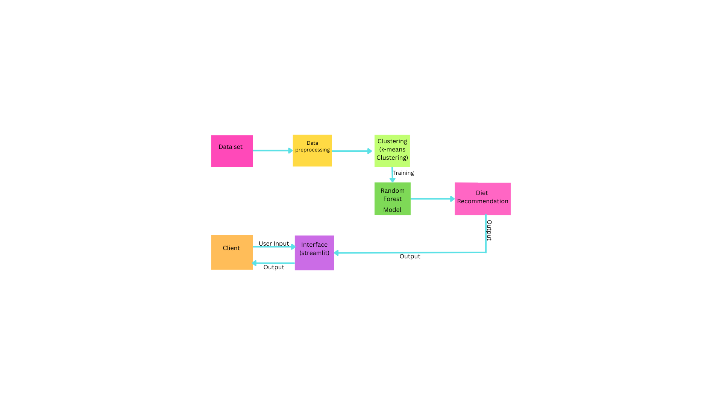

The system architecture explains that initially we start with collecting the data and then clean it, here missing values, duplicates null values are removed. Next we choose the most important features, from the data that will help the model make accurate predictions. The preprocessed data is clustered using a k-means algorithm. This is a technique for grouping similar data points together based on meal type. We build the model using different algorithms. We experiment with various approaches to find the one that works best with our data.Now we train the model with Random forest classifier, teaching it to understand the patterns in the data. We also test it on a separate set of data to check if it’s learning well and to make any necessary adjustments. Once the model is ready. The trained random forest model uses user input to generate personalized diet recommendations, taking into account the user's profile and their clustered group. Finally, these recommendations are presented to the user through the interactive interface

**System Design**

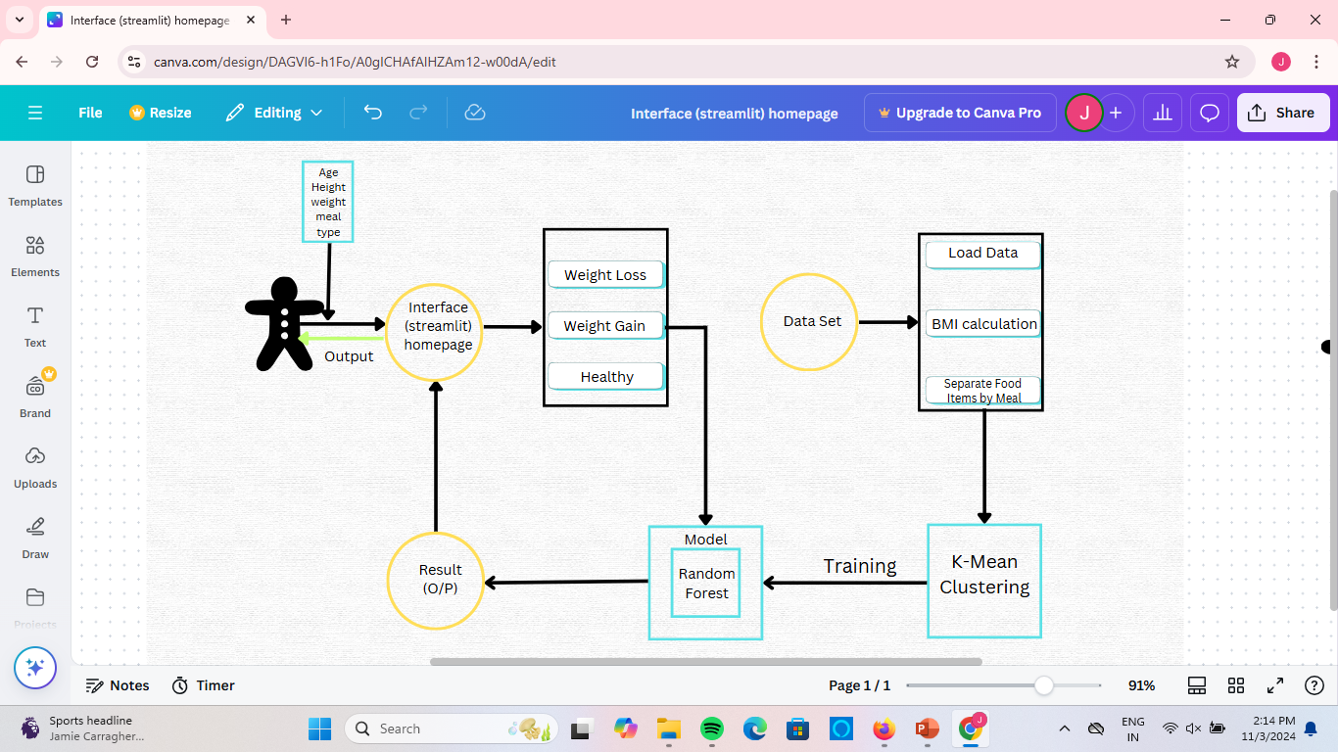

* **User Input:** The user provides their personal information, such as age, height, weight, meal , and any specific goals they may have (like weight loss, weight gain, or maintaining a healthy weight).
* **Interface:** This is the user interface that the system uses to receive user input and display results. It can be a web-based interface built using a framework like Streamlit.
* **Data Loading and Preprocessing**: The system first loads relevant data for analysis, such as a dataset of food items and their nutritional values. Then, the system calculates the user's Body Mass Index (BMI). And Food Item Separation based on The user's chosen meal frequency is used to separate food items into different meal categories
* **K-Means Clustering:** The system then uses the K-Means clustering algorithm to group similar food items together based on their meal type. This clustering helps to further refine the meal planning recommendations.
* **Model Training:** The system utilizes a machine learning model, specifically a Random Forest model, to make predictions. This model is trained on the existing clustered food item data, and it learns to identify patterns that correlate with the user's health goals.
* **Result Display:** The final output is presented to the user through the interface. The system will provide personalized recommendations based on the trained Random Forest model, taking into account the user's goals and clustering analysis.

**CHAPTER-5**

**DATA SET DESCRIPTION**

**\**

1. **DATA SET DESCRIPTION**

**5.1 Data Set Description**

* **Dataset Name:** Nutrition.xlsx
* **Dataset Type**: Tabular data
* **Size**: 8789 rows (observations) and 7 columns (attributes)
* **Missing Values:** None

**Attributes:**

1. **name** - Name of the food item (string)
2. **fiber** - Fiber content (string with unit)
3. **total_fat** - Total fat content per serving, usually in grams (string with unit, e.g., "0.1g")
4. **calories** - Caloric content per serving (numeric, kcal)
5. **carbohydrate** - Carbohydrate content (string with unit)
6. **protein** - Protein content (string with unit)

This dataset offers a comprehensive view of the nutritional profilen of various food items, including macro and micronutrient details, fatty acids, amino acids, and vitamins

**Selected Features and Descriptions**

The function focuses on five main nutritional features: calories, protein, carbohydrate, total_fat, and fiber. Here’s a brief description of each:

1. **Calories**: Represents the total energy provided by the food item, usually measured in kilocalories (kcal). Calories are critical for understanding the energy intake from different foods.
2. **Protein**: Represents the amount of protein in grams. Protein is essential for body tissue repair, immune function, and muscle building. Foods high in protein are often categorized differently from carbohydrate-rich or fat-rich foods.
3. **Carbohydrate**: Measured in grams, this represents the carbohydrate content. Carbohydrates are the body's primary energy source and can vary in quality, from simple sugars to complex carbohydrates.
4. **Total Fat**: Indicates the total fat content in grams. Fat is an important nutrient for energy storage and absorption of certain vitamins, with different meal types often having varying fat requirements.
5. **Fiber**: Measured in grams, fiber helps regulate digestion and can affect blood sugar levels. Foods high in fiber are often categorized differently from low-fiber foods due to their impact on fullness and digestive health.

**Heat map of Nutrition Features**

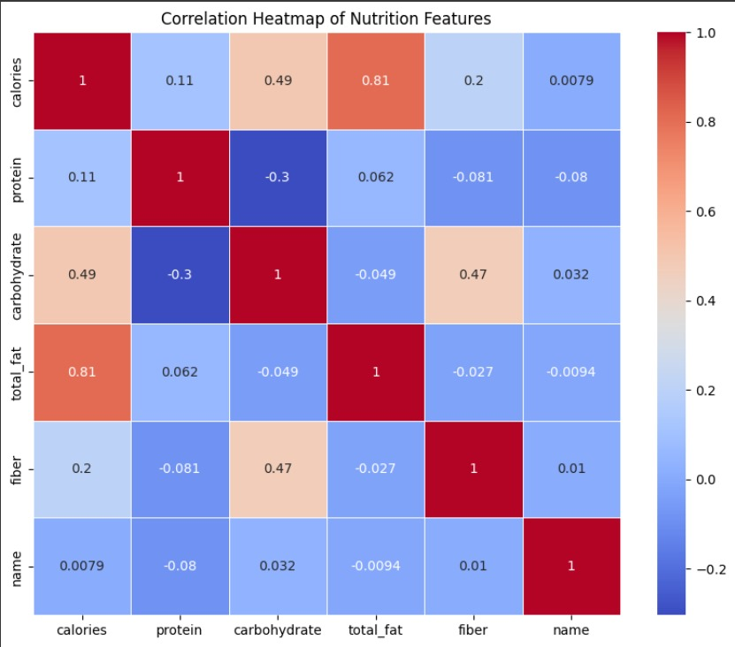

**CHAPTER-6**

**TECHNOLOGIES**

* 1. **TECHNOLOGIES**

**Python**

**About Python**

Python is a high-level, interpreted, interactive and object-oriented scripting language. Python is designed to be highly readable. It uses English keywords frequently where as other languages use punctuation, and it has fewer syntactical constructions than other languages.

* Python is Interpreted − Python is processed at runtime by the interpreter. You do not need to compile your program before executing it. This is similar to PERL and PHP.
* Python is Interactive − You can actually sit at a Python prompt and interact with the interpreter directly to write your programs.
* Python is Object-Oriented − Python supports Object-Oriented style or technique of programming that encapsulates code within objects.
* Python is a Beginner's Language − Python is a great language for the beginner-level programmers and supports the development of a wide range of applications from simple text processing to WWW browsers to games.

**History of python**

Python is a widely-used general-purpose, high-level programming language. It was initially designed by Guido van Rossum in 1991 and developed by Python Software Foundation. It was mainly developed for emphasis on code readability, and its syntax allows programmers to express concepts in fewer lines of code.

In the late 1980s, history was about to be written. It was that time when working on Python started. Soon after that, Guido Van Rossum began doing its application-based work in December of 1989 at Centrum Wiskunde & Informatica (CWI) which is situated in the Netherlands. It was started firstly as a hobby project because he was looking for an interesting project to keep him occupied during Christmas. The programming language in which Python is said to have succeeded is ABC Programming Language, which had interfacing with the Amoeba Operating System and had the feature of exception handling. He had already helped to create ABC earlier in his career and he had seen some issues with ABC but liked most of the features. After that what he did was really very clever. He had taken the syntax of ABC, and some of its good features. It came with a lot of complaints too, so he fixed those issues completely and had created a good scripting language that had removed all the flaws. The inspiration for the name came from BBC‟s TV Show – „Monty Python‟s Flying Circus‟, as he was a big fan of the TV show and also he wanted a short, unique and slightly mysterious name for his invention and hence he named it Python! He was the “Benevolent dictator for life” (BDFL) until he stepped down from the position as the leader on 12th July 2018. For quite some time he used to work for Google, but currently, he is working at Dropbox.

The language was finally released in 1991. When it was released, it used a lot fewer codes to express the concepts, when we compare it with Java, C++ & C. Its design philosophy was quite good too. Its main objective is to provide code readability and advanced developer productivity. When it was released it had more than enough capability to provide classes with inheritance, several core data types exception handling and functions.

**Features of Python**

Python provides many useful features which make it popular and valuable from the other programming languages. It supports object-oriented programming, procedural programming approaches and provides dynamic memory allocation. We have listed below a few essential features.

**1. Easy to learn and use**

Python is easy to learn as compared to other programming languages. Its syntax is straightforward and much the same as the English language. There is no use of the semicolon or curly-bracket, the indentation defines the code block. It is the recommended programming language for beginners.

**2. Expressive Language**

Python can perform complex tasks using a few lines of code. A simple example, the hello world program you simply type print("Hello World"). It will take only one line to execute, while Java or C takes multiple lines.

**3. Interpreted Language**

Python is an interpreted language; it means the Python program is executed one line at a time.

The advantage of being interpreted language, it makes debugging easy and portable.

**4. Cross-platform Language**

Python can run equally on different platforms such as Windows, Linux, UNIX, and Macintosh, etc. So, we can say that Python is a portable language. It enables programmers to develop the software for several competing platforms by writing a program only once.

**5. Free and Open Source**

Python is freely available for everyone. It is freely available on its official website www.python.org. It has a large community across the world that is dedicatedly working towards make new python modules and functions. Anyone can contribute to the Python community. The open-source means, "Anyone can download its source code without paying any penny."

**6. Object-Oriented Language**

Python supports object-oriented language and concepts of classes and objects come into existence. It supports inheritance, polymorphism, and encapsulation, etc. The object-oriented procedure helps to programmer to write reusable code and develop applications in less code.

**7. Extensible**

It implies that other languages such as C/C++ can be used to compile the code and thus it can be used further in our Python code. It converts the program into byte code, and any platform can use that byte code.

**8. Large Standard Library**

It provides a vast range of libraries for the various fields such as machine learning, web developer, and also for the scripting. There are various machine learning libraries, such as Tensor flow, Pandas, Numpy, Keras, and Pytorch, etc. Django, flask, pyramids are the popular framework for Python web development.

**9. GUI Programming Support**

Graphical User Interface is used for the developing Desktop application. PyQT5, Tkinter, Kivy are the libraries which are used for developing the web application.

**10. Integrated**

It can be easily integrated with languages like C, C++, and JAVA, etc. Python runs code line by line like C,C++ Java. It makes easy to debug the code.

**11. Embeddable**

The code of the other programming language can use in the Python source code. We can use Python source code in another programming language as well. It can embed other language into our code.

**12. Dynamic Memory Allocation**

In Python, we don't need to specify the data-type of the variable. When we assign some value to the variable, it automatically allocates the memory to the variable at run time. Suppose we are assigned integer value 15 to x, then we don't need to write int x = 15. Just write x = 15.5.1.4

**Required Python Libraries**

* **Streamlit**
* **Pandas**
* **OS**
* **Sklearn**
* **Joblib**
* **Numpy**
* **VS Code**

**Streamlit:**

Streamlit is an open-source Python library that lets you build interactive web apps for data science and machine learning with minimal code. It automatically creates UI elements and updates outputs in real-time, making it ideal for dashboards and data-driven applications.

**Pandas:**

A powerful data manipulation and analysis library for Python, pandas provides data structures like DataFrames and Series that make it easy to handle structured data.

**NumPy:**

A fundamental library for numerical computing in Python, NumPy provides support for large, multi-dimensional arrays and matrices, along with a collection of mathematical functions to operate on them.

**OS:**

The OS module in Python provides a way to interact with the operating system, allowing users to perform operations like file manipulation, directory traversal, and process management. It helps in working with system paths and environment variables, making it easier to manage files and directories.

**Scikit-learn:**

A popular machine learning library in Python, scikit-learn offers simple and efficient tools for data mining and data analysis. It includes a variety of algorithms for classification, regression, clustering, and model evaluation.

**Joblib:**

Joblib is a Python library for efficiently saving and loading large data or models, especially in machine learning, with support for fast I/O and parallel processing. It is particularly useful for handling large NumPy arrays and caching complex computations.

**VS Code:**

Visual Studio Code (VS Code) is a free, open-source code editor by Microsoft, offering syntax highlighting, debugging, and extension support. It’s lightweight, versatile, and highly customizable for various programming languages

**CHAPTER-7**

**IMPLEMENTATION**

**7 IMPLEMENTATION**

#### 7.1 Implementation Steps

1. Data Collection and Preprocessing
2. Feature Engineering and Model Training
3. User Input and BMI Calculation
4. Recommendation Engine Development
5. User Interface Creation
6. System Integration and Testing

**Home Page and Main Implementation**

def home_page():

    st.title("🥗 Nutrition Recommendation System")

    st.write("Welcome to the Nutrition Recommendation System!")

    st.write("Please select your goal:")

    st.subheader("Weight Loss")

    st.markdown("""

        <p style='text-align: justify;'>

        Achieve healthy weight loss with balanced, lower-calorie meal options tailored

        to help you shed pounds sustainably.

        </p>

    """, unsafe_allow_html=True)

    if st.button("Weight Loss"):

        st.session_state.page = "weight_loss"

        st.rerun()

    st.subheader("Weight Gain")

    st.markdown("""

        <p style='text-align: justify;'>

        Reach your weight gain goals with nutrient-rich, calorie-dense meal plans

        designed to help you build muscle and strength.

        </p>

    """, unsafe_allow_html=True)

    if st.button("Weight Gain"):

        st.session_state.page = "weight_gain"

        st.rerun()

    st.subheader("Healthy Living")

    st.markdown("""

        <p style='text-align: justify;'>

        Enjoy a balanced diet rich in essential nutrients for overall health, boosting energy

        and improving well-being.

        </p>

    """, unsafe_allow_html=True)

    if st.button("Healthy Living"):

        st.session_state.page = "healthy"

        st.rerun()

    st.subheader("About Our Programs:")

    st.write("**Weight Loss Program** 🏋️‍♀️")

    st.write("Designed for those looking to shed pounds in a healthy and sustainable way.")

    st.write("**Weight Gain Program** 💪")

    st.write("Perfect for individuals aiming to build muscle and increase body mass.")

    st.write("**Healthy Living Program** 🥗")

    st.write("Balanced nutrition advice for maintaining optimal health and wellness.")

def main():

    st.write("Current working directory:", os.getcwd())

    model_path = 'rf_model.joblib'

    if os.path.exists(model_path):

        st.write("Model file found.")

    else:

        st.write("Model file not found. It will be trained.")

    if 'page' not in st.session_state:

        st.session_state.page = "home"

    if 'data' not in st.session_state:

        st.session_state.data = load_and_prepare_data()

    if 'rf_model' not in st.session_state:

        try:

            st.session_state.rf_model = load('rf_model.joblib')

        except FileNotFoundError:

            st.session_state.rf_model, _, st.session_state.model_metrics = train_random_forest(st.session_state.data)

    if st.session_state.page == "home":

        home_page()

    elif st.session_state.page == "weight_loss":

        user_input_page("Weight Loss")

    elif st.session_state.page == "weight_gain":

        user_input_page("Weight Gain")

    elif st.session_state.page == "healthy":

        user_input_page("Healthy Living")

if __name__ == "__main__":

    main()

**7.2 Performance Evaluation**

**Model Performance Metrics**

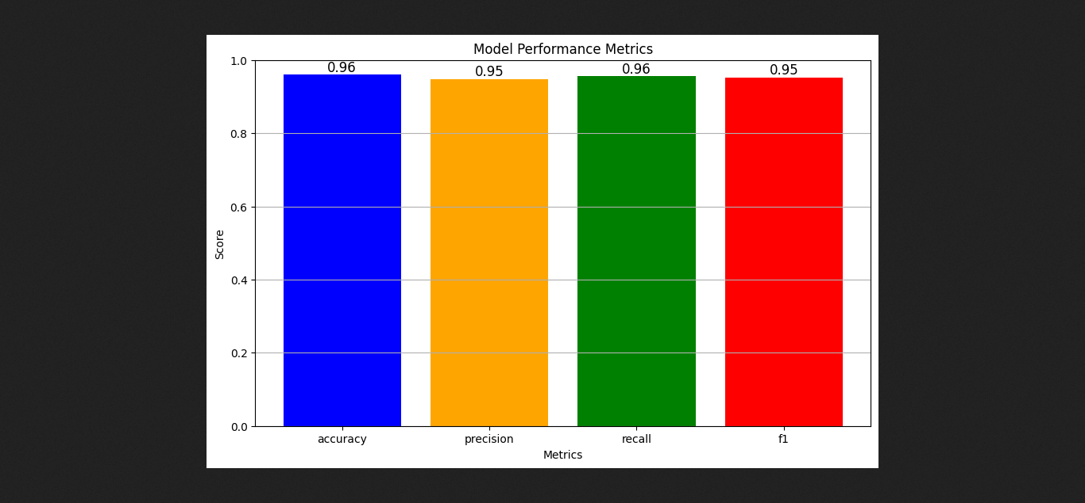

**ROC Curve for Random Forest Model**

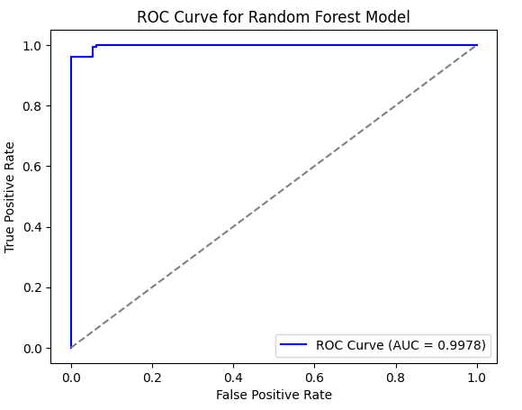

**7.3 TESTING**

The testing strategy encompasses various testing methodologies to ensure the system meets all requirements:

**• Unit Testing:** Individual components are tested for functionality and reliability.

**• Integration Testing:** Tests the interaction between different system components to ensure they work together seamlessly.

**• User Acceptance Testing (UAT):** Involves real users testing the system to validate its usability and functionality.

**TEST CASES**

|  |  |  |  |  |
| --- | --- | --- | --- | --- |
| **Category** | **Description** | **Inputs** | **Expected Result** | **Status** |
| Negative Values | Negative weight | 1. Input (25, -70, 1.75, "Breakfast", "Weight Loss"). | Error message: "Invalid weight. Please enter a positive value." | Fail |
|  | Negative height | 1. Input (25, 70, -1.75, "Lunch", "Weight Gain"). | Error message: "Invalid height. Please enter a positive value." | Fail |
|  | Zero age | 1. Input (0, 70, 1.75, "Dinner", "Healthy"). | Error message: "Invalid age. Please enter a value greater than 0." | Fail |
| Extreme Values | Negative age | 1. Input (-10, 70, 1.75, "Breakfast", "Weight Loss"). | Error message: "Invalid age. Please enter a positive value." | Fail |
|  | Zero weight | 1. Input (25, 0, 1.75, "Lunch", "Weight Gain"). | Error message: "Invalid weight. Please enter a value greater than 0." | Fail |
|  | Zero height | 1. Input (25, 70, 0, "Dinner", "Healthy"). | Error message: "Invalid height. Please enter a value greater than 0." | Fail |
| Borderline Values | Very low weight | 1. Input (20, 35, 1.50, "Breakfast", "Weight Loss"). | Warning: "BMI indicates underweight. Recommendations provided." | Pass |
| Extreme Values | High weight and height | 1. Input (50, 150, 2.10, "Lunch", "Weight Gain"). | Recommendations provided for high BMI. | Pass |
| Unusual Ages | Very young | 1. Input (10, 60, 1.60, "Breakfast", "Healthy"). | Recommendations provided adjusted for age. | Pass |
| Minimal Inputs | Minimal weight | 1. Input (25, 45.5, 1.75, "Breakfast", "Weight Loss"). | Recommendations provided with caution. | Pass |

**TEST RESULTS**

The results of testing confirm that the system fulfills all functional and non-functional requirements. Input validation features, BMI calculation, and personalized diet recommendations operate with a high accuracy rate. The system demonstrates robust error handling for invalid inputs and ensures appropriate recommendations are provided based on user data. These results instill confidence in the system’s reliability, usability, and effectiveness in delivering tailored nutrition advice.

**CHAPTER-8**

**OUTPUT/RESULTS**

**8 OUTPUT/RESULTS**

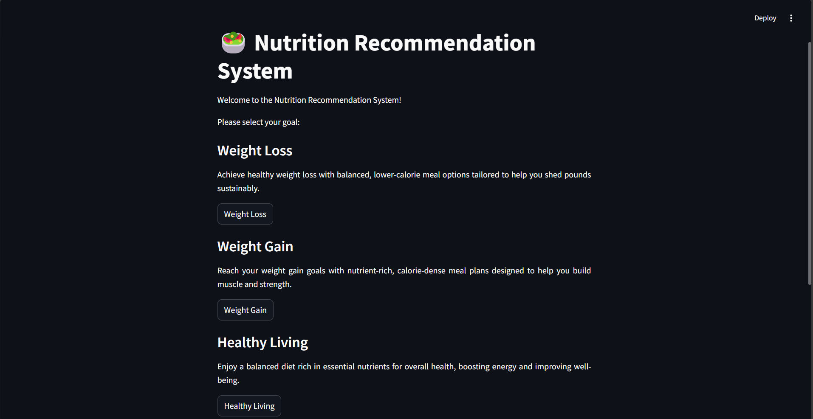

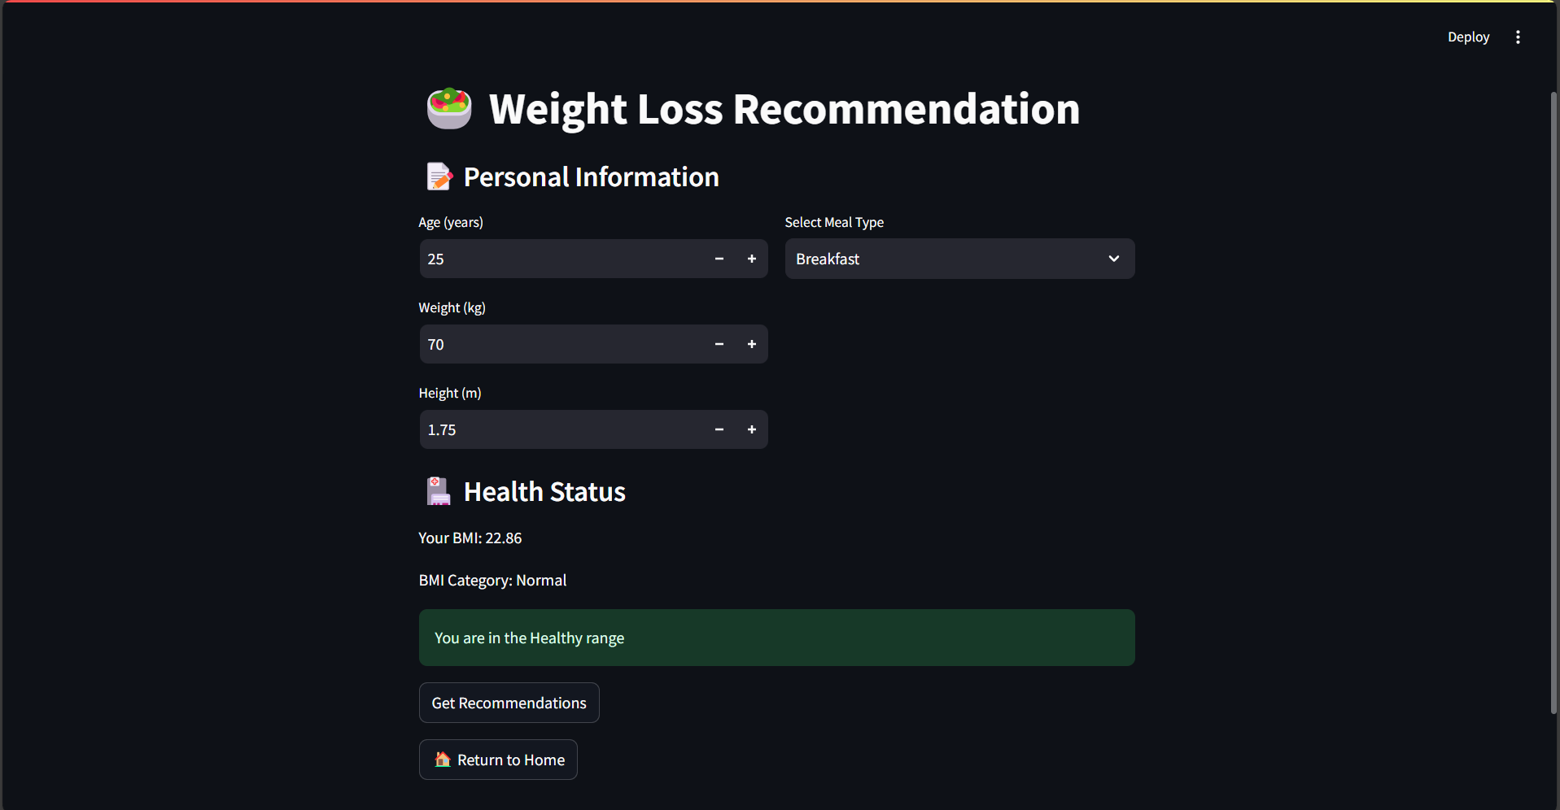

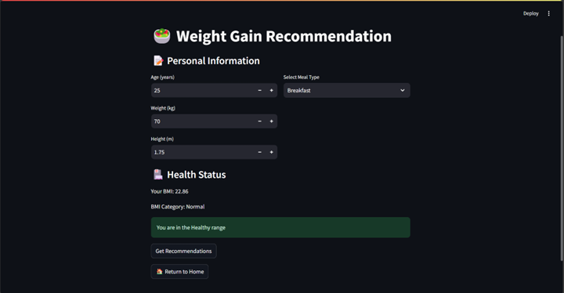

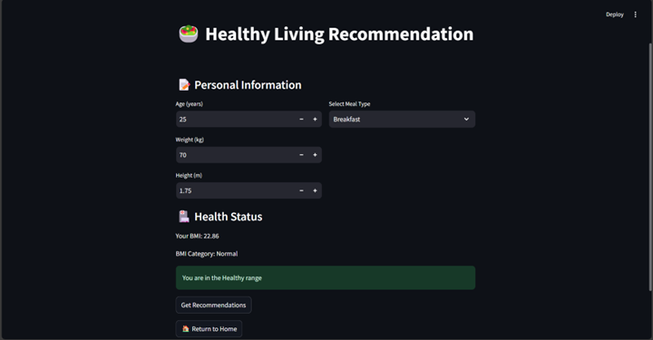

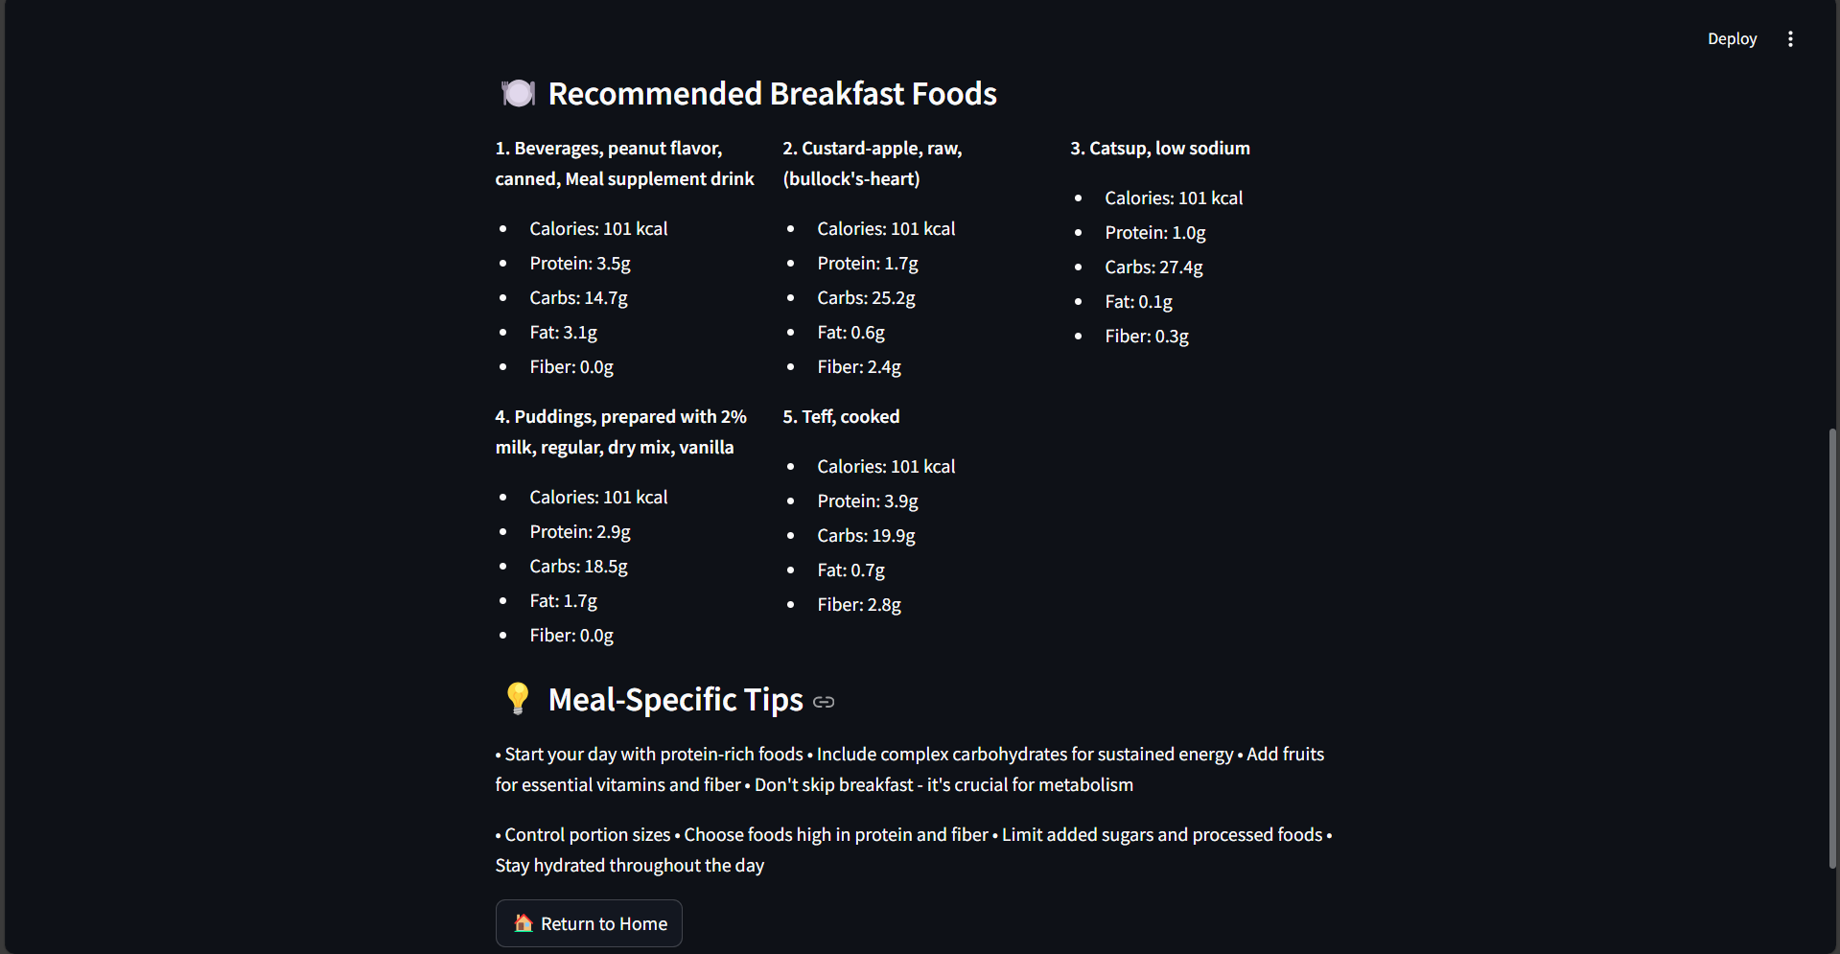

**CHAPTER-9**

**CONCLUSION AND FUTURE SCOPE**

**9 CONCLUSION AND FUTURE SCOPE**

**Conclusion**

The Nutrition Recommendation System provides personalized nutrition guidance through user-friendly platform that helps users make informed dietary choices .

Our solution enhances traditional nutrition guidance by integrating K-Means Clustering and Random Forest Classification algorithms. This makes it particularly suitable for this modern and technology-driven generation who seek efficient solutions for their nutritional needs.

The Nutrition Recommendation System represents an ideal solution for today's health-conscious individuals, offering a practical and personalized approach to nutrition management

**Future Scope**

* AI-Powered Chatbot Implement an intelligent chatbot that can answer user queries about nutrition, provide meal suggestions, and offer general dietary advice. This feature would provide instant support and guidance to users
* Geolocation-Based Recommendations Utilize the user's location to suggest local, seasonal foods and nearby restaurants that align with their dietary goals. This could also help in recommending regional cuisines that fit the user's nutritional needs
* Customizable Dashboard Allow users to customize their dashboard to display the nutritional information and metrics most important to them.
* On-Demand Nutritionist Consultations Implement a feature that allows users to schedule virtual consultations with registered dietitians or nutritionists for more personalized advice and meal planning

**CHAPTER-10**

**REFERENCES**

**10 REFERENCES**

* 1. IEEE Transactions on Biomedical Circuits and Systems, Vol. 12, No. 1, February 2018

The authors of this paper are:

Chih-Han Chen, Maria Karvela, Mohammadreza Sohbati, Thaksin Shinawatra, and Christofer Toumazou

The paper is titled:

"PERSON—Personalized Expert Recommendation System for Optimized Nutrition"

* 1. S. Sezgin and E. Ozkan, "A Smart Recommender System for Nutrition and Healthy Diet," IEEE

International Conference on Big Data (Big Data), 2020.