Successful output-

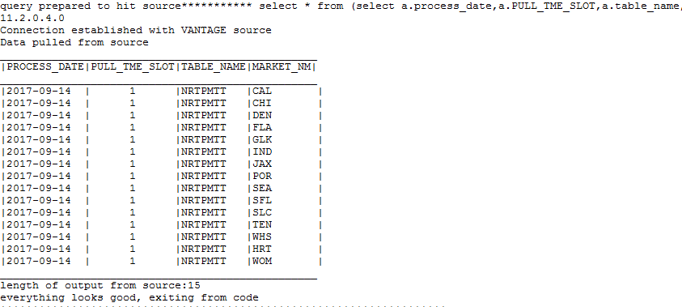

Sample output with unsuccessful conditions on source ref table:

