**Fordham Student Records Program**

The Fordham Student Records Program is a python file that allows users to enter queries to pull information from a text file containing information on Fordham Students (ID #, Last Name, First Name, Graduating Year, Graduating Term and Degree Program).

**Usage**

This program allows a user to choose from 5 queries to pull data from the student’s text file.

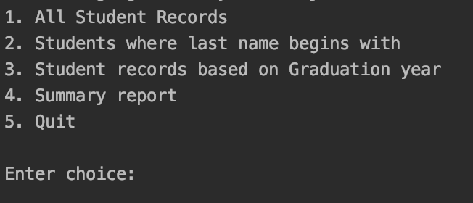

If you enter “1”, the program will return all student records from the file.

If you enter “2”, the program will then ask you to type in a string. You can type in the first letter of a last name or a full last name. The program will then return all records associated with the string you entered from the student file. Example:

If you enter “3”, the program will then ask you type in a graduating year. You must type in “yyyy” to get the appropriate response. Example:

If you enter “4”, the program will give you a summary report detailing the number of students in each program and the percent of students In each program. Example:

If you enter “5”, the program will stop running.

**Contributing**

Pull requests are welcome. For major changes please open an issue first to discuss what you would like to change.

**Author Acknowledgement**

Thank you to the authors who worked hard to make this program successful: Sabrina Yu, Saim Sajjad, Chris Tofalli and Logan Gillard