The University of Azad Jammu And Kashmir
Department of software engineering
Question number 01: Installtion of
Vmware and ubantu.
Step 1:
Click on the setuppand then click on the next.
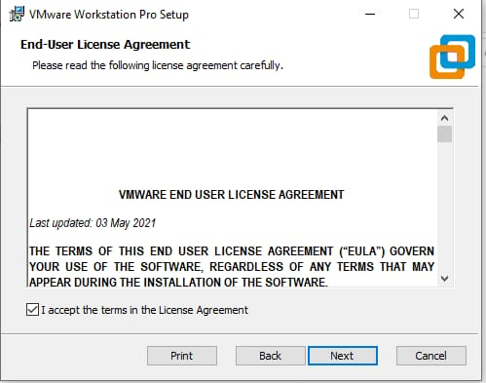
Step2:check the Destop and also on the Start menu program folder.and then click on the next.
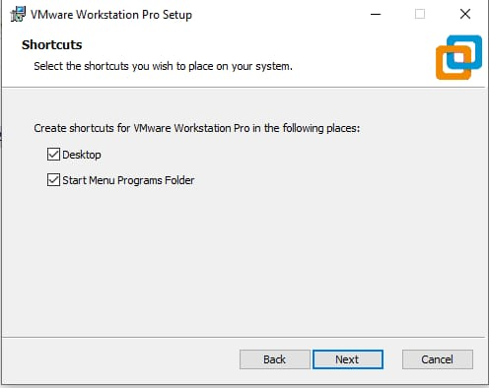
Step 3:Click on the install button.
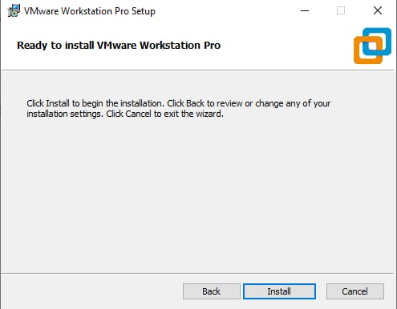
Step 4:Click on the next.
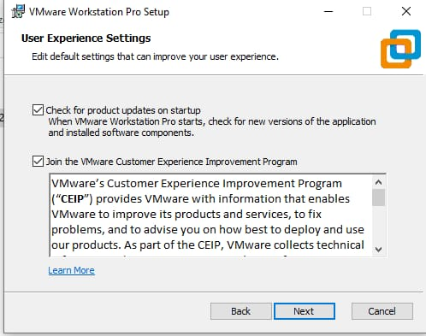
Step 5:The installion process will start.
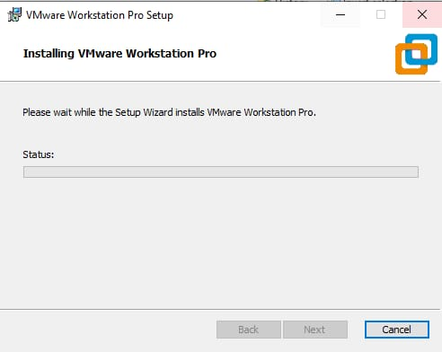
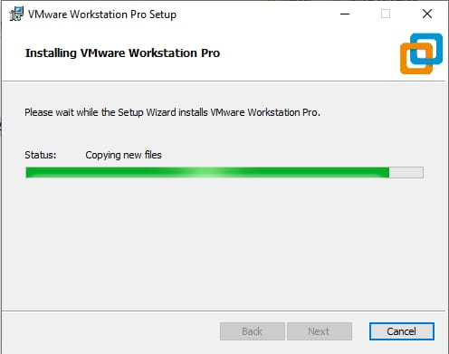
Step 6:Click on the next.
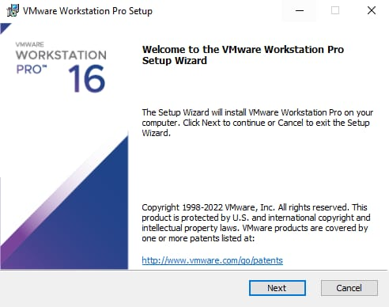
Step 6:This interface will appear.
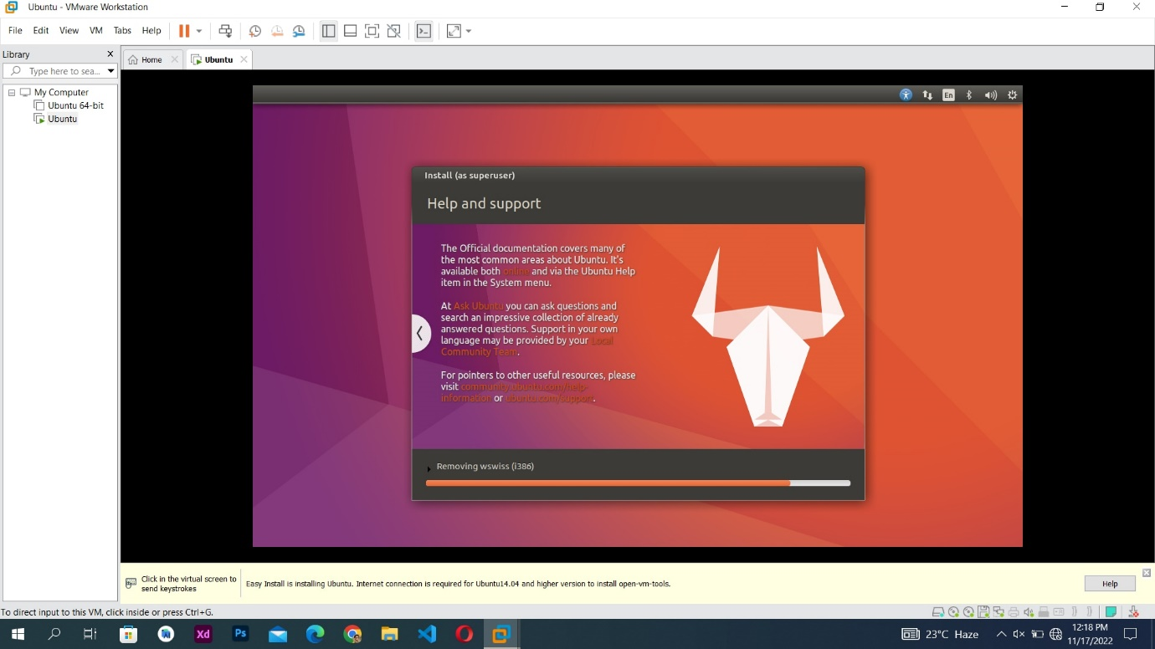
Step8:This type of inter will appear.
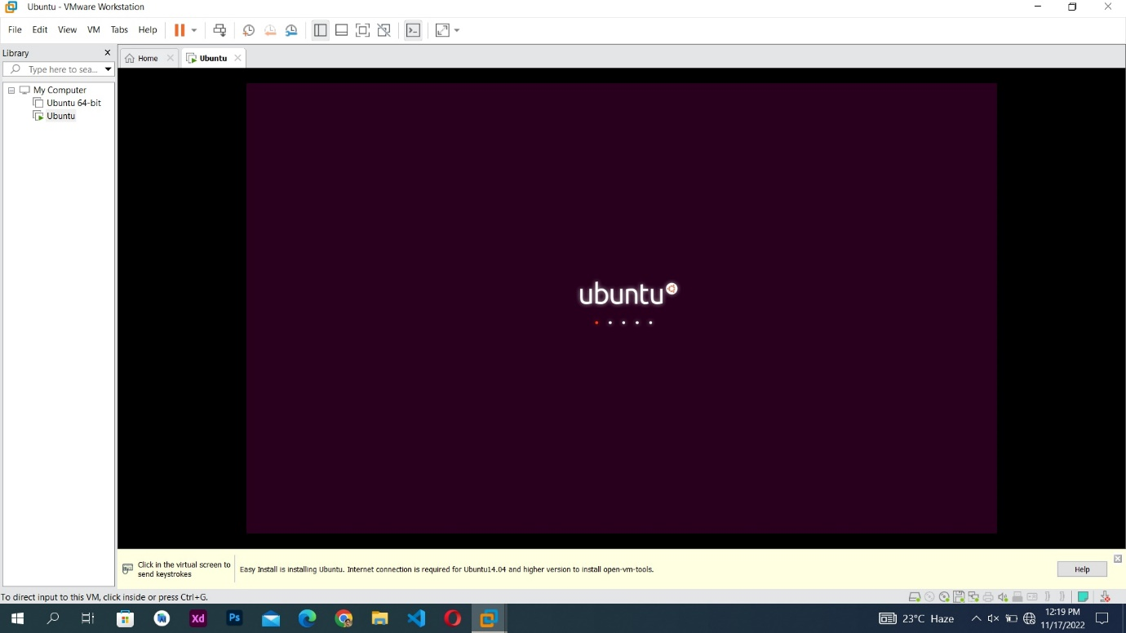
Step 8:Click on the Create a new virtuall machine.
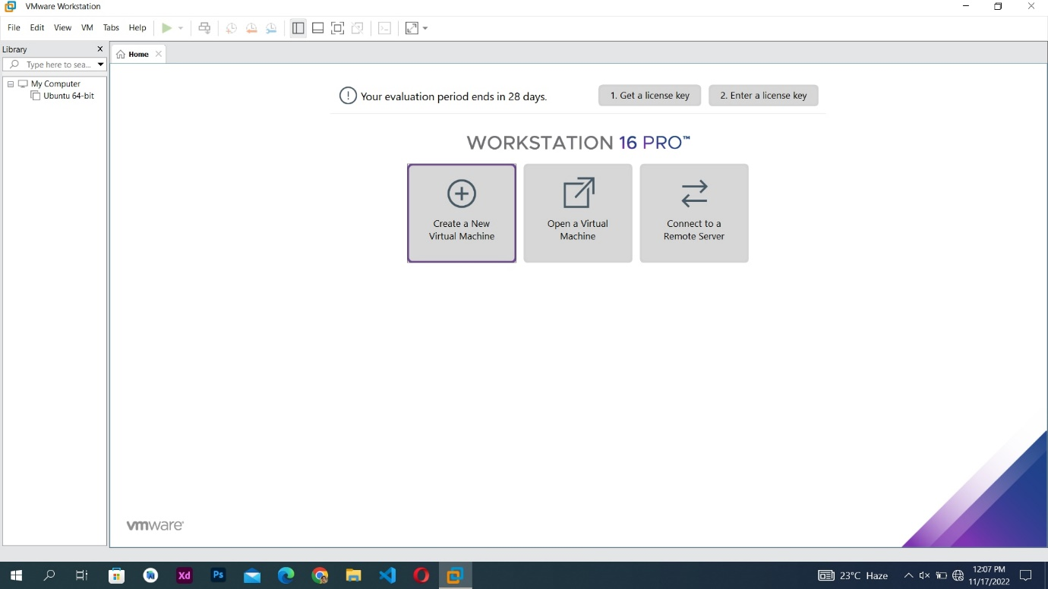
Step 9:Click on the next.
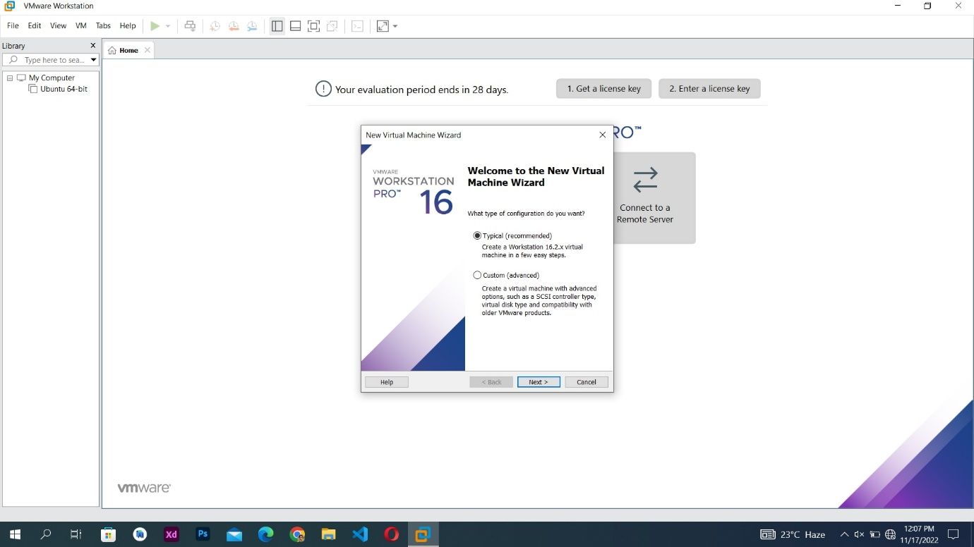
Step 10:click on the installer disc image file(iso).
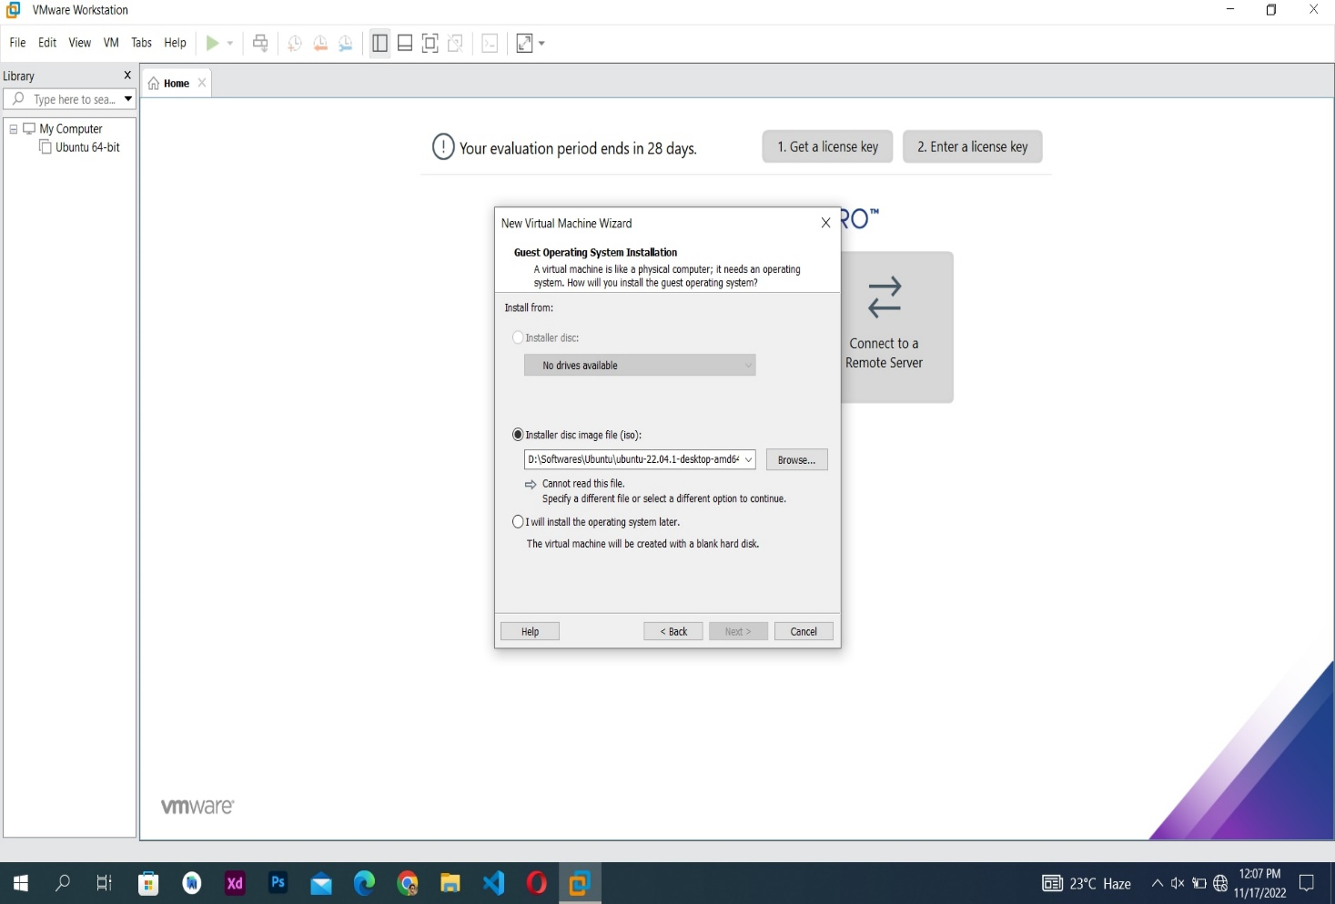
Step 11:Click on the browse and select the path.
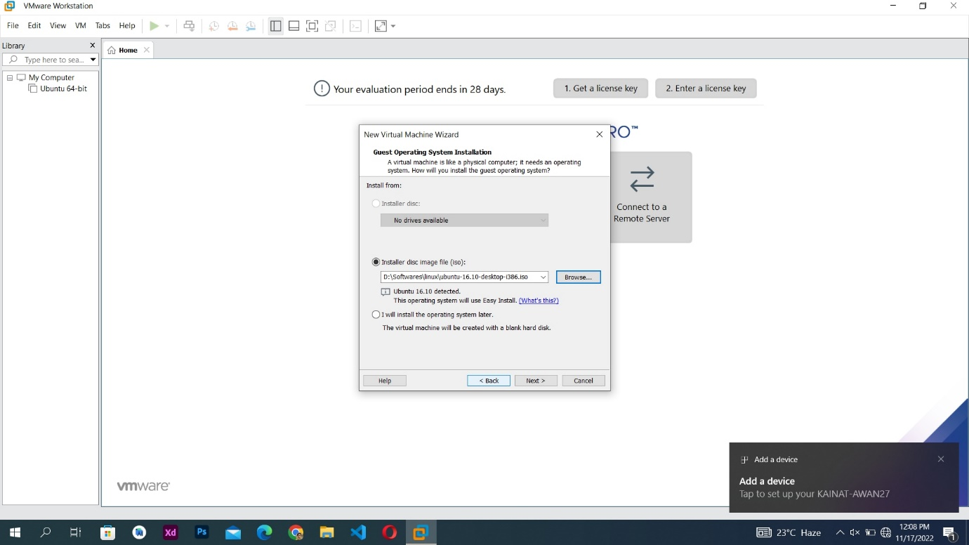
Step 12:Ubanto will be install.
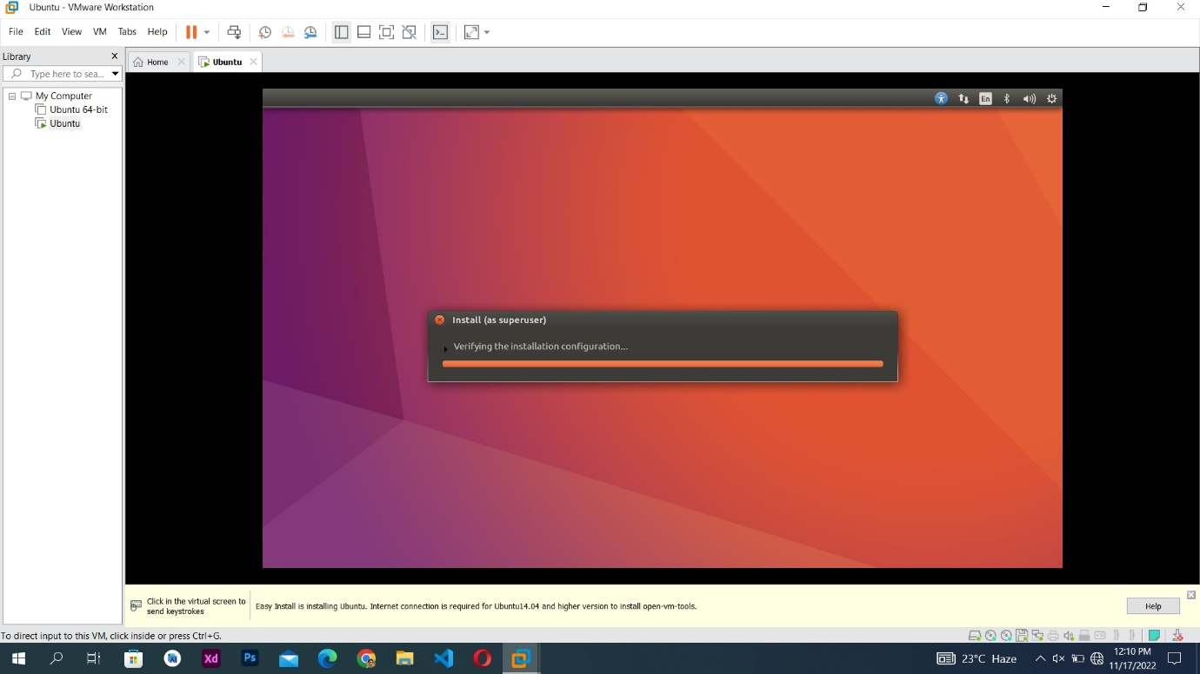
Step 13:This interface will be appear.
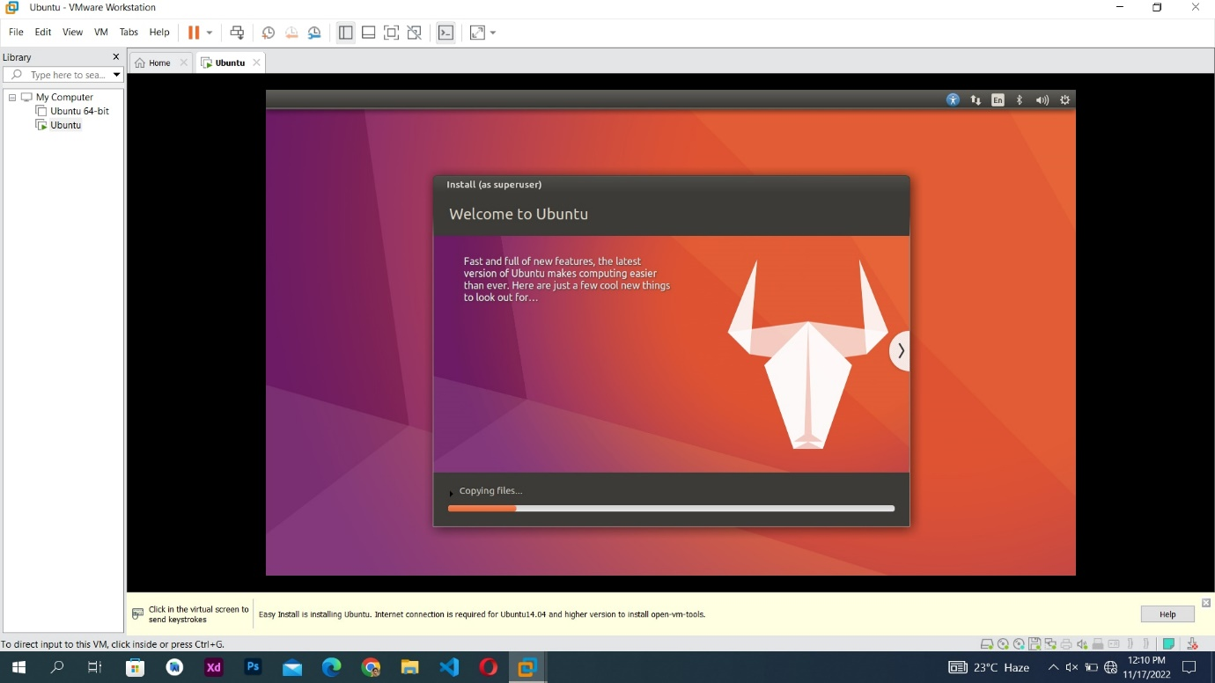
Step 14:This interface will appear like FIND EVEN MORE SOFTWARE.
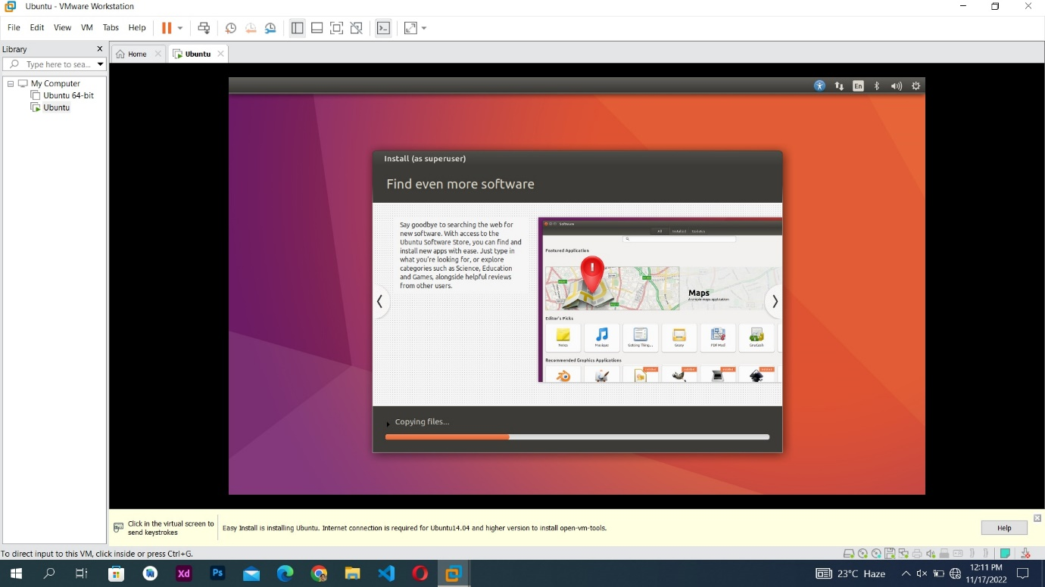
Step 15:ACCESS FOR EVERY ONE interface will be appear.

