1. Use the substitution method to show that each of the following recurrences defined on the reals has the asymptotic solution specified:
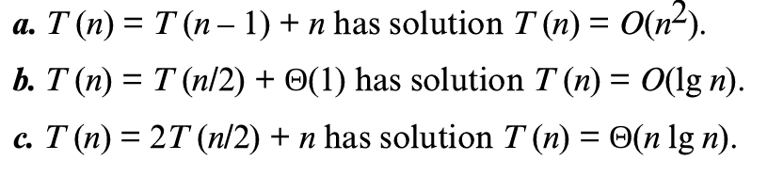
2. For each of the following recurrences, sketch its recursion tree, and guess a good asymptotic upper bound on its solution. Then use the substitution method to verify your answer.
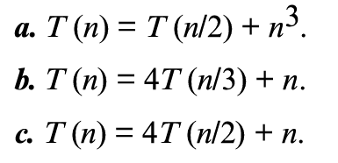
3. Use the master method to give tight asymptotic bounds for the following recurrences.
