Q1 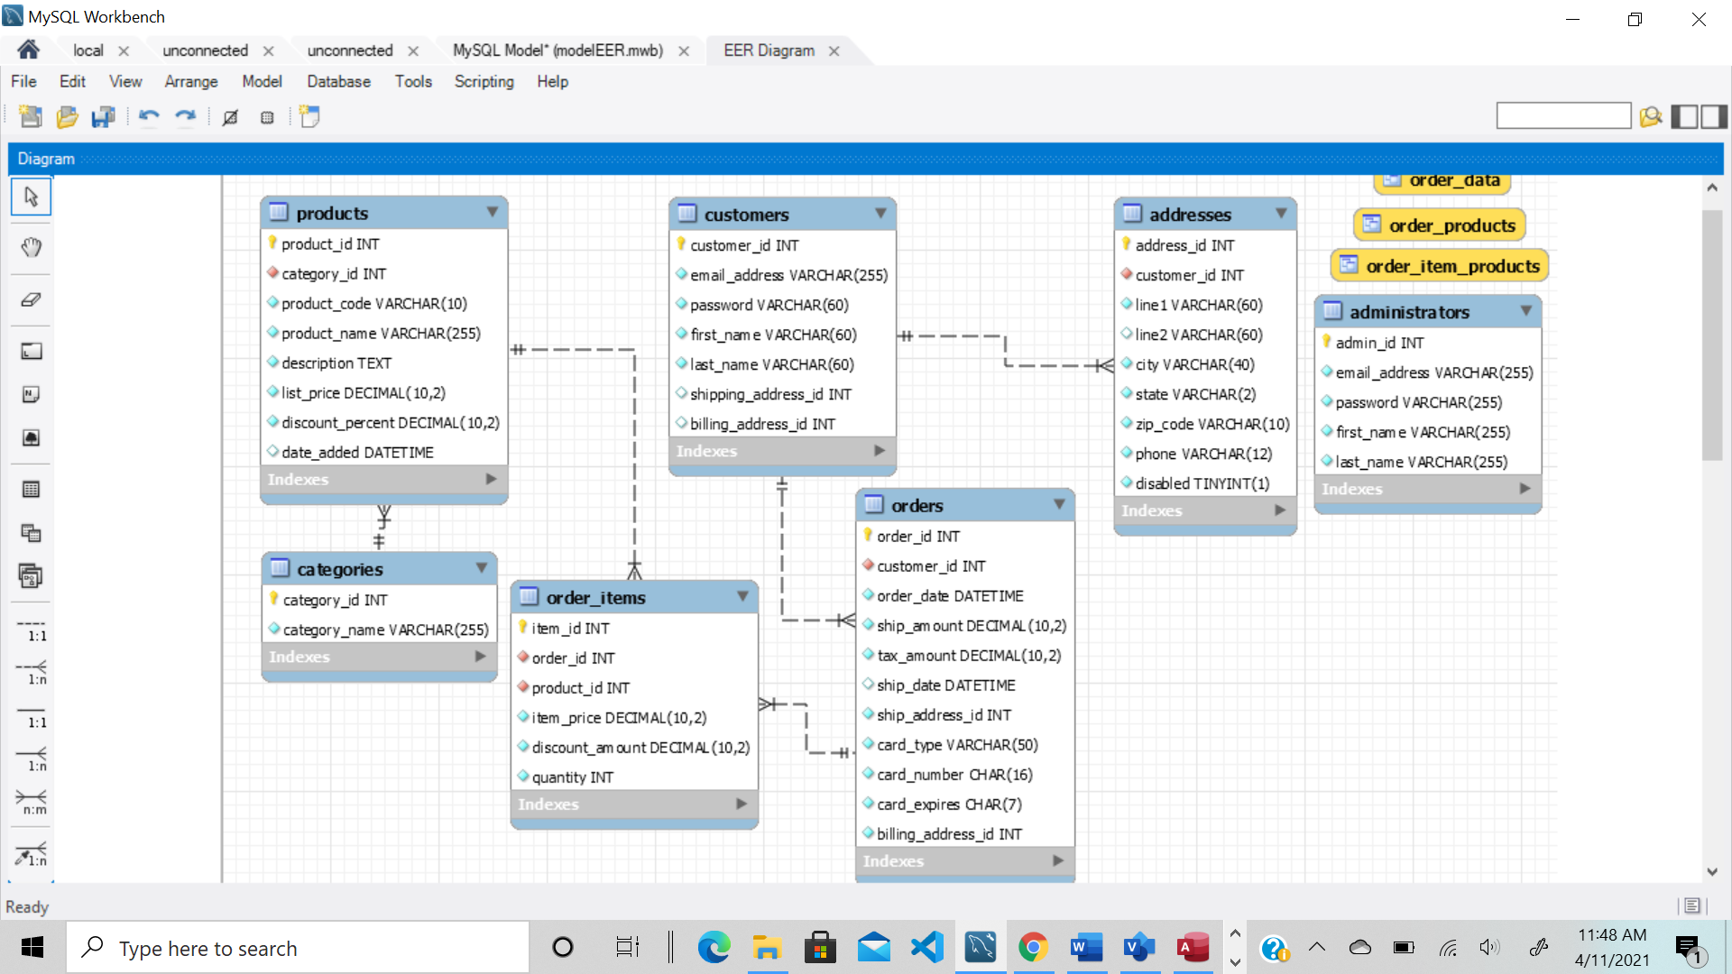

Explanation for two table orders and order_items

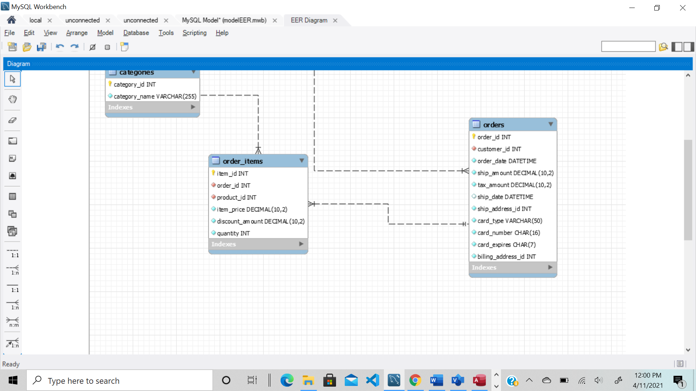

orders table, primary key =order_id, foreign key =customer_id

order_items, primary key= item_id, foreign key= order_id, product_id

relationship = one to many

cardinality shows in figure